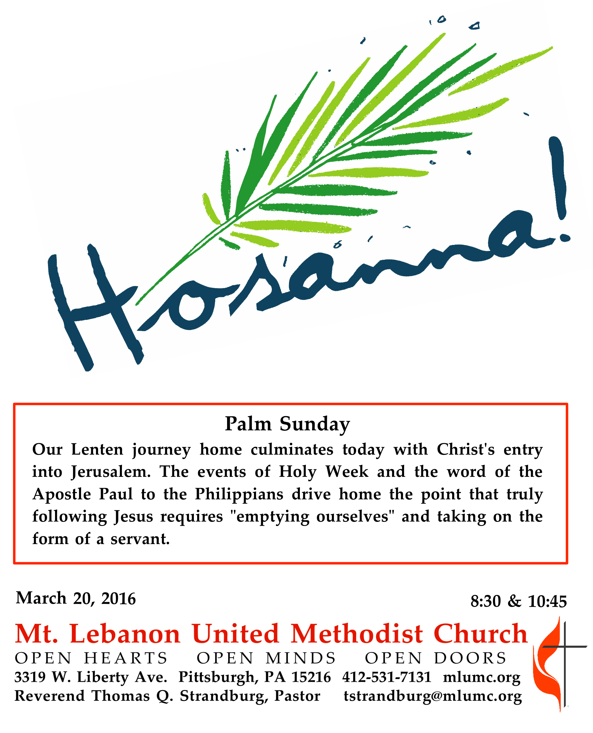
WE GATHER IN GOD’S NAME …
Prelude 10:45 Bwana Asifiwe! (Praise the Lord!) Cathy Moklebust
Chapel Bells

Introit 10:45 Hosanna! Hosanna! Marie Pooler and Helen Kemp Children’s Choir

*Call to Worship
Pastor: Give thanks to God,
People: whose steadfast love endures forever.
Pastor: Give praise to the one who comes in God’s name.
People: We wave our palms in praise and celebration.
Pastor: This is the day that our God has made.
People: Let us rejoice and be glad. Hosanna!
inspired by Mark 11 & Psalm 118

*Worship & Song 3082 Who is he? Hymn to Joy
words by Ken Bible;
music by Ludwig van Beethoven; arr. by Edward Hodges;
© 2004 by LNWhymns.com. CCLI Song 4306348.

… TO GIVE PRAISE TO GOD …

Processional Anthem 10:45 Hail the King Shirley W. McRae
Children’s and Chancel Choirs

Hail the King who comes a-riding down the hill from Bethany,
riding on a lowly donkey, yet to claim his royalty.
Refrain: Sing hosanna to our King.

Though he wears no royal garments, though he bears no gilded crown,
still he comes as our Redeemer riding triumphant into town. Refrain

See the children of the city gathered along his royal way,
palms and flowers spread before him, bless we all this holy day. Refrain

Words of Welcome and Announcements

*please rise in body or spirit

*Opening Prayer (in unison)
God of steadfast love, we celebrate the coming of your Messiah with glad songs and hosannas. We wave our palms and cheer. May we wholeheartedly celebrate the life, the forboding, and the love and grace that this day symbolizes, even while clouds gather on the horizon. As we hear a familiar story told once more, open our hearts to receive these words anew, that they may shape our lives and faith. Amen.

Anthem 10:45 Somebody’s knockin’ at your door African-American Spiritual, Children’s Choir arr. Nichols

1. Somebody's knockin' at your door! Oh, children, why don't you answer!
2. Who's that a-knockin' at your door?
3. Jesus is knockin' at your door!
4. Open the door and let Him in!
5. Come, wave your branches and let Him in!

… TO CELEBRATE THE FAMILY OF FAITH …

The Sign of Peace Please pass the peace to your neighbors as a sign of reconciliation and love.
Leader: The peace of Christ be with you.
People: And also with you.

Gathering Song James Ritchie
This, this is where children belong,
welcomed as part of the worshiping throng.
Water, God’s Word, bread and cup, prayer and song:
This is where children belong.
WORDS: James Ritchie MUSIC: James Ritchie ©1999 Abingdon Press

Message for Young Disciples Rev. Thomas Q. Strandburg
All children are invited. Please sing as children come forward. After the children’s message at the 10:45 service, children ages 3 - 3rd grade may attend Kids Praise in the Welcome Center. Children will be escorted to and from Kids Praise by teachers. They will return to the Sanctuary near the end of the service.

… TO HEAR GOD’S WORD PROCLAIMED …

Scripture Reading Joeta D’Este 8:30
Nate Jara 10:45
A Lesson from the New Testament
Philippians 2:5-11 The call to imitate Christ

Worship & Song 3077 Blessed is he who comes in God’s name Lament
Pastoral Prayer

The Lord’s Prayer
Our Father, who art in heaven, hallowed be thy name. Thy kingdom come, thy will be done, on earth as it is in heaven. Give us this day our daily bread. And forgive us our trespasses, as we forgive those who trespass against us. And lead us not into temptation, but deliver us from evil. For thine is the kingdom, and the power, and the glory forever. Amen.

Scripture Reading
*A Lesson from the Gospels
Luke 19:28-40 Jesus enters Jerusalem

Response
Leader: The Word of the Lord.
People: Thanks be to God.

… TO OFFER OUR GIFTS AND TO DEDICATE OUR LIVES …

Offertory Solo 8:30 The Holy City Stephen Adams

Offertory Anthem 10:45 William Mathias
Ad majorem Dei gloriam (translation: For the greater glory of God.)

*Doxology 95
Praise God, from whom all blessings flow;
Praise God, all creatures here below;
praise God above, ye heavenly host;
praise Father, Son and Holy Ghost. Amen

Prayer of Dedication

Sermon “Thumbs Up to the Bowed Down” Rev. Thomas Q. Strandburg

… TO GO REJOICING IN GOD’S NAME!

*Hymn #280 All glory, laud and honor (stanzas 3-5) St. Theodulph

Benediction

Today’s Services
The flowers in the Chancel are given in loving memory of Bill and June Lowe by Betsy Rayner and Laurie Lowe.

The flowers on the altar are given in loving memory of William B. Lockhart by his daughter, Laurel.

Special music at 8:30 is provided by John Esaias, a very active member of the church and a member of the Chancel Choir.

Special music at 10:45 is provided by the Chapel Bells, directed by Nancy R. Lutz; the Children's Choir, directed by Kim Rhoton and Heidi Pandolfi; and the Chancel choir, directed by Ryan A. Keeling.

Greeters 8:30 Bill and Luann Minnick 10:45 Martha Banyas

Acolytes Juliana and Lydia Slater Cross Bearer Jim Young

Worship options for children We encourage children to participate in the Children’s Sermon at both services, and in Kids Praise during the 10:45 service. Nursery services are offered in Room 204 of the Education Building. Ask ushers or greeters and follow signs for direction.

HOLY WEEK SCHEDULE

Tenebrae Service with Holy Communion, Thursday, March 24, 7:30 pm
Join us this Thursday, March 24, for a Service of Tenebrae with Holy Communion, at 7:30 pm in the sanctuary. In the Tenebrae service, candles will represent Christ and the 12 disciples. Following Holy Communion, the candles will be extinguished as readers and musicians communicate the Gospel accounts of the passion and death of our Lord.

Good Friday Community Worship Service, Friday, March 25, 12 pm
On Good Friday, March 25, a Community Worship Service will be observed from noon to 1 pm in our sanctuary. The service will feature meditations upon critical events in the passion narrative from the Gospel of John, delivered by representatives of Bethany Evangelical Lutheran Church, Bower Hill Community Presbyterian Church, Southminster Presbyterian Church, Sunset Hills United Presbyterian Church, as well as Mt. Lebanon United Methodist Church. Choir members from the participating churches will lead the music.

Easter Sunday Services, March 27
The 8:30 am and 10:45 am services will be celebrated in the sanctuary.

Today’s Scriptures

Philippians 2:5-11
⁵Let the same mind be in you that was in Christ Jesus,
⁶who, though he was in the form of God, did not regard equality with God as something to be exploited,
⁷but emptied himself, taking the form of a slave, being born in human likeness. And being found in human form,
⁸he humbled himself and became obedient to the point of death— even death on a cross.
⁹Therefore God also highly exalted him and gave him the name that is above every name,
¹⁰so that at the name of Jesus every knee should bend, in heaven and on earth and under the earth, ¹¹and every tongue should confess that Jesus Christ is Lord, to the glory of God the Father.

Luke 19:28-40
²⁸After he had said this, he went on ahead, going up to Jerusalem.
²⁹When he had come near Bethphage and Bethany, at the place called the Mount of Olives, he sent two of the disciples,
³⁰saying, “Go into the village ahead of you, and as you enter it you will find tied there a colt that has never been ridden. Untie it and bring it here.
³¹If anyone asks you, ‘Why are you untying it?’ just say this, ‘The Lord needs it.’”
³²So those who were sent departed and found it as he had told them.
³³As they were untying the colt, its owners asked them, “Why are you untying the colt?”
³⁴They said, “The Lord needs it.”
³⁵Then they brought it to Jesus; and after throwing their cloaks on the colt, they set Jesus on it.
³⁶As he rode along, people kept spreading their cloaks on the road.
³⁷As he was now approaching the path down from the Mount of Olives, the whole multitude of the disciples began to praise God joyfully with a loud voice for all the deeds of power that they had seen,
³⁸saying, “Blessed is the king who comes in the name of the Lord! Peace in heaven, and glory in the highest heaven!”
³⁹Some of the Pharisees in the crowd said to him, “Teacher, order your disciples to stop.”
⁴⁰He answered, “I tell you, if these were silent, the stones would shout out.”

Keep in Prayer

Convalescing in Care Facilities
Leila Berkey, Asbury Heights
Jean Bouvy, McMurray Hills Manor
Margie Jellison, Townview, Canonsburg
Kay McDade, Manor Care, Whitehall
Sanford Morton, Sunrise, Upper St. Clair
Jane Morton, Sunrise, Upper St. Clair
David Watson, Concordia

Convalescing at Home
Joyce Feldman, Ann Hoyer,
Amy Lonsinger

In the Military

Jason Boyer, SPC Natalie Brown

Capt. Zachary Allen Finch, USMC
James Iantelli, 1st Lt. Jaskiewicz
S. Sgt. Keith Kimmell, Adam Kmick
PFC Brendan Lamport
Sgt. Matthew McConahan, Thomas Orda
Lt. Col. Mark Patterson
Lt. Com. Scott Patterson

Lt. Col. Sean Patterson
David Poncel, Sgt. Steven Reitz
Capt. Scott B. Rushe, Pastor Rick Townes
Capt. Azizi Wesmiller

Capt. Matthew C. Wesmiller
Sgt. Keith Scott Winkowski

Sgt. Michael Zimmerman

Podcasts of Sunday Sermons
Would you like to share this morning’s sermon with a friend or did you miss a Sunday? Catch up on the messages from MLUMC with a podcast of Pastor Tom’s and others’ Sunday sermons. Sermons
from the past three months are at http:// mlumc.buzzsprout.com. You can navigate to the site from the link on our webpage, www.mlumc.org, through the app, Stitcher or through iTunes.

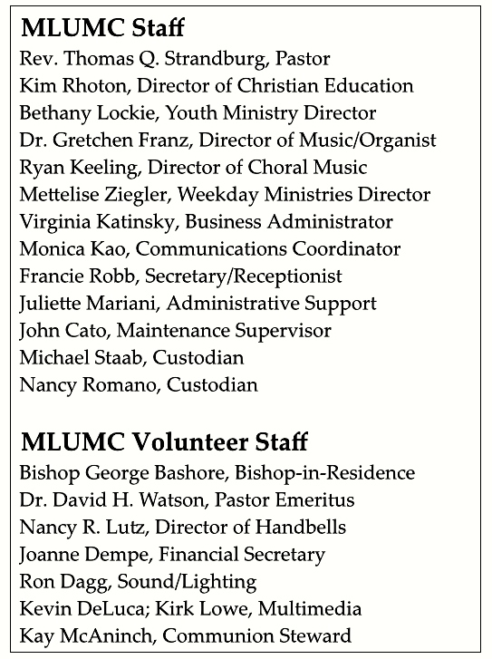

CALENDAR – SUNDAY, MARCH 20 THRU SATURDAY, MARCH 26
SUNDAY 3/20
8:30 am Worship Sanner Chapel
9:30 am Sunday School for All Ages / Coffee Café Various / Brookline Parlor
10:45 am Worship Sanctuary
Kids Praise Welcome Center
After services Network French Toast Brunch Asbury Center
5 pm Youth Group 4th Floor Youth Room
6:30 pm Eagle Board of Review Various

MONDAY, 3/21
7 pm Chapel Bells Rehearsal Bell Room

TUESDAY 3/22
7 pm Boy Scout Troop #23 Asbury/Wesley Hall

WEDNESDAY 3/23
9:30 am Bishop’s Lenten Study Wesley Hall
6:30 pm Wolf Cub Scout Wesley Hall

THURSDAY 3/24
6:30 pm Webelos Wesley Hall
7:30 pm Service of Tenebrae with Holy Communion Sanctuary

FRIDAY 3/25 GOOD FRIDAY, OFFICE CLOSES AT NOON
9:30 am Women’s Bible Study Asbury Center
Noon Community Worship Service Sanctuary
4 pm Community Fish Fry Asbury Center
6:30 pm Cub Scouts Bear Den Wesley Hall

SATURDAY 3/26
10 am Food Distribution Kitchen

