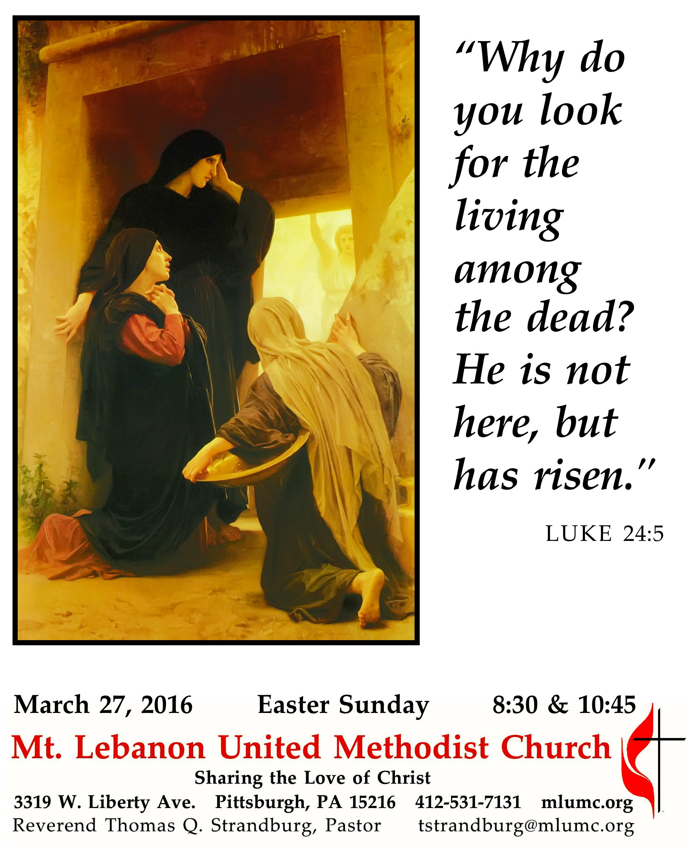
The Resurrection of the Lord

Easter calls us to be amazed at the power of our loving God and at the incredible gift that God has given us – new life, new hope. It points to a radical, life-changing reality that has the power to make a difference in this world.
..

WE GATHER IN GOD’S NAME …

Prelude Entrata Festiva Flor Peeters
Christ overpowereth, Christ now reigneth, Christ doth command.

Call to Worship
Pastor: Christ is risen!
People: Christ is risen indeed! Alleluia!
Pastor: For this perishable body must put on imperishability, and this mortal body must put on immortality.
People: When this perishable body puts on imperishability, and this mortal body puts on immortality, then the saying that is written will be fulfilled: “Death has been swallowed up in victory.”
Pastor: Where, O death, is your victory?
People: Where, O death, is your sting?
Corinthians 15:53-55

… TO GIVE PRAISE TO GOD …

*Hymnal 302 Christ the Lord is risen today (stanzas 1-4) Easter Hymn

*Opening Prayer (in unison)
Sanctifier of time and space, maker of dancing quarks and ancient quasars, of energy and element, blessed are you, Creator God. Your saving love endures forever; your holy light pierces the cold darkness of death and chaos; you make a covenant of life with your creatures, which no evil can overcome. May the glorious radiance of resurrection dispel the shadows in our lives and conform us more closely to your risen Christ, to whom, with you and the Holy Spirit, be all honor, praise, and glory. Amen.
Worship & Song

… TO CELEBRATE THE FAMILY OF FAITH …

The Sign of Peace Please pass the peace to your neighbors as a sign of reconciliation and love.
Leader: The peace of Christ be with you.
People: And also with you.

Gathering Song
This, this is where children belong,
welcomed as part of the worshiping throng.
Water, God’s Word, bread and cup, prayer and song:
This is where children belong WORDS AND MUSIC: James Ritchie ©1999 Abingdon Press
Message for Young Disciples Rev. Thomas Q. Strandburg
All children are invited. Please sing as children come forward. After the children’s message at the 10:45 service, children ages 3 - 3rd grade may attend Kids Praise in the Welcome Center. Children will be escorted to and from Kids Praise by teachers. They will return to the Sanctuary near the end of the service.

*Hymnal 306 The strife is o'er, the battle done Victory

… TO HEAR GOD’S WORD PROCLAIMED …

Scripture Reading
A Lesson from the New Testament
Acts 10:34-43 Peter at the house of Cornelius

Concerns of the Parish

Pastoral Prayer

The Lord’s Prayer
Our Father, who art in heaven, hallowed be thy name. Thy kingdom come, thy will be done, on earth as it is in heaven. Give us this day our daily bread. And forgive us our trespasses, as we forgive those who trespass against us. And lead us not into temptation, but deliver us from evil. For thine is the kingdom, and the power, and the glory forever. Amen.
Scripture Reading
*A Lesson from the Gospels
John 20:1-18 The account of the resurrection

Response
Leader: The Word of the Lord.
People: Thanks be to God.
… TO OFFER OUR GIFTS AND TO DEDICATE OUR LIVES …

Offertory Anthem Philip W. J. Stopford
Christ the Lord is risen again, Christ hath broken every chain,
Hark, angelic voices cry, singing evermore on high, alleluia
He who gave for us his life, who for us endured the strife, is our Paschal Lamb today;
we too sing for joy, and say alleluia!
He who bore all pain and loss comfortless upon the cross, lives in glory now on high,
pleads for us, and hears our cry.
He who slumbered in the grave is exalted now to save;
now through Christendom it rings that the Lamb is King of kings. Alleluia.
Thou, our Paschal Lamb indeed, Christ, thy ransomed people feed;
take our sins and guilt away;
let us sing by night and day alleluia.

*Doxology #94
Praise God from whom all blessings flow;
Praise God, all creatures here below: Alleluia! Alleluia!
Praise God the source of all our gifts!
Praise Jesus Christ, whose power uplifts!
Praise the Spirit, Holy Spirit. Alleluia! Alleluia! Alleluia!

Prayer of Dedication

*Hymnal 308 Thine be the glory Judas Maccabeus

Sermon “Signs of Life” Rev. Thomas Q. Strandburg

The Apostles’ Creed
Pastor: Let us join together in professing the Christian faith as contained in the Scriptures of the Old and New Testaments.
Do you believe in God the Father?
People: I believe in God, the Father Almighty, creator of heaven and earth.
Pastor: Do you believe in Jesus Christ?
People: I believe in Jesus Christ, his only Son, our Lord, who was conceived by the Holy Spirit, born of the Virgin Mary, suffered under Pontius Pilate, was crucified, died, and was buried;
he descended to the dead. On the third day he rose again; he ascended into heaven, is seated at the right hand of the Father, and will come again to judge the living and the dead.

Pastor: Do you believe in the Holy Spirit?
People: I believe in the Holy Spirit, the holy catholic church, the communion of saints, the forgiveness of sins, the resurrection of the body, and the life everlasting.

… TO GO REJOICING IN GOD’S NAME!

Choral Response Messiah: "Hallelujah" Chorus G. F. Handel

Benediction

Postlude

Today’s Services

Special music for the 8:30 service is provided by the Chancel Choir.

Special music at 10:45 is provided by the Chancel Choir with guest instrumentalists: Josh Boudreau and Stephen McGough, trumpet; Bryan Adkins, horn; Gonzalo Fernandez, trombone; Robert Tupper, bass trombone; and Richard Minnotte, timpani. The addition of the instrumentalists is made possible through contributions to the Friends of Music Fund. New contributors are most welcome - make a check to the church and note "Friends of Music Fund."

Our hymnal and the new hymnal supplement are rich resources. As we explore newer texts and tunes we will repeat them several times during the month so that we are more comfortable singing them

Greeters 8:30 Erma Henry 10:45 John and Shirley Baker

Acolytes Anna Rhoton and Rylee Siegert

Cross Bearer 8:30 Matthew Lewis 10:45 Max Siegert

Worship options for children We encourage children to participate in the Children’s Sermon at both services, and in Kids Praise during the 10:45 service. Nursery services are offered in Room 204 of the Education Building. Ask ushers or greeters and follow signs for direction.

Today’s Scriptures
Acts 10:34-43
³⁴Then Peter began to speak to them: “I truly understand that God shows no partiality,
³⁵but in every nation anyone who fears him and does what is right is acceptable to him.
³⁶You know the message he sent to the people of Israel, preaching peace by Jesus Christ—he is Lord of all.
³⁷That message spread throughout Judea, beginning in Galilee after the baptism that John announced:
³⁸how God anointed Jesus of Nazareth with the Holy Spirit and with power; how he went about doing good and healing all who were oppressed by the devil, for God was with him.
³⁹We are witnesses to all that he did both in Judea and in Jerusalem. They put him to death by hanging him on a tree;
⁴⁰but God raised him on the third day and allowed him to appear,
⁴¹not to all the people but to us who were chosen by God as witnesses, and who ate and drank with him after he rose from the dead.
⁴²He commanded us to preach to the people and to testify that he is the one ordained by God as judge of the living and the dead.
⁴³All the prophets testify about him that everyone who believes in him receives forgiveness of sins through his name.”

John 20:1-18
Early on the first day of the week, while it was still dark, Mary Magdalene came to the tomb and saw that the stone had been removed from the tomb.
²So she ran and went to Simon Peter and the other disciple, the one whom Jesus loved, and said to them, “They have taken the Lord out of the tomb, and we do not know where they have laid him.” ³Then Peter and the other disciple set out and went toward the tomb.
⁴The two were running together, but the other disciple outran Peter and reached the tomb first.
⁵He bent down to look in and saw the linen wrappings lying there, but he did not go in.
⁶Then Simon Peter came, following him, and went into the tomb. He saw the linen wrappings lying there,
⁷and the cloth that had been on Jesus’ head, not lying with the linen wrappings but rolled up in a place by itself.
⁸Then the other disciple, who reached the tomb first, also went in, and he saw and believed;
⁹for as yet they did not understand the scripture, that he must rise from the dead.
¹⁰Then the disciples returned to their homes.
¹¹But Mary stood weeping outside the tomb. As she wept, she bent over to look into the tomb;
¹²and she saw two angels in white, sitting where the body of Jesus had been lying, one at the head and the other at the feet.
¹³They said to her, “Woman, why are you weeping?” She said to them, “They have taken away my Lord, and I do not know where they have laid him.”
¹⁴When she had said this, she turned around and saw Jesus standing there, but she did not know that it was Jesus.
¹⁵Jesus said to her, “Woman, why are you weeping? Whom are you looking for?” Supposing him to be the gardener, she said to him, “Sir, if you have carried him away, tell me where you have laid him, and I will take him away.”
¹⁶Jesus said to her, “Mary!” She turned and said to him in Hebrew, “Rabbouni!” (which means Teacher).
¹⁷Jesus said to her, “Do not hold on to me, because I have not yet ascended to the Father. But go to my brothers and say to them, ‘I am ascending to my Father and your Father, to my God and your God.’”
¹⁸Mary Magdalene went and announced to the disciples, “I have seen the Lord”; and she told them that he had said these things to her.

Keep in Prayer

Convalescing in Care Facilities
Leila Berkey, Asbury Heights
Mary Birks, Kane Rehabilitation
Jean Bouvy, McMurray Hills Manor
Margie Jellison, Townview, Canonsburg
Kay McDade, Manor Care, Whitehall
Sanford Morton, Sunrise, Upper St. Clair
Jane Morton, Sunrise, Upper St. Clair
David Watson, Concordia

Convalescing at Home
Joyce Feldman, Ann Hoyer,
Amy Lonsinger

In the Military

Jason Boyer, SPC Natalie Brown

Capt. Zachary Allen Finch, USMC
James Iantelli, 1st Lt. Jaskiewicz
S. Sgt. Keith Kimmell, Adam Kmick
PFC Brendan Lamport
Sgt. Matthew McConahan, Thomas Orda
Lt. Col. Mark Patterson

Lt. Com. Scott Patterson

Lt. Col. Sean Patterson
David Poncel, Sgt. Steven Reitz
Capt. Scott B. Rushe, Pastor Rick Townes
Capt. Azizi Wesmiller

Capt. Matthew C. Wesmiller
Sgt. Keith Scott Winkowski

Sgt. Michael Zimmerman

CALENDAR – SUNDAY, MARCH 27 THROUGH SATUDAY, APRIL 2
Hosting Family Promise through Sunday, April 3

SUNDAY 3/27 EASTER SUNDAY
8:30 am Worship Sanctuary
10:45 am Worship Sanctuary
Kids Praise Welcome Center

MONDAY 3/28 EASTER MONDAY – OFFICE CLOSED
7 pm Chapel Bells Rehearsal Bell Room

TUESDAY 3/29
7 pm Boy Scout Troop #23 Wesley Hall

WEDNESDAY 3/30
7 pm Trustees Welcome Center

THURSDAY 3/31
6:30 pm Promise Bells Rehearsal Bell Room

FRIDAY 4/1
9:30 am Women’s Bible Study Room 102

SATURDAY 4/2
10 am Food Distribution Food Pantry
10 am New Member Orientation Welcome Center

Podcasts of Sunday Sermons
Would you like to share this morning’s sermon with a friend or did you miss a Sunday? Catch up on the messages from MLUMC with a podcast of Pastor Tom’s and others’ Sunday sermons. Sermons from the past three months are at http:// mlumc.buzzsprout.com. You can navigate to the site from the link on our webpage, www.mlumc.org, through the app, Stitcher or through iTunes.

