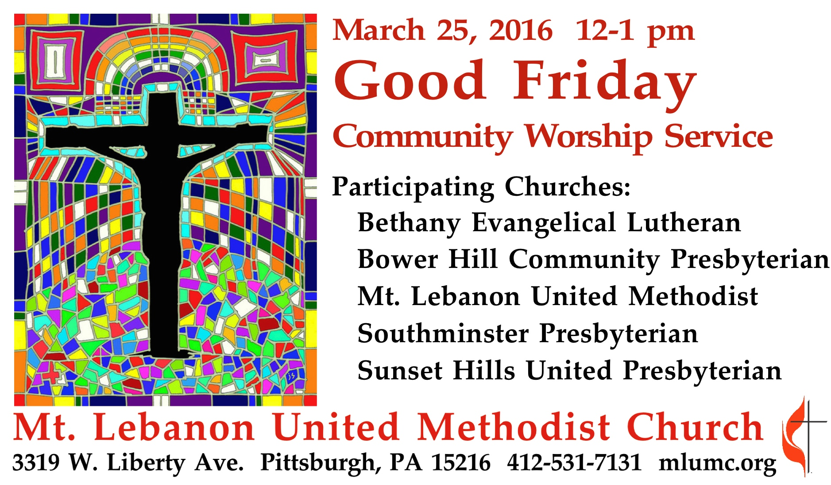

ENTRANCE

Introit Were you there Were you there
Ryan Leonard, clarinet

Call to Worship Rev. Deborah Ackley-Killian
Mt. Lebanon United Methodist Church
Leader: Come, let us gather again in the shadow of the Cross of Christ.
People: We gather to remember the overwhelming evidence of Love’s ultimate sacrifice.
Leader: Who would have guessed that the height and depth, the length and width of God’s love might look like this: a forsaken savior on a cross?
People: Certainly not us. Not us, who are too often lost amid the world’s distractions and responsibilities. Not us, for whom such love was offered without cost.
Leader: Let us gather again in the shadow of the Cross of Christ and commit ourselves to remember the price paid. Let us live our lives in a way that indicates why this Friday is called “Good.”
People: Thanks be to God, who opened the gates of heaven, that we might have the faith, hope, and love, witnessed in Christ’s sacrifice for our salvation.
*Hymnal 286 O sacred Head, now wounded Passion Chorale

PROCLAMATION AND RESPONSE
Prayer of Confession Isaiah 52 – 53, John: 18-19
Leader: He has borne and carried the evil of our hearts.
People: He has borne my evil.
Leader: Because of our transgressions, he was wounded.
People: Because of my hate, prejudice, immorality, greed, lying, intolerance, and blasphemy, he was wounded.
Leader: Our iniquities crushed him and . . .
People: I crushed him! I drove the nails. I wove the thorny crown. I pierced his side.
I shouted “crucify him.”
Leader: The Lord laid it all on him—all our iniquity, punishment, and guilt. He heaped the ugliest part of us onto his amazing beauty.
People: With every puncture, each whip stroke, at every cry of anguish and flinch of pain, in every wound and bruise, he was healing the brokenness of my sinful soul.

A moment of silent prayer

The Lord’s Prayer
Our Father, who art in heaven, hallowed be thy name. Thy kingdom come, thy will be done, on earth as it is in heaven. Give us this day our daily bread. And forgive us our trespasses, as we forgive those who trespass against us. And lead us not into temptation, but deliver us from evil. For thine is the kingdom, and the power, and the glory forever. Amen.

Words of Assurance
We are guilty, but God is faithful.
In this faithfulness, God chose to remember our lawlessness no longer.
Through Christ, our sins—yours and mine— are not only forgiven, they are forgotten.
Christ blotted out the ledger book with his love.

Proclamation of the Passion Narrative John 18:1 – 19:42

Betrayal and Arrest John 18:1-14 Rev. Dr. Daniel B. Merry
Southminster Presbyterian Church
Hymnal 288, stanza 1
Were you there when they crucified my Lord?
Were you there when they crucified my Lord?
Oh! Sometimes it causes me to tremble, tremble, tremble.
Were you there when they crucified my Lord?
Peter Denies Jesus John 18:15-18 Rev. Melba Dibble
Bethany Evangelical Lutheran Church
stanza 2
Were you there when they nailed him to the tree?
Were you there when they nailed him to the tree
Oh! Sometimes it causes me to tremble, tremble, tremble.
Were you there when they nailed him to the tree?

Trial Before Pilate John 18:28-19:16 Rev. Thomas Q. Strandburg
Mt. Lebanon United Methodist Church
stanza 3
Were you there when they pierced him in the side?
Were you there when they pierced him in the side?
Oh! Sometimes it causes me to tremble, tremble, tremble.
Were you there when they pierced him in the side?

The Crucifixion John 19:16-30 Rev. Benjamin F. Libert
Sunset Hills United Presbyterian Church
stanza 4
Were you there when the sun refused to shine?
Were you there when the sun refused to shine?
Oh! Sometimes it causes me to tremble, tremble, tremble.
Were you there when the sun refused to shine?

The Burial John 19:38-42 Rev. Dr. Brian Snyder
Bower Hill Community Presbyterian Church
stanza 5
Were you there when they laid him in the tomb?
Were you there when they laid him in the tomb?
Oh! Sometimes it causes me to tremble, tremble, tremble.
Were you there when they laid him in the tomb?

Offering and Offertory Anthem He suffered and died Jay Althouse
The soldiers found him in dark Gethsemane. Before a mob he was tried.
They took our Jesus and nailed him to a tree. He suffered and died.
A crown of thorns they would place upon his head, and then our Lord was crucified.
Upon the cross Jesus hung until he bled. He suffered and died.
"My God, my God, why have you forsaken me?" He raised his head and he cried.
And with those words, Jesus made his final plea. He suffered and died.

*Hymnal 298 When I survey the wondrous cross Hamburg
Benediction

Departure in Silence

Today's offering benefits the South Hills Interfaith Movement (SHIM).

Clergy Rev. Deborah Ackley-Killian, Mt. Lebanon United Methodist Church
Rev. Melba Dibble, Bethany Evangelical Lutheran Church
Rev. Benjamin F. Libert, Sunset Hills United Presbyterian Church
Rev. Dr. Daniel B. Merry, Southminster Presbyterian Church
Rev. Dr. Brian Snyder, Bower Hill Community Presbyterian Church
Rev. Thomas Q. Strandburg, Mt. Lebanon United Methodist Church

Musicians Ryan Leonard, clarinetist*
Rich Pinkerton, Minister of Music, Southminster Presbyterian Church
Anne Smith, Director of Music, Bower Hill Community Presbyterian Church
Gretchen Franz, Director of Music/Organist, Mt. Lebanon United Methodist Church

Combined Choirs, conducted by Ryan A. Keeling
Bower Hill Community Presbyterian Church; Anne Smith, Director of Music
Mt. Lebanon United Methodist Church; Ryan A. Keeling, Director of Choral Music
Southminster Presbyterian Church; Rich Pinkerton; Minister of Music
Sunset Hills United Presbyterian Church; Shelby Gracey, Director of Music

*The presence of clarinetist Ryan Leonard was made possible through gifts to the Friends of Music Fund, dedicated to enhancing worship at the Mt. Lebanon United Methodist Church.

Traditional Easter Vigil Services - Sat., March 26, 7 pm, Pittsburgh Lutheran United Ministries, (including Bethany Lutheran) St. Paul’s Lutheran Church, 210 N. Jefferson Ave., Canonsburg

Easter Morning Services

Bethany Evangelical Lutheran Southminster Presbyterian
9:15 am Worship 6:30 am Sunrise Worship
@ Southminster House
Bower Hill Community Presbyterian 9 am Contemporary Worship
8:30 am Breakfast, Children’s Easter Egg Hunt 11 am Traditional Worship
9:30 am Worship
Sunset Hills United Presbyterian
Mt. Lebanon United Methodist 10:15 am Worship
8:30 and 10:45 am Worship

