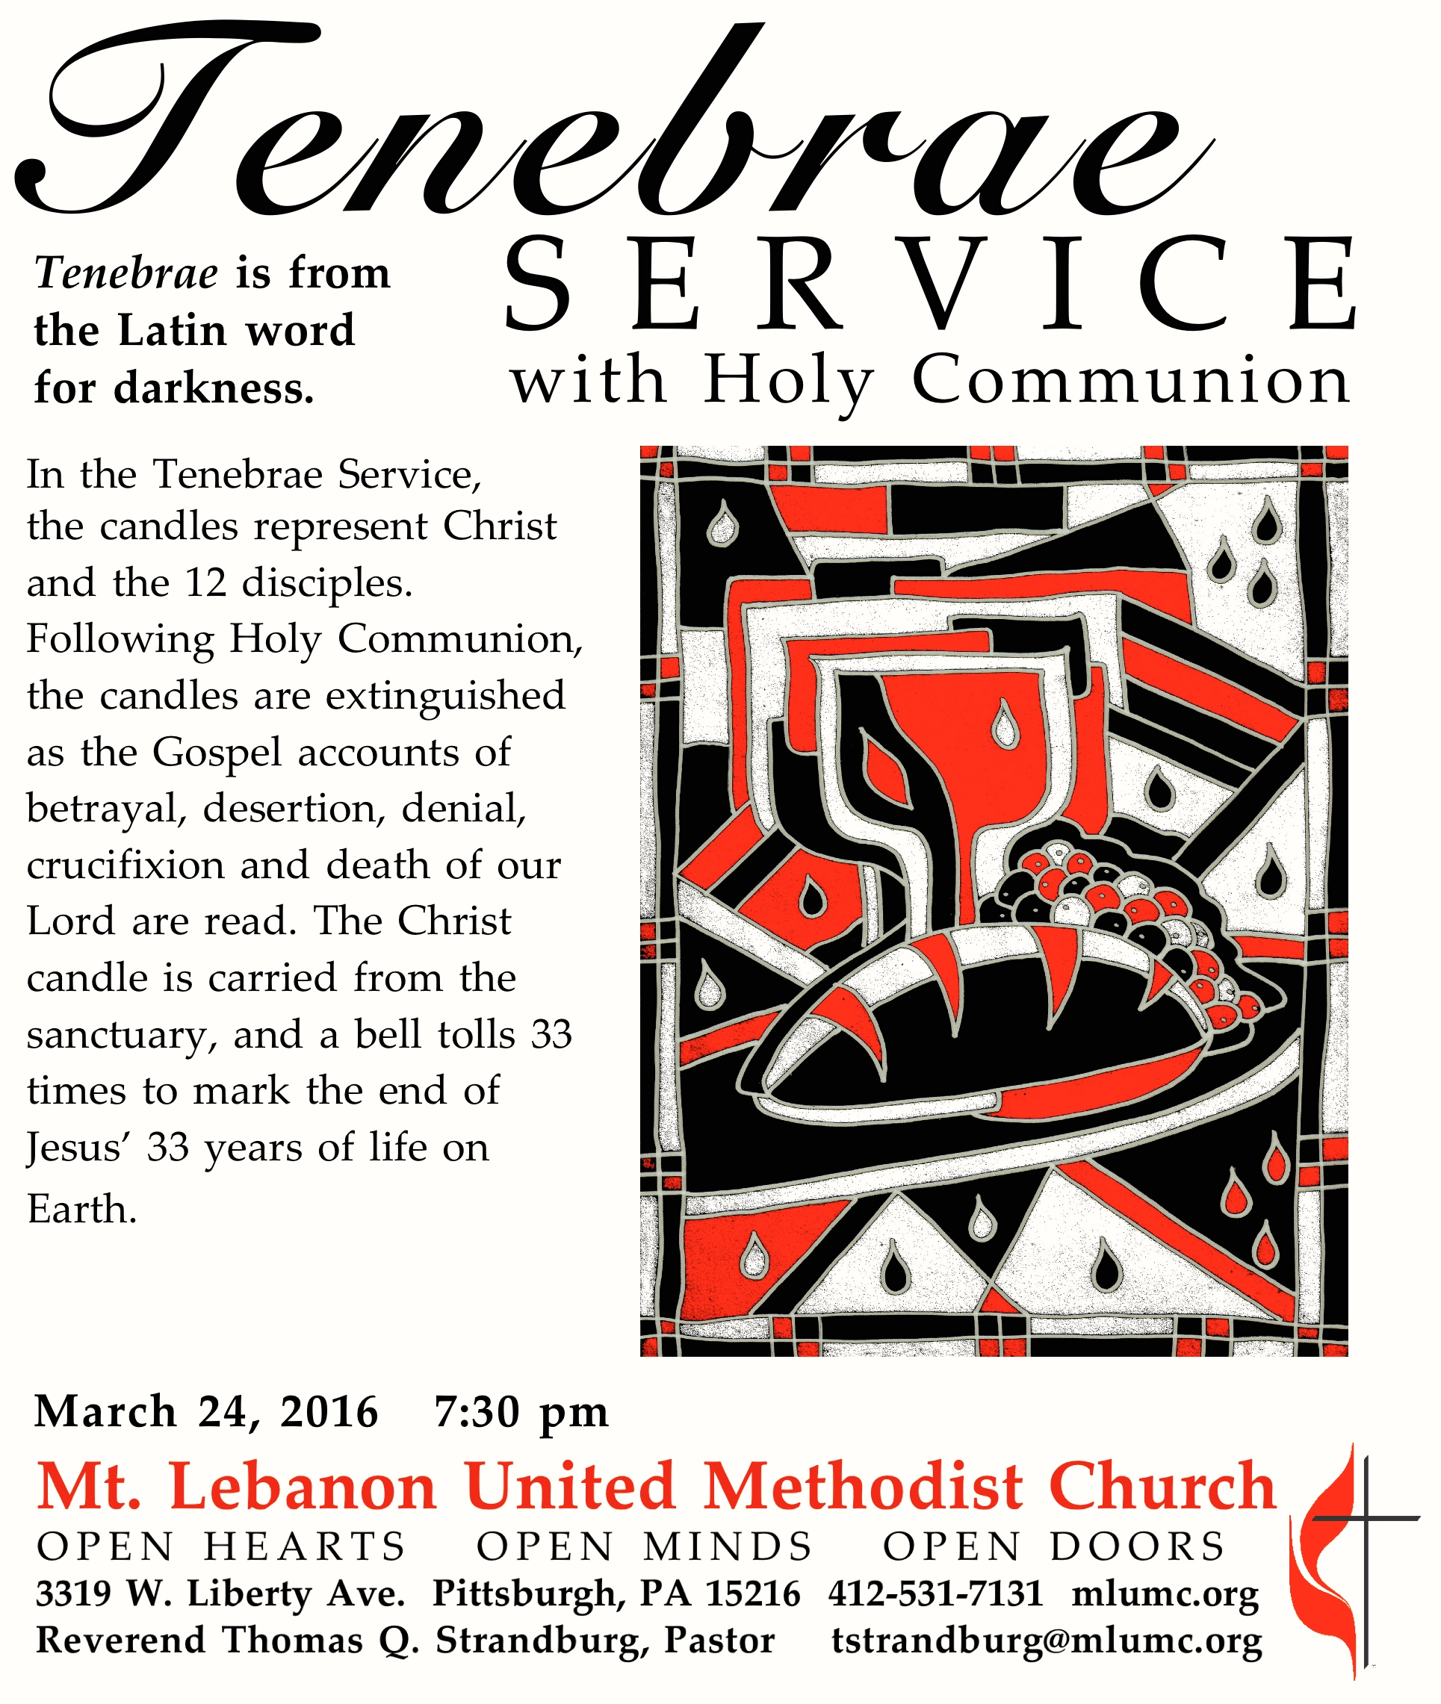

Maundy Thursday Service of Tenebrae with Holy Communion
Reverend Thomas Q. Strandburg

Prelude A lamb goes uncomplaining forth Gerhard Krapf

The Lighting of the Candles
The Light of the World John 1:1-5
The Call of the Disciples Luke 6:12-16

*Hymnal 327 Crown him with many crowns Diademata

Call to Worship
Pastor: Who has believed what we have heard? And to whom has the arm
of the Lord been revealed?
People: For he grew up before God like a young plant, and like a root out
of dry ground.
Pastor: He had no form or comeliness that we should look at him.
People: And no beauty that we should desire him.
Pastor: He was despised and rejected.
People: A man of sorrows and acquainted with grief;
Pastor: And as one from whom others hide their faces, he was despised,
and we esteemed him not.
People: Surely he has borne our griefs and carried our sorrows …

Prayer for Pardon (in unison) Psalm 51
Have mercy on me, O God, according to your steadfast love; according to your abundant mercy blot out my transgressions. Wash me thoroughly from my iniquity, and cleanse me from my sin. For I know my transgressions and my sin is ever before me.

Offering
The Lord’s Supper
Invitation
Words of Institution
Silent Communion

*Hymnal 297 Beneath the cross of Jesus St. Christopher

*please rise in body or spirit

The Service of Tenebrae

The Darkness of Betrayal Matthew 26:17-25 Stacey Rosleck
The Darkness of Spiritual Agony Matthew 26:36-46 Bob Murray

Anthem Watch with Me Jane Griner, text
Daniel E. Gawthrop, music
Tarry here and watch with me. Blood and body proffered now
to sanctify the paschal lamb.
From warmth and comfort driven now to that most bitter cup.
And as He pled, we slept.

Tarry here and watch with me. Bowed by sin yet unredeemed
in sorrow even unto death,
Thy will, not mine, be done this night. In agony He prayed.
And as He bled, we slept.

Tarry here and watch with me. Friends, a stone's throw distance kept;
succor sought, by angels given.
A kiss, betrayal, and a cross; The hour is at hand.
And as it fled, we slept.

The Darkness of Desertion Matthew 26:47-56 Nathan Jara
The Darkness of Denial
Matthew 26:69-75 Rylee Siegert

*Hymnal 288 Were you there Were You There

The Darkness of Injustice Luke 23:13-25 Jane Casey
The Darkness of the Cross John 19:17-22 Scott Miller

Handbell Anthem He never said a mumbalin' word Chapel Bells
African-American Spiritual,
arranged by Arnold Sherman

1. They crucified my Lord, and he never said a mumbalin' word, not a word.
2. They nail him to a tree, and he never said a mumbalin' word, not a word.
3. They pierced him in the side, and he never said a mumbalin' word, not a word.
4. The blood came trickalin' down, and he never said a mumbalin' word, not a word.
5. He bowed his head and died, and he never said a mumbalin' word, not a word.

The Darkness of Death Matthew 27:45-54 James Lutz
The Light of the World John 1:1-5

Benediction

The flowers in the Chancel are given by Sara Mercer in loving memory of her sister,
Ellen Mercer

The flowers on the altar are given by Kay McAninch in memory of Clarence McAninch.

Special music is provided by the Chapel Bells, directed by Nancy R. Lutz, and the Chancel Choir, directed by Ryan A. Keeling.

This evening's offering will be directed to the Family Fund, assisting members of our congregation experiencing financial difficulties in a confidential manner.

Acolytes Max Siegert and Johnny Manning

The word maundy comes from the Latin word mandatum, meaning command. Its usage for Maundy Thursday refers to the foot-washing ceremony at the Last Supper, when Jesus gave the commandment to “love one another.”

Good Friday Community Worship Service will be held in the sanctuary from noon to 1 p.m. tomorrow, March 25. Clergy, lay readers and musicians from churches of the community will participate.

Easter Sunday Services will be held at 8:30 and 10:45 am in the sanctuary.

