

### Weekday Ministries

Child Care Center

Mettelise Ziegler, M.S.

Director

The Weekday

Messenger

December 2015

**Christmas Vacation**

**Do We Need Christmas?**

Christmas vacation begins when the center closes on December 23rd. We will reopen January 4th unless there is a winter snow event!

**Kids Christmas Lunch**

A complimentary lunch will be served to the children 1-year-old and up on December 22. For snacktime after nap, there will be *Happy Birthday Jesus* brownies!

**Agreement Form Updates**

Every December we need for you to update your agreement and emergency forms effective January 2016. There will be a cover sheet showing your new rate, which will be a slight increase over this year to cover rising costs.

**Teacher Breakfast**

Every year we invite parents, on a voluntary basis, to contribute to a group gift for the teachers. This year, Carrie Simpson, Tiny Tot parent, will be collecting contributions and helping to divide and distribute them at our staff breakfast scheduled for 12/21. If you elect to give, please place your money in the envelope on your child’s classroom door or give it to the director. If you write a check, please make it out to

***Carrie Simpson.***

Do you need Christmas? I do.

I am surprising my family with something unexpected for dinner on Christmas Eve. It has to be special because my younger daughter will be home from Texas!

Whether you are looking forward to something similar, or not, there is one thing every one of us needs.

We need a Savior. Some of us don’t realize it, yet. But God says otherwise. He says He loves us just the way we are, but we need our hearts turned towards Him. From the beginning, God planned a celebration that we observe at Christmas-time.

The Virgin Mary celebrated. So did the angels, the shepherds and the wise men.

You and I need to celebrate, too! We need Christmas!

Gentle Mary laid her Child   
Lowly in a manger;   
There He lay, the undefiled,   
To the world a Stranger.   
Such a Babe in such a place,   
Can he be the saviour?   
Ask the saved of all the race   
Who have found His favour.   
  
Angels sang about His birth,   
Wise men sought and found Him;   
Heaven's star shone brightly forth   
Glory all around Him.   
Shepherds saw the wondrous sight,   
Heard the angels singing;   
All the plains were lit that night,   
All the hills were ringing.   
  
Gentle Mary laid her Child   
Lowly in a manger;   
He is still the undefiled,   
But no more a Stranger.   
Son of God of humble birth,   
Beautiful the story;   
Praise His Name in all the earth,   
Hail! the King of Glory!

**Joseph Simpson Cook 1919**



**God Says**

For unto us a child is born; unto us a son is given; and the government shall be upon his shoulder. These will be his royal titles: “Wonderful,” “Counselor,” “The Mighty God,” “The Everlasting Father,” “The Prince of Peace.” 7His ever-expanding, peaceful government will never end. He will rule with perfect fairness and justice from the throne of his father David. He will bring true justice and peace to all the nations of the world. This is going to happen because the Lord of heaven’s armies has dedicated himself to do it!

Isaiah 9:6-7 NLT

3319 W. Liberty Ave. Pittsburgh, PA 15216 412-531-5790

Is Christianity about suffocating us in rules and regulation? Not at all says St. Paul.

***It is for freedom that Christ has set us free. Stand firm, then, and do not let yourselves be burdened again by a yoke of slavery.***Galatians 5:1-2

# Special Dates

We are completely booked until September of 2016 in the Infant room.

Tiny Tots and Supertots are learning about family through *Christmas* and *Jesus Is Born* themes. Tiny Tots are exploring physical characteristics of water by experiencing cold, wet snow. Supertots are exploring textures and smells of Christmas.

Older Toddlers are learning that some plants are evergreen. They are learning about giving and about Jesus coming into the world as a baby. The children are making some beautiful projects to celebrate the season.

Preschool is using Christmas to learn about reality and imagination. They are having fun with Rudolph and Santa. They are using an Advent wreath to count down to Christmas and learning that Jesus is born.

**All-Purpose Cookie Dough**

This is a Swedish cookie dough for Rosenmunnar, which are small balls of dough, indented with a thumbprint, filled with jam and baked at 375 degrees. But, one batch can be different things. Balls can be flattened with cinnamon/sugar; rolled and cut out into shapes; mixed with chopped nuts or crushed potato chips; shaped into wreaths; formed into tart shells…use your imagination! They are buttery delicious!

* Cream 1 c. butter; ½ c. sugar until light and fluffy (lemon-colored).
* Add 2 c. flour and mix just until blended.

That’s it! Shape/then bake at 375 degrees.

http://allrecipes.com/recipe/9745/rosenmunnar/

Please see our website. The Health Form and Parent Handbook are posted there. [www.mlumc.org](http://www.mlumc.org).

**December**

12/8 Cibrone Delivery 3 – 6 PM

12/11 Contributions to Teacher Gift due

12/22 Lunch for the Kids! (free)

12/23 Center closes at 6 PM

1/4/16 Center opens for the new year!

# Classroom Highlights

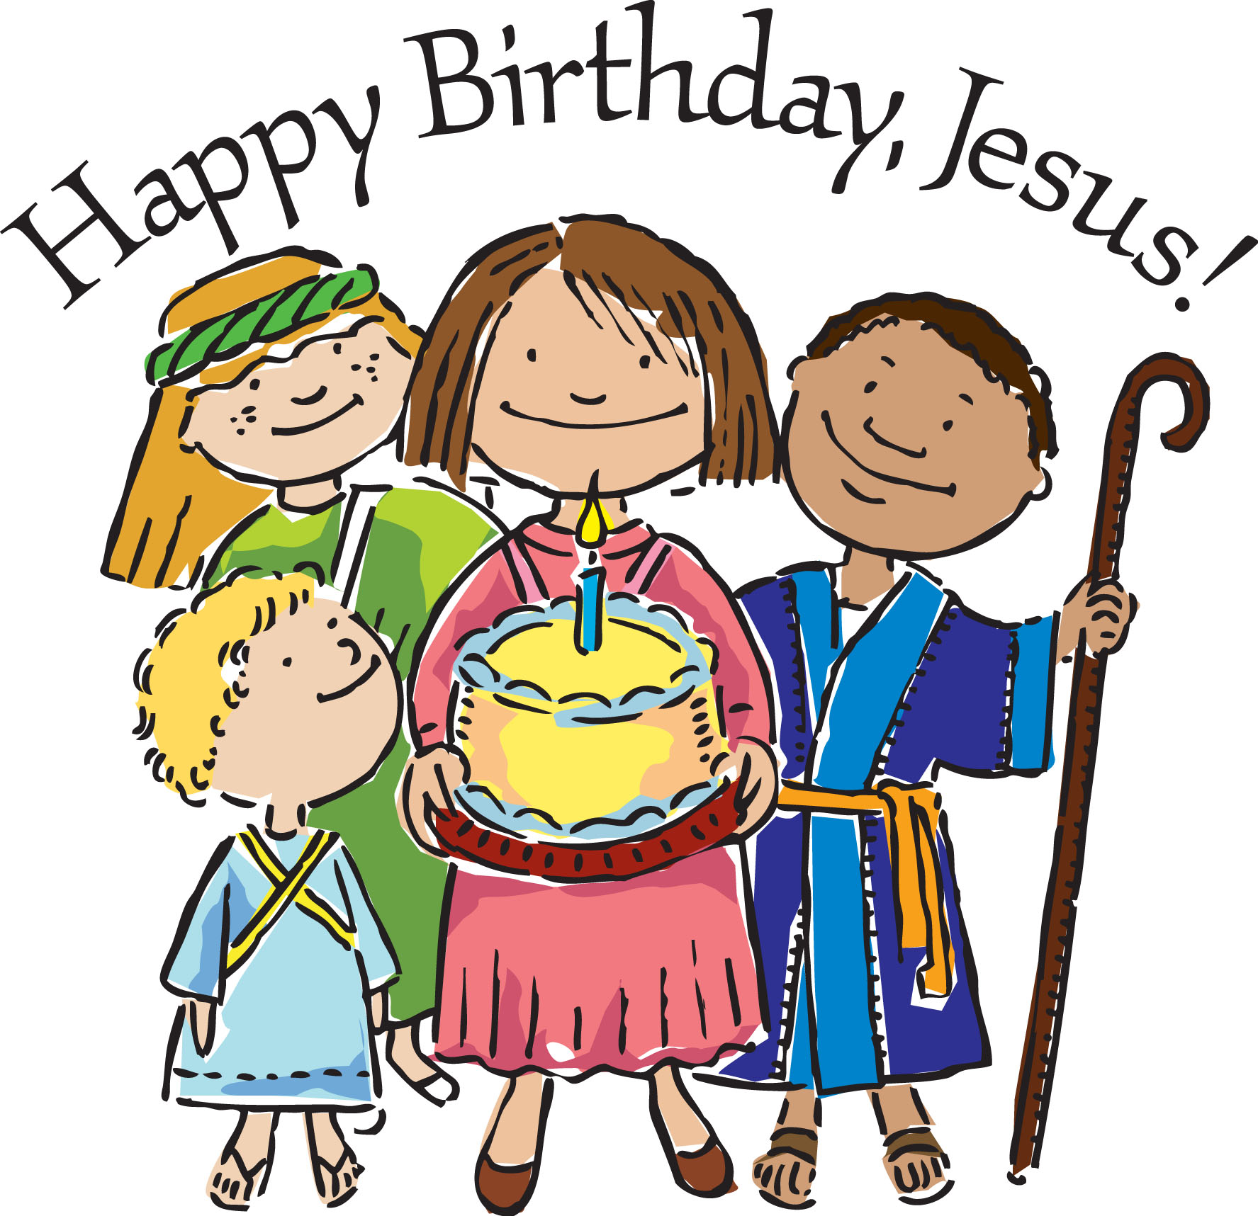

Children: Elsie S. 4 years 12/13

Stella G. 5 years 12/29

Thandie N. 5 years 12/31

The Lord: Jesus Ageless 12/25

**Weather Delays**

**Please note: Weather can cause water main breaks, power outages, ice or snow. We might delay or close.**

It is your responsibility to check the three local TV networks or their websites for information about our center. We will be listed as *MLUMC Weekday Ministries* or *Mt. Lebanon Weekday Ministries*.

**MLUMC Corner**

Come to church! Sunday services are at 8:30 am and 10:45 am. Sunday School is at 9:30 am.

Dec. 13 4:00 PM *Lessons and Carols* with the congregation at St. Bernard’s R.C. Church

Dec. 20 5:00 PM Dinner followed by caroling.

Dec. 24 5:00 PM Christmas Eve for children and families with the “wiggle room” available.

8:00 PM Candlelight Service (nursery available)

11:00 PM Candlelight Service

## Important Reminders

* You must pay your tuition by the 15th as you contracted in the Agreement Form you signed.
* A tax receipt for 2015 will be prepared in January for you.
* We will call you and send your child home with fever, vomiting or diarrhea.
* Use the door code and pass it along to authorized caregivers. Do not open for strangers!