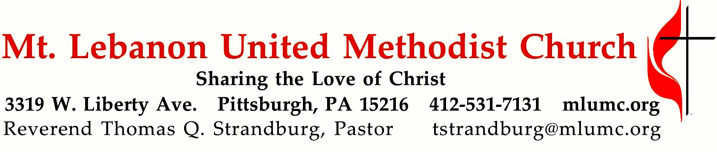
May 29, 2016 8:30 & 10:45
Second Sunday after Pentecost

The discovery of fire by our ancient ancestors helped to move humanity forward. It has traditionally been a symbol of God's presence and power. After Elijah called forth fire from the heavens, the people declared, "The Lord indeed is God!"
WE GATHER IN GOD’S NAME

Gathering Music
Hymn 186 Alleluia Alleluia
Worship & Song 3033 God of great and God of small God of great and small

Greeting
Leader: No one has ever seen God;
People: if we love one another, God lives in us, and God’s love is perfected in us. 1 John 4:12
Announcements

Introit 10:45 John Ness Beck
Open to me the gates of righteousness.
I will praise Thee: for Thou hast heard me, and art become my salvation.

Call to Worship
Pastor: When the world divides us:
People: Come, Holy Spirit, make us one.
Pastor: When the world calls us orphaned:
People: Come, Holy Spirit, make us family.
Pastor: When the world leads us astray:
People: Come, Holy Spirit, call us home. Come and fill this place!
Worship & Song

… TO GIVE PRAISE TO GOD …

*Hymn 79 Holy God, we praise thy name (stanzas 1-4) Grosser Gott

*Opening Prayer (in unison)
O gracious and holy God, give us diligence to seek you, wisdom to perceive you, and patience to wait for you. Grant us, O God, a mind to meditate on you, eyes to behold you, ears to listen for your word, a heart to love you, and a life to proclaim you, through the power of the spirit of Jesus Christ, our Lord. Amen. Benedict of Nurnia, 6th Century

… TO CELEBRATE THE FAMILY OF FAITH …

Sacrament of Baptism 10:45 Baptismal Covenant II, UM Hymnal #39 Charlotte Marilyn Truong, daughter of Meagan and Thomas Truong

People: With God’s help we will proclaim the good news
and live according to the example of Christ.
We will surround Charlotte with a community of love and forgiveness, that she may grow in her service to others.
We will pray for her that she may be a true disciple
who walks in a way that leads to life.

Hymn 77 How great thou art (stanza 1) How Great Thou Art

U.M.W. Presentation 10:45 Recognition of Michael Naragon and Family Promise Volunteers

The Sign of Peace Please pass the peace to your neighbors as a sign of reconciliation and love.
Leader: The peace of Christ be with you.
People: And also with you.

Gathering Song
This, this is where children belong,
welcomed as part of the worshiping throng.
Water, God’s Word, bread and cup, prayer and song:
This is where children belong. WORDS AND MUSIC: James Ritchie ©1999 Abingdon Press

Message for Young Disciples Rev. Thomas Q. Strandburg
All children are invited. Please sing as children come forward. After the children’s message at the 10:45 service, children ages 3 - 3rd grade may attend Kids Praise in the Welcome Center. Children will be escorted to and from Kids Praise by teachers. They will return to the Sanctuary near the end of the service.

*please rise in body or spirit
… TO HEAR GOD’S WORD PROCLAIMED …

Hymn 385 (seated) Let us plead for faith alone Savannah

Scripture Reading 8:30 Scott Miller
10:45 Norma Buhrman
A Lesson from the Hebrew Scriptures
1 Kings 18:20-39 Elijah versus Baal’s prophets

Hymn 619 (seated) Now the silence Now

Pastoral Prayer

The Lord’s Prayer
Our Father, who art in heaven, hallowed be thy name. Thy kingdom come, thy will be done, on earth as it is in heaven. Give us this day our daily bread. And forgive us our trespasses, as we forgive those who trespass against us. And lead us not into temptation, but deliver us from evil. For thine is the kingdom, and the power, and the glory forever. Amen.

Scripture Reading
*A Lesson from the Gospels
Luke 7:1-10 Healing of the centurion’s servant

Response
Leader: The Word of the Lord.
People: Thanks be to God.

… TO OFFER OUR GIFTS AND TO DEDICATE OUR LIVES …

Offertory Solo 8:30 O Master, let me walk with thee arranged by A. C. Witworth

Offertory Anthem 10:45 Philip W.J. Stopford
Synopsis of today's reading from 1 Kings, dramatically captured by the composer, Felix Mendelssohn: God's prophet, Elijah, (Mr. Dilworth), exhorts the priests of the god Baal to create a fire under the sacred offering. The priests (choir) call ever louder for Baal to "hear and answer" but there is only silence. From that silence Elijah offers a simple prayer to God for help: "O hear me Lord and answer me; and show this people that Thou art Lord God; and let their hearts again be turned!" A chorus of angels (choir) responds with, "Cast thy burden upon the Lord." Later in the oratorio God sends fire in response to Elijah's plea, a profound demonstration of God's faithfulness before the followers of the false god Baal.
*Doxology 94
Praise God from whom all blessings flow;
Praise God, all creatures here below: Alleluia! Alleluia!
Praise God the source of all our gifts!
Praise Jesus Christ, whose power uplifts!
Praise the Spirit, Holy Spirit. Alleluia! Alleluia! Alleluia!

Prayer of Dedication

Sermon “Where’s the Fire?” Rev. Thomas Q. Strandburg

… TO GO REJOICING IN GOD’S NAME!

*Hymn 430 O Master, let me walk with thee Maryton

Benediction

Today’s Services
The flowers in the Chancel are given by the Michael family in honor of the church staff and volunteers.

The flowers on the altar are given by Bill Davis in loving memory of his wife, Lydia.

The columbarium flowers are given in loving memory of Joseph Utzig, Jr. by his wife and family.

Special music at 10:45 is provided by the Chancel Choir with soloist Kirby Dilworth.

Our hymnal and the new hymnal supplement are rich resources. As we explore newer texts and tunes we will repeat them during the month so that we are more comfortable singing them.

Greeters 8:30 Rich and Kathy Tremblay 10:45 Martha Banyas

Acolytes Anastasia Sunder and Cary Young

Worship options for children We encourage children to participate in the Children’s Sermon at both services, and in Kids Praise during the 10:45 service. Nursery services are offered in Room 204 of the Education Building. Ask ushers or greeters and follow signs for direction.

Today’s Scriptures
1 Kings 18:20-39
²⁰ So Ahab sent to all the Israelites, and assembled the prophets at Mount Carmel.
²¹ Elijah then came near to all the people, and said, “How long will you go limping with two different opinions? If the Lord is God, follow him; but if Baal, then follow him.” The people did not answer him a word.
²² Then Elijah said to the people, “I, even I only, am left a prophet of the Lord; but Baal’s prophets number four hundred fifty.
²³ Let two bulls be given to us; let them choose one bull for themselves, cut it in pieces, and lay it on the wood, but put no fire to it; I will prepare the other bull and lay it on the wood, but put no fire to it.
²⁴ Then you call on the name of your god and I will call on the name of the Lord; the god who answers by fire is indeed God.” All the people answered, “Well spoken!”
²⁵ Then Elijah said to the prophets of Baal, “Choose for yourselves one bull and prepare it first, for you are many; then call on the name of your god, but put no fire to it.”
²⁶ So they took the bull that was given them, prepared it, and called on the name of Baal from morning until noon, crying, “O Baal, answer us!” But there was no voice, and no answer. They limped about the altar that they had made.
²⁷ At noon Elijah mocked them, saying, “Cry aloud! Surely he is a god; either he is meditating, or he has wandered away, or he is on a journey, or perhaps he is asleep and must be awakened.”
²⁸ Then they cried aloud and, as was their custom, they cut themselves with swords and lances until the blood gushed out over them.
²⁹ As midday passed, they raved on until the time of the offering of the oblation, but there was no voice, no answer, and no response.
³⁰ Then Elijah said to all the people, “Come closer to me”; and all the people came closer to him. First he repaired the altar of the Lord that had been thrown down;
³¹ Elijah took twelve stones, according to the number of the tribes of the sons of Jacob, to whom the word of the Lord came, saying, “Israel shall be your name”;
³² with the stones he built an altar in the name of the Lord. Then he made a trench around the altar, large enough to contain two measures of seed.
³³ Next he put the wood in order, cut the bull in pieces, and laid it on the wood. He said, “Fill four jars with water and pour it on the burnt offering and on the wood.”
³⁴ Then he said, “Do it a second time”; and they did it a second time. Again he said, “Do it a third time”; and they did it a third time,
³⁵ so that the water ran all around the altar, and filled the trench also with water.
³⁶ At the time of the offering of the oblation, the prophet Elijah came near and said, “O Lord, God of Abraham, Isaac, and Israel, let it be known this day that you are God in Israel, that I am your servant, and that I have done all these things at your bidding.
³⁷ Answer me, O Lord, answer me, so that this people may know that you, O Lord, are God, and that you have turned their hearts back.”
³⁸ Then the fire of the Lord fell and consumed the burnt offering, the wood, the stones, and the dust, and even licked up the water that was in the trench.
³⁹ When all the people saw it, they fell on their faces and said, “The Lord indeed is God; the Lord indeed is God.”

Luke 7:1-10
¹ After Jesus had finished all his sayings in the hearing of the people, he entered Capernaum.
² A centurion there had a slave whom he valued highly, and who was ill and close to death.
³ When he heard about Jesus, he sent some Jewish elders to him, asking him to come and heal his slave.
⁴ When they came to Jesus, they appealed to him earnestly, saying, “He is worthy of having you do this for him,
⁵ for he loves our people, and it is he who built our synagogue for us.”
⁶ And Jesus went with them, but when he was not far from the house, the centurion sent friends to say to him, “Lord, do not trouble yourself, for I am not worthy to have you come under my roof;
⁷ therefore I did not presume to come to you. But only speak the word, and let my servant be healed.
⁸ For I also am a man set under authority, with soldiers under me; and I say to one, ‘Go,’ and he goes, and to another, ‘Come,’ and he comes, and to my slave, ‘Do this,’ and the slave does it.” ⁹ When Jesus heard this he was amazed at him, and turning to the crowd that followed him, he said, “I tell you, not even in Israel have I found such faith.”
¹⁰ When those who had been sent returned to the house, they found the slave in good health.

Podcasts of Sunday Sermons Would you like to share this morning’s sermon with a friend or did you miss a Sunday? Catch up on the messages from MLUMC with a podcast of Pastor Tom’s and others’ Sunday sermons. Sermons from the past three months are at
http:// mlumc.buzzsprout.com. You can navigate to the site from the link on our webpage, www.mlumc.org, through the app, Stitcher or through iTunes.

Keep in Prayer

Hospitalized
Earl Killian, Harmarville Rehab

Convalescing in Care Facilities
Betty Lou Albright, Providence Point
Leila Berkey, Asbury Heights
Ruth Bloss, Providence Point
Jean Bouvy, McMurray Hills Manor
Ed Clarke, Asbury Place
Horace DeWald, Providence Point
Kate McDade, Paramount, Bethel Park
Pat Seitz, Concordia
Andy Smith, Concordia

Convalescing at Home
Joyce Feldman, May Frederick, Ann Hoyer, Cindy Reichard, Ginnie Smith

In the Military

Jason Boyer, SPC Natalie Brown

Capt. Zachary Allen Finch, USMC
James Iantelli, 1st Lt. Jaskiewicz
S. Sgt. Keith Kimmell, Adam Kmick
PFC Brendan Lamport
Sgt. Matthew McConahan, Thomas Orda
Lt. Col. Mark Patterson

Lt. Com. Scott Patterson

Lt. Col. Sean Patterson
David Poncel, Sgt. Steven Reitz
Capt. Scott B. Rushe, Pastor Rick Townes
Capt. Azizi Wesmiller

Capt. Matthew C. Wesmiller
Sgt. Keith Scott Winkowski

Sgt. Michael Zimmerman

Sympathy
Condolences are offered to the family of church member Margie Jellison, who died this week. Prayers and words of sympathy to the family may be sent to her son, also a church member:
Donald and Sherri Jellison
1010 Allison Hollow Rd.
Washington, PA 15301-8667

Sympathy is offered to the family of Claire and Elaine Coverdale, church members who moved a few years ago to be closer to their son. Elaine Coverdale passed away on May 12 and Claire on May 17. Prayers and words of comfort may be sent to their son:
Scott Coverdale
401 Bridgewood Drive
Yorktown, VA 23693

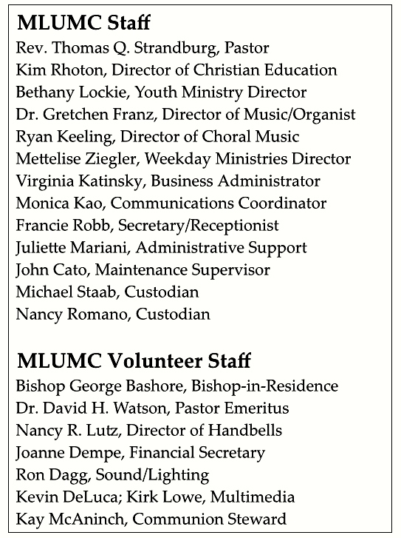

CALENDAR – SUNDAY, MAY 29 THRU SATURDAY, MAY 28
SUNDAY 5/29
8:30 am Worship Sanner Chapel
10:45 am Worship Sanctuary
Kids Praise Welcome Center

MONDAY 5/30 MEMORIAL DAY – OFFICE CLOSED

TUESDAY 5/31
7 pm Boy Scout Troop #23 / Rummage Sale Set-up Various

WEDNESDAY 6/1
6:30 am Northside Lunch Program Prep Kitchen
2 pm Rummage Sale Set-up Asbury Center

THURSDAY 6/2
8:30 am Northside Lunch Program Prep Kitchen
10 am Rummage Sale Set-up Asbury Center
12 pm TNT Asbury Heights

FRIDAY 6/3
9:30 am Women’s Bible Study Room 102
10 am Rummage Sale Set-up Asbury Center
3 pm Rummage Sale Pre-Sale Asbury Center

SATURDAY 6/4
9 am Rummage Sale Asbury Center

