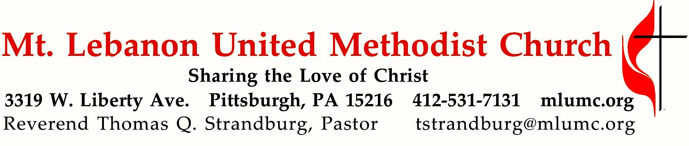
June 26, 2016 8:30 & 10:45
Sixth Sunday after Pentecost

By constricting growth with a mould, farmers are able to produce fruit in a variety of shapes. This morning's text reminds us that we are called to produce fruit which bears the image of God -- Spirit-fruit!
.

WE GATHER IN GOD’S NAME

Gathering Music
Hymn 405 Seek ye first Seek ye
Hymn 336 Of all the Spirit's gifts to me (stanzas 1 and 2) Meyer

Greeting
Leader: Let God grant us grace and bless us; let God’s face shine upon us, so that
God’s way becomes known on earth, and God’s salvation among all the nations.
People: Let the people thank you, O God! Let all the people thank you!
Psalm 67:1-2

Announcements

Call to Worship
Pastor: In the midst of the congregation I will praise you.
People: Rejoice in the Lord, O you righteous, and give thanks to God's holy name!
Pastor: I will extol you, my God and King, and bless your name for ever and ever.
People: Great is the Lord, and greatly to be praised, and God's greatness is unsearchable.

… TO GIVE PRAISE TO GOD …

Worship & Song 3146 O breath of life (standing) Adieu

Opening Prayer (in unison, standing)
God of wind, word, and fire, we bless your name this day
for sending the light and strength of your Holy Spirit.
We give you thanks for all the gifts, great and small,
that you have poured out upon your children.
Accept us with our gifts
to be living praise and witness to your love throughout all the earth;
through Jesus Christ, who lives with you in the unity of the Holy Spirit,
one God, for ever. Amen.
Don E. Saliers, 20th Century

… TO CELEBRATE THE FAMILY OF FAITH …

Commissioning of the Youth Mission Team 8:30

W PA Annual Conference Report Kathy Karns, Lay Delegate

The Sign of Peace Please pass the peace to your neighbors as a sign of reconciliation and love.
Leader: The peace of Christ be with you.
People: And also with you.

Gathering Song
This, this is where children belong,
welcomed as part of the worshiping throng.
Water, God’s Word, bread and cup, prayer and song:
This is where children belong.
WORDS AND MUSIC: James Ritchie ©1999 Abingdon Press

Message for Young Disciples Rev. Thomas Q. Strandburg
All children are invited. Please sing as children come forward. After the children’s message at the 10:45 service, children ages 3 - 3rd grade may attend Kids Praise in the Welcome Center. Children will be escorted to and from Kids Praise by teachers. They will return to Asbury Center near the end of the service.

… TO HEAR GOD’S WORD PROCLAIMED …

Hymn 420 Breathe on me, Breath of God (seated) Trentham

Scripture Reading 8:30 Joeta D’Este 10:45 John Conti
A Lesson from the New Testament
Galatians 5:1, 13-25 Life by the Spirit

Worship & Song 3131 Hear my prayer, O God (stanza 2, seated) Hymn Chant

Pastoral Prayer

The Lord’s Prayer
Our Father, who art in heaven, hallowed be thy name. Thy kingdom come, thy will be done, on earth as it is in heaven. Give us this day our daily bread. And forgive us our trespasses, as we forgive those who trespass against us. And lead us not into temptation, but deliver us from evil. For thine is the kingdom, and the power, and the glory forever. Amen.

Scripture Reading
A Lesson from the Gospels (standing)
Luke 9:51-62 The cost of following Jesus

Response
Leader: The Word of the Lord.
People: Thanks be to God.

… TO OFFER OUR GIFTS AND TO DEDICATE OUR LIVES …

Offertory Solo 8:30 Lord, I want to be a Christian arranged by John Carter

Offertory Anthem 10:45 John Ness Beck
O Love, that will not let me go, I rest my weary soul in Thee;
I give Thee back the life I owe,
that in Thine ocean depths its flow may richer, fuller be.
O joy that seekest me through pain, I cannot close my heart to Thee;
I trace the rainbow through the rain,
and feel the promise is not vain, that morn shall tearless be.

Doxology 94 (standing)
Praise God from whom all blessings flow;
Praise God, all creatures here below: Alleluia! Alleluia!
Praise God the source of all our gifts!
Praise Jesus Christ, whose power uplifts!
Praise the Spirit, Holy Spirit. Alleluia! Alleluia! Alleluia!
Prayer of Dedication

Sermon “Spirit Fruit” Rev. Thomas Q. Strandburg

… TO GO REJOICING IN GOD’S NAME!

Hymn 336 Of all the Spirit's gifts to me (standing) Meyer
Benediction

Today’s Services
The flowers provided for worship today are given in honor of the volunteers who worked Friday’s Community Barbecue.

Special music at 10:45 is provided by the Chancel Choir.

Our hymnal and the new hymnal supplement are rich resources. As we explore newer texts and tunes we will repeat them during the month so that we are more comfortable singing them.

Greeters 8:30 Cindy Biery 10:45 Dawn Lonsinger and Marda Katshir

Worship options for children We encourage children to participate in the Children’s Sermon at both services, and in Kids Praise during the 10:45 service. Nursery services are offered in Room 204 of the Education Building. Ask ushers or greeters and follow signs for direction.

Podcasts of Sunday Sermons Would you like to share this morning’s sermon with a friend or did you miss a Sunday? Catch up on the messages from MLUMC with a podcast of Pastor Tom’s and others’ Sunday sermons. Sermons from the past three months are at
http:// mlumc.buzzsprout.com. You can navigate to the site from the link on our webpage, www.mlumc.org, through the app, Stitcher or through iTunes.

Today’s Scriptures

Galatians 5:1, 13-25
⁵For freedom Christ has set us free. Stand firm, therefore, and do not submit again to a yoke of slavery.

¹³For you were called to freedom, brothers and sisters; only do not use your freedom as an opportunity for self-indulgence, but through love become slaves to one another.
¹⁴For the whole law is summed up in a single commandment, “You shall love your neighbor as yourself.”
¹⁵If, however, you bite and devour one another, take care that you are not consumed by one another. ¹⁶Live by the Spirit, I say, and do not gratify the desires of the flesh.
¹⁷For what the flesh desires is opposed to the Spirit, and what the Spirit desires is opposed to the flesh; for these are opposed to each other, to prevent you from doing what you want.
¹⁸But if you are led by the Spirit, you are not subject to the law.
¹⁹Now the works of the flesh are obvious: fornication, impurity, licentiousness,
²⁰idolatry, sorcery, enmities, strife, jealousy, anger, quarrels, dissensions, factions,
²¹envy, drunkenness, carousing, and things like these. I am warning you, as I warned you before: those who do such things will not inherit the kingdom of God.
²²By contrast, the fruit of the Spirit is love, joy, peace, patience, kindness, generosity, faithfulness, ²³gentleness, and self-control. There is no law against such things.
²⁴And those who belong to Christ Jesus have crucified the flesh with its passions and desires.
²⁵If we live by the Spirit, let us also be guided by the Spirit.

Luke 9:51-62
⁵¹When the days drew near for him to be taken up, he set his face to go to Jerusalem.
⁵²And he sent messengers ahead of him. On their way they entered a village of the Samaritans to make ready for him;
⁵³but they did not receive him, because his face was set toward Jerusalem.
⁵⁴When his disciples James and John saw it, they said, “Lord, do you want us to command fire to come down from heaven and consume them?”
⁵⁵But he turned and rebuked them.
⁵⁶Then they went on to another village.
⁵⁷As they were going along the road, someone said to him, “I will follow you wherever you go.” ⁵⁸And Jesus said to him, “Foxes have holes, and birds of the air have nests; but the Son of Man has nowhere to lay his head.”
⁵⁹To another he said, “Follow me.” But he said, “Lord, first let me go and bury my father.”
⁶⁰But Jesus said to him, “Let the dead bury their own dead; but as for you, go and proclaim the kingdom of God.”
⁶¹Another said, “I will follow you, Lord; but let me first say farewell to those at my home.”
⁶²Jesus said to him, “No one who puts a hand to the plow and looks back is fit for the kingdom of
God.”

Keep in Prayer

Convalescing in Care Facilities
Leila Berkey, Asbury Heights
Jean Bouvy, McMurray Hills Manor
Ed Clarke, Asbury Place
Pat Seitz, Concordia

Convalescing at Home
Betty Lou Albright, Joyce Feldman, May Frederick, Ann Hoyer, Earl Killian, Andy Smith

In the Military

Jason Boyer, SPC Natalie Brown

Capt. Zachary Allen Finch, USMC
James Iantelli, 1st Lt. Jaskiewicz
S. Sgt. Keith Kimmell, Adam Kmick
PFC Brendan Lamport
Sgt. Matthew McConahan, Thomas Orda
Lt. Col. Mark Patterson

Lt. Com. Scott Patterson

Lt. Col. Sean Patterson
David Poncel, Sgt. Steven Reitz
Capt. Scott B. Rushe, Pastor Rick Townes
Capt. Azizi Wesmiller

Capt. Matthew C. Wesmiller
Sgt. Keith Scott Winkowski

Sgt. Michael Zimmerman

Sympathy
Condolences are offered to the family of church member Catherine “Kay” McDade, who died last week. Funeral services were held on Monday, June 20 at Mt. Lebanon United Methodist Church. Prayers and words of sympathy to the family may be sent to her daughter:
Jeannine Schemm
2563 Oldfield Ave.
Bethel Park, PA 15102

Looking to send a card? Here are some helpful addresses.

Providence Point Healthcare Concordia Health Center
200 Adams Ave 1300 Bower Hill Road
Pittsburgh, PA 15243 Pittsburgh, PA 15243

Asbury Heights McMurray Hills Manor
700 Bower Hill Road 249 W McMurray Road
Pittsburgh, PA 15243 McMurray, PA 15317

Manor Care, Whitehall

505 Weyman Rd

Pittsburgh, PA 15236

Birthday wishes can be sent to church member Ann Swartz, who will be 100 years old
this July 31. Send your card to :
Mrs. Ann Swartz
Asbury Heights, Apt. 7206
700 Bower Hill Road
Pittsburgh, PA 15243-2040

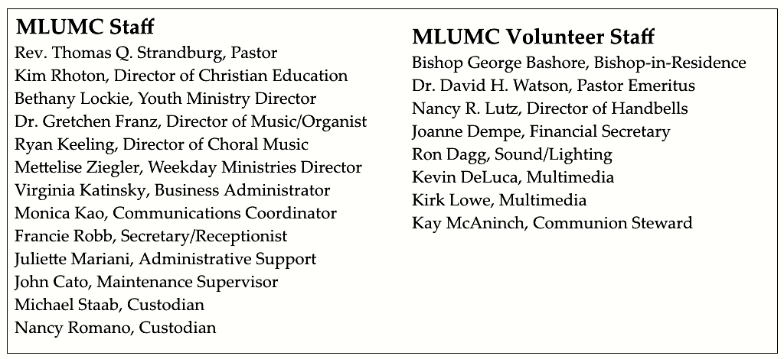

CALENDAR – SUNDAY, JUNE 26 THRU SATURDAY, JULY 2

SUNDAY 6/26 YOUTH MISSION TRIP THROUGH SATURDAY, JULY 2
8:30 am Worship Sanner Chapel
9:30 am Faith for Today Asbury Center
10:45 am Worship Asbury Center
Kids Praise Welcome Center
7 pm BSA Patrol Leaders Room 105

TUESDAY 6/28
7 pm Boy Scout Troop #23 Weslely Hall
7 pm BSA Board of Reviews Room 105

WEDNESDAY 6/29
6 pm Homebuilders Picnic Weslely Hall

SATURDAY 7/2
10 am Food Distribution Food Pantry

