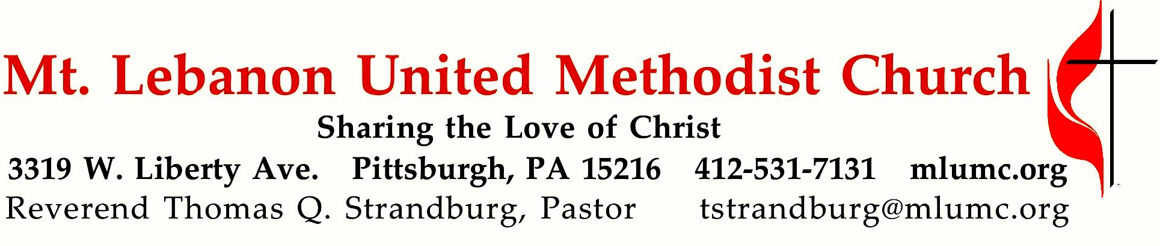
July 10, 2016 8:30 & 10:45
8th Sunday After Pentecost

Have you ever experienced the kindness of strangers? We all have. Jesus' parable of the good Samaritan invites us to consider such service to be a part of our own personal calling.

WE GATHER IN GOD’S NAME …

Gathering Music
Hymn 585 This little light of mine Lattimer
Hymn 572 Pass it on (stanzas 1 and 3) Pass it on

Greeting
Leader: Break forth together into singing, you ruins of Jerusalem;
People: for the Lord has comforted his people.
Isaiah 52:9
Announcements

Call to Worship
Pastor: From our busy lives, God calls us together to worship and to pray.
People: We are here, Holy One!
Pastor: From different places, Christ calls us to gather, to love, and to live.
People: We are here, blessed Jesus!
Pastor: From the unexpected journeys, the Spirit calls us into unity to serve and to grow.
People: We are here, Holy Spirit!
Pastor: Come! Let us worship.
Karen Ellis

… TO GIVE PRAISE TO GOD …

Hymn 577 God of grace and God of glory (standing) Cwm Rhondda
Opening Prayer (in unison, standing)
Loving God, from the very beginning you have journeyed with your people. Journey with us this day, as we learn what it means to follow you. Open our ears to your word. Open our hearts to your love and compassion. Open our hands to receive your grace and to share it with others. Enable us to faithfully claim the name, “Christian,” as we strive to follow the ways and teachings of Jesus, the Christ. Empower us with your Holy Spirit, as we worship you and serve one another. In your holy name, we pray. Amen.

… TO CELEBRATE THE FAMILY OF FAITH …

Sacrament of Baptism 10:45 Baptismal Covenant II, UM Hymnal #39
Asher James Street, son of David and Susan Street

People: With God’s help we will proclaim the good news
and live according to the example of Christ.
We will surround Asher with a community of love and forgiveness, that he may grow in his service to others.
We will pray for him that he may be a true disciple
who walks in a way that leads to life.

The Sign of Peace Please pass the peace to your neighbors as a sign of reconciliation and love.
Leader: The peace of Christ be with you.
People: And also with you.

Gathering Song James Ritchie
This, this is where children belong,
welcomed as part of the worshiping throng.
Water, God’s Word, bread and cup, prayer and song:
This is where children belong.
WORDS: James Ritchie MUSIC: James Ritchie ©1999 Abingdon Press

Message for Young Disciples Rev. Thomas Q. Strandburg
All children are invited. Please sing as children come forward. After the children’s message at the 10:45 service, children ages 3 - 3rd grade may attend Kids Praise in the Welcome Center. Children will be escorted to and from Kids Praise by teachers. They will return to Asbury Center near the end of the service.

… TO HEAR GOD’S WORD PROCLAIMED …

Hymn 432 Jesu, Jesu (seated) Chereponi

Scripture Reading 8:30 Liz DiPietro
10:45 JJ Knabb

A Lesson from the Hebrew Scripture
Amos 7:7-17 A vision of a plumb line

Worship & Song 3131 Hear my prayer, O God (stanza 3, seated) Adieu

Pastoral Prayer

The Lord’s Prayer
Our Father, who art in heaven, hallowed be thy name. Thy kingdom come, thy will be done, on earth as it is in heaven. Give us this day our daily bread. And forgive us our trespasses, as we forgive those who trespass against us. And lead us not into temptation, but deliver us from evil. For thine is the kingdom, and the power, and the glory forever. Amen.

Scripture Reading
A Lesson from the Gospels (standing)
Luke 10:25-37 Parable of the Good Samaritan

Response
Leader: The Word of the Lord.
People: Thanks be to God.

… TO OFFER OUR GIFTS AND TO DEDICATE OUR LIVES …

Offertory Solo 8:30 Amazing Grace arranged by Benjamin Harlan

Offertory Anthem 10:45 Taylor Davis; text by Georgia Harkness (1891-1974)
Hope of the world, thou Christ of great compassion,
Speak to our fearful hearts by conflict rent.
Save us, thy people from consuming passion,
who by our own false hopes and aims are spent.
Hope of the world, God’s gift from highest heaven,
bringing to hungry souls the bread of life,
still lest thy spirit unto us be given, to heal earth’s wounds and end all bitter strife.
Hope of the world, afoot on dusty highways,
showing to wandering souls the path of light,
walk beside us lest the tempting byways lure us away from thee to endless night.

Hope of the world, O Christ, o’er death victorious,
Who by this sign didst conquer grief and pain,
we would be faithful to thy gospel glorious,
thou art our Lord Thou dost forever reign. Hope of the world.

Doxology 94 (standing)
Praise God from whom all blessings flow;
Praise God, all creatures here below: Alleluia! Alleluia!
Praise God the source of all our gifts!
Praise Jesus Christ, whose power uplifts!
Praise the Spirit, Holy Spirit. Alleluia! Alleluia! Alleluia!

Prayer of Dedication

Sermon “The Bad Samaritan” Rev. Thomas Q. Strandburg

… TO GO REJOICING IN GOD’S NAME!

Hymn 356 When we are living (standing) Somos del Señor

Benediction

Today’s Services

The flower arrangement provided for worship today is given by Jean Sweeney in loving memory of Thomas R. Byrer.

Special music at 8:30 is provided by John Esaias and Noel Slater, members of the Chancel Choir and active leaders of this church.

Special music at 10:45 is provided by the Chancel Choir.

Our hymnal and the new hymnal supplement are rich resources. As we explore newer texts and tunes we will repeat them during the month so that we are more comfortable singing them.

Greeters 8:30 Bradley and Laura Shoff and Emily and Evan 10:45 Bob and Chris James

Worship options for children We encourage children to participate in the Children’s Sermon at both services, and in Kids Praise during the 10:45 service. Nursery services are offered in Room 204 of the Education Building. Ask ushers or greeters and follow signs for direction.

Flower Donations The church is in need of Sunday flower arrangements. Honor or remember a loved one or friend with your donation. Contact Sharon Slater, 412-343-1137.

Podcasts of Sunday Sermons Would you like to share this morning’s sermon with a friend or did you miss a Sunday? Catch up on the messages from MLUMC with a podcast of Pastor Tom’s and others’ Sunday sermons. Sermons from the past three months are at
http:// mlumc.buzzsprout.com. You can navigate to the site from the link on our webpage, www.mlumc.org, through the app, Stitcher or through iTunes.

Today’s Scriptures
Amos 7:7-17
⁷This is what he showed me: the Lord was standing beside a wall built with a plumb line, with a plumb line in his hand.
⁸And the Lord said to me, “Amos, what do you see?” And I said, “A plumb line.” Then the Lord said, “See, I am setting a plumb line in the midst of my people Israel; I will never again pass them by;
⁹the high places of Isaac shall be made desolate, and the sanctuaries of Israel shall be laid waste, and I will rise against the house of Jeroboam with the sword.”
¹⁰Then Amaziah, the priest of Bethel, sent to King Jeroboam of Israel, saying, “Amos has conspired against you in the very center of the house of Israel; the land is not able to bear all his words.
¹¹For thus Amos has said, ‘Jeroboam shall die by the sword, and Israel must go into exile away from his land.’”
¹²And Amaziah said to Amos, “O seer, go, flee away to the land of Judah, earn your bread there, and prophesy there;
¹³but never again prophesy at Bethel, for it is the king’s sanctuary, and it is a temple of the kingdom.”
¹⁴Then Amos answered Amaziah, “I am no prophet, nor a prophet’s son; but I am a herdsman, and a dresser of sycamore trees,
¹⁵and the Lord took me from following the flock, and the Lord said to me, ‘Go, prophesy to my people Israel.’
¹⁶“Now therefore hear the word of the Lord. You say, ‘Do not prophesy against Israel, and do not preach against the house of Isaac.”
¹⁷Therefore thus says the Lord: ‘Your wife shall become a prostitute in the city, and your sons and your daughters shall fall by the sword, and your land shall be parceled out by line; you yourself shall die in an unclean land, and Israel shall surely go into exile away from its land.’”

Luke 10:25-37
²⁵Just then a lawyer stood up to test Jesus. “Teacher,” he said, “what must I do to inherit eternal life?”
²⁶He said to him, “What is written in the law? What do you read there?”
²⁷He answered, “You shall love the Lord your God with all your heart, and with all your soul, and with all your strength, and with all your mind; and your neighbor as yourself.”
²⁸And he said to him, “You have given the right answer; do this, and you will live.”
²⁹But wanting to justify himself, he asked Jesus, “And who is my neighbor?”
³⁰Jesus replied, “A man was going down from Jerusalem to Jericho, and fell into the hands of robbers, who stripped him, beat him, and went away, leaving him half dead.
³¹Now by chance a priest was going down that road; and when he saw him, he passed by on the other side.
³²So likewise a Levite, when he came to the place and saw him, passed by on the other side.
³³But a Samaritan while traveling came near him; and when he saw him, he was moved with pity. ³⁴He went to him and bandaged his wounds, having poured oil and wine on them. Then he put him on his own animal, brought him to an inn, and took care of him.
³⁵The next day he took out two denarii, gave them to the innkeeper, and said, ‘Take care of him; and when I come back, I will repay you whatever more you spend.’
³⁶Which of these three, do you think, was a neighbor to the man who fell into the hands of the robbers?”
³⁷He said, “The one who showed him mercy.” Jesus said to him, “Go and do likewise.”

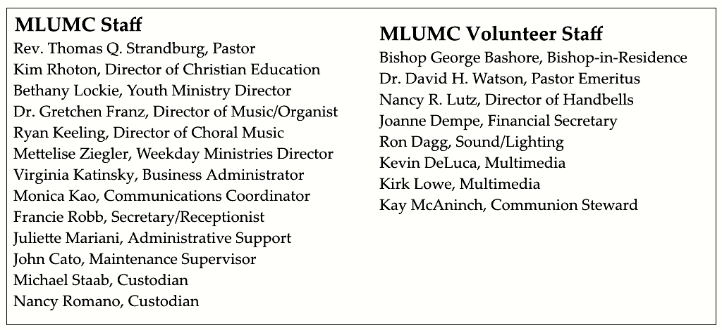

Keep in Prayer

Hospitalized
Earl Killian, Montefiore

Convalescing in Care Facilities
Leila Berkey, Asbury Heights
Jean Bouvy, McMurray Hills Manor
Ed Clarke, Asbury Place
Pat Seitz, Concordia

Convalescing at Home
Betty Lou Albright, Joyce Feldman, May Frederick, Ann Hoyer, Andy Smith

In the Military

Jason Boyer, SPC Natalie Brown

Capt. Zachary Allen Finch, USMC
James Iantelli, 1st Lt. Jaskiewicz
S. Sgt. Keith Kimmell, Adam Kmick
PFC Brendan Lamport
Sgt. Matthew McConahan, Thomas Orda
Lt. Col. Mark Patterson

Lt. Com. Scott Patterson

Lt. Col. Sean Patterson
David Poncel, Sgt. Steven Reitz
Capt. Scott B. Rushe, Pastor Rick Townes
Capt. Azizi Wesmiller

Capt. Matthew C. Wesmiller
Sgt. Keith Scott Winkowski

Sgt. Michael Zimmerman

Sympathy
Condolences are offered to the family of MLUMC custodian Nancy Romano. Her son-in-law, Tony Kunsak passed away last week. Prayers and words of sympathy to the family may be sent to Nancy’s daughter and to Nancy Romano:
Sarah Kunsak
43 Pocono Drive
Pittsburgh, PA 15220

Nancy Romano
44 Academy Ave. #17
Pittsburgh, PA 15228

Looking to send a card? Here are some helpful addresses
UPMC Montefiore Hospital
3459 Fifth Ave.
Pittsburgh, PA 15213

Asbury Heights
700 Bower Hill Road
Pittsburgh, PA 15243

McMurray Hills Manor
249 W McMurray Road
McMurray, PA 15317

Concordia Health Center
1300 Bower Hill Road
Pittsburgh, PA 15243

Birthday wishes can be sent to church member Ann Swartz, who will be 100 years old this July 31. Send your card to :
Mrs. Ann Swartz
Asbury Heights, Apt. 7206
700 Bower Hill Road
Pittsburgh, PA 15243-2040

From Rev. Lutz and Martina Brückner:

Hello friends in Pittsburgh and Mt. Lebanon,
I would like to thank all of you for greetings of farewell from Zwickau and for good wishes for our new beginning in our new congregation close to Zwickau. Martina and I were very pleased! You have become very important in the last seven years, like sisters and brothers. Coming to Pittsburgh, was always a bit like coming home for us. Together we did a lot - in Pittsburgh and in Zwickau. And we like to remember beautiful encounters and moments. Martina and I wish you as a congregation and as individuals God's blessing on your ways. Be guarded and guided by God. And we hope that we can see each other in 2017 - in Zwickau (if you come to Germany) and in Pittsburgh (the children's choir "The Butterflies" plans a tour of Pennsylvania in the fall of 2017).
Be blessed,
Martina and Lutz

CALENDAR – SUNDAY, JULY 10 THRU SATURDAY, JULY 16

SUNDAY 7/10
8:30 am Worship Sanner Chapel
9:30 am Faith for Today Asbury Center
9:30-10:30 am Kids’ Sunday School Room 204
9:30-noon Nursery Room 204
10:45 am Worship Sanctuary
Kids Praise Welcome Center

TUESDAY 7/12
7 pm Boy Scout Troop #23 Wesley Hall
7 pm Boy Scout Board of Reviews Room 105
7 pm Cub Scout Planning Epworth

WEDNESDAY 7/13
6 pm Homebuilders Picnic Asbury Center
6:30 pm Finance Wesley Hall

SATURDAY 7/16
10 am Food Distribution Food Pantry

