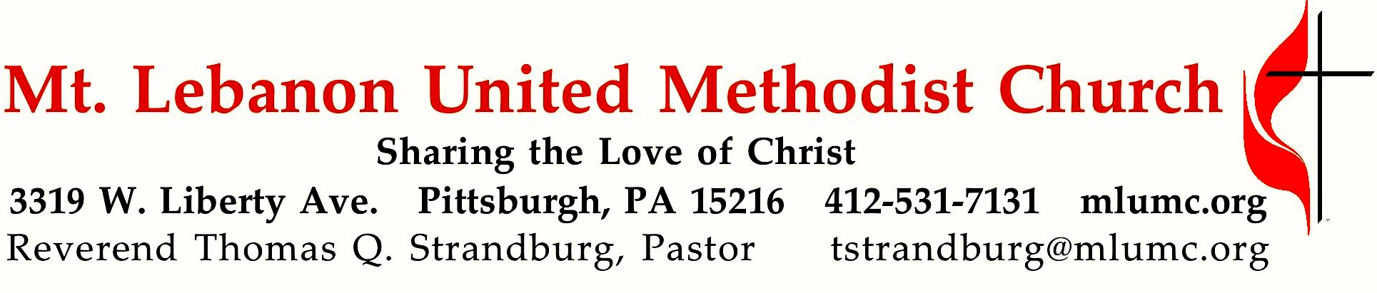
July 31, 2016 8:30 & 10:45
10th Sunday after Pentecost

Throughout the Bible, idolatry is identified as the greatest enemy of faith. Idolatry means allowing anything to occupy the place of reverence which only God should occupy in our lives. In light of Jesus’ warning, what do you worship?

WE GATHER IN GOD’S NAME …

Gathering Music
Hymn 472 Near to the heart of God McAfee
Hymn 473 Lead me, Lord Lead me, Lord

Greeting
Leader: Break forth together into singing, you ruins of Jerusalem;
People: for the Lord has comforted his people.
Isaiah 52:9
Announcements

Call to Worship
Leader: We gather this morning Lord, to hear your Word.
People: May your Word take root in our spirits.
Leader: We gather this morning Lord, seeking your anointing.
People: May your Word grow within us possibilities for our future.
Leader: We gather this morning Lord, seeking direction.
People: May your Word create within us a harvest of blessings.
ALL: COME HOLY SPIRIT, COME!
Junias Dotson, The Africana Worship Book
… TO GIVE PRAISE TO GOD …

Hymn of Praise 73 O worship the King (standing) Lyons
Opening Prayer (in unison, standing)
O God, like a baker you bring the leaven which causes our hopes to rise. With your strong and gentle hands, shape our lives. Warm us with your love. Take our common lives and touch them with your grace, that we may nourish hope among humanity. We pray trusting in your name, through Jesus our Christ. Amen.
Ruth Duck, U.M. Book of Worship

… TO CELEBRATE THE FAMILY OF FAITH …

Recognition of the Ministry of Ryan Keeling, Director of Choral Music

The Sign of Peace Please pass the peace to your neighbors as a sign of reconciliation and love.
Leader: The peace of Christ be with you.
People: And also with you.

Gathering Song James Ritchie
This, this is where children belong,
welcomed as part of the worshiping throng.
Water, God’s Word, bread and cup, prayer and song:
This is where children belong.
WORDS: James Ritchie MUSIC: James Ritchie ©1999 Abingdon Press

Message for Young Disciples Rev. Thomas Q. Strandburg
All children are invited. Please sing as children come forward. After the children’s message at the 10:45 service, children ages 3 - 3rd grade may attend Kids Praise in the Welcome Center. Children will be escorted to and from Kids Praise by teachers. They will return to Asbury Center near the end of the service.

… TO HEAR GOD’S WORD PROCLAIMED …

Hymn 502 Thy holy wings, O Savior (seated) Bred dina vida vingar

Scripture Reading 8:30 Judi Phelps
10:45 Jessica Langston

A Lesson from the Hebrew Scripture
Colossians 3:1-11 Your life hidden in Christ

Worship & Song 3131 Hear my prayer, O God (stanza 4, seated) Adieu

Pastoral Prayer

The Lord’s Prayer
Our Father, who art in heaven, hallowed be thy name. Thy kingdom come, thy will be done, on earth as it is in heaven. Give us this day our daily bread. And forgive us our trespasses, as we forgive those who trespass against us. And lead us not into temptation, but deliver us from evil. For thine is the kingdom, and the power, and the glory forever. Amen.

Scripture Reading
A Lesson from the Gospels (standing)
Luke 12:13-21 Warning against greed

Response
Leader: The Word of the Lord.
People: Thanks be to God.

… TO OFFER OUR GIFTS AND TO DEDICATE OUR LIVES …

Offertory Solo 8:30 Amazing Grace setting by John Carter

Offertory Anthem 10:45 Spiritual, arr. Richard Billingham
I want Jesus to walk with me; all along my pilgrim journey,
Lord, I want Jesus to walk with me.
In my trials, Lord, walk with me;
when the shades of life are falling, Lord, I want Jesus to walk with me.
In my sorrows, Lord, walk with me;
when my heart within is aching, Lord, I want Jesus to walk with me.

Doxology 94 (standing)
Praise God from whom all blessings flow;
Praise God, all creatures here below: Alleluia! Alleluia!
Praise God the source of all our gifts!
Praise Jesus Christ, whose power uplifts!
Praise the Spirit, Holy Spirit. Alleluia! Alleluia! Alleluia!

Prayer of Dedication

Sermon “Idol Worship” Rev. Thomas Q. Strandburg

… TO GO REJOICING IN GOD’S NAME!

Hymn of Commitment 433 All who love and serve your city (standing) Charlestown
Benediction

A reception to say goodbye to the Keeling family is being held following the 10:45 service in the Asbury Alcove.

Today’s Services

One flower arrangement provided for worship today is given by Andy Seay in honor of Ryan, Jenna and Abby Keeling.

One flower arrangement provided for worship today is given by Mary Garber in honor of Grace Killian and her work with our eastern German partner churches in Zwickau and Kemnitz to help immigrants get settled in their new lives.

Special music at 10:45 is provided by the Chancel Choir, conducted for the last time by Ryan A. Keeling, our well-loved Director of Choral Music.

Our hymnal and the new hymnal supplement are rich resources. As we explore newer texts and tunes we will repeat them during the month so that we are more comfortable singing them.

Greeters 8:30 John and Marilyn White 10:45 Jim and Linda Hoover

Worship options for children We encourage children to participate in the Children’s Sermon at both services, and in Kids Praise during the 10:45 service. Nursery services are offered in Room 204 of the Education Building. Ask ushers or greeters and follow signs for direction.

Flower Donations The church is in need of Sunday flower arrangements for August. Honor or remember a loved one or friend with your donation. Contact Sharon Slater, 412-343-1137.

Podcasts of Sunday Sermons Would you like to share this morning’s sermon with a friend or did you miss a Sunday? Catch up on the messages from MLUMC with a podcast of Pastor Tom’s and others’ Sunday sermons. Sermons from the past three months are at
http:// mlumc.buzzsprout.com. You can navigate to the site from the link on our webpage, www.mlumc.org, through the app, Stitcher or through iTunes

Today’s Scriptures
Colossians 3:1-11
So if you have been raised with Christ, seek the things that are above, where Christ is, seated at the right hand of God.
²Set your minds on things that are above, not on things that are on earth,
³for you have died, and your life is hidden with Christ in God.
⁴When Christ who is your life is revealed, then you also will be revealed with him in glory.
⁵Put to death, therefore, whatever in you is earthly: fornication, impurity, passion, evil desire, and greed (which is idolatry).
⁶On account of these the wrath of God is coming on those who are disobedient.
⁷These are the ways you also once followed, when you were living that life.
⁸But now you must get rid of all such things—anger, wrath, malice, slander, and abusive language from your mouth.
⁹Do not lie to one another, seeing that you have stripped off the old self with its practices
¹⁰and have clothed yourselves with the new self, which is being renewed in knowledge according to the image of its creator.
¹¹In that renewal there is no longer Greek and Jew, circumcised and uncircumcised, barbarian, Scythian, slave and free; but Christ is all and in all!

Luke 12:13-21
¹³Someone in the crowd said to him, “Teacher, tell my brother to divide the family inheritance with me.”
¹⁴But he said to him, “Friend, who set me to be a judge or arbitrator over you?”
¹⁵And he said to them, “Take care! Be on your guard against all kinds of greed; for one’s life does not consist in the abundance of possessions.”
¹⁶Then he told them a parable: “The land of a rich man produced abundantly.
¹⁷And he thought to himself, ‘What should I do, for I have no place to store my crops?’
¹⁸Then he said, ‘I will do this: I will pull down my barns and build larger ones, and there I will store all my grain and my goods.
¹⁹And I will say to my soul, ‘Soul, you have ample goods laid up for many years; relax, eat, drink, be merry.’
²⁰But God said to him, ‘You fool! This very night your life is being demanded of you. And the things you have prepared, whose will they be?’
²¹So it is with those who store up treasures for themselves but are not rich toward God.”

Keep in Prayer

Hospitalized
Marda Katshir, St. Clair

Convalescing in Care Facilities
Leila Berkey, Asbury Heights
Jean Bouvy, McMurray Hills Manor
Pat Seitz, Concordia

Convalescing at Home
Joyce Feldman, May Frederick, Ann Hoyer, Earl Killian, Andy Smith

In the Military

Jason Boyer, SPC Natalie Brown

Capt. Zachary Allen Finch, USMC
James Iantelli, 1st Lt. Jaskiewicz
S. Sgt. Keith Kimmell, Adam Kmick
PFC Brendan Lamport
Sgt. Matthew McConahan, Thomas Orda
Lt. Col. Mark Patterson

Lt. Com. Scott Patterson

Lt. Col. Sean Patterson
David Poncel, Sgt. Steven Reitz
Capt. Scott B. Rushe, Pastor Rick Townes
Capt. Azizi Wesmiller

Capt. Matthew C. Wesmiller
Sgt. Keith Scott Winkowski

Sgt. Michael Zimmerman

Looking to send a card? Here are some helpful addresses

Asbury Heights
700 Bower Hill Road
Pittsburgh, PA 15243

McMurray Hills Manor
249 W McMurray Road
McMurray, PA 15317

Concordia Health Center
1300 Bower Hill Road
Pittsburgh, PA 15243

Suffering a Loss: Why and How We All Grieve Differently
Washington & Jefferson College, 60 S. Lincoln St. Washington, PA
Thursday, August 18th 9 am – 4 pm

Just as John Gray’s popular book, Men are from Mars, Women are from Venus, focused on the fundamental psychological differences between men and women, this seminar will help you understand why and how we all grieve differently. Cultural, racial, socioeconomic, gender, ethnicity, age, and religion all affect our grieving process. More than an information-only event, the day will include lots of practical “how tos”, “dos, don’ts” and many specific ways in which we can help ourselves and others in the grieving process.

This Seminar is led by Dr. Daniel Stinson, Director of the W & J Thanatology Certificate Program, Certified Bereavement Facilitator, Certified Palliative Care Specialist, and Certified Advance Bereavement Facilitator.

Price: 175.00 –Registration Fee covers cost of seminar and lunch. To register: Contact Emily Butler, Assistant Director of Graduate and Continuing Studies: continuingstudies@washjeff.edu.
724-503-1001 Ext 6226

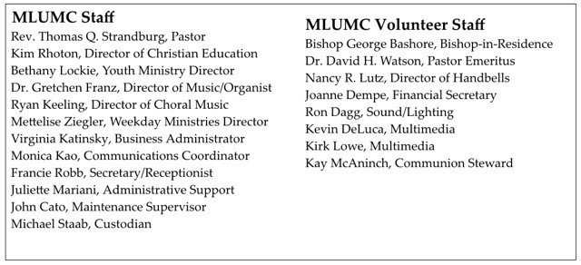

CALENDAR – SUNDAY, JULY 31 THRU SATURDAY, AUGUST 6

SUNDAY 7/31
8:30 am Worship Sanner Chapel
9:30 am Faith for Today Asbury Center
9:30-10:30 am Kids’ Sunday School Room 204
9:30-noon Nursery Room 204
10:45 am Worship Sanctuary
Kids Praise Welcome Center
12 pm Keeling Farewell Reception Asbury Alcove

MONDAY, AUGUST 1 – FRIDAY, AUGUST 5
9:30 am Vacation Bible School Various

TUESDAY 8/2
7 pm Boy Scout Troop #23 Wesley Hall
7 pm Boy Scout Parents Epworth
7 pm Coin Collectors Welcome Center

WEDNESDAY 8/3
6:30 am Northside Lunch Program Prep Kitchen
6 pm Homebuilders Picnic Wesley Hall
7 pm Mission Committee Welcome Center

THURSDAY 8/4
8:30 am Northside Lunch Program Prep Kitchen
12 pm TNT Asbury Heights

SATURDAY 8/6
10 am Food Distribution Food Pantry

