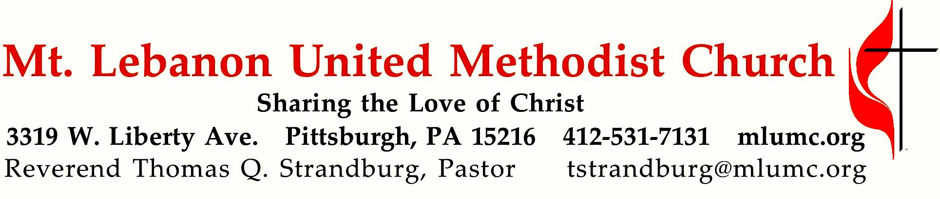
October 2, 2016 8:30 & 10:45

20th Sunday after Pentecost World Communion Sunday

As individuals, even our best Christian efforts are just a few small steps, nothing spectacular in themselves. But when combined with the actions of others, they have a powerful impact. On this World Communion Sunday, we celebrate our partnership with other Christians, that spans divisions of denomination, language, culture, and nationality.

WE GATHER IN GOD’S NAME …

Gathering Music
Hymn 162 Alleluia, Alleluia (stanzas 1 and 2, seated) Alleluia No. 1
Hymn 426 I'll praise my maker while I've breath (stanzas 1 and 2) Marsh Chapel

Greeting
Leader: Sing praises to the Lord, O you God’s faithful ones,
People: and give thanks to God’s holy name.
Psalm 30:4
Announcements

Choral Introit 10:45 Psalm 103:1 Richard C. Baker
Bless the Lord O my soul and all that is within me bless His Holy Name.

Call to Worship
Pastor: The world belongs to God, the Earth and all its people.
People: Today and every day, Christians in many places are praying and lifting songs of praise to God.
Pastor: Let us join our hearts and voices with theirs.
NEJ Common Worship Program

… TO GIVE PRAISE TO GOD …

Hymn of Praise 568 Christ for the world we sing (standing) Italian Hymn
Opening Prayer (in unison, standing)
Living God, today as we come to the table of the Lord with Christians from around the world, we are visited by recollections of the many tables where we have felt welcomed, seen, known, and loved; where we have savored every bite and lingered with the others gathered there. From the busy routine of our lives we come to this gathering. Be with us, Lord Jesus, we pray. Amen.
NEJ Common Worship Program

… TO CELEBRATE THE FAMILY OF FAITH …

The Sign of Peace Please pass the peace to your neighbors as a sign of reconciliation and love.
Leader: The peace of Christ be with you.
People: And also with you.

Gathering Song James Ritchie
This, this is where children belong,
welcomed as part of the worshiping throng.
Water, God’s Word, bread and cup, prayer and song:
This is where children belong.
WORDS: James Ritchie MUSIC: James Ritchie ©1999 Abingdon Press

Message for Young Disciples Rev. Thomas Q. Strandburg
All children are invited. Please sing as children come forward. After the children’s message at the 10:45 service, children ages 3 - 3rd grade may attend Kids Praise in the Welcome Center. Children will be escorted to and from Kids Praise by teachers. They will return to the Sanctuary near the end of the service.

… TO HEAR GOD’S WORD PROCLAIMED …

Communion Hymn 620 One bread, one body (seated) One bread, one body

Prayer for Illumination
With minds and hearts open through the inspiration of the Holy Spirit so that, as the scriptures are shared and the Word proclaimed, we may hear with joy what God is saying to us today, you are invited to rest – to sit silently and rest in God’s love.

After resting, pray together:
Silence in us any voice but your own, Great God.
As these ancient words of scripture are shared,
open not only our hearts, open our minds,
open our imaginations. Amen.
NEJ Common Worship Program

Scripture Reading 8:30 Marcy Picardi
10:45 Michele Nagle
A Lesson from the New Testament
Acts 2:43-47

Prayer Hymn 494 Kum ba yah (stanza 5, seated) Desmond
Someone’s singing, Lord, Kum ba yah. (repeat 3 times)
Oh, Lord, kum ba yah!

Pastoral Prayer

The Lord’s Prayer
Our Father, who art in heaven, hallowed be thy name. Thy kingdom come, thy will be done, on earth as it is in heaven. Give us this day our daily bread. And forgive us our trespasses, as we forgive those who trespass against us. And lead us not into temptation, but deliver us from evil. For thine is the kingdom, and the power, and the glory forever. Amen.

Scripture Reading
A Lesson from the Gospels (standing)
Luke 17:5-10 The key to faithful service

Response
Leader: The Word of the Lord.
People: Thanks be to God.

… TO OFFER OUR GIFTS AND TO DEDICATE OUR LIVES …

Offertory Solo 8:30 Let us break bread together setting by John Carter

Anthem 10:45 When the saints go marching in Traditional, arranged by John Rutter
Glory, glory hallelujah! The Lord goes marching on.
1. Oh, when the saints go marching in; Oh, Lord I want to be in that number, when the saints go marching in.
2. And when the revelation comes…
3. Oh, when the new world is revealed…
4. Oh, when they gather round the throne
Hallelujah, brothers, Hallelujah sisters! Hear the music going round and around,
while the saints go marching up into glory, Oh, hear those angel trumpets sound!
5. And when they crown him King of Kings…
6. And when the sun no more will shine…
7. And on that hallelujah day….
Congregation and Choir:
Oh, when the saints go marching in; Oh, when the saints go marching in:
Oh, Lord, I want to be in that number when the saints go marching in.

Doxology 94 (standing)
Praise God from whom all blessings flow;
Praise God, all creatures here below: Alleluia! Alleluia!
Praise God the source of all our gifts!
Praise Jesus Christ, whose power uplifts!
Praise the Spirit, Holy Spirit. Alleluia! Alleluia! Alleluia!

Prayer of Dedication

Sermon 8:30 “Small Steps” Rev. Thomas Q. Strandburg
10:45 “The Virtue of Sharing” Rev. Jong Man Lee

Anthem 10:45 Thou my everlasting portion F.J. Crosby; S. J. Vail
1. Thou, my everlasting portion, more than friend or life to me;
all along my pilgrim journey, Saviour, let me walk with Thee.
Refrain: Close to Thee; all along my pilgrim journey, Saviour, let me walk with Thee.
2. Not for ease or worldly pleasure, nor for fame my prayer shall be;
gladly will I toil and suffer, only let me walk with Thee.
3. Lead me through the vale of shadows, bear me o'er life's fitful sea;
then the gate of life eternal may I enter, Lord, with Thee.
Korean Methodist Women

Sacrament of Holy Communion Rev. Thomas Q. Strandburg and Rev. Jong Man Lee

The Great Thanksgiving 성만찬 기도문
Leader: The Lord be with you. 하나님께서 여러분과 함께하시길 바랍니다.
People: And also with you. 또한 당신과도 함께하시길 바랍니다.
Leader: Lift up your hearts. 여러분의 마음을 하나님께 드리시기 바랍니다.
People: We lift them up to the Lord. 우리의 마음을 하나님께 드립니다.
Leader: Let us give thanks to the Lord our God. 우리 주 하나님께 감사를 드리십시다.
People: It is right to give our thanks and praise. 우리가 감사와 찬양을 드림이 마땅합니다.
Leader: (The pastor continues in prayer, and concludes with the following words . . .)
And so we thank you and praise you with the faithful people of every time and place, joining with the choirs of heaven and with the whole creation in singing to your
glory:
용서로 복수의 고함소리를 침묵시키십니다. 이에 우리가 언제나 어디서나 신실한 성도들과 함께 당신께 감사와 찬양을 드리며, 하늘의 찬양대와 우주 만물과 연합하여 당신의 영광을 노래합니다:
People: Holy, holy, holy, Lord, God of power and might,
Heaven and earth are full of your glory. Hosanna in the highest.
Blessed is he who comes in the name of the Lord. Hosanna in the highest.
Hosanna in the highest.
Leader: (The pastor continues in prayer, and concludes with the following words . . .)
Let us proclaim the mystery of faith: 이제 우리 믿음의 신비를 선포하십시다:

People: Christ, by your cross and resurrection you have set us free.
You are the Savior of the World.
주님, 당신의 십자가와 부활로 우리를 자유하게 하셨읍니다. 당신은 온 세상의 구세주이십니다.

Leader: Lord our God, your Son has entrusted this pledge of love to us, and so we celebrate the memory of his death and resurrection. Accept us together with your Son. Pour out your Holy Spirit on these gifts, and fill us with that same Spirit as we share this meal, so that all which divides us may be healed. Inspire us to be your people of reconciliation. Make your church throughout the world to be a sign of unity and an instrument of peace.

주 하나님이시여, 당신의 아들이 이 사랑의 서약을 우리에게 부탁하셨으므로, 그의 죽으심과 부활하심을 기억하며 이 기쁨을 함께 나눕니다. 당신의 아들과 함께 우리를 받으시옵소서. 당신의 성령을 이 주님의 선물위에 부으시고, 우리가 이 성만찬을 나누오니 당신의 성령으로 우리에게 채우사, 우리를 갈라지게 하는 모든 것을 치료하시옵소서. 우리를 감화하사 화해를 이루는 당신의 백성이 되게 하시고, 당신의 교회를 이 세상에서 단합의 상징과평화의 도구로 만드시옵소서.

Bring quickly that new world where the fullness of your peace will be revealed. Keep us watchful for that day when people of every race, language and way of life will gather to share in the one eternal banquet with Jesus Christ our Lord. Through him, with him, and in him, in the unity of the Holy Spirit, all glory and honor is yours, almighty Father, now and forever.

당신의 충만한 평화가 나타날 새 세상을 속히 이루시옵소서. 우리를 항상 깨어있게하사인종과 언어와 풍속이 다른 모든 백성들이 모여 우리 주 예수 그리스도와 함께 영원한 잔치에 참여할 그 날을 기다리게 하소서. 전능하신 하나님, 그리스도를 통하여, 그와 함께, 또 그 안에서,
그리고 우리를 하나되게 하시는 성령안에서, 지금부터 영원토록 모든 영광과 존귀를 받으시옵소서.

People: Amen. 아멘.

Giving the Bread and Cup (During Communion, join in singing from the Hymnal beginning with 425, only the first two stanzas.)

… TO GO REJOICING IN GOD’S NAME!

Hymn of Commitment 435 O God of every nation (standing) Llangloffan

Benediction

We welcome Rev. Jong Man Lee, and the members of the Pittsburgh Korean Methodist Church, to our joint celebration of World Communion Sunday during the 10:45 am service. For over fifteen years, our two congregations have joined in ministry together for the sole mission of making disciples of Jesus Christ for the transformation of the world. The Korean congregation meets every Sunday at 2:00 p.m. in Sanner Chapel. Welcome, friends!

We also welcome Ea Kyoung Jun, known to our MLUMC family as "Amy," who is serving as Pastor Lee's translator during the 10:45 service. Amy is a member of our congregation, a worship leader for the Korean congregation, as well as a certified candidate for ministry in the United Methodist Church. We are grateful for her leadership in our midst.

Today’s Services
The chancel flowers are given by Bernice Merchant in honor of her husband, Bill.

The altar flowers are given by William Timmons in loving memory of his parents, Mr. and Mrs. Wilbert G. Timmons.

Special music at 10:45 is provided by the Chancel Choir with pianist Mary Paine, a member of the church who teaches piano in the area, and a vocal ensemble, KMW, from the Korean Church.

Our hymnal and the new hymnal supplement are rich resources. As we explore newer texts and tunes we will repeat them during the month so that we are more comfortable singing them.

Greeters 8:30 Ron and Carolyn Dagg 10:45 Bonnie Lawson

Worship options for children We encourage children to participate in the Children’s Sermon at both services, and in Kids Praise during the 10:45 service. Nursery services are offered in Room 204 of the Education Building. Ask ushers or greeters and follow signs for direction.

Podcasts of Sunday Sermons Would you like to share this morning’s sermon with a friend or did you miss a Sunday? Catch up on the messages from MLUMC with a podcast of Pastor Tom’s and others’ Sunday sermons. Sermons from the past three months are at
http:// mlumc.buzzsprout.com. You can navigate to the site from the link on our webpage, www.mlumc.org, through the app, Stitcher or through iTunes

Today’s Scriptures

Acts 2:43-47
⁴³Awe came upon everyone, because many wonders and signs were being done by the apostles. ⁴⁴All who believed were together and had all things in common; ⁴⁵they would sell their possessions and goods and distribute the proceeds to all, as any had need. ⁴⁶Day by day, as they spent much time together in the temple, they broke bread at home and ate their food with glad and generous hearts, ⁴⁷praising God and having the goodwill of all the people. And day by day the Lord added to their number those who were being saved.

Luke 17:5-10
⁵The apostles said to the Lord, “Increase our faith!” ⁶The Lord replied, “If you had faith the size of a mustard seed, you could say to this mulberry tree, ‘Be uprooted and planted in the sea,’ and it would obey you. ⁷“Who among you would say to your slave who has just come in from plowing or tending sheep in the field, ‘Come here at once and take your place at the table’? ⁸Would you not rather say to him, ‘Prepare supper for me, put on your apron and serve me while I eat and drink; later you may eat and drink’? ⁹Do you thank the slave for doing what was commanded? ¹⁰So you also, when you have done all that you were ordered to do, say, ‘We are worthless slaves; we have done only what we ought to have done!’”

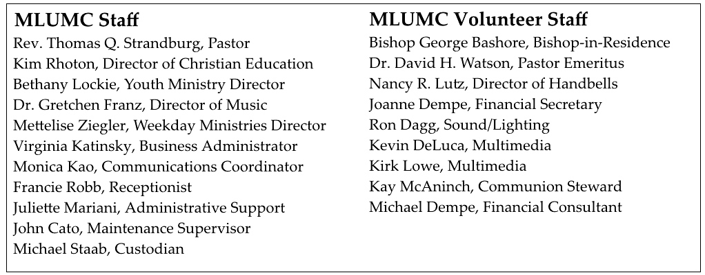

Keep in Prayer
Hospitalized
Bill Merchant, St. Clair
John White, Mercy

Convalescing in Care Facilities
Leila Berkey, Asbury Heights
Jean Bouvy, McMurray Hills Manor
Ed Clarke, Asbury Place
Pat Seitz, Concordia
Tim Watters, Baptist Home

Convalescing at Home
Earl Killian, Andy Smith

In the Military

Jason Boyer, SPC Natalie Brown

Capt. Zachary Allen Finch, USMC
James Iantelli, 1st Lt. Jaskiewicz
S. Sgt. Keith Kimmell, Adam Kmick
PFC Brendan Lamport
Sgt. Matthew McConahan, Thomas Orda
Lt. Col. Mark Patterson

Lt. Com. Scott Patterson

Lt. Col. Sean Patterson
David Poncel, Sgt. Steven Reitz
Capt. Scott B. Rushe, Pastor Rick Townes
Capt. Azizi Wesmiller

Capt. Matthew C. Wesmiller
Sgt. Keith Scott Winkowski

Sgt. Michael Zimmerman

Sympathy
Condolences are offered to the family of retired United Methodist minister, Rev. Robert Critchlow. Rev. Critchlow died on September 25 at the age of 87. Words of sympathy can be sent to his wife and family:
Bonnie Critchlow
971 Pine Ave
Pittsburgh, PA 15234-2171

Expression of Thanks

Dear MLUMC,

I wanted to say thank you for sending Dr. Watson to visit me in St. Clair Hospital. I had my thyroid removed and I’m doing well, back to work and on a normal schedule. I appreciate the thoughts and prayers from everyone. I don’t know how you knew I was going in for surgery, but I am thankful you did.

Love,

Tommilea Giegel

Thank you so much to Chuck Hutchinson for everything he does for our church. Most recently, I am particularly grateful for his help in transporting flowers from the church to my car. His kind actions and attention to detail were helpful and appreciated.

Marjorie Ehni

