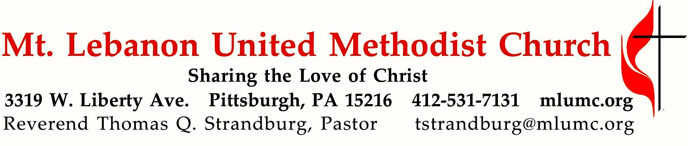
September 11, 2016 8:30 & 10:45

WE GATHER IN GOD’S NAME …

Gathering Music
Hymn 474 Precious Lord, take my hand Precious Lord
Greeting
Leader: In the day of trouble I call on you,
People: for you will answer me. Psalm 86:7

Announcements

Choral Introit 10:45 Psalm 68: 32 Richard C. Baker
Sing unto God ye kingdoms of the earth;
O sing praises unto our God.

Call to Worship
Leader: The Lord be with you.
People: And also with you.
Leader: Church, world, souls, memories, longings and desires yearn for the ancient
vision of the prophets to be fulfilled.

Lectern Side: The eyes of the blind shall be opened, and the ears of the deaf unstopped; then the lame shall leap like a deer, and the tongues of the speechless sing for joy.
Pulpit Side: For waters shall break forth in the wilderness, and streams in the desert,
the burning sand shall become a pool, and the thirsty ground springs of water.
Isaiah 35: 5-7
Leader: By the Spirit, a vision wells up in the people of God who yearn for healing and restoration; for justice, not terrorism; for forgiveness, not hate.
Lectern Side: Then God brought me back to the entrance of the temple. There, water was flowing from below the threshold of the temple . . . south of the altar
it was ankle-deep . . .
then it was knee-deep . . .
then it was up to the waist . . .
then it was a river I could not cross.
Pulpit Side: God led me back along the bank of the river. As I came back,
I saw on the bank of the river a great many trees on one side and on the other. God said to me, “Wherever the river goes everything will live.
There will grow all kinds of trees for food.
Their fruit will be for food and their leaves for healing.”
From Ezekiel 47:1-12

… TO GIVE PRAISE TO GOD …

Hymn of Praise 64 Holy, holy holy! Lord God Almighty Nicaea

Opening Prayer (in unison, standing)
O God, make the door of this house wide enough to receive all who need human love and fellowship, narrow enough to shut out envy, pride, and strife. Make its threshold smooth enough to be no stumbling block to children, nor to straying feet, but rugged and strong enough to turn back evil’s power. God, make the door of this house the gateway to your eternal kingdom.
Worship & Song

Silent Prayers of Confession (standing)

Words of Assurance (standing)

… TO CELEBRATE THE FAMILY OF FAITH …

The Sign of Peace Please pass the peace to your neighbors as a sign of reconciliation and love.
Leader: The peace of Christ be with you.
People: And also with you.

Gathering Song James Ritchie
This, this is where children belong,
welcomed as part of the worshiping throng.
Water, God’s Word, bread and cup, prayer and song:
This is where children belong.
WORDS: James Ritchie MUSIC: James Ritchie ©1999 Abingdon Press

Message for Young Disciples
All children are invited. Please sing as children come forward. After the children’s message at the 10:45 service, children ages 3 - 3rd grade may attend Kids Praise in the Welcome Center. Children will be escorted to and from Kids Praise by teachers. They will return to the Sanctuary near the end of the service.

… TO HEAR GOD’S WORD PROCLAIMED …

Hymn of Comfort 510 Come, ye disconsolate Consolator

Scripture Reading 8:30 Liz DePietro
10:45 Judy Moeller
A Lesson from the Hebrew Scripture
Habakkuk 3:17-18

Prayer Hymn 494 Kum ba yah (stanza 2, seated) Desmond
Someone's prayin' Lord, kum ba yah (repeat 3 times)
Oh, Lord, kum ba yah.

Pastoral Prayer

The Lord’s Prayer
Our Father, who art in heaven, hallowed be thy name. Thy kingdom come, thy will be done, on earth as it is in heaven. Give us this day our daily bread. And forgive us our trespasses, as we forgive those who trespass against us. And lead us not into temptation, but deliver us from evil. For thine is the kingdom, and the power, and the glory forever. Amen.

Scripture Reading
A Lesson from the Gospels (standing)
Matthew 5:38-48 Retaliation vs. Love

Response
Leader: The Word of the Lord.
People: Thanks be to God.

… TO OFFER OUR GIFTS AND TO DEDICATE OUR LIVES …

Offertory Solo 8:30 Kum ba yah arranged by John Carter

Anthem 10:45 In remembrance text and music by Jeffery L. Ames
Lux aeterna, luceat eis, Domine. (translation: Let light eternal shine on them, Lord.)
Turn to me and be gracious, for my heart is in distress.
O God, my God, why hast Thou forsaken me?
My tears linger at night, but joy comes in the morning light.
Lux aeterna, luceat eis, Domine.
Lord, in Your infinte mercy, grant them rest. Rest forevermore.

Doxology 94 (standing)
Praise God from whom all blessings flow;
Praise God, all creatures here below: Alleluia! Alleluia!
Praise God the source of all our gifts!
Praise Jesus Christ, whose power uplifts!
Praise the Spirit, Holy Spirit. Alleluia! Alleluia! Alleluia!

Prayer of Dedication

Sermon “God at Ground Zero” Rev. Timothy Reichard

… TO GO REJOICING IN GOD’S NAME!

Hymn of Commitment 555 Forward through the ages St. Gertrude

Benediction

Today’s Services

The chancel flowers are given by Gerry Oelschlager in honor of Corinne O. Potter.

The altar flowers are in memory of Helen Manning, a gracious Southern lady who was a member of All Twos. The flowers are given by John and Shirley Baker and others who remember Helen.

Special music at 10:45 is provided by the Chancel Choir with guest musicians Joy Crummie, piano; and Jason Allison, horn. The presence of guest musicians is made possible through the Friends of Music Fund. Contributions are always welcome - mark your check Mt. Lebanon UMC/Friends of Music Fund.
Our hymnal and the new hymnal supplement are rich resources. As we explore newer texts and tunes we will repeat them during the month so that we are more comfortable singing them.

Greeters 8:30 Erma Henry 10:45 Anne Hoffman

Acolytes Anastasia Sunder and Anna Rhoton

Worship options for children We encourage children to participate in the Children’s Sermon at both services, and in Kids Praise during the 10:45 service. Nursery services are offered in Room 204 of the Education Building. Ask ushers or greeters and follow signs for direction.

Podcasts of Sunday Sermons Would you like to share this morning’s sermon with a friend or did you miss a Sunday? Catch up on the messages from MLUMC with a podcast of Pastor Tom’s and others’ Sunday sermons. Sermons from the past three months are at
http:// mlumc.buzzsprout.com. You can navigate to the site from the link on our webpage, www.mlumc.org, through the app, Stitcher or through iTunes

Flower Donations Honor or remember a loved one or friend with a Sunday flower arrangement donation. Contact Sharon Slater, 412-343-1137.

Today’s Scriptures

Habakkuk 3:17-18
¹⁷Though the fig tree does not blossom, and no fruit is on the vines; though the produce of the olive fails and the fields yield no food; though the flock is cut off from the fold and there is no herd in the stalls, ¹⁸yet I will rejoice in the Lord; I will exult in the God of my salvation.

Matthew 5:38-48
³⁸“You have heard that it was said, ‘An eye for an eye and a tooth for a tooth.’ ³⁹But I say to you, Do not resist an evildoer. But if anyone strikes you on the right cheek, turn the other also; ⁴⁰and if anyone wants to sue you and take your coat, give your cloak as well; ⁴¹and if anyone forces you to go one mile, go also the second mile. ⁴²Give to everyone who begs from you, and do not refuse anyone who wants to borrow from you.
⁴³“You have heard that it was said, ‘You shall love your neighbor and hate your enemy.’ ⁴⁴But I say to you, Love your enemies and pray for those who persecute you, ⁴⁵so that you may be children of your Father in heaven; for he makes his sun rise on the evil and on the good, and sends rain on the righteous and on the unrighteous. ⁴⁶For if you love those who love you, what reward do you have? Do not even the tax collectors do the same? ⁴⁷And if you greet only your brothers and sisters, what more are you doing than others? Do not even the Gentiles do the same? ⁴⁸Be perfect, therefore, as your heavenly Father is perfect.

Keep in Prayer
Hospitalized
Earl Killian, Montefiore

Convalescing in Care Facilities
Leila Berkey, Asbury Heights
Jean Bouvy, McMurray Hills Manor
Ed Clarke, Asbury Place
Pat Seitz, Concordia

Convalescing at Home
Robert Fairgrieve, Tommilea Giegel,
Andy Smith

In the Military

Jason Boyer, SPC Natalie Brown

Capt. Zachary Allen Finch, USMC
James Iantelli, 1st Lt. Jaskiewicz
S. Sgt. Keith Kimmell, Adam Kmick
PFC Brendan Lamport
Sgt. Matthew McConahan, Thomas Orda
Lt. Col. Mark Patterson

Lt. Com. Scott Patterson

Lt. Col. Sean Patterson
David Poncel, Sgt. Steven Reitz
Capt. Scott B. Rushe, Pastor Rick Townes
Capt. Azizi Wesmiller

Capt. Matthew C. Wesmiller
Sgt. Keith Scott Winkowski

Sgt. Michael Zimmerman

Looking to send a card? Here are some helpful addresses:

UPMC Montefiore Hospital
3459 Fifth Ave.
Pittsburgh, PA 15213

Asbury Heights
700 Bower Hill Road
Pittsburgh, PA 15243

McMurray Hills Manor
249 W McMurray Road
McMurray, PA 15317

Concordia Health Center
1300 Bower Hill Road
Pittsburgh, PA 15243

Expressions of gratitude have been sent to the church. This one is from Arlene Stewart:

Personal Thanks to the Congregation: I am very appreciative for your sharing and caring thoughts concerning the sudden death of our son, Bruce Kenneth Stewart. Bruce and his brother, Mark, grew up with this wonderful church membership.
When I needed you – you were there! Your cards and telephone calls gave me support.
Many thanks!
God bless you “All,”
Arlene Stewart

Former custodian Nancy Romano also has expressed her gratitude:

To all of those special people who offered their prayers, money and kind words – my family and I thank you. It has been my pleasure to work for all of you and to get to know all of you. I will never forget you.
It is my hope you will find someone who cares and loves you as much as I have. Thanks so much for the gift card and the heart-felt messages.
Love,
Nancy Romano and family

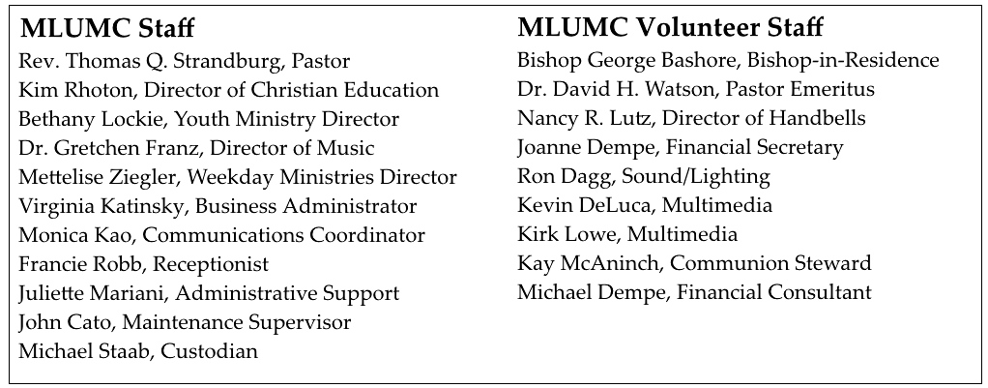

CALENDAR – SUNDAY, SEPTEMBER 11 THRU SATURDAY, SEPTEMBER 16

SUNDAY 9/11
8:30 am Worship Sanner Chapel
9:30 am Faith for Today Asbury Center
9:30 -10:30 am Kids’ Sunday School Room 204
9:30 – noon Nursery Room 204
10:45 am Worship Sanctuary
Kids Praise Welcome Center
12 pm Sunday School Teachers’ Meeting Welcome Center
1 pm Bus leaves for Flight 93 memorial Asbury Center

MONDAY 9/12
7 pm Chapel Bells Rehearsal Bell Room

TUESDAY 9/13
6 pm UMW dinner and meeting Asbury Center
7 pm Boy Scout Troop #23 Wesley Hall
7 pm Boy Scout Board of Reviews Room 105
7 pm Cub Scout Planning Epworth Chapel

WEDNESDAY 9/14
6 pm Homebuilders Picnic Wesley Hall
6:30 pm Wolf Cub Scout Pack Epworth
7 pm Education Committee Brookline Parlor
7:30 pm Finance Committee Wesley Hall

THURSDAY 9/15
9:30 am UMW Faith Circle Meeting Wesley Hall
11:30 am UMW Rebecca Circle Wesley Hall
6:30 pm Promise Bells Rehearsal Bell Room
7 pm Cub Scout Pack Wesley Hall
7:30 pm Chancel Choir Rehearsal Choir Room

SATURDAY 9/17
9 am UMW District Wesley /Asbury Kitchen
10 am Food Distribution Food Pantry

