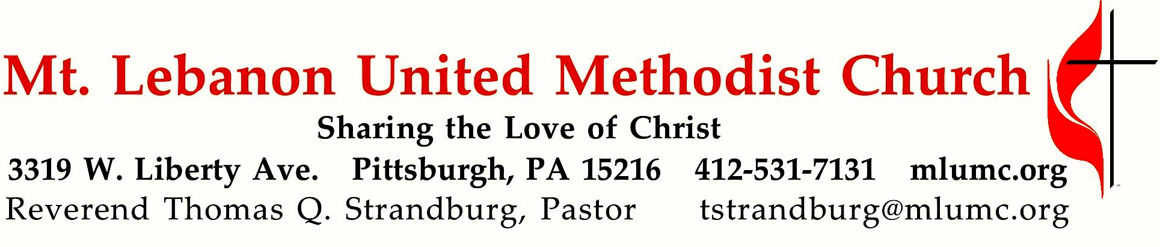
September 25, 2016 8:30 & 10:45

19th Sunday after Pentecost
The Apostle Paul advises his young co-worker Timothy, and all of us, to steer clear of greed and temptation, and to "take hold of what truly is life." Today, we consider that notion of living our own lives to the fullest.

WE GATHER IN GOD’S NAME …

Gathering Music
Hymn 351 Pass me not, O gentle Savior (stanzas 1 and 4, seated) Pass me not

Hymn 60 I'll praise my maker while I've breath (stanzas 2 and 3) Old 113th

Greeting
Leader: But I thank the Lord for his righteousness;
People: I will sing praises to the name of the Lord Most High.
Psalm 7:17 (CEB)

Announcements

Choral Introit 10:45 Psalm 68: 32 Richard C. Baker
Sing unto God ye kingdoms of the earth;
O sing praises unto our God.

Call to Worship
Pastor: You are the salt of the earth.
People: May we season the world with faithfulness, O God.
Pastor: You are the light of the world.
People: May your love shine through us, O Christ our Savior.
Pastor: You are a city built on a hill.
People: May your vigor make us bold witnesses, O Spirit of the living God.
From Worship & Song

… TO GIVE PRAISE TO GOD …

Hymn of Praise 60 I'll praise my maker while I've breath (standing) Old 113th

Opening Prayer (in unison, standing)
Glorious God, source of joy and righteousness, enable us as redeemed and forgiven children evermore to rejoice in singing your praises. Grant that what we sing with our lips we may believe in our hearts, and what we believe in our hearts we may practice in our lives; so that being doers of the Word and not hearers only, we may receive everlasting life; through Jesus Christ our Lord. Amen.
“A Prayer for True Singing” by Fred D. Gealy

… TO CELEBRATE THE FAMILY OF FAITH …

The Sign of Peace Please pass the peace to your neighbors as a sign of reconciliation and love.
Leader: The peace of Christ be with you.
People: And also with you.

Gathering Song James Ritchie
This, this is where children belong,
welcomed as part of the worshiping throng.
Water, God’s Word, bread and cup, prayer and song:
This is where children belong.
WORDS: James Ritchie MUSIC: James Ritchie ©1999 Abingdon Press

Message for Young Disciples Rev. Thomas Q. Strandburg
All children are invited. Please sing as children come forward. After the children’s message at the 10:45 service, children ages 3 - 3rd grade may attend Kids Praise in the Welcome Center. Children will be escorted to and from Kids Praise by teachers. They will return to the Sanctuary near the end of the service.

… TO HEAR GOD’S WORD PROCLAIMED …

Hymn of Adoration 189 Fairest Lord Jesus (seated) St. Elizabeth

Scripture Reading 8:30 Joeta D’Este
10:45 Clark Remington

A Lesson from the Epistles
1 Timothy 6:6-19 Warning about false teachers

Prayer Hymn 494 Kum ba yah (stanza 4, seated) Desmond
Someone needs you, Lord, Kum ba yah. (repeat 3 times)
Oh, Lord, kum ba yah!

Pastoral Prayer

The Lord’s Prayer
Our Father, who art in heaven, hallowed be thy name. Thy kingdom come, thy will be done, on earth as it is in heaven. Give us this day our daily bread. And forgive us our trespasses, as we forgive those who trespass against us. And lead us not into temptation, but deliver us from evil. For thine is the kingdom, and the power, and the glory forever. Amen.

Scripture Reading
A Lesson from the Gospels (standing)
Luke 16:19-31 The story of Lazarus and the rich man

Response
Leader: The Word of the Lord.
People: Thanks be to God.

… TO OFFER OUR GIFTS AND TO DEDICATE OUR LIVES …

Offertory Solo 8:30 I want Jesus to walk with me setting by John Carter

Anthem 10:45 H. P. Smith, arr. Tom Trenney
Mothering God, you gave me birth in the bright morning of this world.
Creator, source of every breath, you are my rain, my wind, my sun.
Mothering Christ, you took my form, offering me your food of light,
grain of life and grape of love, your very body for my peace.
Mothering Spirit, nurturing one, in arms of patience hold me close.
Hold me close so that in faith I root and grow, until I flower, until I know.

Doxology 94 (standing)
Praise God from whom all blessings flow;
Praise God, all creatures here below: Alleluia! Alleluia!
Praise God the source of all our gifts!
Praise Jesus Christ, whose power uplifts!
Praise the Spirit, Holy Spirit. Alleluia! Alleluia! Alleluia!

Prayer of Dedication

Sermon “Now That’s Living!” Rev. Thomas Q. Strandburg

… TO GO REJOICING IN GOD’S NAME!

Hymn of Commitment 580 Lead on, O King eternal (standing) Lancashire

Benediction

Today’s Services
The chancel flowers are given by Louanne Baily in honor and memory of loved ones.

The altar flower arrangement of red and white carnations is given by Margie Ehni in loving memory of her husband, James K. Ehni.

Special music at 10:45 is provided by the Chancel Choir with pianist Cori DeLuca, a member of the church who teaches piano in the area.

Our hymnal and the new hymnal supplement are rich resources. As we explore newer texts and tunes we will repeat them during the month so that we are more comfortable singing them.

Greeters 8:30 The Shoff family: Laura, Bradley, Emily and Evan 10:45 Gloria Barber

Worship options for children We encourage children to participate in the Children’s Sermon at both services, and in Kids Praise during the 10:45 service. Nursery services are offered in Room 204 of the Education Building. Ask ushers or greeters and follow signs for direction.

Podcasts of Sunday Sermons Would you like to share this morning’s sermon with a friend or did you miss a Sunday? Catch up on the messages from MLUMC with a podcast of Pastor Tom’s and others’ Sunday sermons. Sermons from the past three months are at
http:// mlumc.buzzsprout.com. You can navigate to the site from the link on our webpage, www.mlumc.org, through the app, Stitcher or through iTunes

Flower Donations Honor or remember a loved one or friend with a Sunday flower arrangement donation. Contact Sharon Slater, 412-343-1137.

Today’s Scriptures
1 Timothy 6:6-19
⁶Of course, there is great gain in godliness combined with contentment; ⁷for we brought nothing into the world, so that we can take nothing out of it; ⁸but if we have food and clothing, we will be content with these. ⁹But those who want to be rich fall into temptation and are trapped by many senseless and harmful desires that plunge people into ruin and destruction. ¹⁰For the love of money is a root of all kinds of evil, and in their eagerness to be rich some have wandered away from the faith and pierced themselves with many pains. ¹¹But as for you, man of God, shun all this; pursue righteousness, godliness, faith, love, endurance, gentleness. ¹²Fight the good fight of the faith; take hold of the eternal life, to which you were called and for which you made the good confession in the presence of many witnesses.

¹³In the presence of God, who gives life to all things, and of Christ Jesus, who in his testimony before Pontius Pilate made the good confession, I charge you ¹⁴to keep the commandment without spot or blame until the manifestation of our Lord Jesus Christ, ¹⁵which he will bring about at the right time—he who is the blessed and only Sovereign, the King of kings and Lord of lords. ¹⁶It is he alone who has immortality and dwells in unapproachable light, whom no one has ever seen or can see; to him be honor and eternal dominion. Amen. ¹⁷As for those who in the present age are rich, command them not to be haughty, or to set their hopes on the uncertainty of riches, but rather on God who richly provides us with everything for our enjoyment. ¹⁸They are to do good, to be rich in good works, generous, and ready to share, ¹⁹thus storing up for themselves the treasure of a good foundation for the future, so that they may take hold of the life that really is life.

Luke 16:19-31
¹⁹“There was a rich man who was dressed in purple and fine linen and who feasted sumptuously every day. ²⁰And at his gate lay a poor man named Lazarus, covered with sores, ²¹who longed to satisfy his hunger with what fell from the rich man’s table; even the dogs would come and lick his sores. ²²The poor man died and was carried away by the angels to be with Abraham. The rich man also died and was buried. ²³In Hades, where he was being tormented, he looked up and saw Abraham far away with Lazarus by his side. ²⁴He called out, ‘Father Abraham, have mercy on me, and send Lazarus to dip the tip of his finger in water and cool my tongue; for I am in agony in these flames.’ ²⁵But Abraham said, ‘Child, remember that during your lifetime you received your good things, and Lazarus in like manner evil things; but now he is comforted here, and you are in agony. ²⁶Besides all this, between you and us a great chasm has been fixed, so that those who might want to pass from here to you cannot do so, and no one can cross from there to us.’ ²⁷He said, ‘Then, father, I beg you to send him to my father’s house— ²⁸for I have five brothers—that he may warn them, so that they will not also come into this place of torment.’ ²⁹Abraham replied, ‘They have Moses and the prophets; they should listen to them.’ ³⁰He said, ‘No, father Abraham; but if someone goes to them from the dead, they will repent.’ ³¹He said to him, ‘If they do not listen to Moses and the prophets, neither will they be convinced even if someone rises from the dead.’”

Keep in Prayer
Hospitalized
John White, Mercy

Convalescing in Care Facilities
Leila Berkey, Asbury Heights
Jean Bouvy, McMurray Hills Manor
Ed Clarke, Asbury Place
Pat Seitz, Concordia
Tim Watters, Baptist Home

Convalescing at Home
Robert Fairgrieve, Tommilea Giegel,
Earl Killian, Andy Smith

In the Military

Jason Boyer, SPC Natalie Brown

Capt. Zachary Allen Finch, USMC
James Iantelli, 1st Lt. Jaskiewicz
S. Sgt. Keith Kimmell, Adam Kmick
PFC Brendan Lamport
Sgt. Matthew McConahan, Thomas Orda
Lt. Col. Mark Patterson

Lt. Com. Scott Patterson

Lt. Col. Sean Patterson
David Poncel, Sgt. Steven Reitz
Capt. Scott B. Rushe, Pastor Rick Townes
Capt. Azizi Wesmiller

Capt. Matthew C. Wesmiller
Sgt. Keith Scott Winkowski

Sgt. Michael Zimmerman

Looking to send a card? Here are some helpful addresses:

Asbury Heights
700 Bower Hill Road
Pittsburgh, PA 15243

McMurray Hills Manor
249 W McMurray Road
McMurray, PA 15317

Concordia Health Center
1300 Bower Hill Road
Pittsburgh, PA 15243

Baptist Homes

489 Castle Shannon Blvd.

Pittsburgh, PA 15234

Hoyt Leon Hickman
May 1927 – September 2016

Rev. Hoyt Leon Hickman of Los Altos, CA, was born in Pittsburgh to Leon and Mayme Hoyt Hickman and raised in Mt. Lebanon. He was a United Methodist minister, author and recognized authority on worship and liturgical traditions. He died at age 89 earlier this month. Growing up, he and his family were members of this church. He was a graduate of Haverford College, Yale Divinity School and Union Theological Seminary.

As a pastor in the Western PA conference, Hoyt served churches in Windber, Claysville, Beaver Falls, and Erie. As Director of Worship Resource Development for the General Board of Discipleship, he played a pivotal role in developing hymnals, services, and other resources which continue to be used throughout the world. He wrote many of the worship texts that appear in the United Methodist Hymnal and Book of Worship, and is the General Editor of "The Faith We Sing." Hoyt loved teaching and scholarship as well, and wrote a number of published books on Methodist liturgy and worship and was a visiting professor of worship both at Drew University and at Vanderbilt University.

Rev. Hoyt’s family has suggested that memorial donations be made to his Nashville church, The Edgehill United Methodist Church, and perhaps in acknowledgement of his western PA United Methodist roots, to Jumonville Camp and Retreat Center.

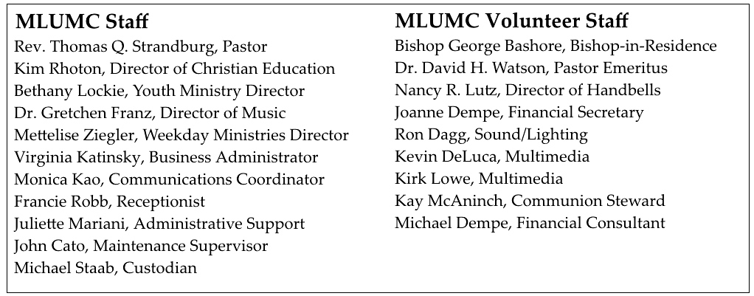

CALENDAR – SUNDAY, SEPTEMBER 25 THRU SATURDAY, OCTOBER 1

SUNDAY 9/25
8:30 am Worship Sanner Chapel
9:30 am Sunday School for All Ages/Coffee Café Various/Brookline Parlor
10:45 am Worship Sanctuary
Kids Praise Welcome Center
12 noon DIA Meeting Welcome Center
5 pm Youth Group Discussion Asbury Center
7 pm Boy Scout Patrol Leaders Room 105

MONDAY 9/26
7 pm Chapel Bells Rehearsal Bell Room

TUESDAY 9/27
6 pm Terrific Tuesday Asbury Center
7 pm Boy Scout Board of Reviews Room 105
7 pm Boy Scout Troop #23 Wesley Hall

WEDNESDAY 9/28
6 pm Homebuilders Picnic Wesley Hall
6:30 pm Wolf Cub Scout Epworth
7 pm Trustees Parsonage

THURSDAY 9/29
6:30 pm Promise Bells Rehearsal Bell Room
7:30 pm Chancel Choir Rehearsal Choir Room

FRIDAY 9/30
9:30 am Women’s Bible Study Room 102

SATURDAY 10/1
10 am Food Distribution Food Pantry
4 pm Family Fall Festival Parking Lot/Asbury Center

