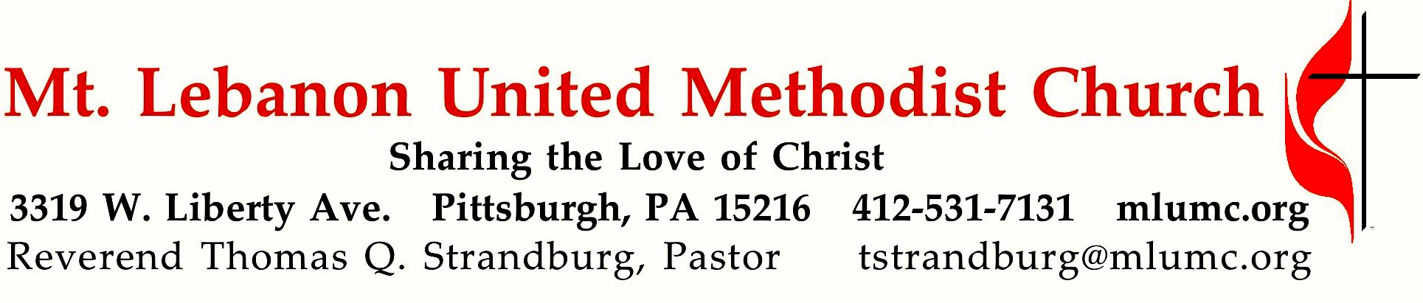
October 16, 2016 Laity Sunday 8:30 & 10:45

WE GATHER IN GOD’S NAME …

Gathering Music
Hymn 395 Take time to be holy (stanzas 1, 2 and 4, seated) Holiness
Hymn 441 What does the Lord require (stanzas 1-3) Sharpthorne

Greeting Robert Mallery
Leader: Enter His gates with thanksgiving and His courts with praise.
People: Give thanks to Him and bless His name, for the Lord is good.
Leader: His loving kindness is everlasting, and His faithfulness to all generations.

Welcome and Announcements

… TO GIVE PRAISE TO GOD …

Prayer of Illumination 8:30 Robert Mallery 10:45 Linda Minnotte
Leader: O Lord, we bless your name, your holy name, pouring out our songs and our lives before you.
People: We thank you for the privilege of gathering together before you, standing before your throne, as your people, your church, and by Your Word made flesh, set free from the power of sin and death. We bless your name, O God!
Leader: Holy Spirit, now move among us through the words you have inspired, and the testimonies of our lives. Move among us, and help us remember who we are, your church, gathered from people of every age, in every tribe, every nation, every language and every culture, and made one people together in Jesus Christ, our Lord.
People: Amen.

Hymn of Praise 558 We are the church (stanzas 1-3, standing) Port Jervis

Invitation to Thanksgiving and Confession 8:30 Cindy Biery
10:45 Cleon and Vera Jane Cornes
Leader: We will go, Lord, into the world, telling and retelling the story with other believers, taking the gospel and making disciples among all the peoples with whom we come in contact. We will go, knowing you will be with us.
You, O God, to whom we would in these moments, pour out our lives in service and in thanksgiving.
But we know the barriers that stand in our way.
We cannot pour ourselves out to you fully as individuals with unconfessed sin in our lives. We cannot pour ourselves out to you fully as your body when we are in conflict with others.
So hear our confession, forgive and deliver us, and give us courage to offer your peace to one another.
Leader: We have sinned against you and each other, Lord.
We have not lived worshipfully.
People: Lord, in your mercy, hear our confession. (Silence)
Leader: We have not loved you wholly. We have not loved our neighbors as ourselves. We have not lived worshipfully.
People: Lord, in your mercy, hear our confession. (Silence)
Leader: We have not denied ourselves and taken up our own cross daily.
We have not lived worshipfully.
People: Lord, in your mercy, hear our confession. (Silence)
Leader: We have not loved kindness, pursued justice, or walked humbly with you. We have not lived worshipfully.
People: Lord, in your mercy, hear our confession. (Silence)
Leader: We have not shared the good news with our lips or in our lives.
We have not lived worshipfully.
People: Lord, in your mercy, hear our confession (Silence)
Leader: The saying is sure: If we confess our sins, God is merciful and just and forgives us our sins, and cleanses us from all unrighteousness.
In the name of Christ, we are forgiven.

… TO CELEBRATE THE FAMILY OF FAITH …

The Sign of Peace Please pass the peace to your neighbors as a sign of reconciliation and love.
Leader: As forgiven and reconciled people, share Christ’s peace with one another The peace of Christ be always with you.
People: And also with you.

Gathering Song James Ritchie
This, this is where children belong,
welcomed as part of the worshiping throng.
Water, God’s Word, bread and cup, prayer and song:
This is where children belong.
WORDS AND MUSIC: James Ritchie ©1999 Abingdon Press

Message for Young Disciples
All children are invited. Please sing as children come forward. After the children’s message at the 10:45 service, children ages 3 - 3rd grade may attend Kids Praise in the Welcome Center. Children will be escorted to and from Kids Praise by teachers. They will return to the Sanctuary near the end of the service.

… TO OFFER OUR GIFTS AND TO DEDICATE OUR LIVES …

Offertory 8:30 Cindy Biery 10:45 Stacey Rosleck
Leader: Forgiven and reconciled to God and one another, let us offer our gifts and our thanks to God!

Offertory Solo 8:30 It is well with my soul setting by J. Bert Carlson

Offertory Anthem 10:45 Spiritual, arr. Paul Sjolund
Kumbaya, my Lord, Kumbaya.
1. Someone's prayin', Lord, Kumbaya 2. Someone's cryin', Lord, Kumbaya.
3. Someone's singin', Lord, Kumbaya 4. Sing alleluia, Lord!

Offertory Prayer

… TO HEAR GOD’S WORD PROCLAIMED …

1. Worship as Love - To put the love of God and neighbor above all else
Scripture: Matthew 22: 37-39 Sally Munro
³⁷He said to him, “’You shall love the Lord your God with all your heart, and with all your soul, and with all your mind.’ ³⁸This is the greatest and first commandment. ³⁹And a second is like it: ‘You shall love your neighbor as yourself.’
Testimony Kathy Michael
Hymn 549 Where charity and love prevail St. Peter
1. (Read) Where charity and love prevail, there God is ever found;
brought here together by Christ's love are we thus bound.
2. (Sing) With grateful joy and holy fear true charity we learn;
let us with heart and mind and strength now love Christ in return.

2. Worship as Discipline – To embody God’s love individually
Scripture: Matthew 16:24
²⁴Then Jesus told his disciples, “If any want to become my followers, let them deny themselves and take up their cross and follow me.
Testimony Clark Remington
Hymn 415 Take up thy cross Germany
1. "Take up thy cross," the Savior said, "if thou wouldst my disciple be;
deny thyself, the world forsake, and humbly follow after me."

3. Worship Calls Us to Justice – To live God’s love through our actions
Scripture: Micah 6:8
⁸He has told you, O mortal, what is good; and what does the Lord require of you but to do justice, and to love kindness, and to walk humbly with your God?
Testimony Sara Mercer
Hymn 441 What does the Lord require Sharpthorne
1. What does the Lord require for praise and offering?
What sacrifice, desire, or tribute bid you bring?
Do justly; love mercy; walk humbly with your God.

4. Worship Calls Us to Evangelism - To go and take God’s love into the world
Scripture: Matthew 28:19-20
¹⁹Go therefore and make disciples of all nations, baptizing them in the name of the Father and of the Son and of the Holy Spirit, ²⁰and teaching them to obey everything that I have commanded you. And remember, I am with you always, to the end of the age.”
Testimony Kirk Lowe

… TO GO REJOICING IN GOD’S NAME!

Hymn of Commitment 571 Go, make of all disciples Lancashire

Blessing and Benediction
Leader: Go out into the world, denying yourself, and proclaim God’s love, justice, and good news in all that you say and do.
People: May the God of steadfastness and encouragement grant us to live in such harmony with one another, in accord with Christ Jesus, that together we may with one voice glorify the God and Father of our Lord Jesus Christ. Amen. Romans 15:5-6

Today’s Services
The chancel flowers are given by Mary Birks in loving memory of her husband Neil. Today would have been his 81st birthday.

The flowers on the altar are given in celebration of Rob and Jane Spicher’s anniversary.

Special music at 10:45 is provided by the Chancel Choir.

Our hymnal and the new hymnal supplement are rich resources. As we explore newer texts and tunes we will repeat them during the month so that we are more comfortable singing them.

Greeters 8:30 Ron Dagg 10:45 David and Barbara Watson

Acolytes Lydia Slater and Anna Rhoton

Worship options for children We encourage children to participate in the Children’s Sermon at both services, and in Kids Praise during the 10:45 service. Nursery services are offered in Room 204 of the Education Building. Ask ushers or greeters and follow signs for direction.

Podcasts of Sunday Sermons Would you like to share this morning’s sermon with a friend or did you miss a Sunday? Catch up on the messages from MLUMC with a podcast of Pastor Tom’s and others’ Sunday sermons. Sermons from the past three months are at
http:// mlumc.buzzsprout.com. You can navigate to the site from the link on our webpage, www.mlumc.org, through the app, Stitcher or through iTunes

Flower Donations Honor or remember a loved one or friend with a Sunday flower arrangement donation. Contact Sharon Slater, 412-343-1137.

Keep in Prayer
Hospitalized
Earl Killian, Montefiore

Convalescing in Care Facilities
Leila Berkey, Asbury Heights
Jean Bouvy, McMurray Hills Manor
Ed Clarke, Asbury Place
Pat Seitz, Concordia
Tim Watters, Baptist Home

Convalescing at Home
Andy Smith, Arlene Stewart

In the Military

Jason Boyer, SPC Natalie Brown

Capt. Zachary Allen Finch, USMC
James Iantelli, 1st Lt. Jaskiewicz
S. Sgt. Keith Kimmell, Adam Kmick
PFC Brendan Lamport
Sgt. Matthew McConahan, Thomas Orda
Lt. Col. Mark Patterson

Lt. Com. Scott Patterson

Lt. Col. Sean Patterson
David Poncel, Sgt. Steven Reitz
Capt. Scott B. Rushe, Pastor Rick Townes
Capt. Azizi Wesmiller

Capt. Matthew C. Wesmiller
Sgt. Keith Scott Winkowski

Sgt. Michael Zimmerman

Looking to send a card? Here are some helpful addresses:

UPMC Montefiore Hospital
3459 Fifth Ave.
Pittsburgh, PA 15213

Asbury Heights
700 Bower Hill Road
Pittsburgh, PA 15243

McMurray Hills Manor
249 W McMurray Road
McMurray, PA 15317

Concordia Health Center
1300 Bower Hill Road
Pittsburgh, PA 15243

Baptist Homes

489 Castle Shannon Blvd.

Pittsburgh, PA 15234

Birthday Greetings

Esther Davis will be 105 years old on October 20. Birthday wishes can be sent to:

Esther Davis

Fair Oaks #403

2200 W. Liberty Ave.

Pittsburgh, PA 15226

Family Promise, a nationwide partnership providing temporary homeless families a place to stay, is staying at our church this week. Our guests are here for evenings and overnight, starting today, Sun. Oct. 16 to next Sunday, Oct. 23. Volunteers are needed to drive a van, prepare meals, host at the church on evenings and overnight and prepare the rooms. Help create a sanctuary for children and parents in need. For more information, contact Hazel Cope, 412-343-7998 or hazelcope1505@gmail.com.

Welcome our new Bishop The Western PA Conference of the UMC is inviting all to the Service of Welcome and Celebration for Bishop Cynthia Moore-Koikoi, on Saturday, Oct. 22 at the Crossfire Campus of the First UMC of Butler. It's at 1802 N. Main St. Ext., Butler, PA 16001 (the corner of Route 8 N and Mercer Road). Childcare for children ages 6 weeks to 5 years is available by reservation. Email the number of children and their ages to bmcneish@butlerfumc.com by October 19.

Holiday Poll Last week a Holiday Poll was distributed during services in order to gather church goers’ opinions on service times for the upcoming holiday season. As you may be aware, both Christmas Day and New Year's Day fall on Sunday this year. Your opinion helps the church maximize attendance on both of these special Sundays. If you did not receive or fill out a poll last Sunday, you can get the poll in the narthex of the sanctuary and at the entrance to Sanner Chapel.

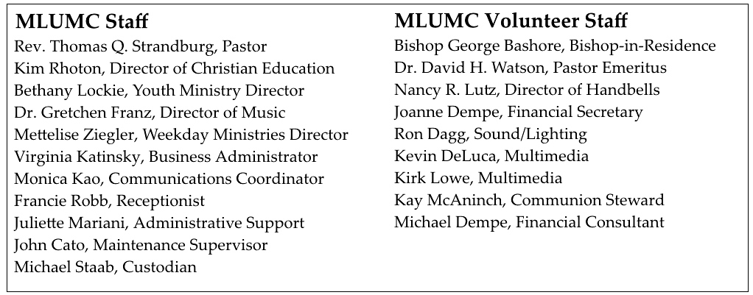

CALENDAR – SUNDAY, OCTOBER 16 THRU SATURDAY, OCTOBER 22
Family Promise Week 10/16 through 10/23

SUNDAY 10/16
8:30 am Worship Sanner Chapel
9:30 am Sunday School for All Ages/Coffee Café Various/Brookline Parlor
10:45 am Worship Sanctuary
Kids Praise Welcome Center
12:30 pm Youth Group leaves for Trax Farms Asbury Center
4:30 pm Youth Choir Choir Room
6:30 pm BSA Eagle Board Review Various

MONDAY 10/17
7 pm Chapel Bells Rehearsal Asbury
7:30 pm Community Events and Outreach Welcome Center

TUESDAY 10/18
6 pm Terrific Tuesday Asbury Center
7 pm Boy Scout Troop #23 Wesley Hall

WEDNESDAY 10/19
7 pm Koinonia UMW Welcome Center
7 pm Church Council Mixers

THURSDAY 10/20
9:30 am UMW Esther Circle Providence Point
9:30 am UMW Circle Faith Wesley Hall
11:30 am UMW Rebecca Welcome Center
6:30 pm Promise Bells Rehearsal Bell Room
7 pm Cub Scout Pack Meeting Welcome Center
7:30 pm Chancel Choir Rehearsal Choir Room

FRIDAY 10/21
9:30 am Women’s Bible Study Room 102

