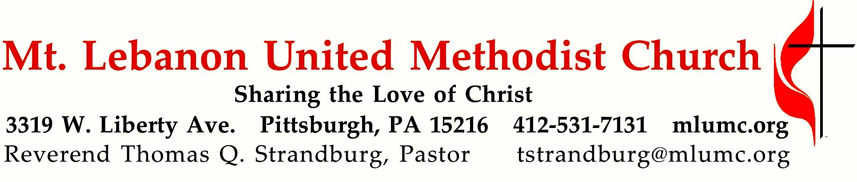

November 20, 2016 8:30 & 10:45
Christ the King Sunday

While human rulers often disappoint us, God’s reign is always faithful. Those who are entrenched in this world cannot see it, but everyone who belongs to the Way listens to the voice of Christ, their king. Ultimately, all human rulers fail us. Christ alone is our rightful king and sovereign.

WE GATHER IN GOD’S NAME …
Gathering Music
Hymn 694 Come, ye thankful people, come (stanzas 1-2, seated) St. George’s Windsor
Hymn 97 For the fruits of this creation (stanzas 1-2) East Acklam
Greeting
Leader: Give thanks to the Lord because he is good!
People: God’s faithful love lasts forever. Psalm 136:1 (CEB)

Announcements

Choral Introit 10:45 Psalm 103: 1 Richard C. Baker
Bless the Lord O my soul and all that is within me bless God’s Holy Name

Call to Worship
Leader: Christ has come to be our king.
People: We have come to be Christ’s people.
Leader: Clothed in righteousness, Christ has come to save us.
People: Let the faithful shout for joy.
Leader: Like the sun rising on a cloudless morning, Christ disperses the darkness with justice and mercy.
People: Worship the prince of peace.
The Abingdon Worship Annual

… TO GIVE PRAISE TO GOD …

Hymn of Praise 168 At the name of Jesus (standing) King’s Weston

Opening Prayer (in unison, standing)
O God, with grace and peace, you clothe your people in the garments of salvation. Open our eyes, that we may behold your glory, and witness your Son coming with the clouds, to rule with justice and righteousness. Open our ears that we may hear his voice calling us to shine like dew on the grass. Open our hearts, that we may love as he loves, and live as he lives. Amen.

… TO CELEBRATE THE FAMILY OF FAITH …

Sacrament of Baptism 10:45 Baptismal Covenant II, UM Hymnal #39 Ellison Anne Hall, daughter of Joshua and Cassi Hall
Godparents, Michael and Amy D’Amico

Pastor: Will you nurture one another in the Christian faith and life
and include Ellison Anne now before you in your care?

People: With God’s help we will proclaim the good news
and live according to the example of Christ.
We will surround Ellison Anne
with a community of love and forgiveness,
that she may grow in his service to others.
We will pray for her that she may be a true disciple
who walks in a way that leads to life.

Third Grade Bible Presentation
Addison Alexander, Julie Aneja, Samantha Kelly

The Sign of Peace Please pass the peace to your neighbors as a sign of reconciliation and love.
Leader: The peace of Christ be with you.
People: And also with you.

Gathering Song James Ritchie
This, this is where children belong,
welcomed as part of the worshiping throng.
Water, God’s Word, bread and cup, prayer and song:
This is where children belong.
WORDS: James Ritchie MUSIC: James Ritchie ©1999 Abingdon Press

Message for Young Disciples Rev. Thomas Q. Strandburg
(All children are invited. Please sing as children come forward.)
After the children’s message at the 10:45 service, children ages 3 through 3rd grade may attend Kids Praise in the Welcome Center. Children will be escorted to and from Kids Praise by teachers. They will return to the Sanctuary near the end of the service, and parents may meet them.

… TO HEAR GOD’S WORD PROCLAIMED …

Hymn 162 8:30 Alleluia, alleluia (seated) Alleluia No. 1

Anthem 10:45 Michael Barrett
I will give jubilant thanks to the Lord. I will be glad in the things God has done.
I will give jubilant thanks to the Lord, to God the ever glorious One.
All glory and honor belong to God, I will rejoice and rejoice again.
I will give jubilant thanks to the Lord. I will give jubilant thanks.
For the beauty of the earth, for the glory of the skies, for the joy which from our birth,
over and around us lies. Christ our God to Thee we raise this our hymn of grateful praise.
I will bring jubilant praise to the Lord. I will give thanks to the Lord most high.
I will bring jubilant praise to the Lord. Rejoice and lift my voice to the sky.
For God is the giver of all good things, I will rejoice, let God's praises ring.
I will give jubilant thanks to the Lord. I will give jubilant praise.
I will give honor and glory and blessings and jubilant thanks to the Lord.

Scripture Reading 8:30 Scott Miller 10:45 Jacob Dale
A Lesson from the New Testament
Colossians 1:11-20 The supremacy of Christ

Pastoral Prayer

The Lord’s Prayer
Our Father, who art in heaven, hallowed be thy name. Thy kingdom come, thy will be done, on earth as it is in heaven. Give us this day our daily bread. And forgive us our trespasses, as we forgive those who trespass against us. And lead us not into temptation, but deliver us from evil. For thine is the kingdom, and the power, and the glory forever. Amen.

Scripture Reading
A Lesson from the Gospel (standing)
Luke 23:33-43 The Crucifixion

Response
Leader: The Word of the Lord.
People: Thanks be to God.

… TO OFFER OUR GIFTS AND TO DEDICATE OUR LIVES …

Stewardship Moment Mr. Jim Young

Offertory Solo 8:30 Blessed assurance setting by John Carter

Anthem 10:45 Delores Dufner, OSB, text; Thomas Keesecker, music
In Christ we come to offer thanks with mind and voice in harmony,
to praise the ageless God of time for life in this community.
O God of seasons' ebb and flow; in Christian life, in work and prayer,
in joyful hope we seek your face and daily find you everywhere.
For Faithful Love in ages past, believers holy, kind and strong,
for sacred story, sacred place, we lift our hearts in festive song.
For Gracious Presence with us still, for family, stranger, guest, and friend,
for ministry and mission shared: we sing of blessings without end.
Transforming Light of future years, empower us now to run the race,
our hearts expanded to proclaim that all is gift and all is grace.

Doxology 94
Praise God from whom all blessings flow;
Praise God, all creatures here below: Alleluia! Alleluia!
Praise God the source of all our gifts!
Praise Jesus Christ, whose power uplifts!
Praise the Spirit, Holy Spirit. Alleluia! Alleluia! Alleluia!

Prayer of Dedication

Sermon “Christ Our Center” Rev. Thomas Q. Strandburg

… TO GO REJOICING IN GOD’S NAME!

Hymn 144 This is my Father’s world (standing) Terra Beata

Benediction

Today’s Services

The flowers in the Chancel are given in loving memory of Joseph Utzig by Priscilla and family.

Special music at 10:45 is provided the Youth Choir and the Chancel Choir, with soloist John Esaias, directed by Nancy R. Lutz. The addition of Josh Boudreau, trumpeter, is made possible through contributions to the Friends of Music Fund. Donations are always welcome.
Greeters 8:30 Erma Henry 10:45 John and Shirley Baker

Acolytes Anna Rhoton and Anastasia Sunder

Worship options for children We encourage children to participate in the Children’s Sermon at both services, and in Kids Praise during the 10:45 service. Nursery services are offered in Room 204 of the Education Building. Ask ushers or greeters and follow signs for direction.

Podcasts of Sunday Sermons Would you like to share this morning’s sermon with a friend or did you miss a Sunday? Catch up on the messages from MLUMC with a podcast of Pastor Tom’s and others’ Sunday sermons. Sermons from the past three months are at http:// mlumc.buzzsprout.com. You can navigate to the site from the link on our webpage, www.mlumc.org, through the app, Stitcher or through iTunes.

Flower Donations Honor or remember a loved one or friend with a Sunday flower arrangement donation. Contact Sharon Slater, 412-343-1137

Today’s Scriptures

Colossians 1:11-20
¹¹May you be made strong with all the strength that comes from his glorious power, and may you be prepared to endure everything with patience, while joyfully¹²giving thanks to the Father, who has enabled you to share in the inheritance of the saints in the light. ¹³He has rescued us from the power of darkness and transferred us into the kingdom of his beloved Son, ¹⁴in whom we have redemption, the forgiveness of sins. ¹⁵He is the image of the invisible God, the firstborn of all creation; ¹⁶for in him all things in heaven and on earth were created, things visible and invisible, whether thrones or dominions or rulers or powers—all things have been created through him and for him. ¹⁷He himself is before all things, and in him all things hold together. ¹⁸He is the head of the body, the church; he is the beginning, the firstborn from the dead, so that he might come to have first place in everything. ¹⁹For in him all the fullness of God was pleased to dwell, ²⁰and through him God was pleased to reconcile to himself all things, whether on earth or in heaven, by making peace through the blood of his cross.

Luke 23:33-43
³³When they came to the place that is called The Skull, they crucified Jesus there with the criminals, one on his right and one on his left. ³⁴Then Jesus said, “Father, forgive them; for they do not know what they are doing.” And they cast lots to divide his clothing. ³⁵And the people stood by, watching; but the leaders scoffed at him, saying, “He saved others; let him save himself if he is the Messiah of God, his chosen one!” ³⁶The soldiers also mocked him, coming up and offering him sour wine, ³⁷and saying, “If you are the King of the Jews, save yourself!” ³⁸There was also an inscription over him, “This is the King of the Jews.” ³⁹One of the criminals who were hanged there kept deriding him and saying, “Are you not the Messiah? Save yourself and us!” ⁴⁰But the other rebuked him, saying, “Do you not fear God, since you are under the same sentence of condemnation? ⁴¹And we indeed have been condemned justly, for we are getting what we deserve for our deeds, but this man has done nothing wrong.” ⁴²Then he said, “Jesus, remember me when you come into your kingdom.” ⁴³He replied, “Truly I tell you, today you will be with me in Paradise.”

Condolences to the family of church member Gwen Lammert, who passed away Wednesday morning, November 16, 2016. The Lammert family is inviting everyone to a memorial reception today in Wesley Hall, honoring the life of Gwen. It takes place following the 10:45 service.

Keep in Prayer

Convalescing in Care Facilities
Leila Berkey, Asbury Heights
Ed Clarke, Asbury Place
May Fredericks, Concordia Health Care
Susan Lichtenfels
Pat Seitz, Concordia Health Care
Andy Smith, Concordia Health Care
Tim Watters, Baptist Homes

Convalescing at Home
Anne Hoffman, Earl Killian, Arlene Stewart

In the Military

Jason Boyer, SPC Natalie Brown

Capt. Zachary Allen Finch, USMC
James Iantelli, 1st Lt. Jaskiewicz

S. Sgt. Keith Kimmell, Adam Kmick
PFC Brendan Lamport

Sgt. Matthew McConahan, Thomas Orda
Lt. Col. Mark Patterson

Lt. Com. Scott Patterson

Lt. Col. Sean Patterson
David Poncel, Sgt. Steven Reitz
Capt. Scott B. Rushe, Pastor Rick Townes
Capt. Azizi Wesmiller

Capt. Matthew C. Wesmiller
Sgt. Keith Scott Winkowski

Sgt. Michael Zimmerman

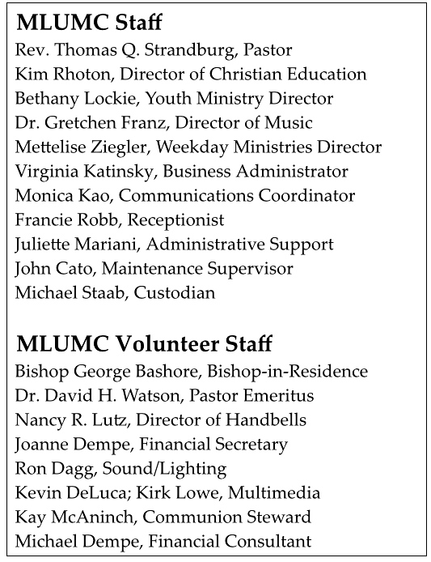

CALENDAR – SUNDAY, NOVEMBER 20 THRU SATURDAY, NOVEMBER2 6

SUNDAY 11/20
8:30 am Worship Sanner Chapel
9:30 am Sunday School for All Ages/Coffee Café Various/Brookline Parlor
10:45 am Worship Sanctuary
Kids Praise Welcome Center
12 pm Gwen Lammert Memorial Reception Wesley Hall
12 pm DIA Meeting Asbury Center
4:30 pm Youth Choir Choir Room
4 pm Boy Scout Eagle Court Asbury Center
5 pm Youth Group Youth Room
6 pm Contemporary Service Sanner Chapel

MONDAY 11/21 THANKSGIVING MEAL PREP – Asbury Center/Kitchen
7 pm Chapel Bells Rehearsal Bell Room
7 pm German Class Welcome Center
7:30 pm Community Events & Outreach Wesley Hall

TUESDAY 11/22 THANKSGIVING MEAL PREP – Asbury Center/Kitchen
7 pm Boy Scout Troop #23 Wesley Hall
7 pm Boy Scout Board of Reviews Room 105

WEDNESDAY 11/23 THANKSGIVING MEAL PREP – Asbury Center/Kitchen

THURSDAY 11/24 THANKSGIVING – OFFICE CLOSED
10 am Thanksgiving Meal Prep and Delivery Asbury Center/Kitchen

FRIDAY 11/25 OFFICE CLOSED

