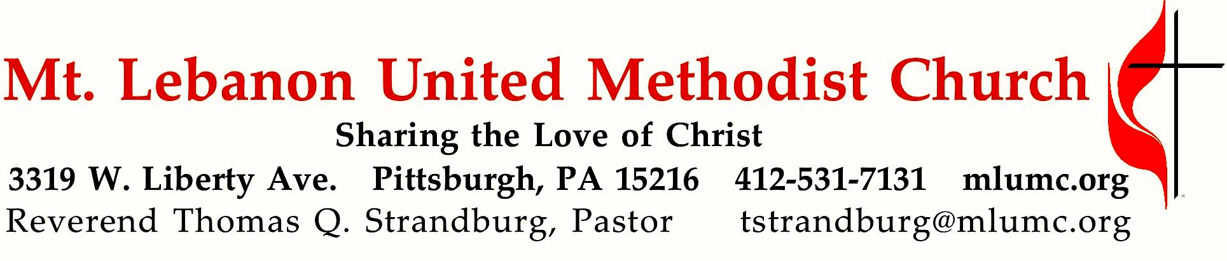

November 27, 2016 8:30 & 10:45
1st Sunday of Advent

Advent is a season of waiting and watching – a time of being alert and believing in the fulfillment of prophecy. The Promised One is coming. Stay alert and watch!

WE GATHER IN GOD’S NAME …
Gathering Music
Hymnal 204 Emmanuel, Emmanuel (seated) McGee
Hymnal 233 Cold December flies away (stanzas 1, 2) Lo Desembre congelat
Worship & Song 3145 Breath of God, Breath of peace (stanza 1*) Patterns

Greeting
Leader: Sing to the Lord a new song! Sing to the Lord, all the earth!
People: Declare God’s glory among the nations; declare his wondrous works among all people. Psalm 96:1, 3

Announcements

Choral Introit 10:45 Prepare ye the way Hart Morris
Prepare ye the way of the Lord! Make straight a highway for our God

Call to Worship
Leader: The days are coming when God will fulfill the promise made to our ancestors.
People: A righteous branch of David’s lineage shall come forth.
Leader: There will be justice and righteousness in the land.
People: This is our salvation.
Leader: Let us worship the God of promises and signs, with eyes to see the signs of God’s promises.
The Abingdon Worship Annual

… TO GIVE PRAISE TO GOD …

Hymn of Praise 196 Come, thou long-expected Jesus (standing) Hyfrydol

Opening Prayer (in unison, standing)
O God, the times and signs are confusing. During this time of worship, help us know your ways, and see clearly the coming of the Promised One. Lead us in your truth and teach us. For we wait with hopeful expectation: to see, to know, to believe. To you we lift our souls in trust and love, knowing you will hold them in your loving hands. Amen.

… TO CELEBRATE THE FAMILY OF FAITH …

Lighting of the Advent Wreath The Angels’ Message: Hear Joel Raney
8:30 Jane and Rob Spicher
10:45 Sharon, Noel, Juliana and Lydia Slater

Reader: Advent is a time to hear again of God’s redeeming work
People: Give us ears, O Lord, and help us to hear.
Reader: Advent is a time to hear again of God’s reconciling love.
People: Give us ears, O Lord, and help us to hear.
Reader: Advent is a time to hear again of God’s unmerited grace.
People: Give us ears, O Lord, and help us to hear.
Reader: Advent is a time to hear again of our ultimate hope.
People: Give us ears, O Lord, and help us to hear.

(Lighting of the Candle)

Sung Response: Listen to the angels, hear the message they bring;
Telling the news of a coming King;
filling the world with hope and good cheer.
Jesus, Emmanuel, God is near.
Closing Prayer

The Sign of Peace Please pass the peace to your neighbors as a sign of reconciliation and love.
Leader: The peace of Christ be with you.
People: And also with you.

Gathering Song James Ritchie
This, this is where children belong,
welcomed as part of the worshiping throng.
Water, God’s Word, bread and cup, prayer and song:
This is where children belong.
WORDS AND MUSIC: James Ritchie ©1999 Abingdon Press

Message for Young Disciples Rev. Thomas Q. Strandburg
(All children are invited. Please sing as children come forward.)
After the children’s message at the 10:45 service, children ages 3 through 3rd grade may attend Kids Praise in the Welcome Center. Children will be escorted to and from Kids Praise by teachers. They will return to the Sanctuary near the end of the service, and parents may meet them.

… TO HEAR GOD’S WORD PROCLAIMED …

Hymnal 719 My Lord, what a morning (seated) Burleigh

Scripture Reading Chris Murray 8:30 Nate Jara 10:45
A Lesson from the New Testament
Romans 13:11-14 The day is near

Worship & Song 3145 Breath of God, Breath of peace (stanza 1, seated) Patterns
*Breath of God, Breath of peace, Breath of love, Breath of life, Breath of justice,
Breath of passion, Breath creating, Breath of healing, Breath of singing, Breath of praying,
Come upon us, come restore us, come inspire us, Breath of God.

Pastoral Prayer

The Lord’s Prayer
Our Father, who art in heaven, hallowed be thy name. Thy kingdom come, thy will be done, on earth as it is in heaven. Give us this day our daily bread. And forgive us our trespasses, as we forgive those who trespass against us. And lead us not into temptation, but deliver us from evil. For thine is the kingdom, and the power, and the glory forever. Amen.

Scripture Reading
A Lesson from the Gospel (standing)
Matthew 24:36-44 Day and hour

Response
Leader: The Word of the Lord.
People: Thanks be to God.
… TO OFFER OUR GIFTS AND TO DEDICATE OUR LIVES …

Offertory Solo 8:30 O come, O come, Emmanuel setting by Hiram Titus

Offertory Anthem 10:45 arranged by John Ferguson ‘Comfort, comfort, now my people; tell of peace!’ so says our God.
Comfort those who sit in darkness mourning under sorrow’s load.
To God’s people now proclaim that God’s pardon waits for them!
Tell them that their war is over; God will reign in peace forever!
For the herald’s voice is crying in the desert far and near,
calling us to true repentance, since the Kingdom now is here.
Oh, that warning cry obey! Now prepare for God away!
Let the valleys rise to meet him and the hills bow down to greet him!
Straight shall be what long was crooked, and the rougher places plain!
Let your hearts be true and humble, as befits his holy reign!
For the glory of the Lord now on earth is shed abroad,
and all flesh shall see the token that God’s word is never broken.

Doxology 94
Praise God from whom all blessings flow;
Praise God, all creatures here below: Alleluia! Alleluia!
Praise God the source of all our gifts!
Praise Jesus Christ, whose power uplifts!
Praise the Spirit, Holy Spirit. Alleluia! Alleluia! Alleluia!

Prayer of Dedication

Sermon “Managing Un-expectations” Rev. Thomas Q. Strandburg

… TO GO REJOICING IN GOD’S NAME!

Hymn of Commitment 206 I want to walk as a child of the light (standing) Houston

Benediction

Today’s Services
The flowers in the Chancel are given in loving memory of Mac McAninch by his family.

The altar flowers are given in loving memory of Dale E. Boyer by Jean and family. Today would have been his 88th birthday.

Special music at 10:45 is provided by the Chancel Choir with flautist Jennifer Barnabei and percussionist Tony Picardi.

Greeters 8:30 Carolyn and Ron Dagg 10:45 Berni and Scott Bowes

Worship options for children We encourage children to participate in the Children’s Sermon at both services, and in Kids Praise during the 10:45 service. Nursery services are offered in Room 204 of the Education Building. Ask ushers or greeters and follow signs for direction.

Podcasts of Sunday Sermons Would you like to share this morning’s sermon with a friend or did you miss a Sunday? Catch up on the messages from MLUMC with a podcast of Pastor Tom’s and others’ Sunday sermons. Sermons from the past three months are at http:// mlumc.buzzsprout.com. You can navigate to the site from the link on our webpage, www.mlumc.org, through the app, Stitcher or through iTunes.

Flower Donations Honor or remember a loved one or friend with a Sunday flower arrangement donation. Contact Sharon Slater, 412-343-1137

Today’s Scriptures
Romans 13:11-14
¹¹Besides this, you know what time it is, how it is now the moment for you to wake from sleep. For salvation is nearer to us now than when we became believers; ¹²the night is far gone, the day is near. Let us then lay aside the works of darkness and put on the armor of light; ¹³let us live honorably as in the day, not in reveling and drunkenness, not in debauchery and licentiousness, not in quarreling and jealousy. ¹⁴Instead, put on the Lord Jesus Christ, and make no provision for the flesh, to gratify its desires.

Matthew 24:36-44
³⁶“But about that day and hour no one knows, neither the angels of heaven, nor the Son, but only the Father. ³⁷For as the days of Noah were, so will be the coming of the Son of Man. ³⁸For as in those days before the flood they were eating and drinking, marrying and giving in marriage, until the day Noah entered the ark, ³⁹and they knew nothing until the flood came and swept them all away, so too will be the coming of the Son of Man. ⁴⁰Then two will be in the field; one will be taken and one will be left. ⁴¹Two women will be grinding meal together; one will be taken and one will be left. ⁴²Keep awake therefore, for you do not know on what day your Lord is coming. ⁴³But understand this: if the owner of the house had known in what part of the night the thief was coming, he would have stayed awake and would not have let his house be broken into. ⁴⁴Therefore you also must be ready, for the Son of Man is coming at an unexpected hour.

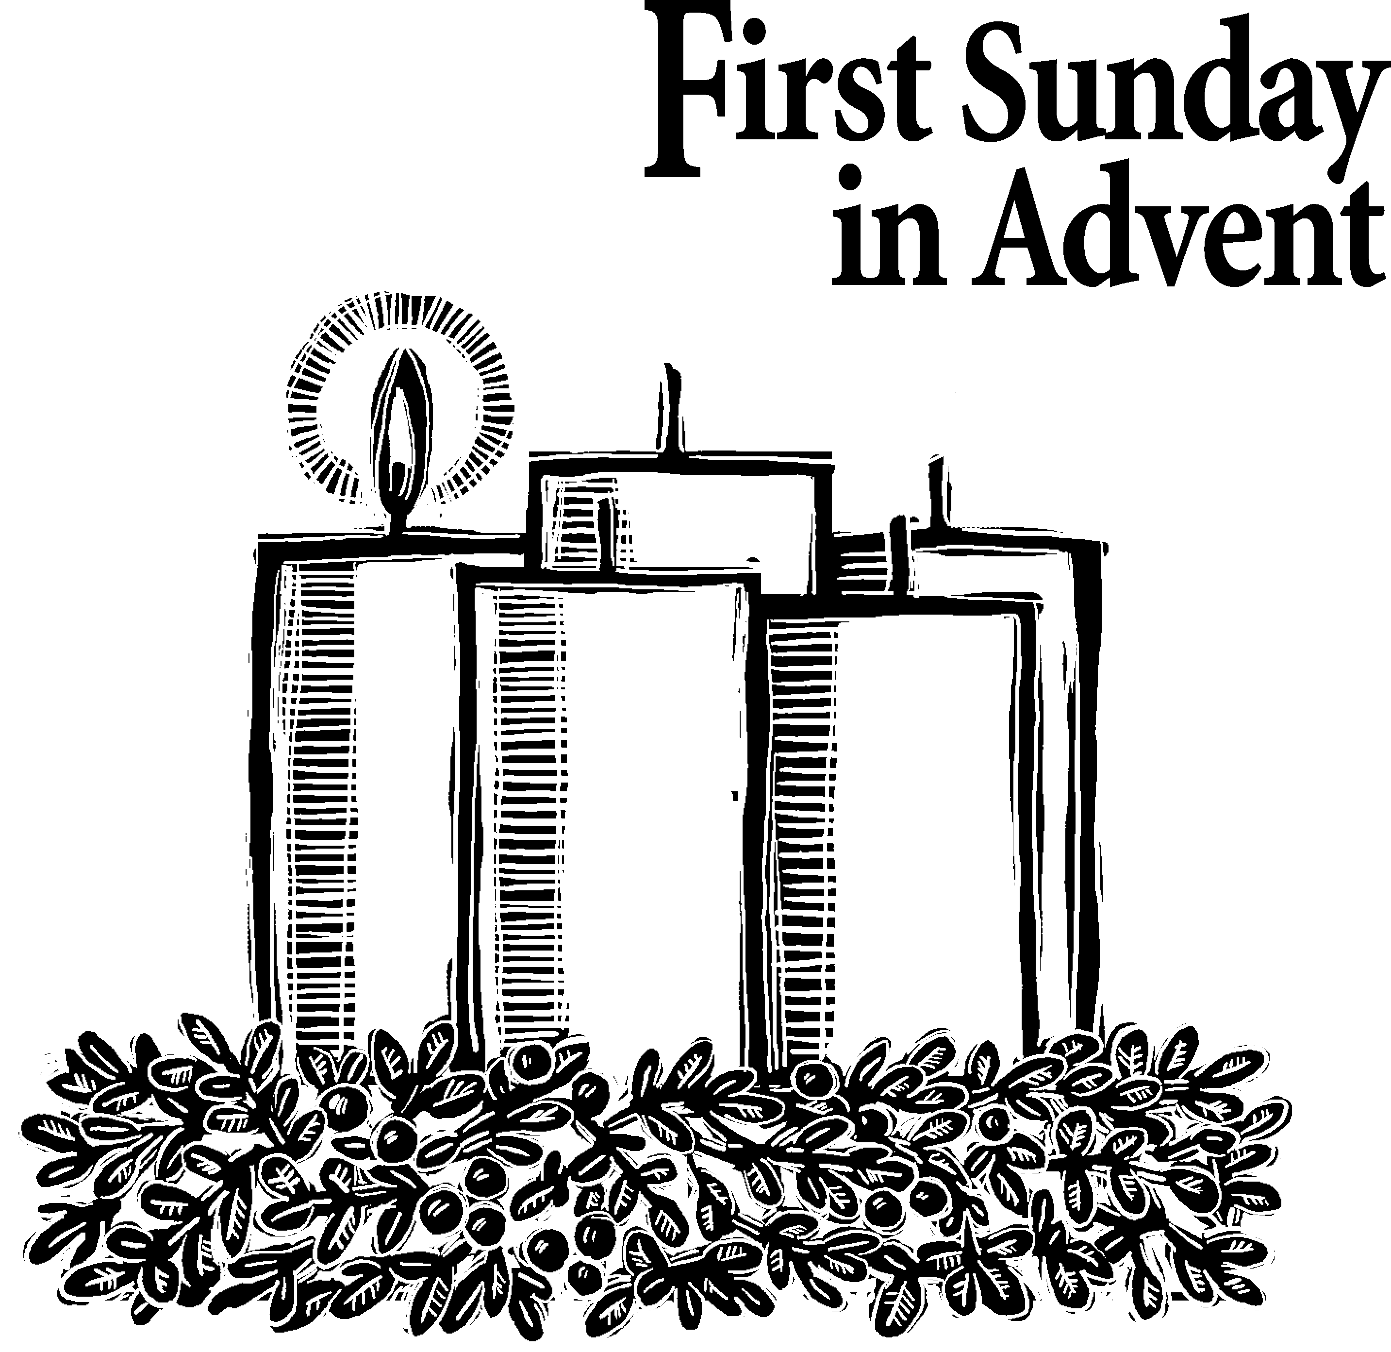Each year the W PA Conference and Eastern German Conference create daily Advent and Christmas devotionals for use in our homes and churches. We have chosen devotionals from each week.

Jeremiah 33: 14-16
‘The days are coming,’ declares the Lord, ‘when I will fulfill the good promise I made to the people of Israel and Judah.“ ‘In those days and at that time I will make a righteous Branch sprout from David’s line; he will do what is just and right in the land. In those days Judah will be saved and Jerusalem will live in safety. This is the name by which it will be called: The Lord Our Righteous Savior.’ (New International Version)

Rev. Arnie McFarland, Calvary UMC in Somerset, PA
Sometimes it’s good to remember what the word “advent” means. Its origin is Latin and the word itself means, “coming into place, view or being; arrival. When it is spelled with a capital “A” it is the four-week period before Christmas commemorating the coming of Christ into the world. It can also mean the Second Coming of Christ. This passage in Jeremiah seems to speak of an advent of sorts, a time when God will “fulfil the good promise I made to the people of Israel and Judah.” Indeed, with the birth of Jesus part of that prophecy was fulfilled. The righteous branch from David’s line was certainly Jesus, and because there was no sin nature in him, Jesus did what was right and just. We are still waiting for Judah to be saved and to see Jerusalem live in safety. It is hard to imagine that a time is actually coming when not just Judah or Israel but the whole world will live in peace and safety. Our world will be a world where there is no war, no famine, no disease, no hatred and no jealousy. Where people don’t die in horrible plane crashes, nation’s leaders don’t have to spend weeks at a time bargaining for an end of generations of hostilities between their people—where there is no need for a standing army, or a military budget to amass weapons of destruction—where there is no need for the medical profession and health insurance in fact all insurance will be a thing of the past. There will be no police, no courts, no sheriffs, or any kind of law enforcement. When you start trying to grasp the way it’s going to be it starts to really stretch your imagination. But if God says it is coming then you can be sure it will. As we worship our way through this Advent season let us pray that God will speed the Advent of Jesus.

Pastor Thomas Günther, Chemnitz
The city I live in is called Chemnitz. This name was first mentioned in 1143. But in 1953 the city was renamed. It was now called Karl-Marx-Stadt, even if the founder of Communism neither was born in the city nor has ever visited it. Chemnitz was renamed only for political reasons. It should become a communist city. Then the communist era ended and now Chemnitz is called Chemnitz again. I read V.16 and I am astonished: Jerusalem also shall be renamed? How come? I am skeptical and reality seems to confirm my skepticism. Was there ever an age when Jerusalem was a safe place? Judah and Israel, that’s just the narrow strip of land between the eastern shore of Mediterranean Sea and the desert. Countless armies have passed through the region before and after the time of Jeremiah leaving behind their blood trails. Even today the Middle East is not a safe place. Has Jeremiah, the Prophet, failed? Or should even God not stand by his promise? Everyone should find his personal answer of faith to this question. I say: This promise is not yet fulfilled. But just for this reason I want to believe God and the good thing which he has promised (V.14) never giving up hope. He has spoken unto Israel and Judah. His people in those days were just as divided as our world is today. The gap is getting wider and wider dividing religions and cultures, global North and South, the rich and the poor. The great utopias have lost their power. What if we Christians were also to give up our hope? No, I want to hold on to the promise that God’s word is true. The good thing that he has promised will come. One day judgment and righteousness will prevail in the land. People will dwell safely in Jerusalem and everywhere where it is denied to them now. I will observe the Advent season, nurturing this hope. Jesus is born. God is not yet finished with us. He wants to go on with us, even if it still might be a long and winding road to go. This hope is not to be a utopia but should encourage and inspire us to an active life as Christians.

Keep in Prayer

Convalescing in Care Facilities
Leila Berkey, Asbury Heights
Ed Clarke, Asbury Place
May Fredericks, Concordia Health Care
Mary Garber
Susan Lichtenfels
Pat Seitz, Concordia Health Care
Andy Smith, Concordia Health Care
Tim Watters, Baptist Homes

Convalescing at Home
Jean George, Anne Hoffman, Earl Killian

In Sympathy
Condolences are offered to the family of church member Joan Harden, who died this past week. Words of sympathy for the family can be sent to her daughter:
Mary Remington
1739 Quigg Drive
Pittsburgh, PA 15241

In the Military

Jason Boyer, SPC Natalie Brown

Capt. Zachary Allen Finch, USMC
James Iantelli, 1st Lt. Jaskiewicz
S. Sgt. Keith Kimmell, Adam Kmick
PFC Brendan Lamport
Sgt. Matthew McConahan, Thomas Orda
Lt. Col. Mark Patterson

Lt. Com. Scott Patterson

Lt. Col. Sean Patterson
David Poncel, Sgt. Steven Reitz
Capt. Scott B. Rushe, Pastor Rick Townes
Maj. Azizi Wesmiller

Maj. Matthew C. Wesmiller
Sgt. Keith Scott Winkowski

Sgt. Michael Zimmerman

CALENDAR – SUNDAY, NOVEMBER 27 THRU SATURDAY, DECEMBER 3

SUNDAY 11/27
8:30 am Worship Sanner Chapel
9:30 am Sunday School for All Ages/Coffee Café Various/Brookline Parlor
10:45 am Worship Sanctuary
Kids Praise Welcome Center
4 pm Youth Choir Choir Room
7 pm BSA Patrol Leaders Room 105

MONDAY 11/28
7 pm Chapel Bells Rehearsal Bell Room
7:30
pm German Class Welcome Center

TUESDAY 11/29
6 pm Terrific Tuesday Asbury Center
7 pm Boy Scout Troop #23 Wesley Hall

WEDNESDAY 11/30
6:30 am Northside Lunch Prep Asbury Kitchen

THURSDAY 12/1
8:30 am Northside Lunch Prep Asbury Kitchen
9:30 am Hands & Hearts Epworth Chapel
12 pm TNT Asbury Heights
6:30 pm Promise Bells Rehearsal Bell Room
7:30 pm Chancel Choir Rehearsal Choir Room

FRIDAY 12/2
9:30 am Women’s Bible Study Room 102

SATURDAY 12/3
10 am Food Distribution Food Pantry
10 am New Member Info Session Wesley Hall

