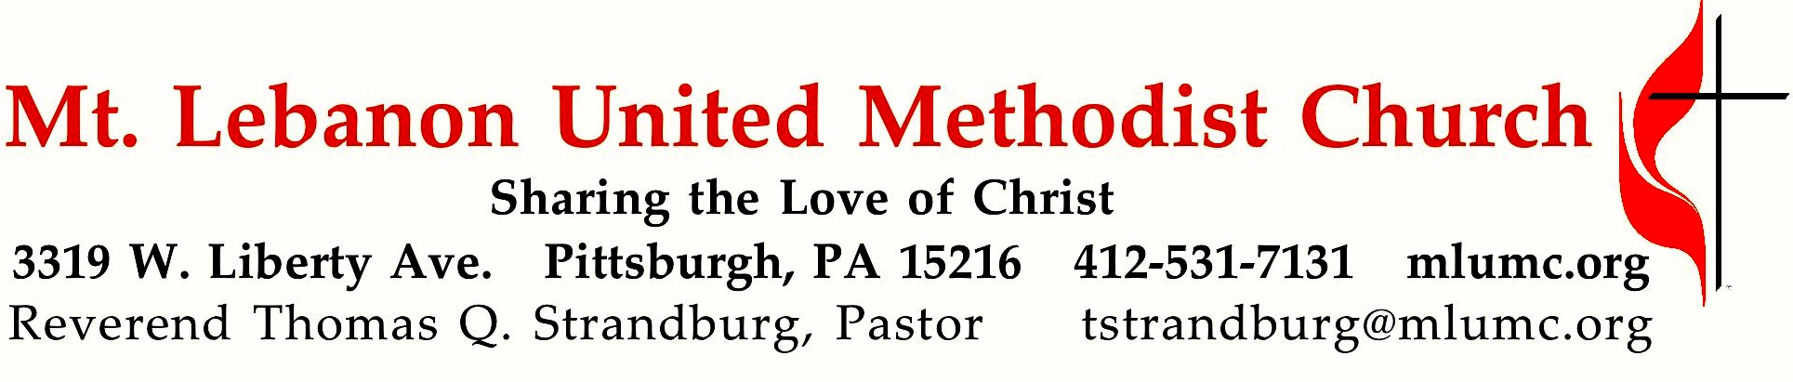

January 1, 2017 10:45
Today is the eighth day of the Christmas season, which begins on Christmas day and ends twelve days later on January 5th. Epiphany, on January 6th, begins a new season in the Christian calendar. On this day we consider the question - What gift did God really bring this Christmas?

WE GATHER IN GOD’S NAME …
Greeting
Leader: Hallelujah! Praise God!
People: Shout God’s praise from the mountaintops!
Let the angels sing God’s praise! Based on Psalm 148:1-2

Announcements

Stewardship Moment Jim Young

Call to Worship
Leader: Praise God, you lights of heaven: sun and moon and stars!
People: Praise God, you rolling thunder clouds!
Leader: For God is your creator: God commanded, and it was so!
People: Praise God from ocean’s depths, you sea monsters and swimming things!
Leader: Praise God from the air, you lightning bolts; you hail and frost and snow!
People: Praise God from the earth, you mountains and hills, you orchards and forests!
Leader: Praise God all animals, you wild beasts and herds of cattle and flying birds!
People: Praise God you human rulers, you kings and queens of the earth!
Leader: Praise God all people, women and men; all ages and tongues and races!
All: Let everything praise the Lord; for God’s name alone is above all things!
Praise God! Hallelujah! Amen.
Based on Psalm 148:3-13

… TO GIVE PRAISE TO GOD …

Hymn 220 Angels from the realms of glory (standing) Regent Square

Opening Prayer (in unison)
Send, O God, into the darkness of this troubled world, the light of your Son.
Let the star of your hope touch the minds of all people with the bright beams of mercy and truth; and so direct our steps that we may ever walk in the way revealed to us,
as the shepherds of Bethlehem walked with joy to the manger where he dwelled,
who now and ever reigns in our hearts, Jesus Christ our Lord. Amen.

… TO CELEBRATE THE FAMILY OF FAITH …

The Sign of Peace Please pass the peace to your neighbors as a sign of reconciliation and love.
Leader: The peace of Christ be with you.
People: And also with you.

Gathering Song James Ritchie
This, this is where children belong,
welcomed as part of the worshiping throng.
Water, God’s Word, bread and cup, prayer and song:
This is where children belong.
WORDS: James Ritchie MUSIC: James Ritchie ©1999 Abingdon Press

Message for Young Disciples Rev. Thomas Q. Strandburg
All children are invited. Please sing as children come forward. There is no Kids Praise today following the Children’s Message.

… TO HEAR GOD’S WORD PROCLAIMED …

Scripture Reading Rev. Kimberly Greway
A Lesson from the Gospels (standing)
Matthew 2:13-23

Prayer for the New Year 2017 (see insert)

The Lord’s Prayer
Our Father, who art in heaven, hallowed be thy name. Thy kingdom come, thy will be done, on earth as it is in heaven. Give us this day our daily bread. And forgive us our trespasses, as we forgive those who trespass against us. And lead us not into temptation, but deliver us from evil. For thine is the kingdom, and the power, and the glory forever. Amen.
Scripture Reading
A Lesson from the New Testament
Hebrews 2:10-18

Response
Leader: The Word of the Lord.
People: Thanks be to God.

Sermon “What Gift Did God Bring” Rev. Thomas Q. Strandburg

… TO OFFER OUR GIFTS AND TO DEDICATE OUR LIVES …

Offertory Anthem New Year John Rutter
Turn your eyes to the light; cast away the words of darkness, let them go:
turn your eyes to the light. Turn your face to the sun; feel the warmth,
the hope of new beginnings with each new year.
The light was always there, if we could but see it; and warmth was in the air;
if we’d known how to feel. Turn your eyes to the light, turn your face to the sun:
new light, new hope, new year.
Turn your ears to the sound; somewhere near, a voice is calling: hear the news,
turn your ears to the sound. Turn your heart to the love;
Christ is come to bring the world new life. The voice is always there,
if the world will hear it; and love is always there, if you search in your heart.
Turn your ears to the sound, turn your heart to the love:
new life, new love, new year, new life, and love, and light, and hope, this good New Year.

Doxology 94 (standing)
Praise God from whom all blessings flow;
Praise God, all creatures here below: Alleluia! Alleluia!
Praise God the source of all our gifts!
Praise Jesus Christ, whose power uplifts!
Praise the Spirit, Holy Spirit. Alleluia! Alleluia! Alleluia!

Prayer of Dedication

Sacrament of Holy Communion Rev. Kimberly Greway
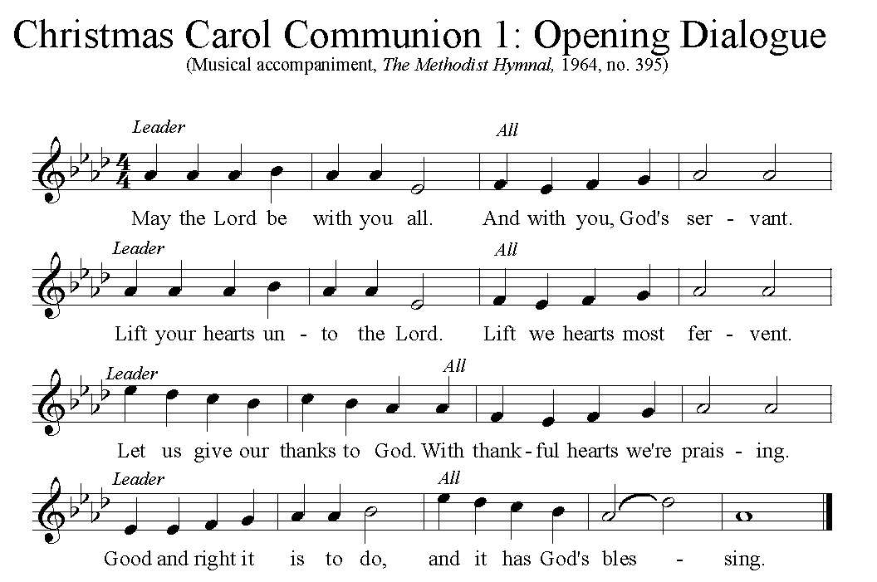

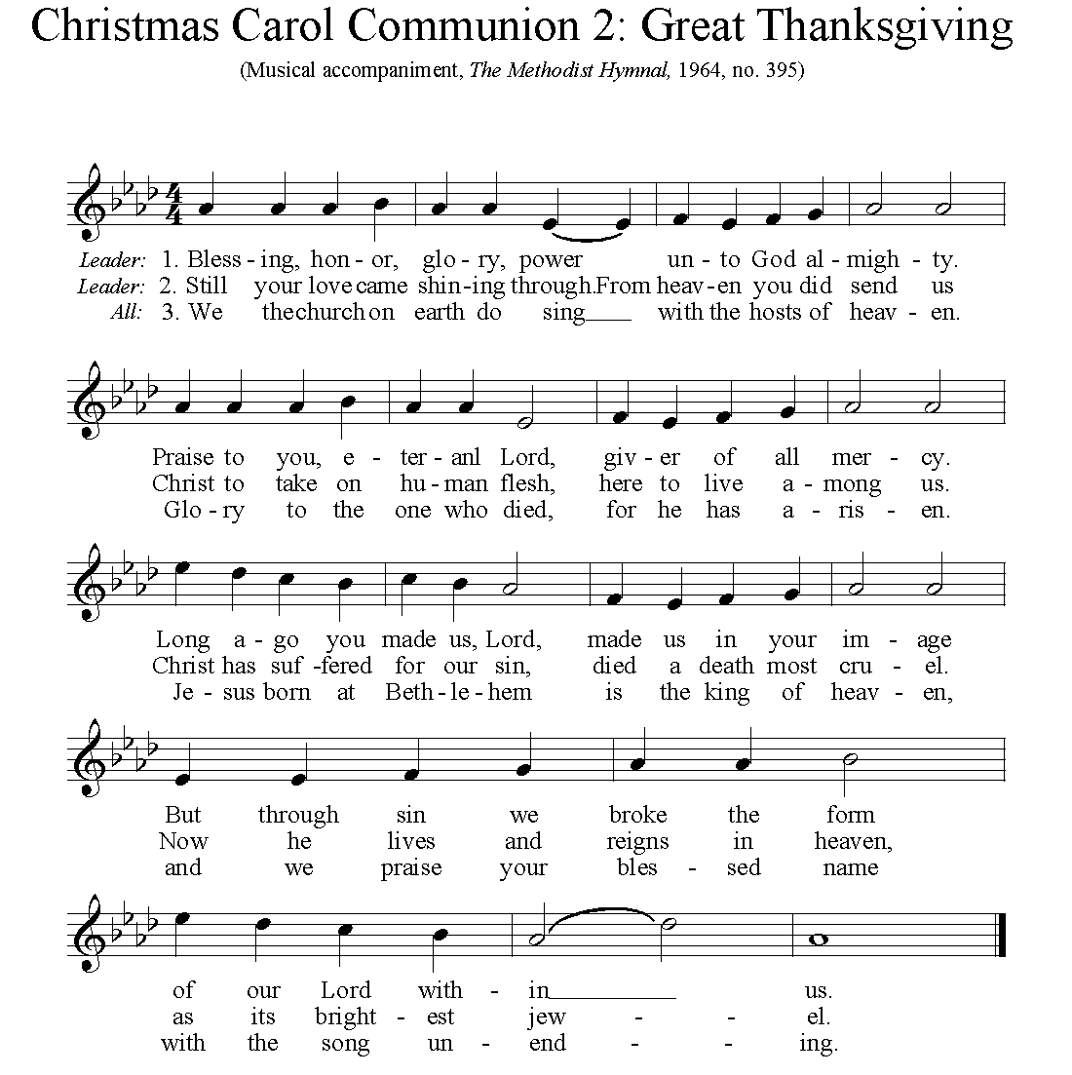

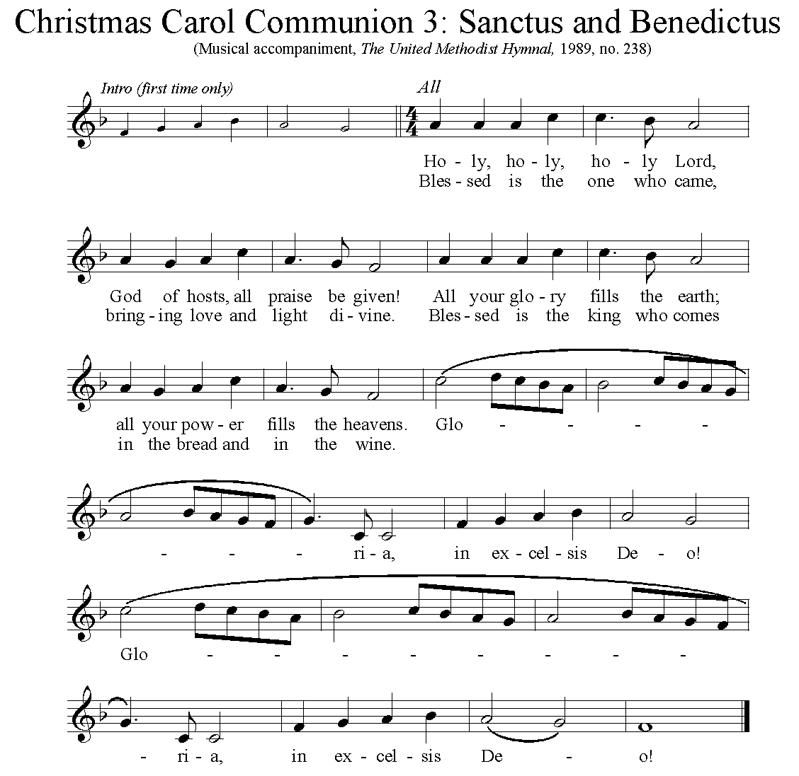

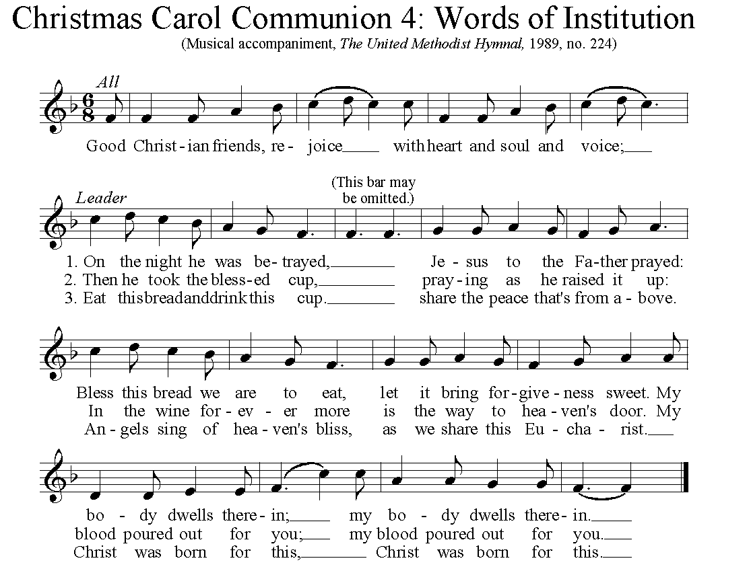

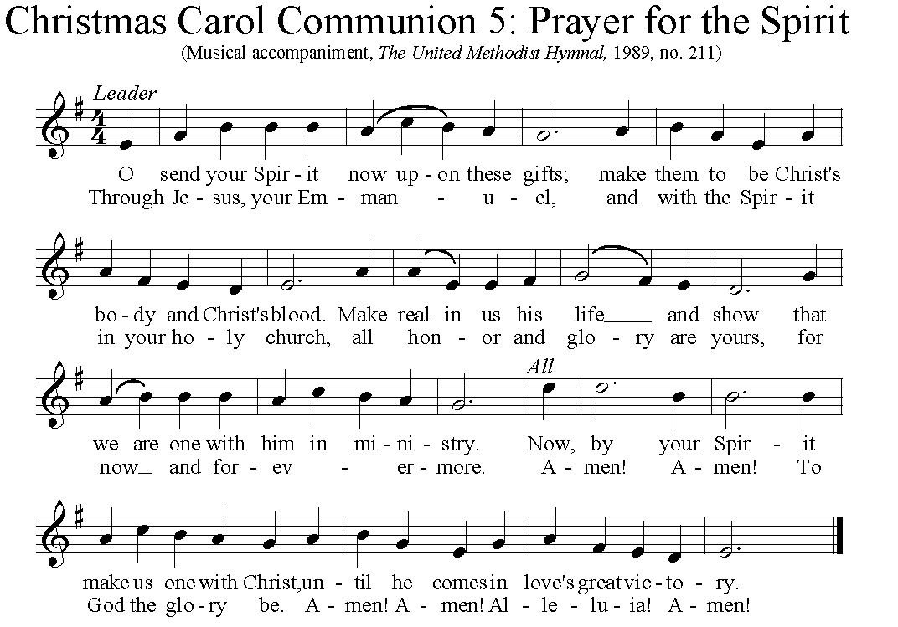

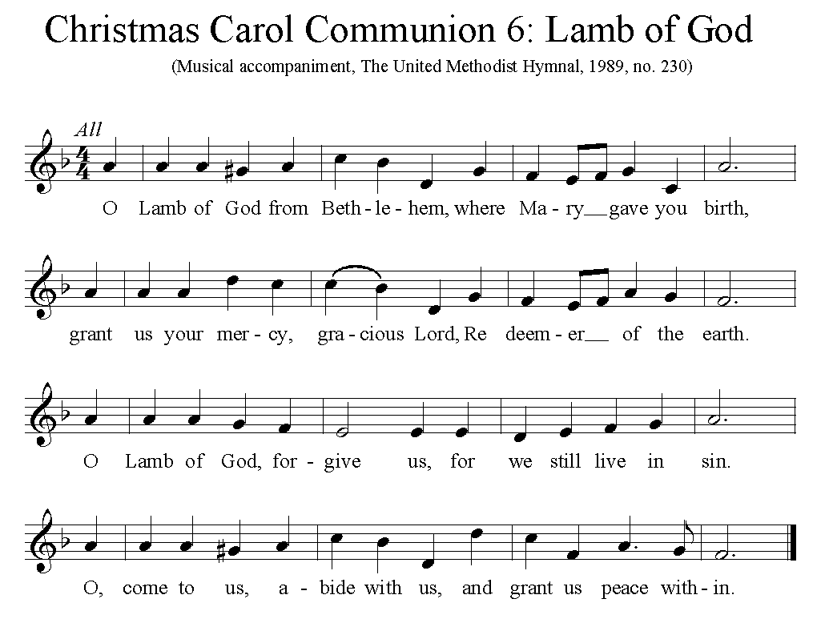

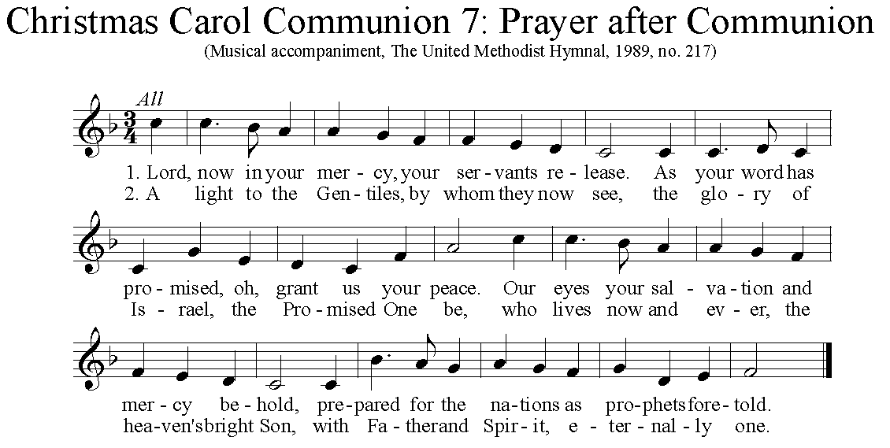

… TO GO REJOICING IN GOD’S NAME!

Hymn 242 Love came down at Christmas (standing) Gartan

Benediction

Today’s Services

The flowers in the chancel are given with best wishes for the new year to all members, visitors and volunteers of the church.

The flowers on the altar are given in honor of all those who volunteer and work to alleviate hunger in our world.

Special music is provided by the Chancel Choir.

Greeters John and Marda Katshir Acolytes Lydia Slater and Max Siegert

Sunday School, 8:30-9:30, and worship for children during the 10:45 service, Kids Praise, will resume next Sunday.
Podcasts of Sunday Sermons Would you like to share this morning’s sermon with a friend or did you miss a Sunday? Catch up on the messages from MLUMC with a podcast of Pastor Tom’s and others’ Sunday sermons. Sermons from the past three months are at http:// mlumc.buzzsprout.com. You can navigate to the site from the link on our webpage, www.mlumc.org, through the app, Stitcher or through iTunes.
Today’s Scriptures
Matthew 2:13-23
¹³Now after they had left, an angel of the Lord appeared to Joseph in a dream and said, “Get up, take the child and his mother, and flee to Egypt, and remain there until I tell you; for Herod is about to search for the child, to destroy him.” ¹⁴Then Joseph got up, took the child and his mother by night, and went to Egypt, ¹⁵and remained there until the death of Herod. This was to fulfill what had been spoken by the Lord through the prophet, “Out of Egypt I have called my son.”
¹⁶When Herod saw that he had been tricked by the wise men, he was infuriated, and he sent and killed all the children in and around Bethlehem who were two years old or under, according to the time that he had learned from the wise men. ¹⁷Then was fulfilled what had been spoken through the prophet Jeremiah: ¹⁸“A voice was heard in Ramah, wailing and loud lamentation, Rachel weeping for her children; she refused to be consoled, because they are no more.”
¹⁹When Herod died, an angel of the Lord suddenly appeared in a dream to Joseph in Egypt and said, ²⁰“Get up, take the child and his mother, and go to the land of Israel, for those who were seeking the child’s life are dead.” ²¹Then Joseph got up, took the child and his mother, and went to the land of Israel. ²²But when he heard that Archelaus was ruling over Judea in place of his father Herod, he was afraid to go there. And after being warned in a dream, he went away to the district of Galilee. ²³There he made his home in a town called Nazareth, so that what had been spoken through the prophets might be fulfilled, “He will be called a Nazorean.”

Hebrews 2:10-18
¹⁰It was fitting that God, for whom and through whom all things exist, in bringing many children to glory, should make the pioneer of their salvation perfect through sufferings. ¹¹For the one who sanctifies and those who are sanctified all have one Father. For this reason Jesus is not ashamed to call them brothers and sisters, ¹²saying, “I will proclaim your name to my brothers and sisters, in the midst of the congregation I will praise you.” ¹³And again, “I will put my trust in him.” And again, “Here am I and the children whom God has given me.”
¹⁴Since, therefore, the children share flesh and blood, he himself likewise shared the same things, so that through death he might destroy the one who has the power of death, that is, the devil, ¹⁵and free those who all their lives were held in slavery by the fear of death. ¹⁶For it is clear that he did not come to help angels, but the descendants of Abraham. ¹⁷Therefore he had to become like his brothers and sisters in every respect, so that he might be a merciful and faithful high priest in the service of God, to make a sacrifice of atonement for the sins of the people. ¹⁸Because he himself was tested by what he suffered, he is able to help those who are being tested.

Keep in Prayer
Hospitalized
Joseph Festor, UPMC Montefiore

Convalescing in Care Facilities
Leila Berkey, Asbury Heights
Ed Clarke, Asbury Place
May Frederick , Concordia Health Care
Mary Garber, Providence Point
Susan Lichtenfels, Curahealth Pittsburgh,
Oakdale
Pat Seitz, Concordia Health Care
Tim Watters, Baptist Homes

Convalescing at Home
Gloria Barber, Bob Fairgrieve, Jean George, Earl Killian

In Sympathy
Condolences are offered to the family of church member Andrew “Andy” W. Smith, age 91, who died on Thursday, December 22nd. A memorial service is scheduled for Wednesday, January 4th at 3 pm in our Sanctuary. Prayers and words of comfort for the family can be sent to his son:
Mr. Thomas B. Smith
3551 Isle way
Oxnard, CA 93035

In the Military

Jason Boyer, SPC Natalie Brown

Capt. Zachary Allen Finch, USMC
James Iantelli, 1st Lt. Jaskiewicz
S. Sgt. Keith Kimmell, Adam Kmick
PFC Brendan Lamport
Sgt. Matthew McConahan, Thomas Orda
Lt. Col. Mark Patterson

Lt. Com. Scott Patterson

Lt. Col. Sean Patterson
David Poncel, Sgt. Steven Reitz
Capt. Scott B. Rushe, Pastor Rick Townes
Maj. Azizi Wesmiller

Maj. Matthew C. Wesmiller
Sgt. Keith Scott Winkowski

Sgt. Michael Zimmerman

Our Apportionment Challenge
Making Progress - Before his recent death, Andy Smith donated $41,000 as a challenge to the congregation to match his gift. If we raise $41,000, we will be able to pay the full apportionment asking from the Western Pennsylvania Conference. The Finance Committee approved that all Christmas offerings should be credited toward this match. The congregation has responded very generously and, to date, has contributed $32,200. This means that we are only $8,800 short of our goal that needs to be reached by January 12. If you have not made your Christmas Offering yet, we encourage you to do so. Our apportionment supports local, state, national and international ministries through the W PA Conference and the United Methodist Church.

ANNOUNCEMENTS

Blood Pressure Screening The first Sunday of the month blood pressure screening by members of the MLUMC Health Ministry is being postponed from today to next Sunday. Stop in to Brookline Parlor Jan. 8th after the 10:45 service for a blood pressure check.

Volunteer Readers are needed in February for our Northside reading ministry. We carpool from the church at 8:30 on Tuesday mornings and return at 10:30. Interested in helping with this mission? Contact Clark Remington corkrem@verizon.net.

Haiti Mission Trip Clark and Mary Remington will be going to Haiti at the end of March to continue the church's mission with the Thomas Food Project. Projects will include teaching and playing educational games with children, teacher training, and constructing bio-sand filters to provide clean water. If you would like to join them, email Clark at corkrem@verizon.net
Trip expenses will be defrayed by the Harold Heard Haiti Mission Endowment.

Boy Scout Spaghetti Dinner Boy Scout Troop 23 will be holding their annual spaghetti dinner on Sat., January 21 from 4 -8 pm in Asbury Center. The cost is $8, age 12 to adult, and $5, youth under the age of 12. The scouts will be selling tickets on Sunday, January 8 and 15. You can also buy tickets the day of the dinner, but advance ticket sales helps the scouts to plan!
The meal includes homemade spaghetti sauce, salad, bread, beverage and dessert and most importantly full service, just like a restaurant. Take-out is also available.

Each year the W PA Conference and Eastern German Conference create daily Advent and Christmas devotionals for use in our homes and churches. We have chosen devotionals from each week.

Rev. Edward W. Rogosky
Ezechiel 36: 26 I will give you a new heart and put a new spirit in you; I will remove from you your heart of stone and give you a heart of flesh. (New International Version)
It is the possibility of a “new heart and a new flesh” or a new way of thought, “the heart” and a new way of living, “the spirit” within the human being that lives on even after the Christmas rush is over.
What would such a thing look like? A world where all people are important to God and each other. It may be a world where trust and care replace mistrust and anger. It may be a world where all people embrace a new heart and flesh with the old stones of anger, hatred and misery have gone. A certain blessing for the upcoming year.
Pastor Lutz Brückner, Kirchberg and Wilkau-Haßlau
In Germany, we know of a story called “The cold heart” by Wilhelm Hauff. Peter, the main character, is a young charcoal burner from the Black Forest .He can hardly live of his tiring, exhausting work which is producing charcoal. He feels inferior and disdained. He is sick and tired of living like this. This is how he gets prone to the temptations of an evil forest spirit who promises him a better life, if he only gives him his heart. Peter agrees and in return for his heart, he receives a heart that is cold and hard and made of stone. After that, life goes up hill for Peter indeed. He gets rich and marries a beautiful girl. Everything seems peachy. At first he doesn’t feel how he changes – suddenly he can’t feel anything at all. He doesn’t feel sorrow or love either. He doesn’t even feel anything for his old mother. He doesn’t share his new found wealth with her and complains that he gives her some pennies once in a while. He cannot even rejoice in anything. Beforehand, it was different. He could be happy about the tiniest things, like a little flower at the side of the path. But now the heart of stone doesn’t feel any emotions at all. The heart of stone only knows greed and selfishness. One day, Peter’s wife gives something to eat to a beggar. Peter gets really angry about this and in his anger, he slays his wife. When he sees what he has done, he begins to think. Something is not right in his life. Is it actually possible to truly live with such a cold heart? Feeling is part of our lives – how should it work, to live without emotions? Nevertheless, some people seem to have a heart of stone. We speak of “cold blooded, cold hearted” or that somebody “can’t be softened”. We also say that “hardheartedness rules” when somebody only thinks of himself. Such a person is unable to love, be merciful or show compassion.
The prophet Ezekiel is accusing the Israelites, who lived in Babylon after the destruction of Jerusalem, of exactly that: God says, your hearts are made of stone. There is no altruism, no brotherly love among you. You also lost the love to god. Everything is cold, just like a stone. A hard verdict!
In the old German story, Peter wins his heart back with a trick. Everything turns out alright: his wife comes back to life; he has a good income and social standing. He doesn’t become very rich but has enough to get by.
This is a fairy tale. What does it look like in real life? What is it like with the cold hearted people? And: Am I sometimes cold hearted myself? My heart is not always as warm, compassionate and full of love as it should be. Can I do something against this? The answer is written in Ezekiel. God declares here:” Your hearts are of stone”. But he also says: “I will give you a new heart and a new spirit. I will take away the heart of stone and give you a heart of flesh”. God himself will take care of this and plant his love in our hearts. God’s love lets us love other people and God himself, it lets us be gracious, gives us compassion and makes us be merciful.
With this heart of flesh, which God wants to give me, I can walk on his ways through the new year, to spread what the world is truly lacking: love and compassion. Through this, through us, others might find that they are also missing the heart of flesh, the love and compassion and that they can find exactly this in God. It is very much needed...

CALENDAR – SUNDAY, JANUARY 1 THRU SATURDAY, JANUARY 7

SUNDAY 1/1 NEW YEAR’S DAY
10:45 am Worship Sanctuary

MONDAY 1/2 OFFICE CLOSED FOR NEW YEAR’S DAY HOLIDAY
6:30 pm Tiger Cub Scouts Epworth

TUESDAY 1/3
7 pm Boy Scout Troop #23 Wesley Hall
7 pm Boy Scout Planning Epworth Chapel
7 pm Coin Collectors Welcome Center
7:30 pm SPRC Library

WEDNESDAY 1/4
6:30 am Northside Lunch Program Prep Kitchen
3 pm Andy Smith Memorial Service Sanctuary

THURSDAY 1/5
8:30 am Northside Lunch Program Prep Kitchen
9:30 pm Hands & Hearts Epworth
12 pm TNT Asbury Heights
6:30 pm Promise Bells Rehearsal Bell Room
7:30 pm Chancel Choir Rehearsal Choir Room

FRIDAY 1/6
9:30 am Women’s Bible Study Room 102

SATURDAY 1/7
10 am Food Distribution Food Pantry

