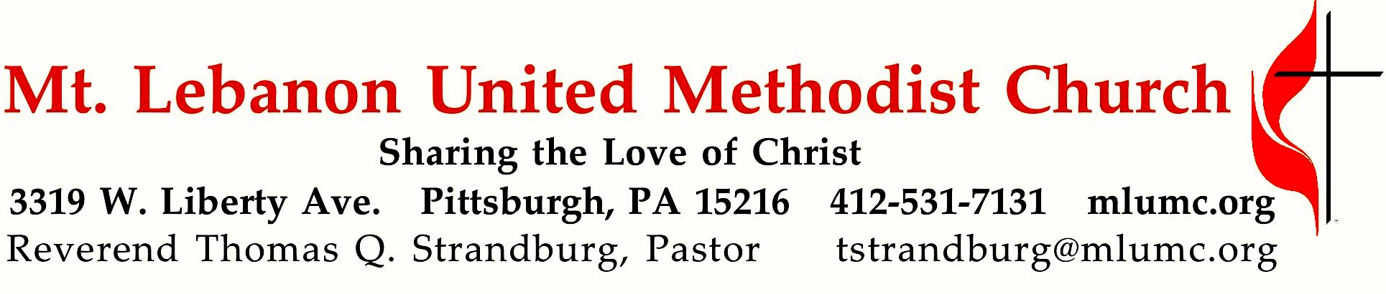

December 11, 2016 8:30 & 10:45
3rd Sunday in Advent
Teddy Bear Sunday
On this Sunday, the story of John the Baptist in Matthew 11 is filled with a vision of hope for the future. Jesus instructs his disciples to report to John that the blind can see, the lame can walk, and the deaf can now hear. Hope is on the way!

WE GATHER IN GOD’S NAME …
Gathering Music

Hymn 220 Angels from the realms of glory (stanzas 1-2) Regent Square
Hymn 221 In the bleak midwinter (stanzas 1-2) Cranham

Greeting
Leader: Sing to the Lord a new song! Sing to the Lord, all the earth!
People: Declare God’s glory among the nations; declare his wondrous works among all people. Psalm 96:1, 3

Announcements

Stewardship Update Virginia Katinsky

Choral Introit 10:45 Prepare ye the way Hart Morris
Prepare ye the way of the Lord! Make straight a highway for our God.

Call to Worship
Leader: Rejoice in the Lord always, again I say rejoice!
People: With joyful hearts, we draw living water from the wellspring of God’s salvation.
Leader: With loud singing, we return to a home of love.
People: With loud shouts, we return to our God.
Leader: Rejoice in the Lord always, again I say rejoice!
Adapted from Philippians 4
… TO GIVE PRAISE TO GOD …

Hymn of Praise 233 Cold December flies away (standing) Lo Desembre congelat

Opening Prayer (in unison)
Redeemer God, with laughter in our mouths and joy in our hearts, we draw living water from the wellspring of your salvation. For you save the lame and gather the outcast, turning their shame into praise. You gather the lost and bring the exile home at last. Who is like you in all the earth? There are none that compare to you, O God. In your presence, we dwell secure. In your love, we find the power to transform the world. Enable us to live out the faith we profess, following the example of Christ our Lord. Amen.

… TO CELEBRATE THE FAMILY OF FAITH …

Lighting of the Advent Wreath The Angels’ Message: Accept Joel Raney
8:30 Bob and Chris Murray
10:45 James, Amy, and Natalia Bentz

Reader: During Advent our eyes are opened to the wonders of God.
People: With God all things are possible.
Reader: During Advent our faith is nurtured by the promise of God.
People: With God all things are possible.
Reader: During Advent our hope is reawakened to the presence of God.
People: With God all things are possible.
Reader: During Advent our lives are touched by the love of God.
People: With God all things are possible.

(Lighting of the Candle)

Sung Response: Listen to the angels, hear the message they bring;
Telling the news of a coming King;
filling the world with hope and good cheer.
Jesus, Emmanuel, God is near.

Closing Prayer

Reception into Membership 10:45 UMH #33
Kirsten Fisher, Mika Fisher, Amy Martin, Jeff Martin, Anne Stokes, Timothy Stokes

Pastor: Members of the household of God, I commend these persons to your love and care. Do all in your power to increase their faith, confirm their hope,
and perfect them in love.
People: We give thanks for all that God has already given you and we welcome you in Christian love. As members together with you in the body of Christ and in this congregation of the United Methodist Church, we renew our covenant faithfully to participate in the ministries of the church by our prayers, our presence, our gifts, our service, and our witness that in everything God may be glorified through Jesus Christ.

The Sign of Peace Please pass the peace to your neighbors as a sign of reconciliation and love.
Leader: The peace of Christ be with you.
People: And also with you.

Offering of Teddy Bears
Those who have not already done so are invited to bring their gifts to the chancel area during the Passing of the Peace.

Gathering Song James Ritchie
This, this is where children belong,
welcomed as part of the worshiping throng.
Water, God’s Word, bread and cup, prayer and song:
This is where children belong. WORDS AND MUSIC: James Ritchie ©1999 Abingdon Press

Message for Young Disciples Rev. Thomas Q. Strandburg
(All children are invited. Please sing as children come forward.)
After the children’s message at the 10:45 service, children ages 3 - 3rd grade may attend Kids Praise in the Welcome Center. Children will be escorted to and from Kids Praise by teachers. They will return to the Sanctuary near the end of the service, and parents may meet them.

Blessing of the Teddy Bears

… TO HEAR GOD’S WORD PROCLAIMED …

Hymn 216 8:30 Lo, how a Rose e’er blooming Es ist ein Ros

Anthem 10:45 Douglas E. Wagner
Refrain: Waiting, watching, wondering, under a cold, cloudless sky,
waiting, watching, wondering, where the Lord in humble guise will lie.
Waiting for a sign of hope, watching for a star,
wondering how might a little child the gates of heaven unbar.
Wondering why God sends his Son to sinners all below.
Saints and angels sing this night, glad that it is so. Refrain
Waiting, watching, wondering this night,
love will bring down to us promises and light. Refrain
Scripture Reading 8:30 Marcy Picardi 10:45 Joy Conti
A Lesson from the Hebrew Scriptures
Isaiah 12:2-6 The Lord is our strength and our shield

Worship & Song 3145 Breath of God, Breath of peace (stanza 2, seated) Patterns Word of God, Word of peace, Word of love, Word of life, Word of justice,
Word of passion, Word creating, Word of healing, Word of singing, Word of praying,
Come upon us, come restore us, come inspire us, Breath of God.

Pastoral Prayer

The Lord’s Prayer
Our Father, who art in heaven, hallowed be thy name. Thy kingdom come, thy will be done, on earth as it is in heaven. Give us this day our daily bread. And forgive us our trespasses, as we forgive those who trespass against us. And lead us not into temptation, but deliver us from evil. For thine is the kingdom, and the power, and the glory forever. Amen.

Scripture Reading
A Lesson from the Gospel
Matthew 11:2-11 The ministry of John the Baptist

Response
Leader: The Word of the Lord.
People: Thanks be to God.

… TO OFFER OUR GIFTS AND TO DEDICATE OUR LIVES …

Offertory Solo 8:30 Lo, how a Rose e’er blooming setting by John Carter

Offertory Anthem 10:45 Spiritual, arr. Andre Thomas
Keep your lamps trimmed and burning, the time is drawing nigh.
Children don’t get weary ‘til your work is done.
Christian journey soon be over, the time is drawing nigh.
Keep your lamps trimmed and burning, the time is drawing nigh.

Doxology 94
Praise God from whom all blessings flow;
Praise God, all creatures here below: Alleluia! Alleluia!
Praise God the source of all our gifts!
Praise Jesus Christ, whose power uplifts!
Praise the Spirit, Holy Spirit. Alleluia! Alleluia! Alleluia!
Prayer of Dedication

Sermon “Hope in the King” Rev. Thomas Q. Strandburg

… TO GO REJOICING IN GOD’S NAME!

Hymn 218 It came upon a midnight clear (standing) Carol

Benediction

Today’s Services
The flowers in the chancel are given by Joyce McGill in loving memory of her brother,
Trevor Morrow.

The flowers on the altar are given in loving memory of Allan and Marian Pearson.

Special music at 10:45 is provided the Chancel Choir with percussionist Courtney Heath, our Children’s Choir Director, and the Youth Choir.

Acolytes Lydia Slater and Anastasia Sunder

Greeters 8:30 Judi Phelps 10:45 Ed and Bette Lou Reichard

Worship options for children We encourage children to participate in the Children’s Sermon at both services, and in Kids Praise during the 10:45 service. Nursery services are offered in Room 204 of the Education Building. Ask ushers or greeters and follow signs for direction.

Podcasts of Sunday Sermons Would you like to share this morning’s sermon with a friend or did you miss a Sunday? Catch up on the messages from MLUMC with a podcast of Pastor Tom’s and others’ Sunday sermons. Sermons from the past three months are at http:// mlumc.buzzsprout.com. You can navigate to the site from the link on our webpage, www.mlumc.org, through the app, Stitcher or through iTunes.

Flower Donations Honor or remember a loved one or friend with a Sunday flower arrangement donation. Contact Sharon Slater, 412-343-1137

Today’s Scriptures
Isaiah 12:2-6
²Surely God is my salvation; I will trust, and will not be afraid, for the Lord God is my strength and my might; he has become my salvation. ³With joy you will draw water from the wells of salvation.
⁴And you will say in that day: Give thanks to the Lord, call on his name; make known his deeds among the nations; proclaim that his name is exalted. ⁵Sing praises to the Lord, for he has done gloriously; let this be known in all the earth. ⁶Shout aloud and sing for joy, O royal Zion, for great in your midst is the Holy One of Israel.

Matthew 11:2-11
²When John heard in prison what the Messiah was doing, he sent word by his disciples ³and said to him, “Are you the one who is to come, or are we to wait for another?” ⁴Jesus answered them, “Go and tell John what you hear and see: ⁵the blind receive their sight, the lame walk, the lepers are cleansed, the deaf hear, the dead are raised, and the poor have good news brought to them. ⁶And blessed is anyone who takes no offense at me.”
⁷As they went away, Jesus began to speak to the crowds about John: “What did you go out into the wilderness to look at? A reed shaken by the wind? ⁸What then did you go out to see? Someone dressed in soft robes? Look, those who wear soft robes are in royal palaces. ⁹What then did you go out to see? A prophet? Yes, I tell you, and more than a prophet. ¹⁰This is the one about whom it is written, ‘See, I am sending my messenger ahead of you, who will prepare your way before you.’ ¹¹Truly I tell you, among those born of women no one has arisen greater than John the Baptist; yet the least in the kingdom of heaven is greater than he.

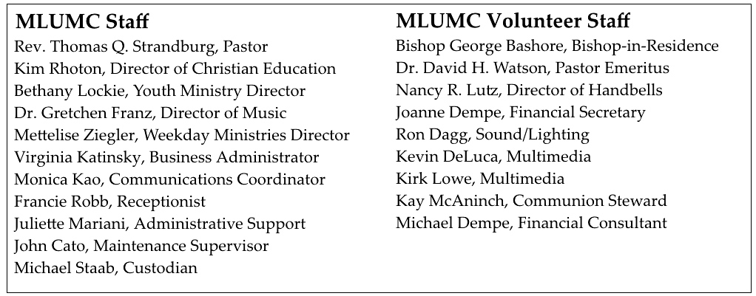

Keep in Prayer
Hospitalized
Gloria Barber, St. Clair Hospital
Bob Fairgrieve, St. Clair
Joseph Festor, UPMC Montefiore
Andy Smith, St. Clair

Convalescing in Care Facilities
Leila Berkey, Asbury Heights
Ed Clarke, Asbury Place
May Fredericks, Concordia Health Care
Mary Garber, Providence Point
Susan Lichtenfels, Curahealth Pittsburgh,
Oakdale
Pat Seitz, Concordia Health Care
Tim Watters, Baptist Homes

Convalescing at Home
Jean George, Anne Hoffman, Earl Killian

In the Military

Jason Boyer, SPC Natalie Brown

Capt. Zachary Allen Finch, USMC
James Iantelli, 1st Lt. Jaskiewicz
S. Sgt. Keith Kimmell, Adam Kmick
PFC Brendan Lamport
Sgt. Matthew McConahan, Thomas Orda
Lt. Col. Mark Patterson

Lt. Com. Scott Patterson

Lt. Col. Sean Patterson
David Poncel, Sgt. Steven Reitz
Capt. Scott B. Rushe, Pastor Rick Townes
Maj. Azizi Wesmiller

Maj. Matthew C. Wesmiller
Sgt. Keith Scott Winkowski

Sgt. Michael Zimmerman

Looking to send a card? Here are some helpful addresses:

St. Clair Hospital
1000 Bower Hill Road
Pittsburgh, PA 15243

UPMC Montefiore Hospital
3459 Fifth Ave.
Pittsburgh, PA 15213

Asbury Heights
700 Bower Hill Road
Pittsburgh, PA 15243

Concordia Health Center
1300 Bower Hill Road
Pittsburgh, PA 15243

Birthday Wishes
Happy Birthday to church member Genevieve Sihol who turned 100 yesterday. You may send your birthday greetings to the following address:
Mrs. Genevieve Sihol
700 Bower Hill Rd.
Pittsburgh, PA 15243

Gerry Oelschlager is also having a 100th birthday on Wednesday, December 21. Send your cards and wishes:

Mrs. Gerry Oelschlager

200 Adams Ave.

#209 PC

Pittsburgh, PA 15243

CALENDAR – SUNDAY, DECEMBER 11 THRU SATURDAY, DECEMBER 17

SUNDAY 12/11 New Member Sunday
8:30 am Worship Sanner Chapel
9:30 am Sunday School for All Ages/Coffee Café Various/Brookline Parlor
10:45 am Worship Sanctuary
Kids Praise Welcome Center
3:15 pm Youth Group meets to walk to St. Bernard’s Asbury Center
4 pm Combined Lessons & Carols Service St. Bernard’s Church

MONDAY 12/12
7 pm Chapel Bells Rehearsal Bell Room
7:30 pm German Class Welcome Center

TUESDAY 12/13
7 pm Boy Scout Troop #23 Wesley Hall
7 pm Boy Scout Board of Reviews Room 105
7 pm Cub Scout Planning Epworth Chapel
7 pm Charge Conference Asbury Center
7 pm Tableaux Rehearsal Sanctuary

WEDNESDAY 12/14
6:30 pm Cub Scout Wolf Pack Meeting Epworth Chapel
6:30 pm Finance Wesley Hall
6:30 pm Tiger Den Room 105

THURSDAY 12/15
9:30 am UMW Faith Circle Wesley Hall
6:30 pm Promise Bells Rehearsal Bell Room
7 pm Cub Scout Pack Meeting Asbury Center
7:30 pm Chancel Choir Rehearsal Sanctuary

FRIDAY 12/16
9:30 am Women’s Bible Study Room 102

SATURDAY 12/17
10 am Food Distribution Food Pantry

