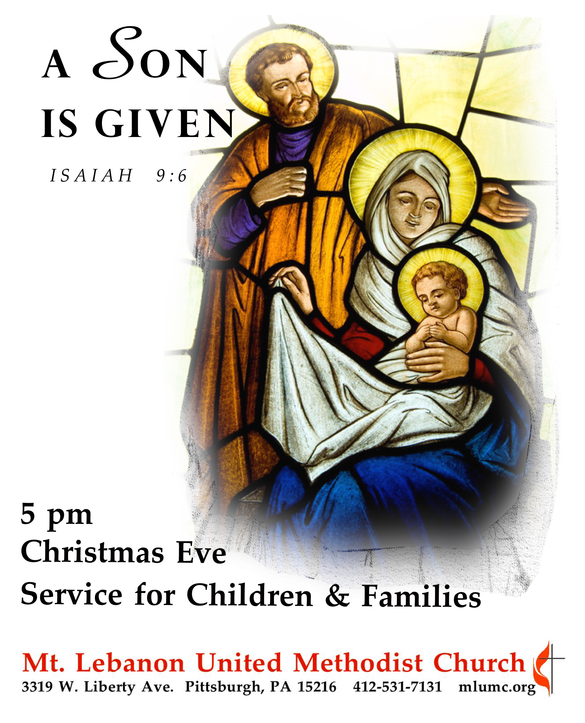
December 24, 2016 Christmas Eve Service for Children & Families 5 pm

Gathering and Greeting Rev. Thomas Q. Strandburg
Leader: In the beginning was the Word, and the Word was with God, and the Word was God. He was in the beginning with God. All things came into being through him, and without him not one thing came into being. What has come into being in him was life, and the life was the light of all people. The light shines in the darkness, and the darkness did not overcome it.
People: Thanks be to God!

Welcome Rev. Thomas Q. Strandburg

Call to Worship Liam DeLuca
Leader: He’s coming! He’s coming! The Savior of the World is coming!
People: Let us prepare our hearts to greet him!
Leader: He comes to each one of us, healing and restoring our lives!
People: Praise be to God for God’s mighty gift to us.
Leader: O Come, Prince of Peace, bring your light to us!
People: We are ready to receive you in our lives! AMEN.
http://www.ministrymatters.com/all/entry/4460/worship-connection-christmas-eve-2015-option-2
Processional Carol 234 O come, all ye faithful (1, 3, 4, 6)

Lighting of the Advent and Christ Candles Mark, Merry, Jacob and Rachel Cerneskie

Sung Response 238 Angels we have heard on high (stanzas 1 and 2)

Christmas Lessons and Carols

First Lesson Isaiah 9:2-7 Addison Alexander
Children’s Choir Light of Light Nancy Gifford

Second Lesson Psalm 96 Fiona Curran
Carol 224 Good Christian Men Rejoice (1, 2)

Third Lesson Titus 2:11-14 Grant Volek
Carol 230 O Little Town of Bethlehem (1, 3)

Fourth Lesson Luke 2:1-7 Hannah Baker
Children’s Choir Bagpipe Carol Traditional French, arranged by Marlene Herald and Eloise McCormick, Orff arrangement by Courtney Heath

Fifth Lesson Luke 2:8-20 Emily Shoff
Children’s Choir Carol of the Cuckoo Carolyn Jennings

Story of the Silent Night Dandi Daley Mackall
Children return to their families at the story completion.

Christmas Offering
Offertory Sussex Carol setting by Dale Wood

Lighting of the Candles
Remember to keep lighted candles upright; only tilt the unlit candle to avoid dripping wax on yourself, the pew and the carpet. As the sanctuary lights dim, the pastor will light a candle from the Christ candle and share it with the ushers. They will light the candles of those seated in the pews.

Carol 239 Silent night, holy night

Carol 246 Joy to the world

Benediction Rev. Thomas Q. Strandburg

Candles may now be extinguished.

Join us on tomorrow Sunday, December 25th, for a Christmas Day Service at 10:45 am in the Sanctuary to celebrate the Christmas season, and Sunday, January 1st, for a service at 10:45 only, also in the Sanctuary. There will be no Sunday School or Kids’ Praise during the December 25th or January 1st services.

Tonight’s Service
Special music is provided by the Children’s Chorus co-directed by Courtney Heath and Kim Rhoton. Piano accompaniment is by our Director of Music, Dr. Gretchen Franz. We thank the children and their parents for their help making this a special worship service.

Nursery services – A wiggle room is available for parents and children in Brookline Parlor, adjacent to the sanctuary.

Holiday hours – The church office is closed and will reopen on Tuesday, December 27th at
8:30 am. The office will also be closed on Friday, December 30th and Monday, January 2nd for the New Year’s holiday.

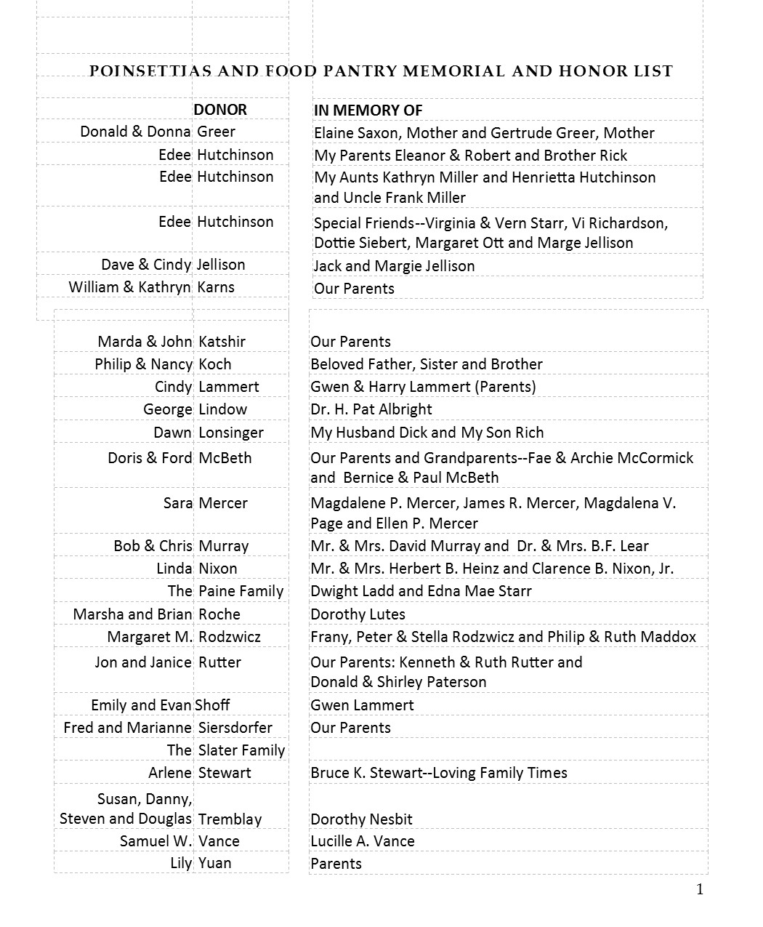
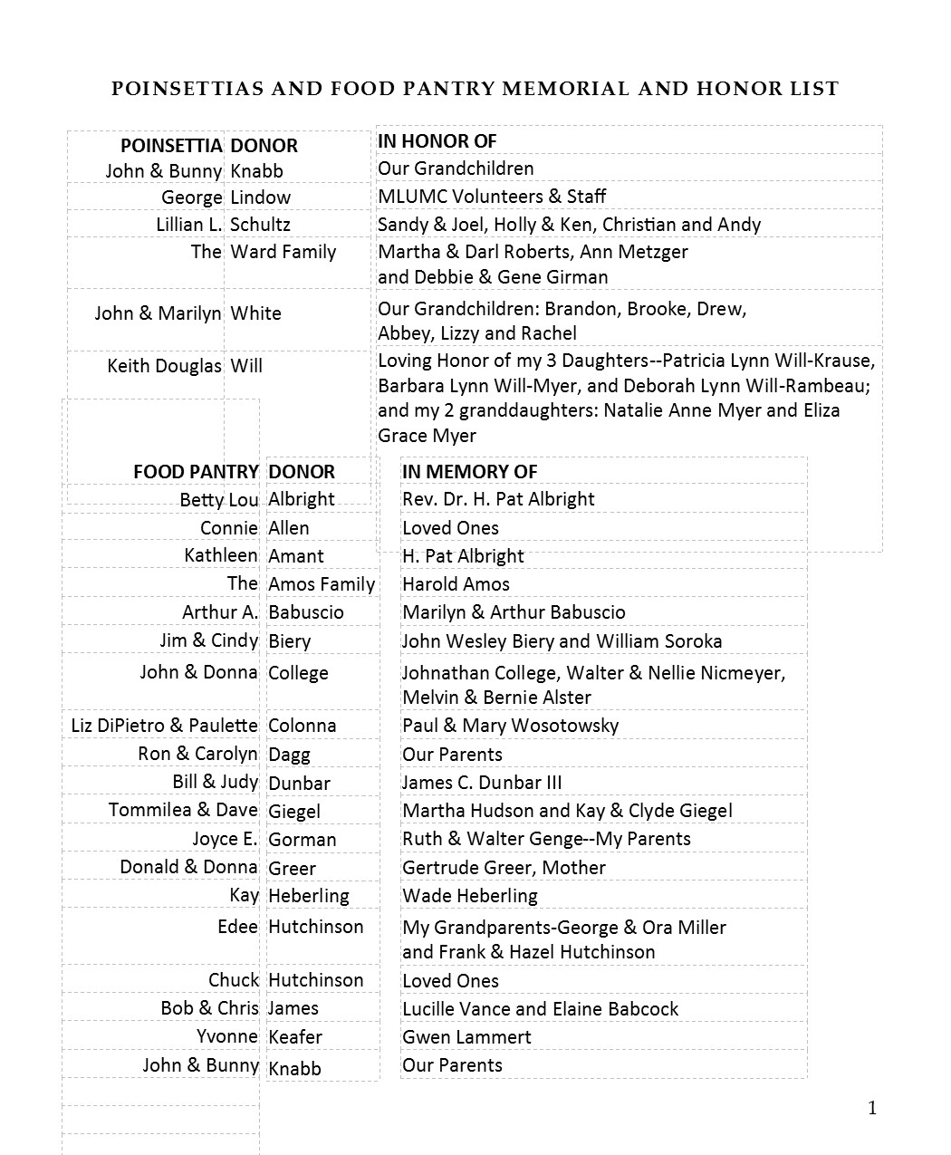

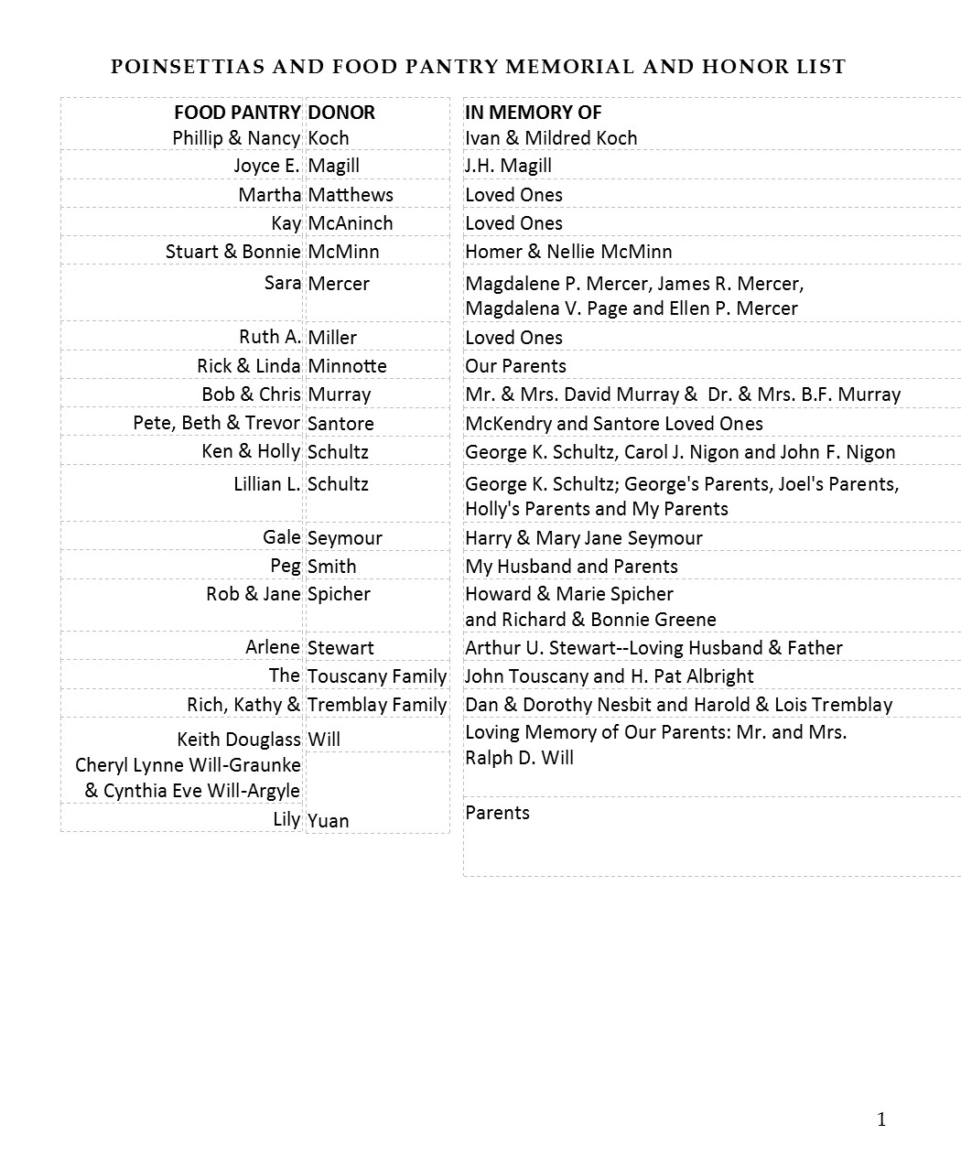

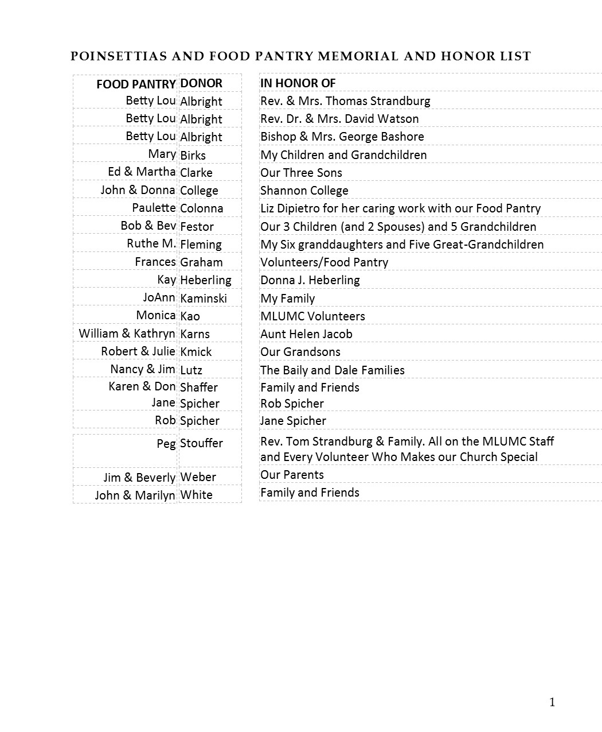

In Sympathy
Condolences are offered to the family of church custodian Mike Staab, on the death of his mother Helen Staab, who passed away on Wednesday, December 21. The funeral took place this morning at St. Valentine Church in Bethel Park. Words of sympathy can be sent to Mike and the Staab family at: 1424 Dormont Ave., Pittsburgh, PA 15216.

