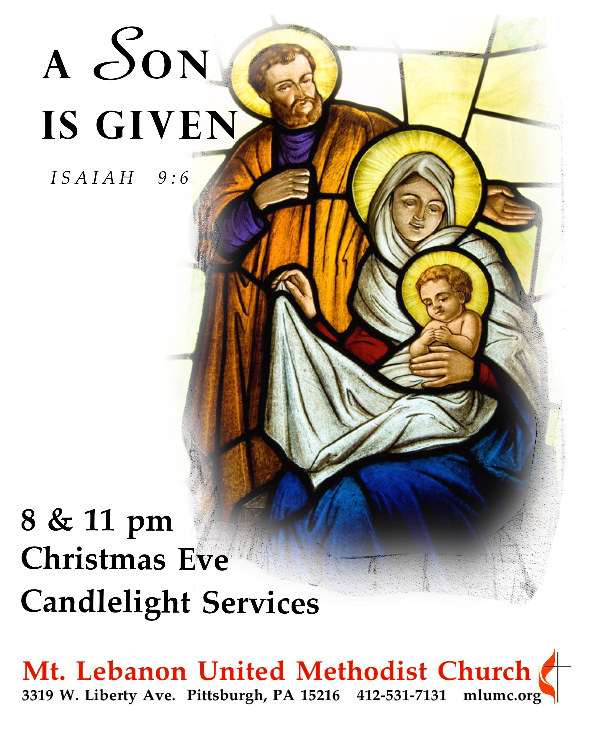
December 24, 2016 Christmas Eve Candlelight Services 8 & 11 pm
A Service of Light
The service begins in darkness, and the light increases throughout, symbolizing the coming of the Light of Christ into the world. A series of candles will be lighted throughout the service, representing the appearance of the Light to the following persons – The Holy Family (Mary, Joseph, and the Baby Jesus), the Angel Gabriel and the other angels, the shepherds, and the Wise Men. By the end of the service, the Light will spread through the entire congregation and through us to the whole world.

Prelude A Festival of Carols Frank Ferko
Away in a manger arranged by Jeffrey Van
Pastoral Variations on an old Noël Marcel Samuel-Rousseau

Call to Worship
Leader: Rejoice, for God is with us – Emmanuel
People: In the darkness of our world shines God’s holy light.
Leader: Now there is reason to hope, to love, to laugh, and to live.
People: God is truly with us. We are not alone. Thanks be to God!

Processional 234 O come, all ye faithful (stanzas 1, 3, 4 & 6, standing) Adeste fidele

Opening Prayer (in unison)
Gracious God, with joy and thanksgiving we gather as your people. We have come to hear again the timeless story of Christ’s birth. In the excitement of this night, quiet our hearts that we may know the peace and fullness of this holy time. Shine, O Light, in the darkness of our world. Sing, O angels, in the stillness of our hearts, “Glory to God in the highest, and on earth peace among those God favors.” This we pray in the name of the Child of Bethlehem. Amen.

Lighting of the Advent Wreath The Angels’ Message: Welcome Joel Raney
8 pm Chris and Stacey Roslek
11 pm Rob and Jane Spicher
Reader: Tonight we gather with joyful hearts to receive God’s greatest gift.
People: Joy to the world, the Lord has come!
Reader: Tonight we hear again the good news that was given for all people.
People: Joy to the world, the Lord has come!
Reader: Tonight we join in steadfast wonder at God’s amazing love.
People: Joy to the world, the Lord has come!
Reader: Tonight we welcome the Savior whose birth has forever changed our lives.
People: Joy to the world, the Lord has come!

(Lighting of the Candle)

Sung Response: Listen to the angels, hear the message they bring;
Telling the news of a coming King;
filling the world with hope and good cheer.
Jesus, Emmanuel, God is near.

Closing Prayer

Service of Lessons & Carols

The Prophecy of the Messiah Isaiah 9:2, 6-7, John 1:1-2, 4-5
Carol 204 Emmanuel, Emmanuel
One candle is lit, representing the angel Gabriel.

The Coming of Jesus is Announced to Mary and Joseph Luke 1:26-38, Matthew 1:18-25
Carol 196 Come, thou long-expected Jesus
Two candles are lit, representing Mary & Joseph.

The Preparations for the Birth of Jesus Luke 2:1-5
Carol 230 O little town of Bethlehem (stanzas 1 & 4)

Jesus is Born Luke 2:6-7
Carol 217 Away in a manger (stanza 1)
One candle is lit, representing the Baby Jesus.
Anthem Hallelu Stephen Paulus

Jesus’ Birth is Announced to the Shepherds Luke 2:9-14
Carol 218 It came upon the midnight clear (stanza 1)
Two candles are lit, representing the angels.
Carol 245 The first Noel (stanza 1)
Three candles are lit, representing the shepherds.

The Shepherds Find the Baby Jesus Luke 2:15-18
Carol 245 The first Noel (stanza 2)
Anthem What child is this? arranged by Dale Warland

The Wise Men Bring Their Gifts to Jesus Matthew 2:1-11
Carol 245 The first Noel (stanzas 3, 4, 5)
Three candles are lit, representing the Wise Men.

Christmas Offering We three kings arranged by Stephen Paulus

Offertory Response
Carol 219 What child is this (stanza 3) Greensleeves
So bring him incense, gold, and myrrh, come peasant king to own him.
The King of Kings salvation brings. Let loving hearts enthrone him.
This, this is Christ the King whom shepherds guard and angels sing.
Haste, haste to bring him laude the Babe, the Son of Mary.

Christmas Meditation “Hope Has Arrived” Rev. Thomas Q. Strandburg

Christmas Prayer (in unison)
Eternal God, by the birth of Jesus Christ you gave yourself to the world.
Grant that, being born in our hearts, he may save us from all our sins,
and restore within us the image and likeness of our Creator,
to whom be everlasting praise and glory, world without end. Amen.

The Passing of the Light
Remember to keep lighted candles upright; only tilt the unlit candle to avoid dripping wax on yourself, the pew and the carpet. As the sanctuary lights dim the pastors will light a candle from the Christ candle and share it with the ushers. They will light the candles of those seated in the pews.

Anthem Gesu Bambino Pietro Yon

Carol 239 Silent night, holy night (stanzas 1, 3)

Carol 246 Joy to the world (stanzas 1, 4)

Benediction Nunc Dimittis Rev. Thomas Q. Strandburg
Leader: Master, now you are dismissing your servants in peace.
People: For our eyes have seen your salvation, which you have prepared in the presence of all people.
Leader: A light for revelation to the Gentiles and for glory to your people Israel.
People: Let us share this Light with the world.

Congregational Benedictions Please exchange greetings and blessings with each other.

Join us on tomorrow Sunday, December 25th, for a Christmas Day Service at 10:45 am in the Sanctuary to celebrate the Christmas season, and Sunday, January 1st, for a service at 10:45 only, also in the Sanctuary.

Tonight’s Services
Assisting Pastor Strandburg tonight is Amy Lee (Ea Kyoung Jun), who is a certified candidate for the ordained ministry in the United Methodist Church, and a student at Pittsburgh Theological Seminary.

Special Music is provided by the Chancel Choir, with soloists Kathleen Whittaker, Kirby Dilworth and Robert Mallery (11:00); and instrumentalists Julia Scott, harp; and Craig Johnson, flute. The presence of the instrumentalists is made possible through contributions to the Friends of Music Fund. Donations are always welcome. Make your check out to the church/Friends of Music Fund.

Acolytes 8:00 Juliana Slater and Cary Young

Nursery services – A wiggle room is available for parents and children in Brookline Parlor, adjacent to the sanctuary.

Holiday hours – The church office is closed and will reopen on Tuesday, December 27th at
8:30 am. The office will also be closed on Friday, December 30th and Monday, January 2nd for the New Year’s holiday.

Each year the W PA Conference and Eastern German Conference create daily Advent and Christmas devotionals for use in our homes and churches. We have chosen devotionals from each week.

Bishop Rosemarie Wenner, Frankfurt/Main
Matthew 1:21
She will give birth to a son, and you are to give him the name Jesus, because he will save his people from their sins. (New International Version)

In Germany we love nativity plays. Many congregations work hard with their children in order to perform well. I was a proud member of the team when I was young. I loved to play Mary. The role of Josef very often was a rather passive one. Quite often Josef was just standing there behind Mary. No one expected important words coming from him. I was glad that it is a male role. By reading the gospel of Matthew we realize that the scripts of those nativity plays do not reflect correctly the biblical role of Josef. Josef had to accept the son of God as his own son, offering care for Mary and the baby boy. This was a difficult and an important role. Josef had not aimed for it. But he was called by God. And he faithfully responded to God’s call. Josef did not only say “yes” with his lips, but with his actions. He served as a human father for a godly child. As fathers were privileged to do in ancient times, he had to name his firstborn son. But the name had been chosen by God.

The baby boy should be called Jesus. Jesus means God is the saver. In the announcement that Josef received it was further explained: Jesus will save his people from their sins. For Jewish believers it was clear: God is the only one who is able to forgive sins. If Jesus was able to save from sins, than Jesus indeed was God’s son as well as Josef’s son. It is hard to believe that God becomes human in the son of Mary, the young women and that God’s son will grow up in the home of the carpenter Josef. But this is part of the story how God wanted to save his people from their sins and reestablish the relationship between God and those who are willing to receive forgiveness. God becomes one of us. We are all called to accept the unexpected news so that our lives will be changed. Are we listeners like Josef? And are we ready to respond to the call to join the family of God by accepting Jesus as savior and following him? I wish we could learn from Josef. He is indeed worthy to be looked upon as a role model.

Bishop Cynthia Moore-Koikoi, Western Pennsylvania Conference

Luke 2: 11-13
Today in the town of David a Savior has been born to you; he is the Messiah, the Lord. This will be a sign to you: You will find a baby wrapped in cloths and lying in a manger.” Suddenly a great company of the heavenly host appeared with the angel and praising God. (New International Version)

Christmas is a time of great joy. It is a season when we connect with friends and family. Sometimes, however, these very connections make it more challenging for us to take the time needed to connect with the one whose birth created this season. According to Luke during that first Christmas, Mary and Joseph connected with friends and family in Beth- lehem, shepherds, a prophets and a prophetess. But after being visited by the shepherds, Mary took the opportunity to reconnect with God as she pondered everything the shepherds had said. I wonder what it would be like if after every visit with friends and family during this holiday season we stopped to deliberately reflect on the good news and great joy of the birth of Jesus. What if after every cookie or gift exchange, dinner, or party, we took time just to treasure and ponder the words, “to you is born this day in the city of David a Savior, who is the Messiah, the Lord.” Perhaps these moments of reflection are all God needs to move in our hearts so that during this season we truly become agents of peace and good will toward humankind.
Prayer: Lord help us during this season of connections, not to forget to connect with you.

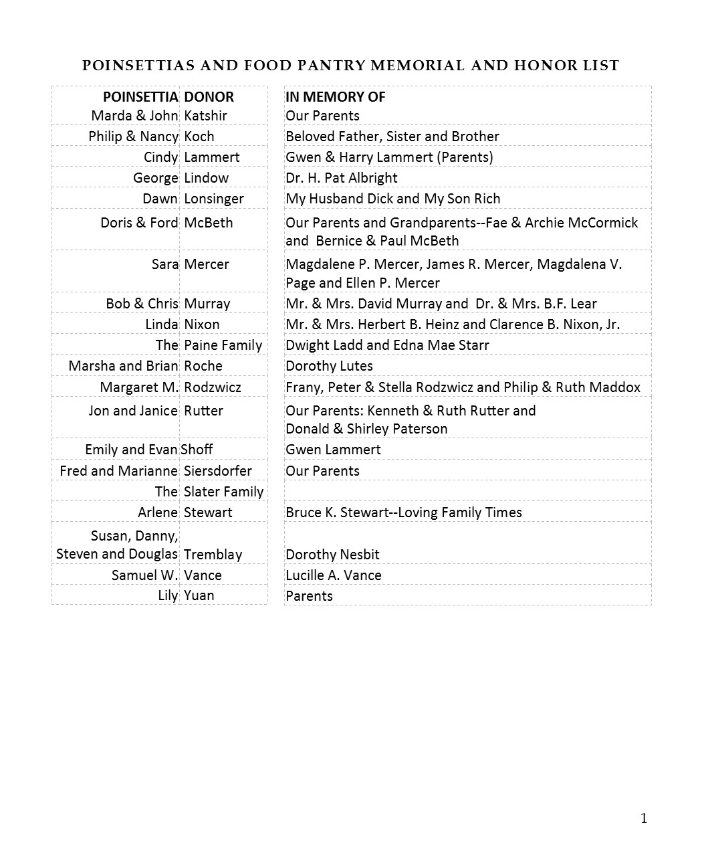

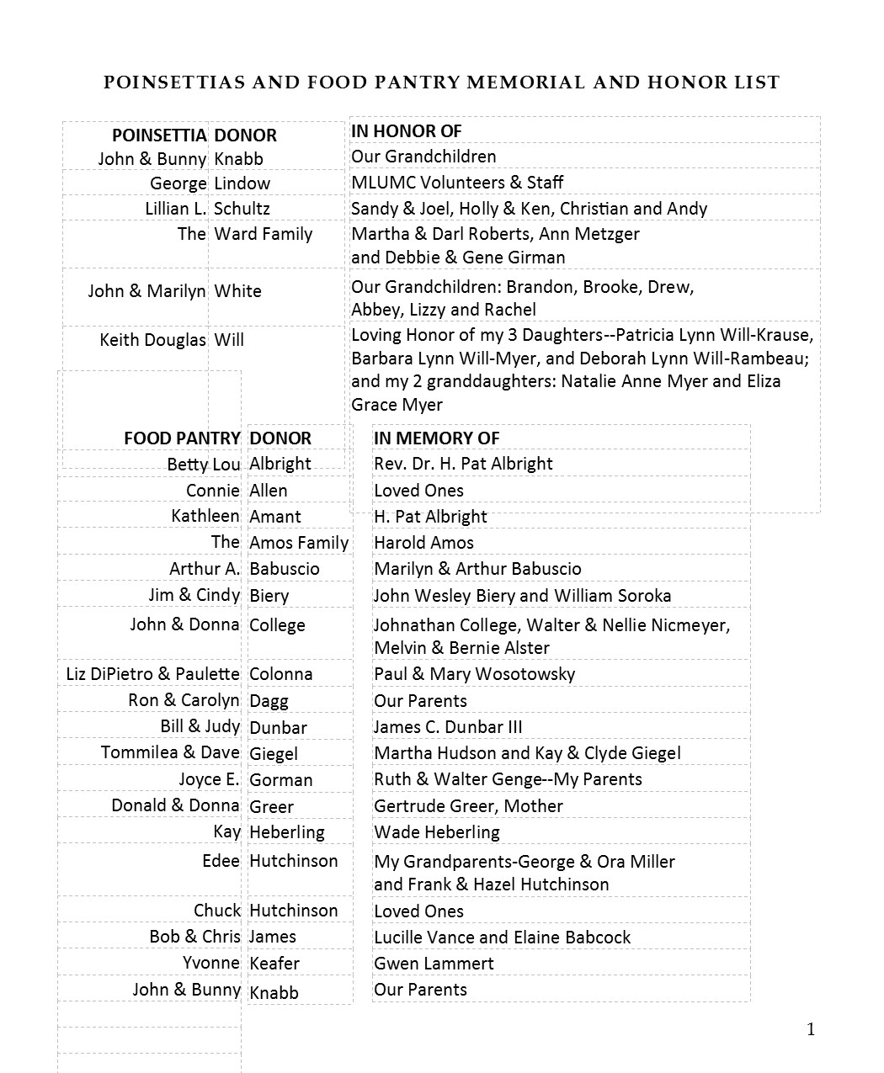
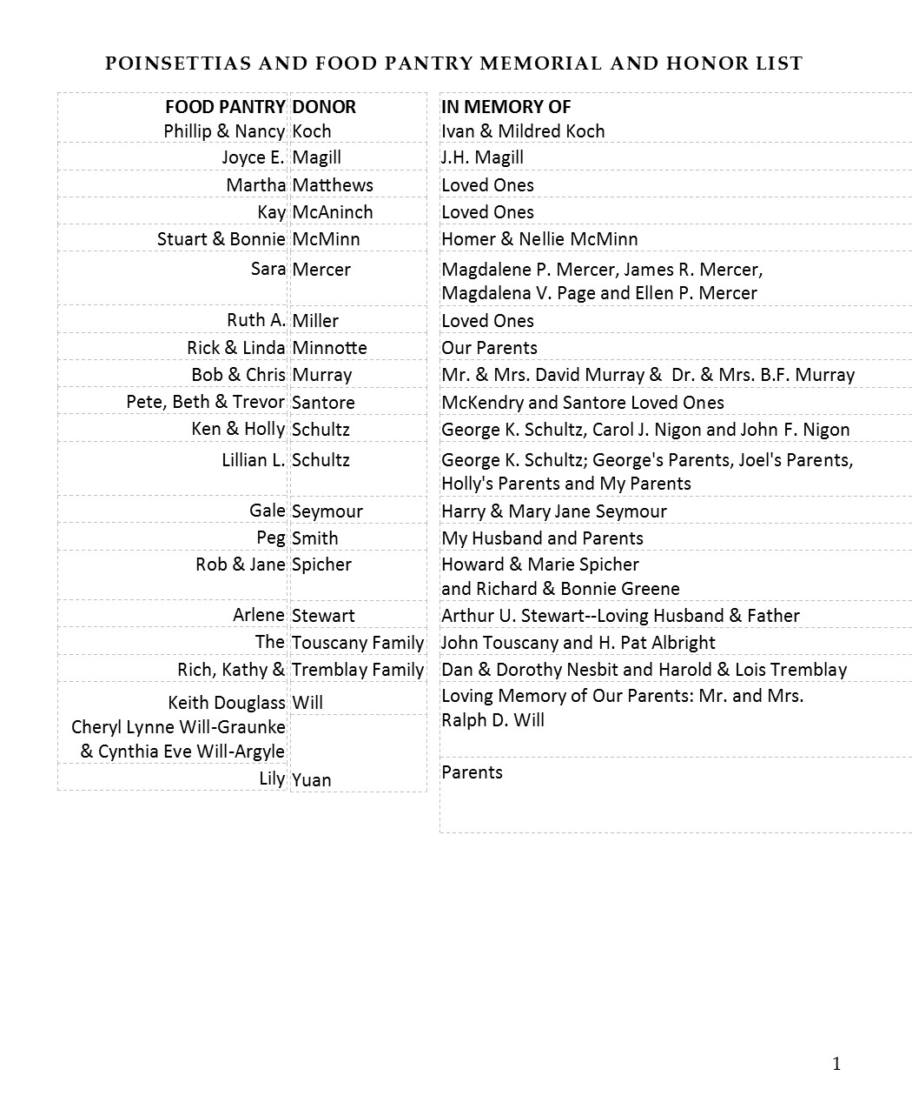
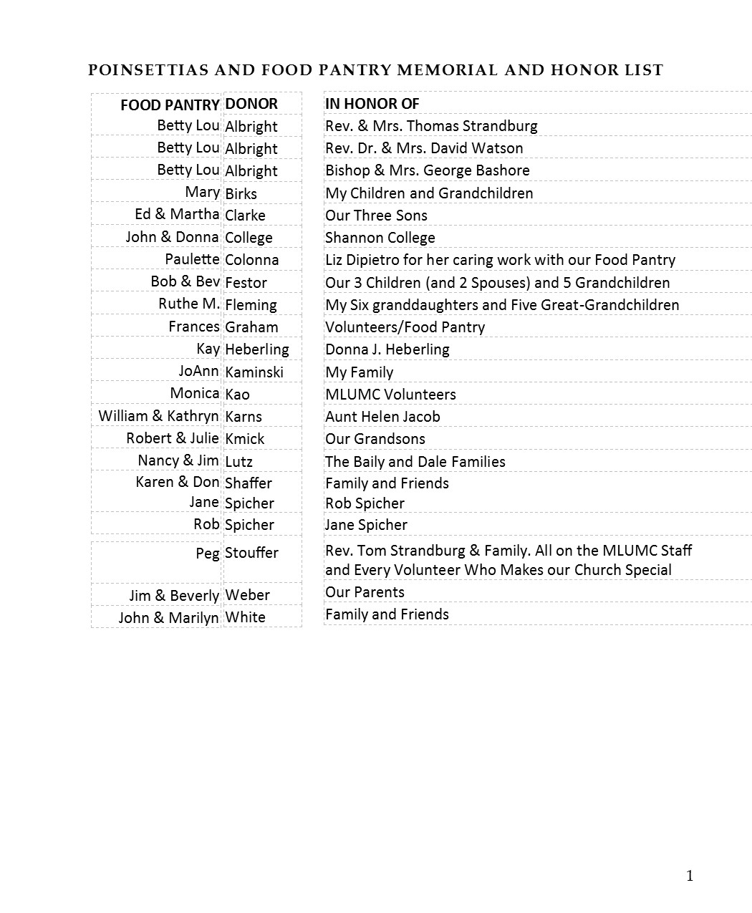

In Sympathy
Condolences are offered to the family of church custodian Mike Staab, on the death of his mother Helen Staab, who passed away on Wednesday, December 21. The funeral took place this morning at St. Valentine Church in Bethel Park. Words of sympathy can be sent to Mike and the Staab family at: 1424 Dormont Ave., Pittsburgh, PA 15216.

