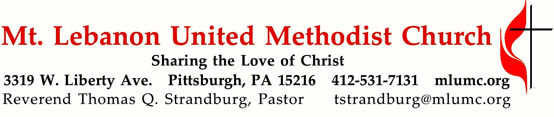
December 25, 2016 10:45
CHRISTMAS DAY
Because of Christ’s coming into the world, we all are family! As the words of the apostle Paul affirm to us today, “Both the one who makes men holy and those who are made holy are of the same family.” (Hebrews 2:11, NIV)
WE GATHER IN GOD’S NAME …

Gathering Music
Hymn 251 Go, tell it on the mountain Go tell it on the mountain
Hymn 217 Away in a manger Away in a manger

Call to Worship
Leader: Christ is born, give him glory!
People: Christ has come down from heaven, receive him! Christ is now on earth; exalt him!
Leader: O you earth, sing to the Lord!
People: O you nations, praise him in joy, for he has been glorified!
Traditional Byzantine Christmas Prayer

… TO GIVE PRAISE TO GOD …

Hymn 250 Once in royal David’s city Irby

Lighting of the Christ Candle

Opening Prayer (in unison)
O God our Father, you have brought us again to the glad season
when we celebrate the birth of your Son, Jesus Christ our Lord.
Grant that his Spirit may be born anew in our hearts this day
and that we may joyfully welcome him to reign over us.
Open our ears that we may hear again the angelic chorus of old.
Open our lips that we, too, may sing with uplifted hearts.

Glory to God in the highest, and on earth, peace, goodwill toward all;
through Jesus Christ our Lord. Amen. Book of Worship, 1944

… TO CELEBRATE THE FAMILY OF FAITH …

The Sign of Peace Please pass the peace to your neighbors as a sign of reconciliation and love.
Leader: The peace of Christ be with you.
People: And also with you.

Gathering Song James Ritchie
This, this is where children belong,
welcomed as part of the worshiping throng.
Water, God’s Word, bread and cup, prayer and song:
This is where children belong. WORDS AND MUSIC: James Ritchie ©1999 Abingdon Press

Message for Young Disciples Rev. Thomas Q. Strandburg
(All children are invited. Please sing as children come forward. Kids’ Praise is not being held today.)

Scripture Reading Sally Munro
A Lesson from the Epistles
Hebrews 2:10-18 Christ our High Priest

Hymn 230 O little town of Bethlehem (stanza 3) St. Louis
Hymn 240 Hark! The herald angels sing Mendelssohn

Pastoral Prayer

The Lord’s Prayer
Our Father, who art in heaven, hallowed be thy name. Thy kingdom come, thy will be done, on earth as it is in heaven. Give us this day our daily bread. And forgive us our trespasses, as we forgive those who trespass against us. And lead us not into temptation, but deliver us from evil. For thine is the kingdom, and the power, and the glory forever. Amen.

… TO HEAR GOD’S WORD PROCLAIMED …

Scripture Reading
A Lesson from the Gospels
John 1:1-14 In the beginning was the Word

Response
Leader: The Word of the Lord.
People: Thanks be to God.

Sermon “We Are Family” Rev. Thomas Q. Strandburg

… TO OFFER OUR GIFTS AND TO DEDICATE OUR LIVES …

Offertory Anthem Hallelu Stephen Paulus
Down in a valley, sing hallelu! Mary had a baby, sing hallelu!
What did she name Him; Named Him Jesus, hallelu!

Doxology Hymn 254 We three kings (stanza 2) Kings of Orient
Prayer of Dedication

… TO GO REJOICING IN GOD’S NAME!

Hymn 238 Angels we have heard on high Gloria

Benediction

Join us next Sunday, January 1st, for a service at 10:45 only, in the Sanctuary. There will be no Sunday School or Kids’ Praise during the service

Today’s Services
Special music at 10:45 is provided by the Chancel Choir.

Greeters Carolyn and Ron Dagg

In Sympathy Condolences are offered to the family of church custodian Mike Staab, on the death of his mother Helen Staab, who passed away on Wednesday, December 21. The funeral took place on Saturday at St. Valentine Church in Bethel Park. Words of sympathy can be sent to Mike and the Staab family at: 1424 Dormont Ave., Pittsburgh, PA 15216.

Holiday hours The church office is closed and will reopen on Tuesday, December 27th at
8:30 am. The office will also be closed on Friday, December 30th and Monday, January 2nd for the New Year’s holiday.

Today’s Scriptures (The congregation may follow the readings with the Bibles in the pews.)
Hebrews 2:10-18, The New Testament, page 219
John 1:1-14, The New Testament, pages 91-92

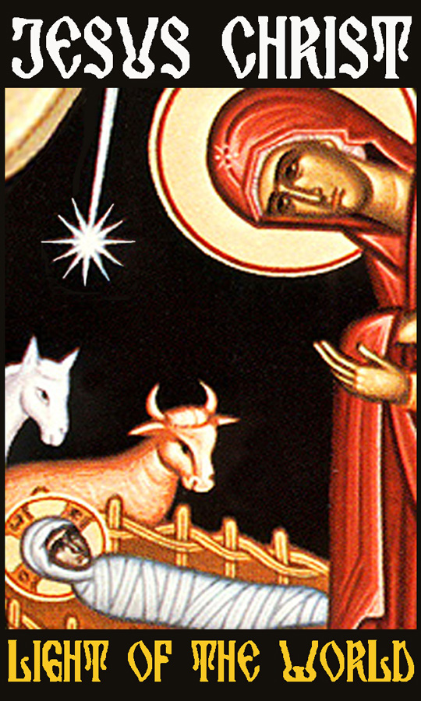Each year the W PA Conference and Eastern German Conference create daily Advent and Christmas devotionals for use in our homes and churches. We have chosen devotionals from each week.

Rev. Daniel P. Grimes, Pine City UMC, Knox PA

She will give birth to a son, and you are to give him the name Jesus, because he will save his people from their sins. (Matthew 1:21 New International Version)
We live in fear too often. Fear will keep us from doing what God wants us to do. It will consume us if we let it. Do you think Joseph was afraid to take Mary as his wife? Punishment would have been harsh, according to today’s standards. Possibly death, because it could have been considered adultery. Joseph was hesitant, then God reassured him. The words of God in Matthew 1:20 b-21: “Joseph son of David, don’t be afraid to take Mary as your wife, because the child she carries was conceived by the Holy Spirit. She will give birth to a son, and you will call him Jesus, because he will save his people from their sins” reassured Joseph to take Mary as his wife.

What would our lives look like if Joseph had acted out of his fear and not listened to God’s reassurance? Would we celebrate Christmas the same way? Would Mary have been stoned for adultery? Or would God have protected her no matter what they situation was? I believe God would have protected her no matter what the situation, but Joseph would have missed out on being a part of raising the Son of God as He walked on the earth. Ask yourself; how many times have I made a decision out of fear and not obedience? What have I missed out on by deciding that way? Joseph was picked by God for the task of being the earthly father of Jesus Christ. I believe God knew he could do it, but Joseph’s insecurity and fear just about caused him to miss out on the awesome job God had for him. What have we missed out on because we were afraid? Mary gave birth to salvation. It was in the name of Jesus Christ. For salvation to happen we all need to do our part and step out, without fear, and do the work and will of God.

Pastor Michael Kropff, Zschorlau
“To you is born this day in the city of David a Savior, who is the Messiah, the Lord. This will be a sign for you: you will find a child wrapped in bands of cloth and lying in a manger.” And suddenly there was with the angel a multitude of the heavenly host (Luke 2:11-13 NRSV)

Luke 2, the Christmas Story or the Story of Jesus’ Birth – a text we all know. Read and heard every year. It’s familiar and gives a homey feeling – the holy night, full of warmth and light, shelter in a stall, the Good News for the shepherds, songs of praise from the fields. A safe world. Just like when we were kids. But who is this child? The Savior and Redeemer, Christ, the Messiah, the Lord. Big words for such a small baby. Aren’t these all descriptions and titles which are actually for a entitled for a ruler? Titles which were used to address the Emperor Augustus? The Redeemer is not a sweet little baby, but a sovereignty. Messiah, in Greek Christ, is the title of an anointed king. Lord is the word which the Jews had already used in the Old Testament to address God our Lord. Not a sweet, loving Redeemer. Not a nice, homey, children’s experience. It deals with big politics, God Himself. How is this Savior, this Messiah, this Lord different. What are the symbols of His power? A crown? A sword? Scepter and imperial orb? NO! His symbols are diapers and a crib – a child. What rejection and blasphemy of kings and rulers, presidents and chancellors..... This Lord, this child, is different. The diapers a reminder of His cloak that would be divided under the cross. His wooden crib a reminder of the cross on which He would be nailed. This child in diapers and in a crib is the Savior, the anointed King, the Lord – this helpless and naked man on the cross.

Who are we hoping for? A poor, helpless child, a man on a cross? Or on the powerful, the chancellor or presidents? Where is help? In Washington? In Berlin? In the City of David! When is the day of salvation? Today! Not on election day, November 18th and not in autumn 2017. For today Jesus was born and today He wants to be born again in our hearts.

