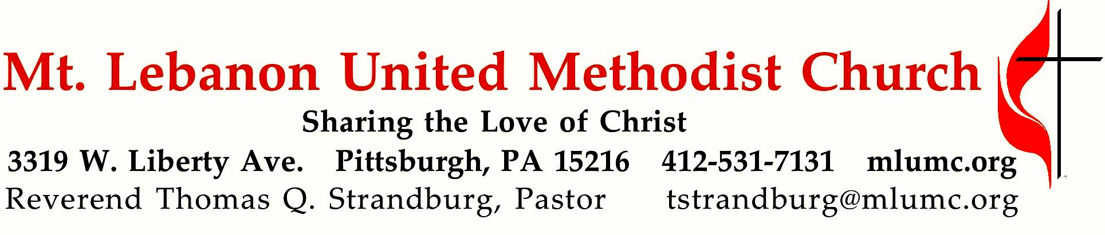
January 29, 2017 8:30 & 10:45
4th Sunday after Epiphany
Remember Jim Collins' 2001 bestseller, Good to Great: Why Some Companies Make the Leap and Others Don't? It highlighted 11 companies that had gone from good to great. For our spiritual lives, the Bible suggests a different approach. Rather than seeking to go from good to great, God suggests moving from great to good.

WE GATHER IN GOD’S NAME …

Gathering Music
Hymn 348 Softly and tenderly Jesus is calling (stanzas 1, 2 and 4, seated) Thompson
Worship & Song 3019 Bidden, unbidden (stanza 2) Jewel

Greeting
Leader: Rise up, O Lord! Deliver me, O my God!
People: Deliverance belongs to the Lord; may your blessings be on your people! Psalm 3:7a, 8
Announcements

Introit 10:45 O come let us sing unto the Lord.
Let us make a joyful noise unto the rock of our salvation. Richard C. Baker

Call to Worship
Leader: Where can we go and seek refuge?
People: We’ve taken refuge in you, Lord.
Leader: Who can rescue us from the grip of the wrongdoer?
People: We plead our case to you, Lord.
Leader: Is there any place we can run to escape the spiritual dangers
that surround us?
People: The Lord is our rock and refuge.
Leader: Let us lift up our praise as we celebrate the deliverance found
only in the Lord.
… TO GIVE PRAISE TO GOD …

Worship & Song 3012 When words alone cannot express* (standing) Lasst uns erfreuen

Opening Prayer (in unison)
God of hope and love, let your light shine upon us this day. Let your patience and kindness flow through us, inspiring us to new depths of love and hope. Transform our love, that we might overcome envy and resentment, and rejoice in justice and righteousness. Envelop us in your love, that believing, hoping, and enduring may become our way of life on the path of love. In loving hope, we pray. Amen.

… TO CELEBRATE THE FAMILY OF FAITH …

The Sign of Peace Please pass the peace to your neighbors as a sign of reconciliation and love.
Leader: The peace of Christ be with you.
People: And also with you.

Gathering Song James Ritchie
This, this is where children belong,
welcomed as part of the worshiping throng.
Water, God’s Word, bread and cup, prayer and song:
This is where children belong.
WORDS AND MUSIC: James Ritchie ©1999 Abingdon Press

Message for Young Disciples Rev. Thomas Q. Strandburg
(All children are invited. Please sing as children come forward.)

After the children’s message at the 10:45 service, children ages 3 - 3rd grade may attend Kids Praise in the Welcome Center. Children will be escorted to and from Kids Praise by teachers. They will return to the Sanctuary near the end of the service, and parents may meet them.

… TO HEAR GOD’S WORD PROCLAIMED …

Hymn 468 Dear Jesus, in whose life I see (seated) Hursley

Scripture Reading 8:30 Kathy Tremblay
10:45 Sara Knabb
A Lesson from the Hebrew Scriptures
Micah 6:1-8 What does the Lord require?

Worship & Song 3022 Peace of our praying (stanza 3, seated) Pahoa

Pastoral Prayer

The Lord’s Prayer
Our Father, who art in heaven, hallowed be thy name. Thy kingdom come, thy will be done, on earth as it is in heaven. Give us this day our daily bread. And forgive us our trespasses, as we forgive those who trespass against us. And lead us not into temptation, but deliver us from evil. For thine is the kingdom, and the power, and the glory forever. Amen.

Scripture Reading
A Lesson from the Gospels
Matthew 5:1-12 The Beatitudes

Response
Leader: The Word of the Lord.
People: Thanks be to God.

… TO OFFER OUR GIFTS AND TO DEDICATE OUR LIVES …

Offertory Solo 8:30 Now with singing and praise arranged by Dale Wood

Offertory Anthem 10:45 With all I am text by John Thornburg, music by Taylor Davis
Though I may master all things known, though I may forfeit all I own
and do not love, I search in vain to find the God who knows my name.

Love does not hide or run away, it does not threaten or delay.
Alive in hope, it braves our schemes, it bears our pain, believes our dreams.

With all I am, in all I do, I pledge my faith, I honor you.
I give you, Lord, my solemn vow; my life, my love, I offer now.
My life, my love, I offer now.

Doxology 94
Praise God from whom all blessings flow;
Praise God, all creatures here below: Alleluia! Alleluia!
Praise God the source of all our gifts!
Praise Jesus Christ, whose power uplifts!
Praise the Spirit, Holy Spirit. Alleluia! Alleluia! Alleluia!

Prayer of Dedication

Sermon “From Great to Good ” Rev. Thomas Q. Strandburg

… TO GO REJOICING IN GOD’S NAME!

Hymn 555 Forward through the ages (standing) St. Gertrude

Benediction

Today’s Services

The flowers in the Chancel are given by Martin and Jean Ives in loving memory of his mother, Katherine Ives.

The flowers on the altar are given by Jane Spicher in celebration of Rob Spicher’s birthday on February 3.

Special music at 10:45 is provided by the Chancel Choir, accompanied by pianist Cori DeLuca, a member of the church who teaches piano in the area.

*Our hymn of the month begins “When words alone cannot express all that our hearts ache to confess, bring music!” Contemporary poet and Presbyterian minister John Thornburg is so right, for whether we whistle or hum a happy tune or sing the words of a comforting hymn, music offers another dimension to our lives. Alleluia!

Acolytes Lydia and Juliana Slater

Greeters 8:30 Carolyn and Ron Dagg 10:45 Betty Lou Albright

Worship options for children We encourage children to participate in the Children’s Sermon at both services, and in Kids Praise during the 10:45 service. Nursery services are offered in Room 204 of the Education Building. Ask ushers or greeters and follow signs for direction.

Podcasts of Sunday Sermons Would you like to share this morning’s sermon with a friend or did you miss a Sunday? Catch up on the messages from MLUMC with a podcast of Pastor Tom’s and others’ Sunday sermons. Sermons from the past three months are at
http:// mlumc.buzzsprout.com. You can navigate to the site from the link on our webpage, www.mlumc.org, through the app, Stitcher or through iTunes

Flower Donations Honor or remember a loved one or friend with a Sunday flower arrangement donation. Contact Sharon Slater, 412-343-1137.

Today’s Scriptures
Micah 6:1-8
Hear what the Lord says: Rise, plead your case before the mountains, and let the hills hear your voice. ²Hear, you mountains, the controversy of the Lord, and you enduring foundations of the earth; for the Lord has a controversy with his people, and he will contend with Israel. ³“O my people, what have I done to you? In what have I wearied you? Answer me! ⁴For I brought you up from the land of Egypt, and redeemed you from the house of slavery; and I sent before you Moses, Aaron, and Miriam. ⁵O my people, remember now what King Balak of Moab devised, what Balaam son of Beor answered him, and what happened from Shittim to Gilgal, that you may know the saving acts of the Lord.”

⁶“With what shall I come before the Lord, and bow myself before God on high? Shall I come before him with burnt offerings, with calves a year old? ⁷Will the Lord be pleased with thousands of rams, with ten thousands of rivers of oil? Shall I give my firstborn for my transgression, the fruit of my body for the sin of my soul?” ⁸He has told you, O mortal, what is good; and what does the Lord require of you but to do justice, and to love kindness, and to walk humbly with your God?

Matthew 5:1-12
When Jesus saw the crowds, he went up the mountain; and after he sat down, his disciples came to him. ²Then he began to speak, and taught them, saying:

³“Blessed are the poor in spirit, for theirs is the kingdom of heaven.
⁴Blessed are those who mourn, for they will be comforted.
⁵Blessed are the meek, for they will inherit the earth.
⁶Blessed are those who hunger and thirst for righteousness, for they will be filled.
⁷Blessed are the merciful, for they will receive mercy.
⁸Blessed are the pure in heart, for they will see God.
⁹Blessed are the peacemakers, for they will be called children of God.
¹⁰Blessed are those who are persecuted for righteousness’ sake, for theirs is the kingdom of heaven. ¹¹Blessed are you when people revile you and persecute you and utter all kinds of evil against you falsely on my account.

¹²Rejoice and be glad, for your reward is great in heaven, for in the same way they persecuted the prophets who were before you.”

Keep in Prayer
Hospitalized
Lynne Beck, Allegheny General
Morgan May Shotsberger, Children’s
Ann Swartz, St. Clair

Convalescing in Care Facilities
Leila Berkey, Asbury Heights
Ed Clarke, Asbury Place
Esther Davis, Fair Oaks
May Frederick, Concordia Health Care
Tim Watters, Baptist Homes

Convalescing at Home
Mary Caldwell, Jean George, Earl Killian,
Susan Lichtenfels, Dawn Lonsinger

In the Military

Jason Boyer, SPC Natalie Brown

Capt. Zachary Allen Finch, USMC
James Iantelli, 1st Lt. Jaskiewicz
S. Sgt. Keith Kimmell, Adam Kmick
PFC Brendan Lamport
Sgt. Matthew McConahan

Sgt. Richard Okello, Thomas Orda
Lt. Col. Mark Patterson

Lt. Com. Scott Patterson

Lt. Col. Sean Patterson
David Poncel, Sgt. Steven Reitz
Capt. Scott B. Rushe, Pastor Rick Townes
Maj. Azizi Wesmiller

Maj. Matthew C. Wesmiller
Sgt. Keith Scott Winkowski

Sgt. Michael Zimmerman

In Sympathy

Condolences are offered to the family of church member Robert “Bob” Fairgrieve, age 83, who died on Sunday, January 15, 2017. A memorial service was held on Wednesday, January 18 at our church. Bob was a member of MLUMC for over 68 years. Words of comfort for the family can be sent to his wife:

Mrs. Carol Fairgrieve

300 Madison Ave.

Apt. 517

Pittsburgh, PA 15243

Expressions of sympathy can be sent to MLUMC’s former pastor, Rev. Oden Warman at the sudden passing of his brother John Warman on Tuesday, January 17, 2017:

Oden and Debbie Warman

6830 Wilson Road

Friendship, MD 2075

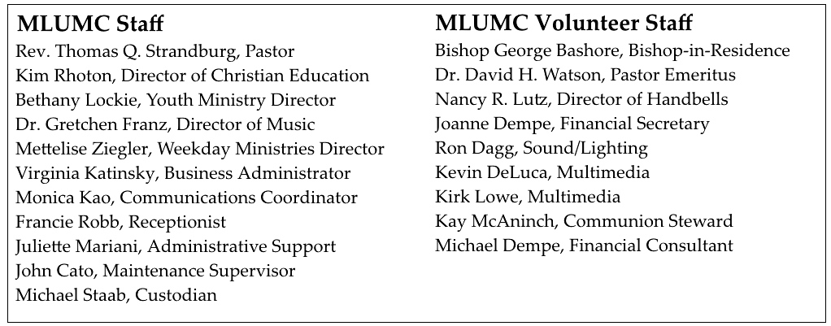

Looking to send a card? Here are some helpful addresses:

Asbury Heights Baptist Homes
700 Bower Hill Road 489 Castle Shannon Blvd.
Pittsburgh, PA 15243 Pittsburgh, PA 15234

Concordia Health Center St. Clair Hospital
1300 Bower Hill Road 1000 Bower Hill Road
Pittsburgh, PA 15243 Pittsburgh, PA 15243

Become a Greeter: Extend a Welcome Hand
The Sunday morning greeter is often the first person a visitor or member contacts on entering the church. A greeter’s smile, handshake and cheerful words may set the tone for not only a church goer’s worship experience, but also an entire day. MLUMC is in need of Sunday morning greeters. Consider serving at one of the two worship services. You’ll become a vital part of the church’s ministry of hospitality and make new friends. If you can offer this service once or twice a year, fill out the form below and drop it in the collection basket or deliver it to the office.

Greeter Volunteer Name _______________________________________________
Worship service choice _______8:30 ______10:45
Phone # _________________________ email ________________________________
CALENDAR – SUNDAY, JANUARY 29 THRU SATURDAY, FEBRUARY 4

SUNDAY 1/29
8:30 am Worship Sanner Chapel
9:30 am Sunday School/ Coffee Café Various/ Brookline Parlor
10:45 am Worship Sanctuary
Kids Praise Welcome Center
4:30 pm Youth Choir Rehearsal Choir Room
5 pm Youth Group Asbury Center

MONDAY 1/30
7 pm Chapel Bells Rehearsal Bell Room
7:30 pm German Class Welcome Center

TUESDAY 1/31
6 pm Terrific Tuesday Asbury Center
7 pm Boy Scout Troop #23 Wesley Hall

WEDNESDAY 2/1
6:30 am Northside Lunch Program Prep Kitchen
6 pm Homebuilders’ Picnic Wesley Hall

THURSDAY 2/2
8:30 am Northside Lunch Program Prep Kitchen
9:30 am Hands & Hearts Epworth
12 pm TNT Asbury Heights
6:30 pm Promise Bells Rehearsal Bell Room
7:30 pm Chancel Choir Rehearsal Choir Room

FRIDAY 2/3
9:30 am Women’s Bible Study Room 102

SATURDAY 2/4
10 am Food Distribution Pantry
11:30 am Food Pantry Open House Asbury Center

