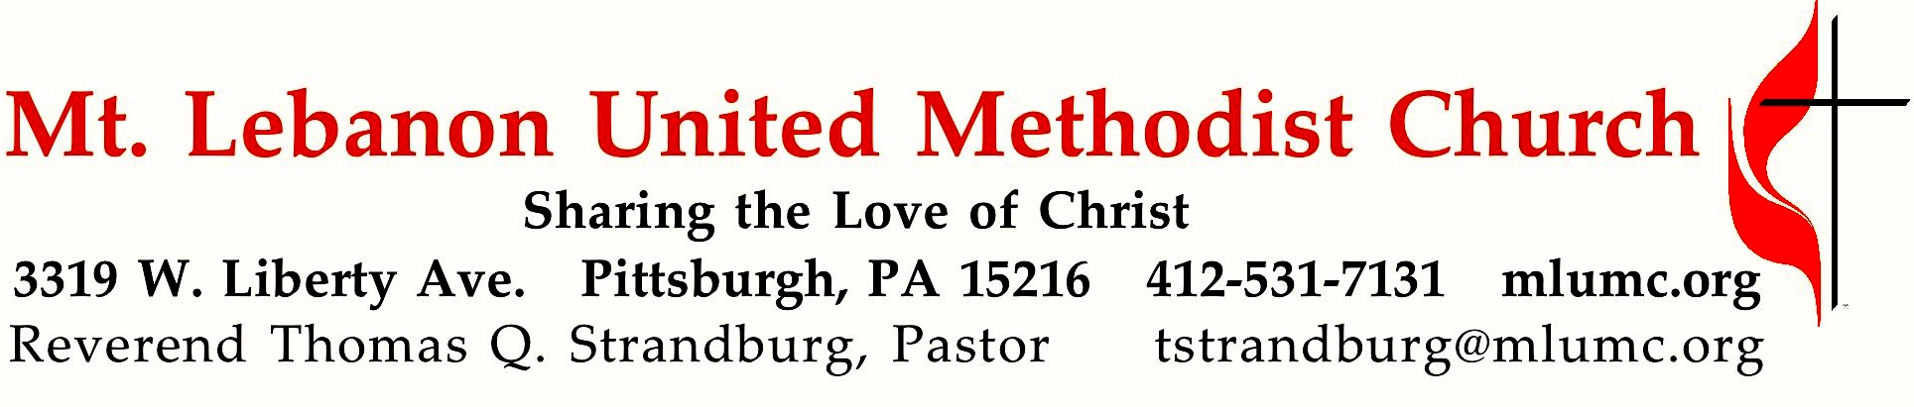
January 8, 2017 8:30 & 10:45

1st Sunday after the Epiphany – Baptism of the Lord
Father in heaven, at the baptism of Jesus in the River Jordan, You proclaimed Him Your beloved Son and anointed Him with the Holy Spirit. Grant that all who are baptized into His name may keep the covenant they have made, and boldly confess Him as Lord and Savior, who with You and the Holy Spirit lives and reigns, one God, in glory everlasting. Amen. Hymn 253

WE GATHER IN GOD’S NAME …

Gathering Music
Hymn 248 On This Day Earth Shall Ring (stanzas 3,4) Personent Hodie
Worship & Song 3051 A Star Shone Bright Garland

Greeting Bishop George W. Bashore
Leader: "The voice of the Lord is powerful;
the voice of the Lord is full of majesty."
Ps. 29:4
Let us hear the voice of the Lord: "When Jesus had been baptized. . . suddenly the heavens were opened to him and he saw the Spirit of God descending like a dove and alighting on him. And a voice from heaven said, 'This is my beloved Son, with whom I am well pleased."' Matt. 3:16,17
People: (sung, Hymn 234, stanza 2)
True God of true God, Light from Light Eternal,
lo, he shuns not the Virgin's womb;
Son of the Father, begotten, not created;
O come, let us adore him, O come, let us adore him,
O come, let us adore him, Christ the Lord!

The Church in Mission and Worship (Announcements)

Choral Introit 10:45 Thomas Keesecker
Arise, shine; for your light has come, and the glory of the Lord has risen upon you.

… TO GIVE PRAISE TO GOD …

Affirmation of Faith The Nicene Creed Hymn 880

Hymn of Praise 189 Fairest Lord Jesus St. Elizabeth

Prayer of Confession and Assurance of Pardon (seated) Hymn 890

Sung Response, Hymn 241 That boy-child of Mary (stanzas 2,5,6) Blantyre

… TO CELEBRATE THE FAMILY OF FAITH …

The Sign of Peace Please pass the peace to your neighbors as a sign of reconciliation and love.
Leader: The peace of Christ be with you.
People: And also with you.

Gathering Song James Ritchie
This, this is where children belong,
welcomed as part of the worshiping throng.
Water, God’s Word, bread and cup, prayer and song:
This is where children belong.
WORDS AND MUSIC: James Ritchie ©1999 Abingdon Press

Message for Young Disciples Kim Rhoton
All children are invited. Please sing as children come forward. After the children’s message at the 10:45 service, children ages 3 - 3rd grade may attend Kids Praise in the Welcome Center. Children will be escorted to and from Kids Praise by teachers. They will return to the Sanctuary near the end of the service.

… TO HEAR GOD’S WORD PROCLAIMED …

Hymn 598 O Word of God incarnate Munich

Scripture Reading 8:30 Liz DiPietro
10:45 Scott Ullman
A Lesson from the Gospel (standing)
Matthew 3:13-17; 16:13-17; 17:1-5

Response
Leader: The Word of the Lord.
People: Thanks be to God.
Hymn 526 What a friend we have in Jesus Converse

Pastoral Prayer

Worship & Song 3068 The Lord’s Prayer Malotte

… TO OFFER OUR GIFTS AND TO DEDICATE OUR LIVES …

Offertory Anthem 10:45 My Son, the Beloved David Blackwell
In those days Jesus came from Nazareth of Galilee and was baptized by John in the Jordan.
And as he came out of the water, he saw the heavens torn apart
and the Spirit descending like a dove on him.
And a voice came from heaven, “You are my Son, the Beloved; with you I am well pleased.
My Son, the Beloved.” Mark 1: 9-11

Doxology 94 (standing)
Praise God from whom all blessings flow;
Praise God, all creatures here below: Alleluia! Alleluia!
Praise God the source of all our gifts!
Praise Jesus Christ, whose power uplifts!
Praise the Spirit, Holy Spirit. Alleluia! Alleluia! Alleluia!

Prayer of Dedication

Sermon "We Believe in One Lord, Jesus Christ, the Only Son of God"
Bishop George W. Bashore

Choral Affirmation 10:45 Sir John Stainer
God so loved the world that He gave His only begotten Son,
that whoso believeth in Him should not perish, but have everlasting life.
For God sent not His Son into the world to condemn the world;
but that the world through Him might be saved. John 3: 16

… TO GO REJOICING IN GOD’S NAME!

Benediction

Choral Benediction 10:45 Peter C. Lutkin
The Lord bless you and keep you, the Lord lift his countenance upon you; and give you peace,
the Lord make his face to shine upon you, and be gracious unto you. Amen.

Today’s Services
The chancel flowers are given by the Floss, Caputo, Masar, and Krewin families in loving memory of Kathy Caputo, Judy Floss, Frank Floss, Tom Knowlson and Bitty Floss.

The flowers on the altar are given by Bill and Bernice Merchant in honor of the Chancel Choir.

Special music at 10:45 is provided by the Chancel Choir.

Greeters 8:30 Erma Henry 10:45 The Siegert family – Michael, Patty, Rylee and Max

Acolytes Rylee Siegert and Cary Young

Worship options for children We encourage children to participate in the Children’s Sermon at both services, and in Kids Praise during the 10:45 service. Nursery services are offered in Room 204 of the Education Building. Ask ushers or greeters and follow signs for direction.

Podcasts of Sunday Sermons Would you like to share this morning’s sermon with a friend or did you miss a Sunday? Catch up on the messages from MLUMC with a podcast of Pastor Tom’s and others’ Sunday sermons. Sermons from the past three months are at
http:// mlumc.buzzsprout.com. You can navigate to the site from the link on our webpage, www.mlumc.org, through the app, Stitcher or through iTunes

Flower Donations Honor or remember a loved one or friend with a Sunday flower arrangement donation. Contact Sharon Slater, 412-343-1137.

Blood Pressure Screenings Stop in to Brookline Parlor after the 10:45 service for a blood pressure check from the MLUMC Health Ministry (WHOM.) The ministry team nurses offer screenings the first Sunday of every month.

Today’s Scriptures

Matthew 3:13-17
¹³Then Jesus came from Galilee to John at the Jordan, to be baptized by him. ¹⁴John would have prevented him, saying, “I need to be baptized by you, and do you come to me?” ¹⁵But Jesus answered him, “Let it be so now; for it is proper for us in this way to fulfill all righteousness.” Then he consented. ¹⁶And when Jesus had been baptized, just as he came up from the water, suddenly the heavens were opened to him and he saw the Spirit of God descending like a dove and alighting on him. ¹⁷And a voice from heaven said, “This is my Son, the Beloved, with whom I am well pleased.”

16:13-17
¹³Now when Jesus came into the district of Caesarea Philippi, he asked his disciples, “Who do people say that the Son of Man is?” ¹⁴And they said, “Some say John the Baptist, but others Elijah, and still others Jeremiah or one of the prophets.” ¹⁵He said to them, “But who do you say that I am?” ¹⁶Simon Peter answered, “You are the Messiah, the Son of the living God.” ¹⁷And Jesus answered him, “Blessed are you, Simon son of Jonah! For flesh and blood has not revealed this to you, but my Father in heaven.

17:1-5
Six days later, Jesus took with him Peter and James and his brother John and led them up a high mountain, by themselves. ²And he was transfigured before them, and his face shone like the sun, and his clothes became dazzling white. ³Suddenly there appeared to them Moses and Elijah, talking with him. ⁴Then Peter said to Jesus, “Lord, it is good for us to be here; if you wish, I will make three dwellings here, one for you, one for Moses, and one for Elijah.” ⁵While he was still speaking, suddenly a bright cloud overshadowed them, and from the cloud a voice said, “This is my Son, the Beloved; with him I am well pleased; listen to him!”

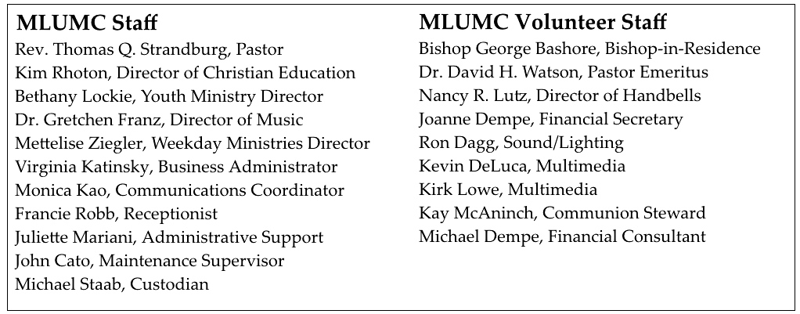

Keep in Prayer
Hospitalized
Joseph Festor, UPMC Montefiore

Convalescing in Care Facilities
Leila Berkey, Asbury Heights
Ed Clarke, Asbury Place
May Frederick , Concordia Health Care
Mary Garber, Providence Point
Susan Lichtenfels, Curahealth Pittsburgh,
Oakdale
Pat Seitz, Concordia Health Care
Ann Swartz, Asbury Center
Tim Watters, Baptist Homes

Convalescing at Home
Gloria Barber, Bob Fairgrieve, Jean George, Earl Killian

In the Military

Jason Boyer, SPC Natalie Brown

Capt. Zachary Allen Finch, USMC
James Iantelli, 1st Lt. Jaskiewicz
S. Sgt. Keith Kimmell, Adam Kmick
PFC Brendan Lamport
Sgt. Matthew McConahan, Thomas Orda
Lt. Col. Mark Patterson

Lt. Com. Scott Patterson

Lt. Col. Sean Patterson
David Poncel, Sgt. Steven Reitz
Capt. Scott B. Rushe, Pastor Rick Townes
Capt. Azizi Wesmiller

Capt. Matthew C. Wesmiller
Sgt. Keith Scott Winkowski

Sgt. Michael Zimmerman

Sympathy
Condolences are offered to the family of long-time church member William E. Frey, who died on Tuesday, December 27 at the age of 93. Words of sympathy can be sent to the family in care of the funeral home: www.johnfslater.com .

The church sends sympathy to the family of church member Andrew “Andy” W. Smith, age 91, who died on Thursday, December 22nd. A memorial service was held Wednesday, January 4th in our Sanctuary. Prayers and words of comfort for the family can be sent to his son:
Mr. Thomas B. Smith
3551 Isle way
Oxnard, CA

Letters of Gratitude
My dear friends of MLUMC,
Thank you so much for all of your support and prayers during my mom’s passing. It meant so much to me and my family - especially to me.
All our love,
Mike Staab

Dear Members of Mt Lebanon United Methodist Church,
Thank you for your generous donation toward our Christmas dinners.
You are a blessing to that ministry. May the Lord bless you throughout the New year.
Rev. J. Scott Shetter
First Presbyterian Church of Castle Shannon

Spreading Cheer to Shut-ins
Thanks so much to all those who delivered poinsettias to shut-ins. Your kindness spread the cheer of the birth of Christ and is greatly appreciated.

Become a Greeter: Extend a Welcome Hand
The Sunday morning greeter is often the first person a visitor or member contacts on entering the church. A greeter’s smile, handshake and cheerful words may set the tone for not only a church goer’s worship experience, but also an entire day. MLUMC is in need of Sunday morning greeters. Consider serving at one of the two worship services. You’ll become a vital part of the church’s ministry of hospitality and make new friends. If you can offer this service once or twice a year, fill out the form below and drop it in the collection basket or deliver it to the office.

Greeter Volunteer Name _______________________________________________
Worship service choice _______8:30 ______10:45
Phone # _________________________ email ________________________________

CALENDAR – SUNDAY, JANUARY 8 THRU SATURDAY, JANUARY 14

SUNDAY 1/8
8:30 am Worship Sanner Chapel
9:30 am Sunday School for All Ages/Coffee Café Various/Brookline Parlor
10:45 am Worship Sanctuary
Kids Praise Welcome Center
5 pm Youth Group Asbury Center

MONDAY 1/9
7 pm Chapel Bells Rehearsal Asbury
7:30 pm German Classes Welcome Center

TUESDAY 1/10
7 pm Boy Scout Troop #23 Wesley Hall
7 pm Boy Scout Board of Reviews Room 105
7 pm Cub Scout Planning Committee Epworth
7:30 pm Zwickau Planning Meeting Welcome Center

WEDNESDAY 1/11
6:30 pm Wolf Cub Scouts Epworth
7 pm Tiger Den Room 105
7:30 pm Finance Committee Wesley Hall

THURSDAY 1/12
6:30 pm Promise Bells Rehearsal Bell Room
6:30 pm Webelo I Wesley Hall
7:30 pm Chancel Choir Rehearsal Choir Room

FRIDAY 1/13
9:30 am Women’s Bible Study Room 102
1:30 pm Memoirs Group Wesley Hall
6:30 pm Bear Den Cub Scouts Epworth

