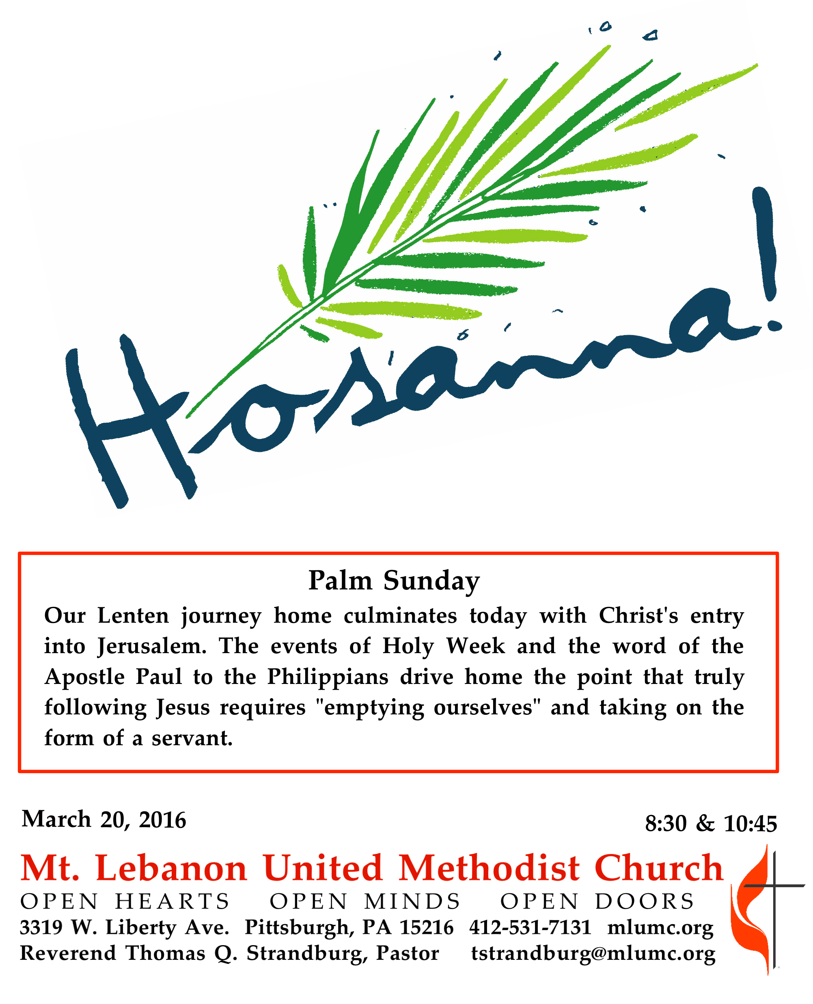
Palm Sunday

The bodily resurrection of Jesus demonstrates that the ultimate power of our world, death, does not have the last word in creation. That last word belongs to God, who continues to redeem and shape this world into the Kingdom that Jesus proclaimed.

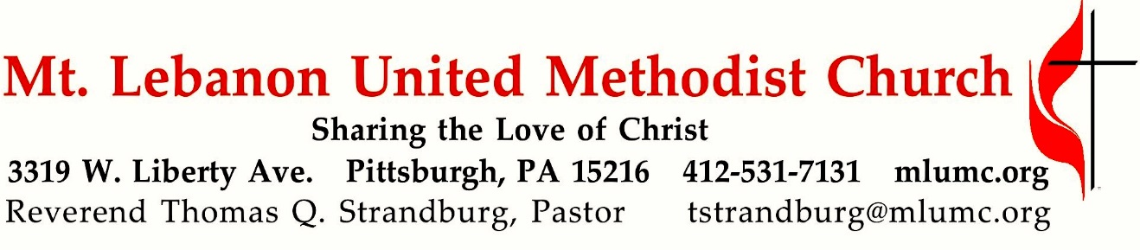
April 9, 2017 8:30 & 10:45
WE GATHER IN GOD’S NAME …
Gathering Music 8:30 Hymn 277 Tell me the story of Jesus (seated) Stories of Jesus

Prelude 10:45 Josh Boudreau, Jeff Nicodemus and Tim Winfield, trumpet

Words of Welcome and Announcements

Introit 10:45 Hosanna! Hosanna! Michael McCabe
Behold He comes! All hail the King

Call to Worship
Pastor: Give thanks to God,
People: whose steadfast love endures forever.
Pastor: Give praise to the one who comes in God’s name.
People: We wave our palms in praise and celebration.
Pastor: This is the day that our God has made.
People: Let us rejoice and be glad. Hosanna!
inspired by Mark 11 & Psalm 118

… TO GIVE PRAISE TO GOD …

Processional Anthem Hymn 279 Filled with excitement (standing) Hosanna

Opening Prayer (in unison)
God of steadfast love, we celebrate the coming of your Messiah with glad songs and hosannas. We wave our palms and cheer. May we wholeheartedly celebrate the life, the forboding, and the love and grace that this day symbolizes, even while clouds gather on the horizon. As we hear a familiar story told once more, open our hearts to receive these words anew, that they may shape our lives and faith. Amen.

Anthem 10:45 Ride on, King Jesus! African-American Spiritual, arr. Joe Cox
Children’s Choir

Refrain: Ride on, King Jesus! No one can a-hinder me!
I was but young with I began, but now my race is almost done. Refrain
King Jesus rides a milk-white horse, the river of Jordan he did cross. Refrain

… TO CELEBRATE THE FAMILY OF FAITH …

The Sign of Peace Please pass the peace to your neighbors as a sign of reconciliation and love.
Leader: The peace of Christ be with you.
People: And also with you.

Gathering Song James Ritchie
This, this is where children belong,
welcomed as part of the worshiping throng.
Water, God’s Word, bread and cup, prayer and song:
This is where children belong.
WORDS: James Ritchie MUSIC: James Ritchie ©1999 Abingdon Press

Message for Young Disciples Rev. Thomas Q. Strandburg
All children are invited. Please sing as children come forward. After the children’s message at the 10:45 service, children ages 3 - 3rd grade may attend Kids Praise in the Welcome Center. Children will be escorted to and from Kids Praise by teachers. They will return to the Sanctuary near the end of the service.

…TO OFFER OUR GIFTS AND TO DEDICATE OUR LIVES…

Offertory Anthem 8:30 The Holy City Stephen Adams

Offertory 10:45

Doxology 95
Praise God, from whom all blessings flow;
Praise God, all creatures here below;
Praise God above, ye heavenly host;
Praise Father, Son and Holy Ghost. Amen

Prayer of Dedication

Hymn 280 All glory, laud and honor (stanzas 3-5, standing) St. Theodulph

… TO HEAR GOD’S WORD PROCLAIMED …

Scripture Reading 8:30 Judi Phelps
10:45 Bob James
A Lesson from the Hebrew Scriptures
Ezekiel 37:1-14 The valley of dry bones

Pastoral Prayer

The Lord’s Prayer
Our Father, who art in heaven, hallowed be thy name. Thy kingdom come, thy will be done,
on earth as it is in heaven. Give us this day our daily bread. And forgive us our trespasses, as we forgive those who trespass against us. And lead us not into temptation, but deliver us from evil. For thine is the kingdom, and the power, and the glory forever. Amen.

Anthem 10:45 Handel, arr. Lundquist
Daughter Zion, now rejoice! Shout with joy, Jerusalem!
Lo, thy King now comes to thee; words of peace He brings to thee.
Glory be to David’s Son! Greatest blessing unto Him!
Peace proceedeth from His throne; grace and truth He giveth us.

Scripture Reading
A Lesson from the Gospels
Matthew 21:1-11 Jesus enters Jerusalem

Response
Leader: The Word of the Lord.
People: Thanks be to God.

Anthem 10:45 Lloyd Pfautsch
Refrain: Hosanna! Blessed is He who comes!
All glory laud and honor to Thee, Redeemer, King,
to whom the lips of children made sweet hosannas ring!
The people of the Hebrews with palms before Thee went;
our praise and prayer and anthems unto Thee we present.
Thou art the King of Israel, Thou David’s royal Son.
who in the Lord’s name comest, the King and blessed One!
To Thee, before Thy passion, they sang their hymns of praise.
To Thee, now high exalted hosannas we raise!
Accept our praise, this tribute we bring, Thou Son of David, our promised king!
All glory, laud and honor to Thee Redeemer King!
To whom we lift our voices and loud hosannas sing!

Sermon “I Believe in Life Everlasting” Rev. Thomas Q. Strandburg

The Apostles’ Creed
I believe in God, the Father Almighty,
creator of heaven and earth.

I believe in Jesus Christ, his only Son, our Lord,
who was conceived by the Holy Spirit,
born of the Virgin Mary,
suffered under Pontius Pilate,
was crucified, died, and was buried;
he descended to the dead.
On the third day he rose again;
he ascended into heaven,
is seated at the right hand of the Father,
and will come again to judge the living and the dead.

I believe in the Holy Spirit,
the holy catholic church,
the communion of saints,
the forgiveness of sins,
the resurrection of the body,
and the life everlasting. Amen.
*The Apostles’ Creed (ecumenical version)

Hymn 71 Glory Be to the Father Greatorex

… TO GO REJOICING IN GOD’S NAME!

Hymn 278 Hosanna, loud hosanna (standing) Ellacombe

Benediction

Benediction response 10:45 Share God’s Love Mark Patterson
Take the light of Christ into the world. Serving others wherever you go.
Share God’s hope, share God’s love.

Today’s Services
The flowers in the Chancel are given in loving memory of Bill and June Lowe by Betsy Rayner and Laurie Lowe.

The flowers on the altar are given by Roger and Gladys Arnold and family in loving memory of her parents, Mr. & Mrs. Cameron A. Wian.

The flowers in the narthex are given in loving memory of William B. Lockhart by his daughter, Laurel.

Special music at 8:30 is provided by Kirby Dilworth, John Esaias and Robert Richards, members of the Chancel Choir.

Special music at 10:45 is provided by the Children’s Choir, directed by Courtney Heath and Kim Rhoton; and the Chancel Choir with Linda Minnotte, handbells; Richard Minnotte, percussion; and Josh Boudeau, Jeff Nicodemus and Tim Winfield, trumpet. The presence of the trumpeters is made possible through donations to the Friends of Music Fund.

Greeters 8:30 Erma Henry 10:45 Mark Lewis

Acolytes Anna Rhoton and Anatasia Sunder Cross Bearer Cary Young

Worship options for children We encourage children to participate in the Children’s Sermon at both services, and in Kids Praise during the 10:45 service. Nursery services are offered in Room 204 of the Education Building. Ask ushers or greeters and follow signs for direction.

Today’s Scriptures

Ezekiel 37:1-14
The hand of the Lord came upon me, and he brought me out by the spirit of the Lord and set me down in the middle of a valley; it was full of bones. ²He led me all around them; there were very many lying in the valley, and they were very dry. ³He said to me, “Mortal, can these bones live?” I answered, “O Lord God, you know.” ⁴Then he said to me, “Prophesy to these bones, and say to them: O dry bones, hear the word of the Lord. ⁵Thus says the Lord God to these bones: I will cause breath to enter you, and you shall live. ⁶I will lay sinews on you, and will cause flesh to come upon you, and cover you with skin, and put breath in you, and you shall live; and you shall know that I am the Lord.” ⁷So I prophesied as I had been commanded; and as I prophesied, suddenly there was a noise, a rattling, and the bones came together, bone to its bone. ⁸I looked, and there were sinews on them, and flesh had come upon them, and skin had covered them; but there was no breath in them.⁹Then he said to me, “Prophesy to the breath, prophesy, mortal, and say to the breath: Thus says the Lord God: Come from the four winds, O breath, and breathe upon these slain, that they may live.” ¹⁰I prophesied as he commanded me, and the breath came into them, and they lived, and stood on their feet, a vast multitude. ¹¹Then he said to me, “Mortal, these bones are the whole house of Israel. They say, ‘Our bones are dried up, and our hope is lost; we are cut off completely.’ ¹²Therefore prophesy, and say to them, Thus says the Lord God: I am going to open your graves, and bring you up from your graves, O my people; and I will bring you back to the land of Israel. ¹³And you shall know that I am the Lord, when I open your graves, and bring you up from your graves, O my people. ¹⁴I will put my spirit within you, and you shall live, and I will place you on your own soil; then you shall know that I, the Lord, have spoken and will act,” says the Lord.

Matthew 21:1-11
When they had come near Jerusalem and had reached Bethphage, at the Mount of Olives, Jesus sent two disciples, ²saying to them, “Go into the village ahead of you, and immediately you will find a donkey tied, and a colt with her; untie them and bring them to me. ³If anyone says anything to you, just say this, ‘The Lord needs them.’ And he will send them immediately.” ⁴This took place to fulfill what had been spoken through the prophet, saying, ⁵“Tell the daughter of Zion, Look, your king is coming to you, humble, and mounted on a donkey, and on a colt, the foal of a donkey.” ⁶The disciples went and did as Jesus had directed them; ⁷they brought the donkey and the colt, and put their cloaks on them, and he sat on them. ⁸A very large crowd spread their cloaks on the road, and others cut branches from the trees and spread them on the road. ⁹The crowds that went ahead of him and that followed were shouting, “Hosanna to the Son of David! Blessed is the one who comes in the name of the Lord! Hosanna in the highest heaven!” ¹⁰When he entered Jerusalem, the whole city was in turmoil, asking, “Who is this?”¹¹The crowds were saying, “This is the prophet Jesus from Nazareth in Galilee.”

Keep in Prayer

Convalescing in Care Facilities
Leila Berkey, Asbury Heights
Jean Boyer, Concordia
Ed Clarke, Asbury Place
Bonnie Critchlow, Jefferson Rehabilitation
David Lewis, Jefferson Rehabilitation
Pat Seitz, Concordia
Tim Watters, Baptist Home

Convalescing at Home
Lynne Beck, Mary Caldwell, Betsy Heston, May Frederick, JoAnn Kaminski, Earl Killian, Susan Lichtenfels, Dawn Lonsinger

In the Military

Jason Boyer, SPC Natalie Brown

Capt. Zachary Allen Finch, USMC
James Iantelli, 1st Lt. Jaskiewicz
S. Sgt. Keith Kimmell, Adam Kmick
PFC Brendan Lamport
Sgt. Matthew McConahan

Sgt. Richard Okello, Thomas Orda
Lt. Col. Mark Patterson

Lt. Com. Scott Patterson

Lt. Col. Sean Patterson
David Poncel, Sgt. Steven Reitz
Capt. Scott B. Rushe, Pastor Rick Townes
Maj. Azizi Wesmiller

Maj. Matthew C. Wesmiller
Sgt. Keith Scott Winkowski

Sgt. Michael Zimmerman

Podcasts of Sunday Sermons
Would you like to share this morning’s sermon with a friend or did you miss a Sunday? Catch up on the messages from MLUMC with a podcast of Pastor Tom’s and others’ Sunday sermons. Sermons from the past three months are at http:// mlumc.buzzsprout.com. You can navigate to the site from the link on our webpage, www.mlumc.org, through the app, Stitcher or through iTunes.

HOLY WEEK SCHEDULE

Tenebrae Service with Holy Communion, Thursday, April 13, 7:30 pm
Join us this Thursday, March 24, for a Service of Tenebrae with Holy Communion, at 7:30 pm in the sanctuary. In the Tenebrae service, candles will represent Christ and the 12 disciples. Following Holy Communion, the candles will be extinguished as readers and musicians communicate the Gospel accounts of the passion and death of our Lord.

Good Friday Community Worship Service, Friday, April 14, 12 pm
On Good Friday, March 25, a Community Worship Service will be observed from noon to 1 pm in our sanctuary. The service will feature meditations upon critical events in the passion narrative from the Gospel of John, delivered by representatives of Bethany Evangelical Lutheran Church, Bower Hill Community Presbyterian Church, Southminster Presbyterian Church, Sunset Hills United Presbyterian Church, as well as Mt. Lebanon United Methodist Church. Choir members from the participating churches will lead the music.

The Great Vigil of Easter, Saturday, April 15, 7:00 pm
Our congregation has been invited to attend this service by our friends and neighbors at Bethany Lutheran Church. It will take place on Saturday, April 15th, at 7:00 p.m. This is the most important worship event of the year for Lutherans and many other Christians. The service will be held at St. Andrew Lutheran Church, East Carnegie, 218 Alter St. This Vigil will feature the Evangelical Lutheran bishop, Kurt Kusserow, who will preach and preside at the Easter Communion. We will also enjoy a brass quintet from the Pittsburgh Symphony Orchestra. Pastor Tom has also agreed to participate in the service.

Easter Sunday Services, April 16
The 8:30 am and 10:45 am services will be celebrated in the sanctuary.

