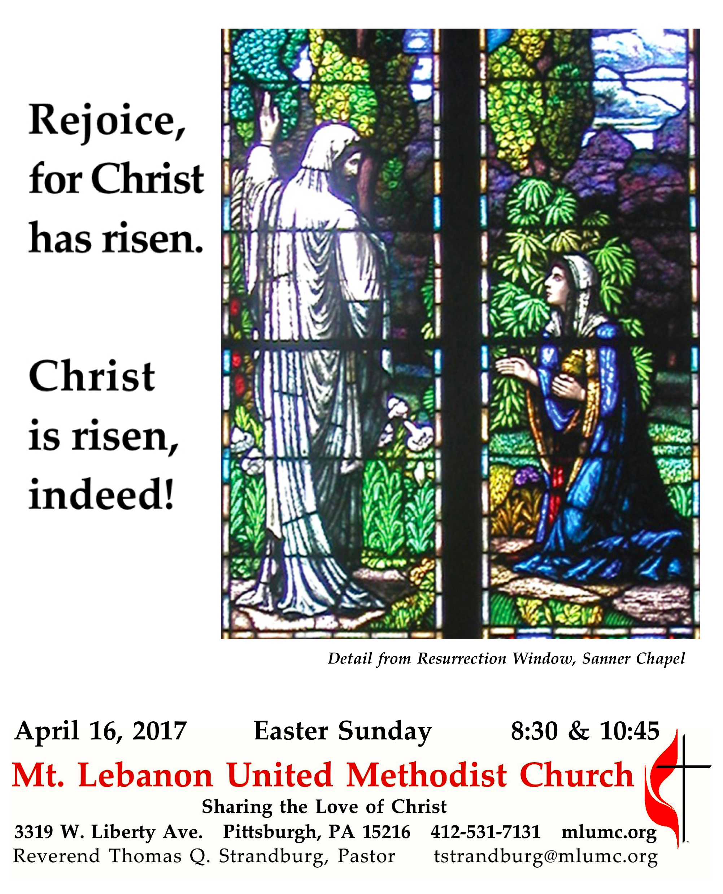
The Resurrection of the Lord

Easter calls us to be amazed at the power of our loving God and at the incredible gift that God has given us – new life, new hope. It points to a radical, life-changing reality that has the power to make a difference in this world.
..

WE GATHER IN GOD’S NAME …

Prelude 8:30 Come, thou fount of every blessing arranged by Dale Wood
10:45 Brass Quintet

Greeting
Pastor: Christ is risen!
People: Christ is risen indeed! Alleluia!
Traditional Easter Acclamation

Announcements

Call to Worship
Pastor: For this perishable body must put on imperishability, and this mortal body must put on immortality.
People: When this perishable body puts on imperishability, and this mortal body puts on immortality, then the saying that is written will be fulfilled: “Death has been swallowed up in victory.”
Pastor: Where, O death, is your victory?
People: Where, O death, is your sting?
Corinthians 15:53-55

… TO GIVE PRAISE TO GOD …

Hymn 302 Christ the Lord is risen today (stanzas 1-4, standing) Easter Hymn

Opening Prayer (in unison)
Sanctifier of time and space, maker of dancing quarks and ancient quasars, of energy and element, blessed are you, Creator God. Your saving love endures forever; your holy light pierces the cold darkness of death and chaos; you make a covenant of life with your creatures, which no evil can overcome. May the glorious radiance of resurrection dispel the shadows in our lives and conform us more closely to your risen Christ, to whom, with you and the Holy Spirit, be all honor, praise, and glory. Amen.
Worship & Song
… TO CELEBRATE THE FAMILY OF FAITH …

The Sign of Peace Please pass the peace to your neighbors as a sign of reconciliation and love.
Leader: The peace of Christ be with you.
People: And also with you.

Gathering Song
This, this is where children belong,
welcomed as part of the worshiping throng.
Water, God’s Word, bread and cup, prayer and song:
This is where children belong WORDS AND MUSIC: James Ritchie ©1999 Abingdon Press
Message for Young Disciples Rev. Thomas Q. Strandburg
All children are invited. Please sing as children come forward.

Hymn 306 The strife is o'er, the battle done (standing) Victory

… TO HEAR GOD’S WORD PROCLAIMED …

Scripture Reading
A Lesson from the New Testament
Colossians 3:1-4 Your life hidden with Christ

Pastoral Prayer

The Lord’s Prayer
Our Father, who art in heaven, hallowed be thy name. Thy kingdom come, thy will be done, on earth as it is in heaven. Give us this day our daily bread. And forgive us our trespasses, as we forgive those who trespass against us. And lead us not into temptation, but deliver us from evil. For thine is the kingdom, and the power, and the glory forever. Amen.

Gospel Acclamation Christ the Lord is risen, alleluia Paul Fetler

Scripture Reading
A Lesson from the Gospels
John 20:1-18 The account of the resurrection

Response
Leader: The Word of the Lord.
People: Thanks be to God.

… TO OFFER OUR GIFTS AND TO DEDICATE OUR LIVES …

Offertory Anthem Rejoice, ye heavenly powers Stephen Main
What is this mystery, so great and new? Trembling for joy, all creation cries;
the Lord has risen from the dead, and Death beneath Him lies.
Rejoice, ye heavenly powers. O sing, ye choirs of angels!
Exult all creation around God’s throne for Christ our King is risen,
sound the trumpet of salvation.
O mystery great and glorious that mortal flesh should conquer death and sin,
and all our human pains and wounds the Lord should heal by bearing them.
Rejoice, O ye earth in splendor, radiant in the brightness of your King!
Rejoice, holy Church, exult in glory, the light of Christ shines upon you.
Let the earth resound and echo the song of God’s own people. Rejoice!

Doxology #94
Praise God from whom all blessings flow;
Praise God, all creatures here below: Alleluia! Alleluia!
Praise God the source of all our gifts!
Praise Jesus Christ, whose power uplifts!
Praise the Spirit, Holy Spirit. Alleluia! Alleluia! Alleluia!

Prayer of Dedication

Hymn 308 Thine be the glory (standing) Judas Maccabeus

Sermon “Your Spiritual Emoji” Rev. Thomas Q. Strandburg

The Apostles’ Creed
Pastor: Let us join together in professing the Christian faith as contained in the Scriptures of the Old and New Testaments.
Do you believe in God the Father?
People: I believe in God, the Father Almighty, creator of heaven and earth.
Pastor: Do you believe in Jesus Christ?
People: I believe in Jesus Christ, his only Son, our Lord, who was conceived by the Holy Spirit, born of the Virgin Mary, suffered under Pontius Pilate, was crucified, died, and was buried;
he descended to the dead. On the third day he rose again; he ascended into heaven, is seated at the right hand of the Father, and will come again to judge the living and the dead.
Pastor: Do you believe in the Holy Spirit?
People: I believe in the Holy Spirit, the holy catholic church, the communion of saints, the forgiveness of sins, the resurrection of the body, and the life everlasting.
… TO GO REJOICING IN GOD’S NAME!

Choral Response Messiah: "Hallelujah" Chorus G. F. Handel

Benediction

Postlude 10:45 Grand Choeur Dialogue Eugène Gigout

Today’s Services

Special music for the 8:30 service is provided by the Chancel Choir.

Special music for the 10:45 service is provided by the Chancel Choir with guest instrumentalists: Josh Boudreau and Stephen McGough, trumpet; Bryan Adkins, horn; Gonzalo Fernandez, trombone; Robert Tupper, bass trombone; and Ajay Wadhwani, timpani; with Richard Minnotte, conductor. Soloists are Rev. Kimberly Greway, Kathleen Whittaker, Betsy Rayner, Sharon Slater, Linda Minnotte, and Sally Munro. The addition of the instrumentalists is made possible through contributions to the Friends of Music Fund. New contributors are most welcome - make a check to the church and note "Friends of Music Fund."

Greeters 8:30 Ron and Carolyn Dagg 10:45 Bill and Lavisa Ward

Acolytes Anastasia and Elyse Sunder

Cross Bearer 8:30 Brad Argiro 10:45 Cary Young

Worship options for children We encourage children to participate in the Children’s Sermon at both services, and in Kids Praise during the 10:45 service. Nursery services are offered in Room 204 of the Education Building. Ask ushers or greeters and follow signs for direction.

Honor or remember a loved one with a flower donation. To donate an arrangement for the altar, Chancel or Columbarium, contact Sharon Slater, 412-343-1137.

Podcasts of Sunday Sermons Would you like to share this morning’s sermon with a friend or did you miss a Sunday? Catch up on the messages from MLUMC with a podcast of Pastor Tom’s and others’ Sunday sermons. A month’s sermons are at http://mlumc.buzzsprout.com or navigate to the site from the link on our webpage, www.mlumc.org. Sermons older than a month will be posted to iTunes. Full recordings of the service are available upon request.

Today’s Scriptures
Colossians 3:1-4
So if you have been raised with Christ, seek the things that are above, where Christ is, seated at the right hand of God. ²Set your minds on things that are above, not on things that are on earth, ³for you have died, and your life is hidden with Christ in God. ⁴When Christ who is your life is revealed, then you also will be revealed with him in glory.”

John 20:1-18
Early on the first day of the week, while it was still dark, Mary Magdalene came to the tomb and saw that the stone had been removed from the tomb. ²So she ran and went to Simon Peter and the other disciple, the one whom Jesus loved, and said to them, “They have taken the Lord out of the tomb, and we do not know where they have laid him.” ³Then Peter and the other disciple set out and went toward the tomb. ⁴The two were running together, but the other disciple outran Peter and reached the tomb first. ⁵He bent down to look in and saw the linen wrappings lying there, but he did not go in. ⁶Then Simon Peter came, following him, and went into the tomb. He saw the linen wrappings lying there, ⁷and the cloth that had been on Jesus’ head, not lying with the linen wrappings but rolled up in a place by itself. ⁸Then the other disciple, who reached the tomb first, also went in, and he saw and believed; ⁹for as yet they did not understand the scripture, that he must rise from the dead. ¹⁰Then the disciples returned to their homes.

¹¹But Mary stood weeping outside the tomb. As she wept, she bent over to look into the tomb;
¹²and she saw two angels in white, sitting where the body of Jesus had been lying, one at the head and the other at the feet. ¹³They said to her, “Woman, why are you weeping?” She said to them, “They have taken away my Lord, and I do not know where they have laid him.” ¹⁴When she had said this, she turned around and saw Jesus standing there, but she did not know that it was Jesus.
¹⁵Jesus said to her, “Woman, why are you weeping? Whom are you looking for?” Supposing him to be the gardener, she said to him, “Sir, if you have carried him away, tell me where you have laid him, and I will take him away.” ¹⁶Jesus said to her, “Mary!” She turned and said to him in Hebrew, “Rabbouni!” (which means Teacher). ¹⁷Jesus said to her, “Do not hold on to me, because I have not yet ascended to the Father. But go to my brothers and say to them, ‘I am ascending to my Father and your Father, to my God and your God.’” ¹⁸Mary Magdalene went and announced to the disciples, “I have seen the Lord”; and she told them that he had said these things to her.

Keep in Prayer

Convalescing in Care Facilities
Leila Berkey, Asbury Heights
Jean Boyer, Concordia
Ed Clarke, Asbury Place
Pat Seitz, Concordia
Tim Watters, Baptist Home

Convalescing at Home
Lynne Beck, Mary Caldwell, David Lewis, Betsy Heston, May Frederick, JoAnn Kaminski, Earl Killian, Susan Lichtenfels, Dawn Lonsinger

In the Military

Jason Boyer, SPC Natalie Brown

Capt. Zachary Allen Finch, USMC
James Iantelli, 1st Lt. Jaskiewicz
S. Sgt. Keith Kimmell, Adam Kmick
PFC Brendan Lamport
Sgt. Matthew McConahan

Sgt. Richard Okello, Thomas Orda
Lt. Col. Mark Patterson

Lt. Com. Scott Patterson

Lt. Col. Sean Patterson
David Poncel, Sgt. Steven Reitz
Capt. Scott B. Rushe, Pastor Rick Townes
Maj. Azizi Wesmiller

Maj. Matthew C. Wesmiller
Sgt. Keith Scott Winkowski

Sgt. Michael Zimmerman

Looking to send a card? Here are some helpful addresses:

Asbury Heights
700 Bower Hill Road
Pittsburgh, PA 15243

Baptist Homes
489 Castle Shannon Blvd.
Pittsburgh, PA 15234

Concordia Health Center
1300 Bower Hill Road
Pittsburgh, PA 15243

CALENDAR – SUNDAY, APRIL 16 THROUGH SATUDAY, APRIL 22

SUNDAY 4/16 EASTER SUNDAY
8:30 am Worship Sanctuary
10:45 am Worship Sanctuary

MONDAY 4/17 EASTER MONDAY – OFFICE CLOSED
7 pm Chapel Bells Rehearsal Bell Room
7:30 pm Community Events & Outreach Committee Wesley Hall

TUESDAY 4/18
7 pm Boy Scout Troop #23 Wesley Hall
7 pm Church Council Welcome Center

WEDNESDAY 4/19
7 pm Trustees Welcome Center

THURSDAY 4/20
9:30 am UMW Faith Circle Wesley Hall
6:30 pm Promise Bells Rehearsal Bell Room
7 pm Cub Scout Pack Meeting Asbury Center
7:30 pm Chancel Choir Rehearsal Choir Room

FRIDAY 4/21
9:30 am Women’s Bible Study Room 102

