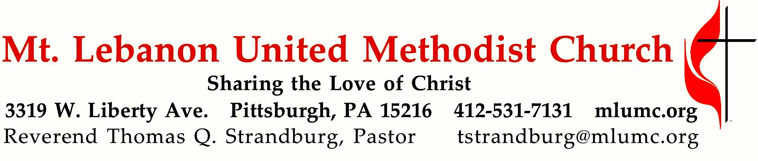
May 28, 2017 8:30 & 10:45

We welcome one of our candidates for ministry, Amy Jun, as preacher for this day. Amy has been a member of our church since 2012, and a certified candidate for ministry since 2016. Her husband, Rev. Jong Man Lee, is the pastor of our Korean congregation, where Amy serves as the regular worship leader. She has been approved for commissioning as a provisional member of the Western Pennsylvania Annual Conference of the United Methodist Church. Her commissioning will occur during the upcoming session of the Annual Conference at Grove City College. We rejoice with Amy and her entire family on this wonderful achievement!

Ascension Sunday

The Apostle Paul warned the early Christian church in Corinth – “So, if you think you are standing firm, be careful that you don’t fall. (1 Corinthians 10:12)” We celebrate that God’s hands are always available to us, to keep us from falling. However, sometimes we still fall because we miss God’s hands. So, be careful when you think you are standing!

WE GATHER IN GOD’S NAME

Gathering Music
Worship & Song 3119 Take, O take me as I am Take, O take
Hymn 632 Draw us in the Spirit’s tether Union Seminary

Greeting
Leader: No one has ever seen God;
People: if we love one another, God lives in us, and God’s love is perfected in us. 1 John 4:12
Announcements

Call to Worship
Pastor: When the world divides us:
People: Come, Holy Spirit, make us one.
Pastor: When the world calls us orphaned:
People: Come, Holy Spirit, make us family.
Pastor: When the world leads us astray:
People: Come, Holy Spirit, call us home. Come and fill this place!
Worship & Song

… TO GIVE PRAISE TO GOD …

Hymn 568 Christ for the world we sing (standing) Italian Hymn

Opening Prayer (in unison)
O gracious and holy God, give us diligence to seek you, wisdom to perceive you, and patience to wait for you. Grant us, O God, a mind to meditate on you, eyes to behold you, ears to listen for your word, a heart to love you, and a life to proclaim you, through the power of the spirit of Jesus Christ, our Lord. Amen. Benedict of Nurnia, 6th Century

… TO CELEBRATE THE FAMILY OF FAITH …

The Sign of Peace Please pass the peace to your neighbors as a sign of reconciliation and love.
Leader: The peace of Christ be with you.
People: And also with you.

Gathering Song
This, this is where children belong,
welcomed as part of the worshiping throng.
Water, God’s Word, bread and cup, prayer and song:
This is where children belong. WORDS AND MUSIC: James Ritchie ©1999 Abingdon Press

Message for Young Disciples Rev. Thomas Q. Strandburg
All children are invited. Please sing as children come forward. After the children’s message at the 10:45 service, children ages 3 - 3rd grade may attend Kids Praise in the Welcome Center. Children will be escorted to and from Kids Praise by teachers. They will return to the Sanctuary near the end of the service.

… TO HEAR GOD’S WORD PROCLAIMED …

Hymn 128 He leadeth me (seated) He leadeth me

Scripture Reading 8:30 Marcy Picardi
10:45 Stacey Rosleck
A Lesson from the New Testament
1 Corinthians 10:1-12 Warnings from Israel’s history

Worship & Song 3137 Lord Jesus Christ, your light shines Jésus le Christ
Lord Jesus Christ, your light shines within us.
Let not my doubts nor my darkness speak to me.
Lord Jesus Christ, your light shines within us.
Let my heart always welcome your love.

Pastoral Prayer

The Lord’s Prayer
Our Father, who art in heaven, hallowed be thy name. Thy kingdom come, thy will be done, on earth as it is in heaven. Give us this day our daily bread. And forgive us our trespasses, as we forgive those who trespass against us. And lead us not into temptation, but deliver us from evil. For thine is the kingdom, and the power, and the glory forever. Amen.

Celtic Alleluia O’Carroll and Walker
Cantor: Alleluia (4 times)
Congregation: Alleluia (sing 4 times)

Scripture Reading
A Lesson from the Gospels
John 17:1-11 The ascension of Jesus

Response
Leader: The Word of the Lord.
People: Thanks be to God.

… TO OFFER OUR GIFTS AND TO DEDICATE OUR LIVES …

Offertory Solo 8:30 My Jesus, I love thee setting by Dale Wood

Offertory Anthem 10:45 Everett Titcomb
I will not leave you comfortless, I will come to you yet again: alleluia.
And your heart shall be joyful. Allelluia.

Doxology 94
Praise God from whom all blessings flow;
Praise God, all creatures here below: Alleluia! Alleluia
Praise God the source of all our gifts!
Praise Jesus Christ, whose power uplifts!
Praise the Spirit, Holy Spirit. Alleluia! Alleluia! Alleluia!

Prayer of Dedication

Sermon “Be careful, when you think you are standing”
Amy Jun, Certified Candidate for Ministry

… TO GO REJOICING IN GOD’S NAME!

Hymn 529 How firm a foundation (standing) Foundation

Benediction

Today’s Services
The flowers on the altar are given by Leslie Troy in honor and memory of loved ones.

The flowers in the Chancel are given in memory of all men and women who have died in military service for the United States.

Special music at 10:45 is provided by the Chancel Choir.

Greeters 8:30 Paulette Colonna 10:45 Kay McAninch

Worship options for children We encourage children to participate in the Children’s Sermon at both services, and in Kids Praise during the 10:45 service. Nursery services are offered in Room 204 of the Education Building. Ask ushers or greeters and follow signs for direction.

Podcasts of Sunday Sermons Would you like to share this morning’s sermon with a friend or did you miss a Sunday? Catch up on the messages from MLUMC with a podcast of Pastor Tom’s and others’ Sunday sermons. A month’s sermons are at http://mlumc.buzzsprout.com or navigate to the site from the link on our webpage, www.mlumc.org. Sermons older than a month will be posted to iTunes. Full recordings of the service are available upon request.

Honor or remember a loved one with a flower donation. To donate an arrangement for the altar, Chancel or Columbarium, contact Sharon Slater, 412-343-1137.

Today’s Scriptures
1 Corinthians 10:1-12
I do not want you to be unaware, brothers and sisters, that our ancestors were all under the cloud, and all passed through the sea, ²and all were baptized into Moses in the cloud and in the sea, ³and all ate the same spiritual food, ⁴and all drank the same spiritual drink. For they drank from the spiritual rock that followed them, and the rock was Christ. ⁵Nevertheless, God was not pleased with most of them, and they were struck down in the wilderness.

⁶Now these things occurred as examples for us, so that we might not desire evil as they did. ⁷Do not become idolaters as some of them did; as it is written, “The people sat down to eat and drink, and they rose up to play.” ⁸We must not indulge in sexual immorality as some of them did, and twenty-three thousand fell in a single day. ⁹We must not put Christ to the test, as some of them did, and were destroyed by serpents. ¹⁰And do not complain as some of them did, and were destroyed by the destroyer. ¹¹These things happened to them to serve as an example, and they were written down to instruct us, on whom the ends of the ages have come. ¹²So if you think you are standing, watch out that you do not fall.

John 17:1-11
After Jesus had spoken these words, he looked up to heaven and said, “Father, the hour has come; glorify your Son so that the Son may glorify you, ²since you have given him authority over all people, to give eternal life to all whom you have given him. ³And this is eternal life, that they may know you, the only true God, and Jesus Christ whom you have sent. ⁴I glorified you on earth by finishing the work that you gave me to do. ⁵So now, Father, glorify me in your own presence with the glory that I had in your presence before the world existed.

⁶”I have made your name known to those whom you gave me from the world. They were yours, and you gave them to me, and they have kept your word. ⁷Now they know that everything you have given me is from you; ⁸for the words that you gave to me I have given to them, and they have received them and know in truth that I came from you; and they have believed that you sent me. ⁹I am asking on their behalf; I am not asking on behalf of the world, but on behalf of those whom you gave me, because they are yours. ¹⁰All mine are yours, and yours are mine; and I have been glorified in them.

¹¹And now I am no longer in the world, but they are in the world, and I am coming to you. Holy Father, protect them in your name that you have given me, so that they may be one, as we are one.

Keep in Prayer

Convalescing in Care Facilities
Leila Berkey, Asbury Heights
Ed Clarke, Asbury Place
Pat Seitz, Concordia
Betty Trout, Providence Point Health Center
Tim Watters, Baptist Home

Convalescing at Home
Mary Caldwell, Cleon Cornes, David Lewis, May Frederick, Earl Killian, Susan Lichtenfels

In the Military

Jason Boyer, SPC Natalie Brown

Capt. Zachary Allen Finch, USMC
James Iantelli, 1st Lt. Jaskiewicz
S. Sgt. Keith Kimmell, Adam Kmick
PFC Brendan Lamport
Sgt. Matthew McConahan

Sgt. Richard Okello, Thomas Orda
Lt. Col. Mark Patterson

Lt. Com. Scott Patterson

Lt. Col. Sean Patterson
David Poncel, Sgt. Steven Reitz
Capt. Scott B. Rushe, Pastor Rick Townes
Maj. Azizi Wesmiller

Maj. Matthew C. Wesmiller
Sgt. Keith Scott Winkowski

Sgt. Michael Zimmerman

Condolences

The congregation offers prayers and sympathy to the family of church member Sam Vance who died on Thursday, May 11, 2017 and Ruth Bloss who died Wednesday, May 17, 2017. Condolences may be sent to their families:

Mrs. Christine James

1109 Raven Drive

Pittsburgh, PA 15243-1239

Mr. Thomas Bloss

429 Serrano Ave.

Pittsburgh, PA 15243-2053

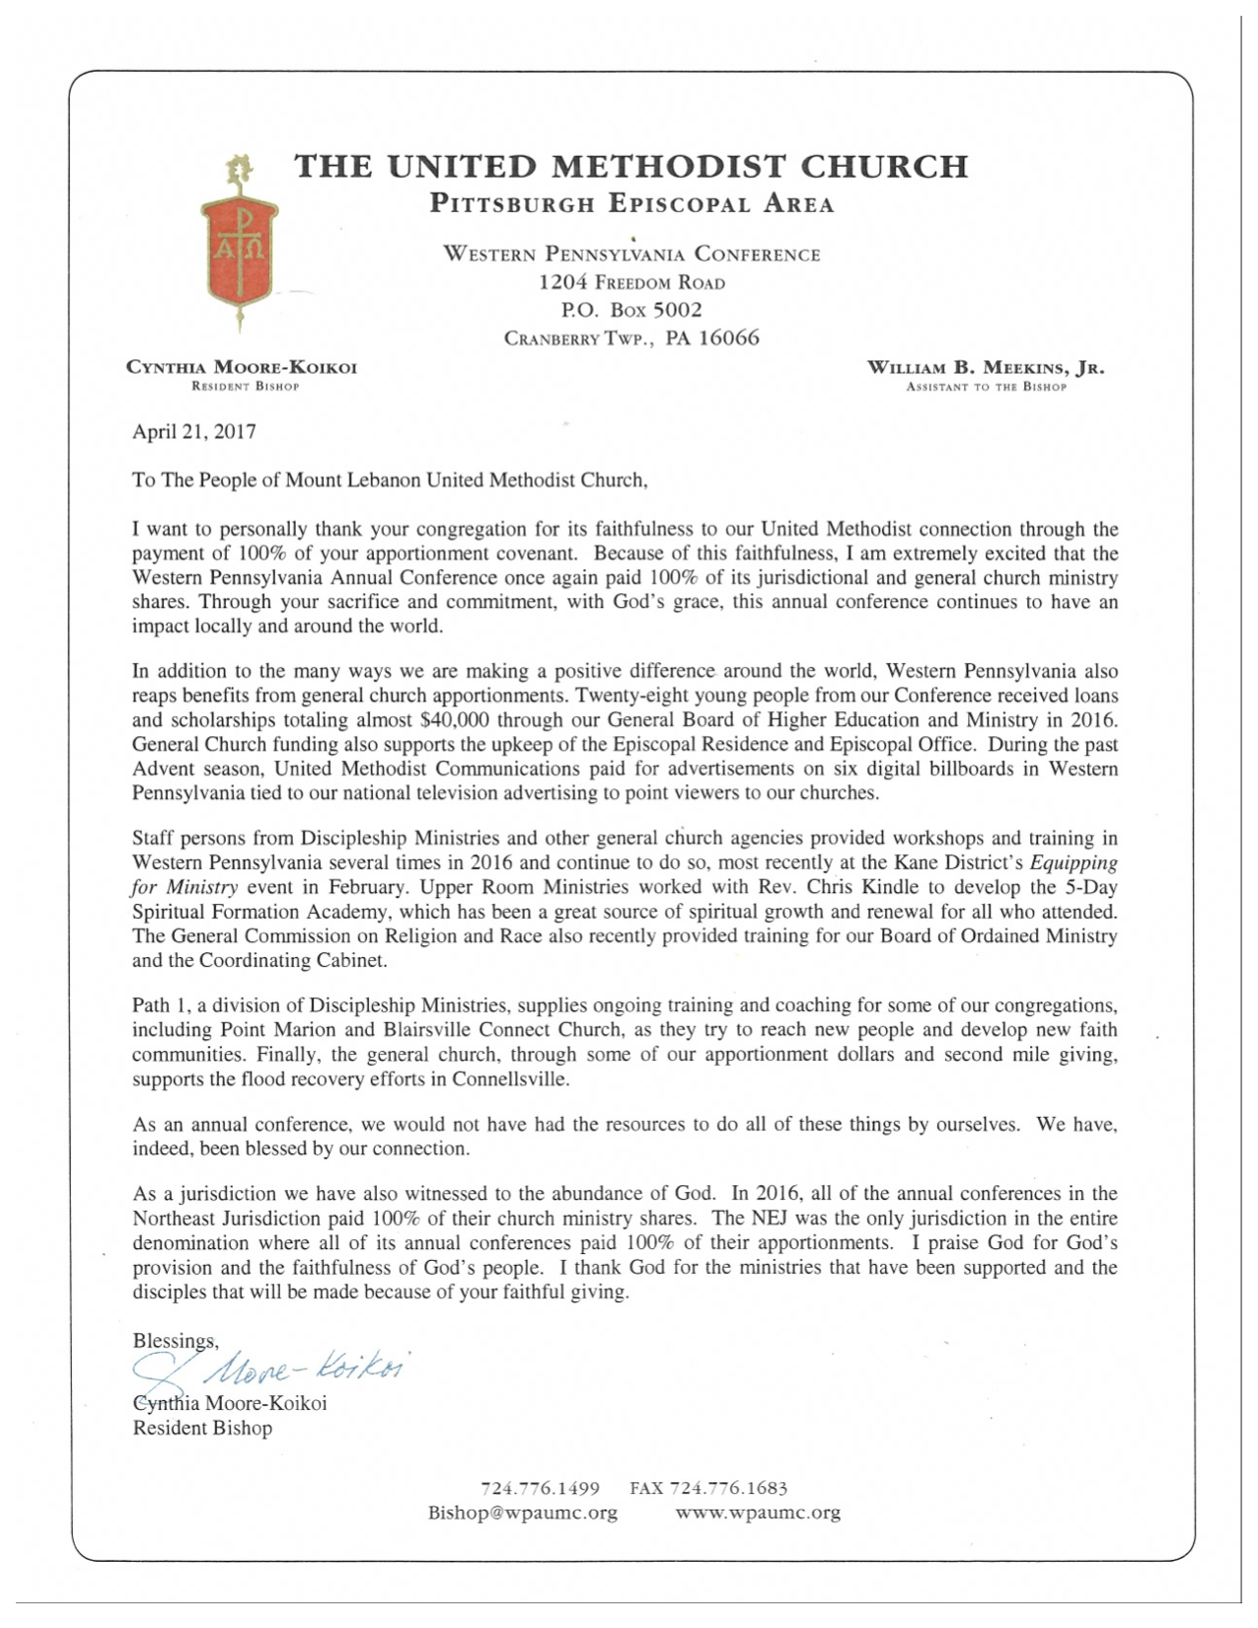
CALENDAR – SUNDAY, MAY 28 THRU SATURDAY, JUNE 2

SUNDAY 5/28
8:30 am Worship Sanner Chapel
10:45 am Worship Sanctuary
Kids Praise Welcome Center
7 pm BSA Patrol Leaders Room 105

MONDAY 5/29 MEMORIAL DAY – OFFICE CLOSED

TUESDAY 5/30
7 pm Boy Scout Troop #23 / Rummage Sale Set-up Various

WEDNESDAY 5/31
6:30 am Northside Lunch Program Prep Kitchen
2 pm Rummage Sale Set-up Asbury Center

THURSDAY 6/1
8:30 am Northside Lunch Program Prep Kitchen
10 am Rummage Sale Set-up Asbury Center
12 pm TNT Asbury Heights

FRIDAY 6/2
9:30 am Women’s Bible Study Room 102
10 am Rummage Sale Set-up Asbury Center

SATURDAY 6/3
9 am Rummage Sale Asbury Center

