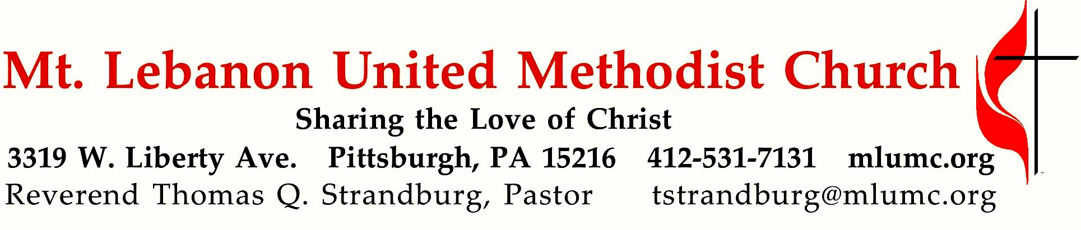
Second Sunday after Pentecost
Father’s Day
We come from a long line of doers. Just look at our history. Martin Luther dared to do a new thing by challenging the Roman Catholic Church to change. John Wesley dared to do a new thing by challenging the Anglican Church to change. What new thing is God calling us to do today?

June 18, 2017 8:30 & 10:45

WE GATHER IN GOD’S NAME

Gathering Music 8:30
Hymn 145 Morning has broken Bunessan

Greeting
Leader: Let God grant us grace and bless us; let God’s face shine upon us, so that
God’s way becomes known on earth, and God’s salvation among all the nations.
People: Let the people thank you, O God! Let all the people thank you!
Psalm 67:1-2

Announcements

Call to Worship
Pastor: When tears are our food,
People: God comes with a feast.
Pastor: When fear is our path,
People: God brings us courage.
Pastor: When sorrow is our friend,
People: God comforts and loves us.
Pastor: When all hope seems lost,
People: God is our rock and redeemer.
1 Kings 19, Psalm 42

… TO GIVE PRAISE TO GOD …

Hymn 144 This is my Father’s world (standing) Terra beata

Opening Prayer (in unison, standing)
Come to us in silence and in word, O God. Speak to our hearts that we may hear and respond. Soothe our souls that we may rest and renew. Strengthen our spirits that we may grow in faith and courage. In your name, we pray. Amen.

… TO CELEBRATE THE FAMILY OF FAITH …

Sacrament of Baptism 10:45 Baptismal Covenant II, UM Hymnal #39

Joachim Christopher Alexander, son of Michael and Dovey Alexander

People: With God’s help we will proclaim the good news and live according to the example of Christ. We will surround Joachim Christopher with a community of love and forgiveness, that he may grow in his service to others. We will pray for him that he may be a true disciple who walks in a way that leads to life.

The Sign of Peace Please pass the peace to your neighbors as a sign of reconciliation and love.
Leader: The peace of Christ be with you.
People: And also with you.

Gathering Song
This, this is where children belong,
welcomed as part of the worshiping throng.
Water, God’s Word, bread and cup, prayer and song:
This is where children belong.
WORDS AND MUSIC: James Ritchie ©1999 Abingdon Press

Message for Young Disciples Rev. Thomas Q. Strandburg
All children are invited. Please sing as children come forward. After the children’s message at the 10:45 service, children ages 3 - 3rd grade may attend Kids Praise in the Welcome Center. Children will be escorted to and from Kids Praise by teachers. They will return to Asbury Center near the end of the service.

… TO HEAR GOD’S WORD PROCLAIMED …

Scripture Reading 8:30 Scott Miller
A Lesson from the Hebrew Scriptures 10:45 Joyce Magill
Isaiah 43:14-21 God is about to do a new thing

Worship & Song 3137 Jésus le Christ
Lord Jesus Christ, your light shines within us.
Let not my doubts nor my darkness speak to me.
Lord Jesus Christ, your light shines within us.
Let my heart always welcome your love.

Pastoral Prayer

The Lord’s Prayer
Our Father, who art in heaven, hallowed be thy name. Thy kingdom come, thy will be done, on earth as it is in heaven. Give us this day our daily bread. And forgive us our trespasses, as we forgive those who trespass against us. And lead us not into temptation, but deliver us from evil. For thine is the kingdom, and the power, and the glory forever. Amen.

Celtic Alleluia O’Carroll and Walker
Cantor: Alleluia (4 times)
Congregation: Alleluia (sing 4 times)

Scripture Reading
A Lesson from the Gospels
Matthew 28:16-20 The Great Commission

Response
Leader: The Word of the Lord.
People: Thanks be to God.

… TO OFFER OUR GIFTS AND TO DEDICATE OUR LIVES …

Offertory Solo 8:30 And can it be? Dan Forrest

Offertory Anthem 10:45 Eugene Butler
Refrain: Go ye into all the world and preach My gospel to ev’ry creature!
Jesus said, “This is the great commandment: that ye love one another as I have loved you.
Greater love hath no man than this; that he lay down his life for his friends.
Let not your heart be troubled, if you believe in God, you believe in Me.”
Doxology 94 (standing)
Praise God from whom all blessings flow;
Praise God, all creatures here below: Alleluia! Alleluia!
Praise God the source of all our gifts!
Praise Jesus Christ, whose power uplifts!
Praise the Spirit, Holy Spirit. Alleluia! Alleluia! Alleluia!

Prayer of Dedication

Sermon “Dare to Do a New Thing” Rev. Thomas Q. Strandburg

Commissioning of Our Partnership Exchange Team to Zwickau 10:45 Bishop George W. Bashore

Bishop Bashore: All who take upon themselves the name of Christ are called into ministries of love and service by the example of Christ. In his final prayer with his own disciples, Jesus prayed for us, that we may all be one. He said, “As you, Father, are in me and I am in you, may they also be in us, so that the world may believe that you have sent me.”(John 17:21) As these members of our community begin their work of ministry and relationship building among the people of Zwickau, in eastern Germany, we pray the blessings of God and this community upon their endeavors.
Congregation: We recognize you as ambassadors of this congregation in ministry with the people of Zwickau and dedicate you to service in the name of Jesus Christ. Through our prayers we will be united with you in your work. May God richly bless your labors.
All: Amen.

… TO GO REJOICING IN GOD’S NAME!

Hymn 584 Lord, you give the great commission (standing) Abbot’s Leigh

Benediction

Today’s Services
The flowers provided for worship today are in honor and loving memory of all fathers, teachers and role models.

Special music at 10:45 is provided by the Chancel Choir with percussionist Richard Minnotte.

Greeters 8:30 Erma Henry 10:45 Leslie Troy

Worship options for children We encourage children to participate in the Children’s Sermon at both services, and in Kids Praise during the 10:45 service. Nursery services are offered in Room 204 of the Education Building. Ask ushers or greeters and follow signs for direction.

Back row L to R:
Rev. Tom Strandburg, Mike and Mary Paine, Deanna Baird, Kathleen Amant, Scott and Bernie Bowes. Front row L to R: Kathy Strandburg, Keith Will and Lori Barr.
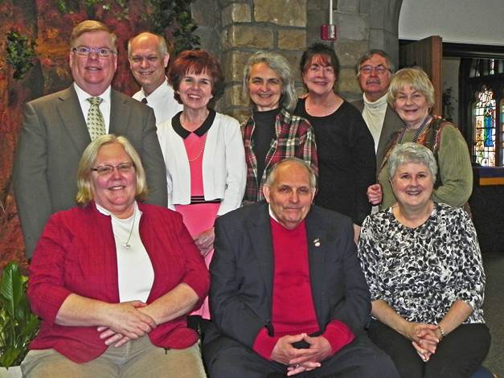

Zwickau Exchange Team
Since 1996, our church has been in partnership with the Evangelische-Methodistische Friedenskirche in Zwickau, Germany. Throughout that time, our parishioners have exchanged visits approximately every two years. Our German friends last sent a delegation in 2015. This year, it is our turn. This evening, a group of eleven will depart for Germany. The team consists of the following persons: Kathleen Amant, Deanna Baird, Lori Barr, Scott & Bernie Bowes, Mary Garber, Mike & Mary Paine, Tom & Kathy Strandburg, and Keith Will. Please remember this team in your prayers. Most of them will return home on July 5th.

Podcasts of Sunday Sermons Would you like to share this morning’s sermon with a friend or did you miss a Sunday? Catch up on the messages from MLUMC with a podcast of Pastor Tom’s and others’ Sunday sermons. A month’s sermons are at http://mlumc.buzzsprout.com or navigate to the site from the link on our webpage, www.mlumc.org. Sermons older than a month will be posted to iTunes. Full recordings of the service are available upon request.

Honor or remember a loved one with a flower donation. To donate an arrangement for the worship service, contact Sharon Slater, 412-343-1137.

Today’s Scriptures
Isaiah 43:14-21
¹⁴Thus says the Lord, your Redeemer, the Holy One of Israel: For your sake I will send to Babylon and break down all the bars, and the shouting of the Chaldeans will be turned to lamentation. ¹⁵I am the Lord, your Holy One, the Creator of Israel, your King. ¹⁶Thus says the Lord, who makes a way in the sea, a path in the mighty waters, ¹⁷who brings out chariot and horse, army and warrior; they lie down, they cannot rise, they are extinguished, quenched like a wick: ¹⁸Do not remember the former things, or consider the things of old. ¹⁹I am about to do a new thing; now it springs forth, do you not perceive it? I will make a way in the wilderness and rivers in the desert. ²⁰The wild animals will honor me, the jackals and the ostriches; for I give water in the wilderness, rivers in the desert, to give drink to my chosen people, ²¹the people whom I formed for myself so that they might declare my praise.

Matthew 28:16-20
¹⁶Now the eleven disciples went to Galilee, to the mountain to which Jesus had directed them. ¹⁷When they saw him, they worshiped him; but some doubted. ¹⁸And Jesus came and said to them, “All authority in heaven and on earth has been given to me. ¹⁹Go therefore and make disciples of all nations, baptizing them in the name of the Father and of the Son and of the Holy Spirit, ²⁰and teaching them to obey everything that I have commanded you. And remember, I am with you always, to the end of the age.”

Keep in Prayer

Convalescing in Care Facilities
Leila Berkey, Asbury Heights
Ed Clarke, Asbury Place
Pat Seitz, Concordia
Tim Watters, Baptist Home

Convalescing at Home
Mary Caldwell, David Lewis,
May Frederick, Earl Killian,
Susan Lichtenfels, Betty Trout

In the Military

Jason Boyer, SPC Natalie Brown

Capt. Zachary Allen Finch, USMC
James Iantelli, 1st Lt. Jaskiewicz
S. Sgt. Keith Kimmell, Adam Kmick
PFC Brendan Lamport
Sgt. Matthew McConahan

Sgt. Richard Okello, Thomas Orda
Lt. Col. Mark Patterson

Lt. Com. Scott Patterson

Lt. Col. Sean Patterson
David Poncel, Sgt. Steven Reitz
Capt. Scott B. Rushe, Pastor Rick Townes
Maj. Azizi Wesmiller

Maj. Matthew C. Wesmiller
Sgt. Keith Scott Winkowski

Looking to send a card? Here are some helpful addresses
Asbury Heights
700 Bower Hill Road
Pittsburgh, PA 15243

Baptist Homes
489 Castle Shannon Boulevard
Pittsburgh, PA 15234

Concordia Health Center
1300 Bower Hill Road
Pittsburgh, PA 15243

Thank you
During the recent rummage sale, volunteers signed and delivered to Betty Lou Albright a card and flowers as a 'thank you' for all her years of leadership and support for the rummage sale. She has decided to retire! Here is her response to the church:
Dear Friends,
You filled my heart with joy when I received the beautiful flowers and lovely card on Saturday afternoon! Years ago when I took over the rummage sale, who could have imagined the hundreds of thousands of dollars this church would raise and will continue to raise for missions? In "retirement", I will continue to support your efforts with my prayers and my love for all of you. God bless you all. God bless MLUMC and our mission to the peoples of the world.
Love,
Betty Lou Albright

CALENDAR – SUNDAY, JUNE 18 THRU SATURDAY, JUNE 24
Hosting Family Promise Sunday, June 18 through Sunday, June 25

SUNDAY 6/18
8:30 am Worship Sanner Chapel
9:30 am Faith for Today Asbury Center
10:45 am Worship Asbury Center
Kids Praise Welcome Center
2 pm Korean Worship Sanner Chapel
6:30 pm BSA Board of Review Various

MONDAY 6/19
7:30 pm Community Events & Outreach Welcome Center

TUESDAY 6/20
7 pm Boy Scout Troop #23 Court of Honor Asbury Center

WEDNESDAY 6/21
6 pm Homebuilders’ Picnic Asbury Center

THURSDAY 6/22
9:30 am Hands & Hearts Asbury Center

FRIDAY 6/23
9:30 am Women’s Bible Study Room 102

SATURDAY 6/24
5 pm Community BBQ Asbury Center

