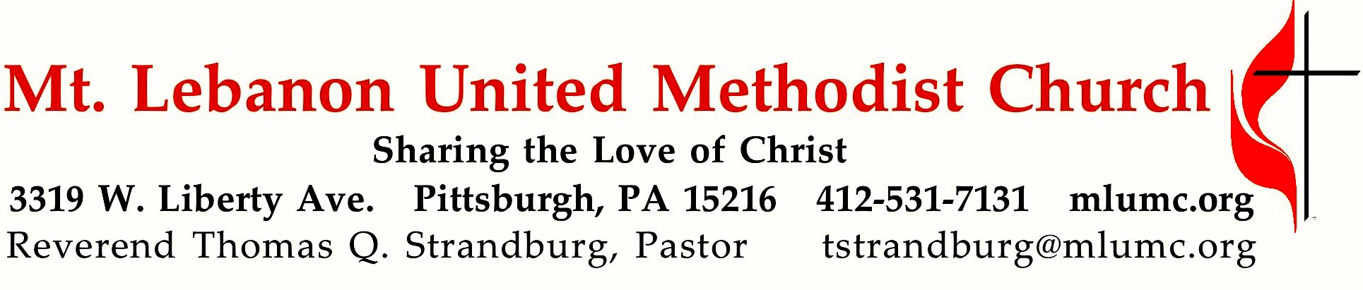
July 30, 2017 8:30 & 10:45
Then Sings My Soul
Summer Sermon Series
The protestant reformer, Martin Luther, once said: “Next to the word of God, the noble art of music is the greatest treasure in the world.” Today we begin a series of messages on some of the great hymns of our faith, beginning with Luther’s own, A Mighty Fortress is Our God.

WE GATHER IN GOD’S NAME …

Gathering Music 8:30
Hymn 420 Breathe on me, breath of God Trentham

Greeting
Leader: This is the day that the Lord has made.
People: Let us rejoice and be glad in it!
Psalm 118:24

Announcements

Call to Worship
Pastor: Lord, you have been our dwelling place in all generations.
People: Before the mountains were brought forth, or ever you had formed the earth and the world, from everlasting to everlasting you are God.
Pastor: You turn us back to dust, and say, “Turn back, you mortals.”
People: For a thousand years in your sight are like yesterday when it is past,
or like a watch in the night.
Psalm 90:1-4 (traditionally, a psalm of Moses)

… TO GIVE PRAISE TO GOD …

Hymn 540 I love thy kingdom, Lord (standing) St. Thomas

Opening Prayer (in unison, standing)
O God, you are the hope of all the ends of the earth, the God of the spirits of all flesh. Hear our humble intercession for all races and families on earth, that you will turn all hearts to yourself. Remove from our minds hatred, prejudice, and contempt for those who are not of our own race or color, class or creed, that, departing from everything that estranges and divides, we may by you be brought into unity of spirit, in the bond of peace. Amen.
Church of Scotland, 20th Century

… TO CELEBRATE THE FAMILY OF FAITH …

Confirmation and Reception into Membership 10:45 UMH pg. 33
Introduction to the Service
Presentation of Candidate – Luke Grabowski
Renunciation of Sin and Profession of Faith
Confirmation
Reception into Membership
Commendation and Welcome

People: We give thanks for all that God has already given you and we welcome you in Christian love. As members together with you in the body of Christ and in this congregation of the United Methodist Church, we renew our covenant faithfully to participate in the ministries of the church by our prayers, our presence, our gifts, our service, and our witness that in everything God may be glorified through Jesus Christ.

The Sign of Peace Please pass the peace to your neighbors as a sign of reconciliation and love.
Leader: The peace of Christ be with you.
People: And also with you.

Gathering Song James Ritchie
This, this is where children belong,
welcomed as part of the worshiping throng.
Water, God’s Word, bread and cup, prayer and song:
This is where children belong.
WORDS: James Ritchie MUSIC: James Ritchie ©1999 Abingdon Press

Message for Young Disciples Rev. Thomas Q. Strandburg
All children are invited. Please sing as children come forward. After the children’s message at the 10:45 service, children ages 3 - 3rd grade may attend Kids Praise in the Welcome Center. Children will be escorted to and from Kids Praise by teachers. They will return to Asbury Center near the end of the service.

… TO HEAR GOD’S WORD PROCLAIMED …

Hymn 419 I am thine, O Lord (seated) I am thine

Scripture Reading 8:30 Joeta D’Este
10:45 Jane Casey
A Lesson from the Hebrew Scriptures
Psalm 46:1-11 God is our refuge and strength

Worship & Song 3137 Jésus le Christ
Lord Jesus Christ, your light shines within us.
Let not my doubts nor my darkness speak to me.
Lord Jesus Christ, your light shines within us.
Let my heart always welcome your love.

Pastoral Prayer

The Lord’s Prayer
Our Father, who art in heaven, hallowed be thy name. Thy kingdom come, thy will be done, on earth as it is in heaven. Give us this day our daily bread. And forgive us our trespasses, as we forgive those who trespass against us. And lead us not into temptation, but deliver us from evil. For thine is the kingdom, and the power, and the glory forever. Amen.

Celtic Alleluia Alleluia (sing 4 times) O’Carroll and Walker

Scripture Reading
A Lesson from the New Testament
Romans 8:28-39 God’s love in Christ Jesus

Response
Leader: The Word of the Lord.
People: Thanks be to God.

… TO OFFER OUR GIFTS AND TO DEDICATE OUR LIVES …

Offertory Solo 8:30 There is a happy land arranged by Wilbur Held

Offertory Anthem 10:45 John Ness Beck
Who shall separate us from the love of Christ?
Shall tribulation, or distress, or persecution, or famine, or nakedness or peril, or sword?
No, in these things we are more than conquerors through him that loved us.
I am persuaded that death, nor life, nor angels, nor height, nor depth,
nor any other creature shall be able to separate us from the love of God,
which is in Christ Jesus our Lord. Amen.

Doxology 94 (standing)
Praise God from whom all blessings flow;
Praise God, all creatures here below: Alleluia! Alleluia!
Praise God the source of all our gifts!
Praise Jesus Christ, whose power uplifts!
Praise the Spirit, Holy Spirit. Alleluia! Alleluia! Alleluia!

Prayer of Dedication

Sermon “A Mighty Fortress is Our God” Rev. Thomas Q. Strandburg

… TO GO REJOICING IN GOD’S NAME!

Hymn 110 A mighty fortress is our God (standing) Ein’ feste Burg

Benediction

Benediction Response 10:45 The Lord bless you and keep you Peter Lutkin

Today’s Services

The flowers for worship today are given by Pete, Beth and Trevor Santore in loving memory of the McKendry and Santore families.

Special music at 10:45 is provided by the Chancel Choir.

Greeters 8:30 Judi Phelps 10:45 Betty Lou Albright

Worship options for children We encourage children to participate in the Children’s Sermon at both services, and in Kids Praise during the 10:45 service. Nursery services are offered in Room 204 of the Education Building. Ask ushers or greeters and follow signs for direction.

Today’s Scriptures

Psalm 46
¹God is our refuge and strength, a very present help in trouble.
²Therefore we will not fear, though the earth should change, though the mountains shake in the heart of the sea;
³though its waters roar and foam, though the mountains tremble with its tumult. Selah
⁴There is a river whose streams make glad the city of God, the holy habitation of the Most High.
⁵God is in the midst of the city; it shall not be moved; God will help it when the morning dawns.
⁶The nations are in an uproar, the kingdoms totter; he utters his voice, the earth melts.
⁷The Lord of hosts is with us; the God of Jacob is our refuge. Selah
⁸Come, behold the works of the Lord; see what desolations he has brought on the earth.
⁹He makes wars cease to the end of the earth; he breaks the bow, and shatters the spear; he burns the shields with fire.
¹⁰“Be still, and know that I am God! I am exalted among the nations, I am exalted in the earth.”
¹¹The Lord of hosts is with us; the God of Jacob is our refuge. Selah

Romans 8:28-39
²⁸We know that all things work together for good for those who love God, who are called according
to his purpose.

²⁹For those whom he foreknew he also predestined to be conformed to the image of his Son, in order that he might be the firstborn within a large family. ³⁰And those whom he predestined he also called; and those whom he called he also justified; and those whom he justified he also glorified.

³¹What then are we to say about these things? If God is for us, who is against us? ³²He who did not withhold his own Son, but gave him up for all of us, will he not with him also give us everything else? ³³Who will bring any charge against God’s elect? It is God who justifies. ³⁴Who is to condemn? It is Christ Jesus, who died, yes, who was raised, who is at the right hand of God, who indeed intercedes for us. ³⁵Who will separate us from the love of Christ? Will hardship, or distress, or persecution, or famine, or nakedness, or peril, or sword? ³⁶As it is written, “For your sake we are being killed all day long; we are accounted as sheep to be slaughtered.” ³⁷No, in all these things we are more than conquerors through him who loved us. ³⁸For I am convinced that neither death, nor life, nor angels, nor rulers, nor things present, nor things to come, nor powers, ³⁹nor height, nor depth, nor anything else in all creation, will be able to separate us from the love of God in Christ Jesus our Lord.

Podcasts of Sunday Sermons Would you like to share this morning’s sermon with a friend or did you miss a Sunday? Catch up on the messages from MLUMC with a podcast of Pastor Tom’s and others’ Sunday sermons. A month’s sermons are at http://mlumc.buzzsprout.com or navigate to the site from the link on our webpage, www.mlumc.org. Sermons older than a month will be posted to iTunes. Full recordings of the service are available upon request.

Honor or remember a loved one with a flower donation. To donate an arrangement for the worship service, contact Sharon Slater, 412-343-1137.

Faith for Today 9:30-10:30 am Sundays Asbury Center

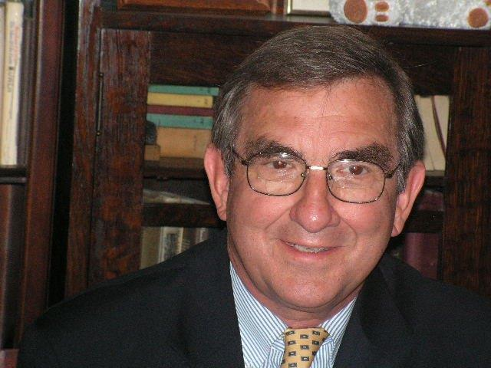Today Dr. Jack Aupperle, Reflections on Tom Brokaw: A Life Well Lived
Tom Brokaw’s life is captured in his work, The Greatest Generation, and a more recent work, A Lucky Life Interrupted. Based upon these works Dr. Aupperle will develop critical themes of Brokaw’s values which speak to the issues of today’s world.

Jack Aupperle is a graduate of Bethany College and Drew University. While at Drew he was a Tipple Scholar and was the recipient of the John Heston Wiley Award for excellence in Homiletics. He has served United Methodist Churches in Western Pennsylvania retiring in 2002. He has been a member of the faculty of St. Vincent. College for 34 years. He was recently named Professor of the Year by a joint committee of students and faculty

August 6 Young Helping Heroes, Family Friendly Interactive
After a fun week at Vacation Bible School learning about God’s heroes, it is our turn to put on our hero capes and save the day! Adults and children are invited to learn about mission projects within our church while they participate in doing stations that will help others in our community and around the world.

August 13 MLUMC Youth, Mission Work in Virginia
This year’s youth mission team worked with Project Crossroads in Marion, VA. Hear how their lives were touched in providing home renovations for low income families.

August 20 Ministries of MLUMC, Celebration Sunday

August 27 Mission Work Abroad: Updates on Haiti and Zwickau

HELP WANTED: Volunteers for Worship Services

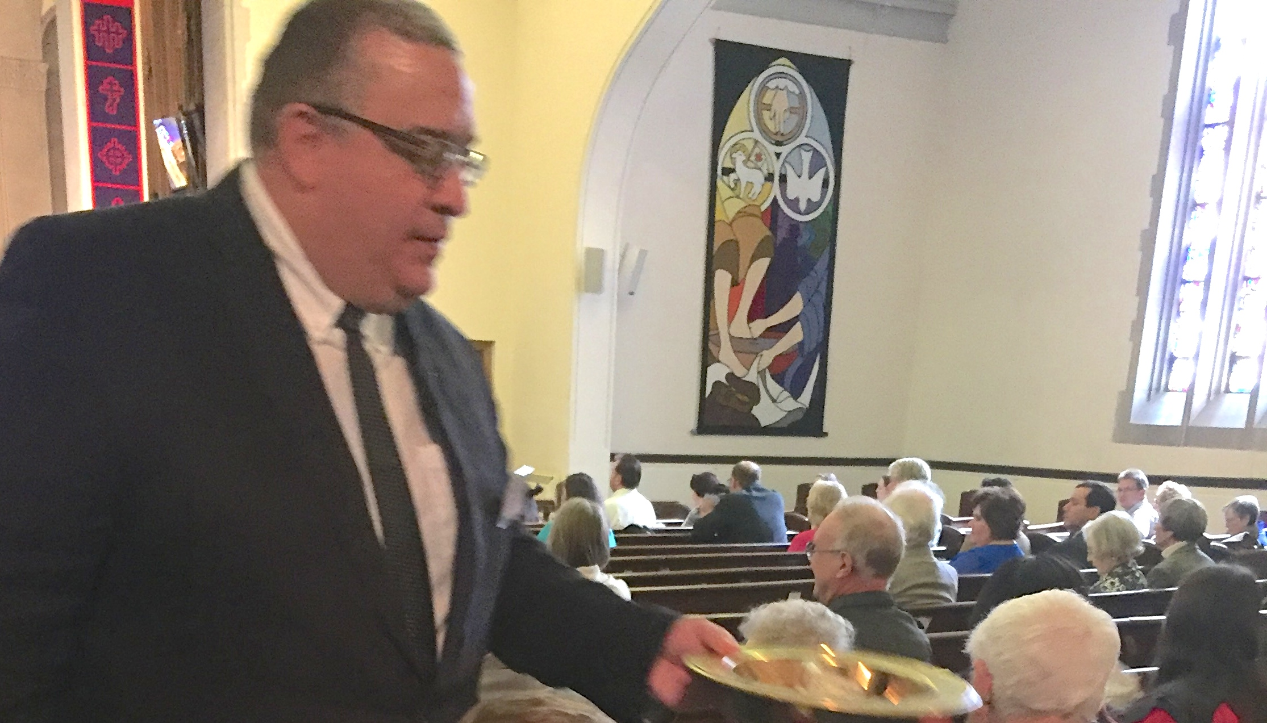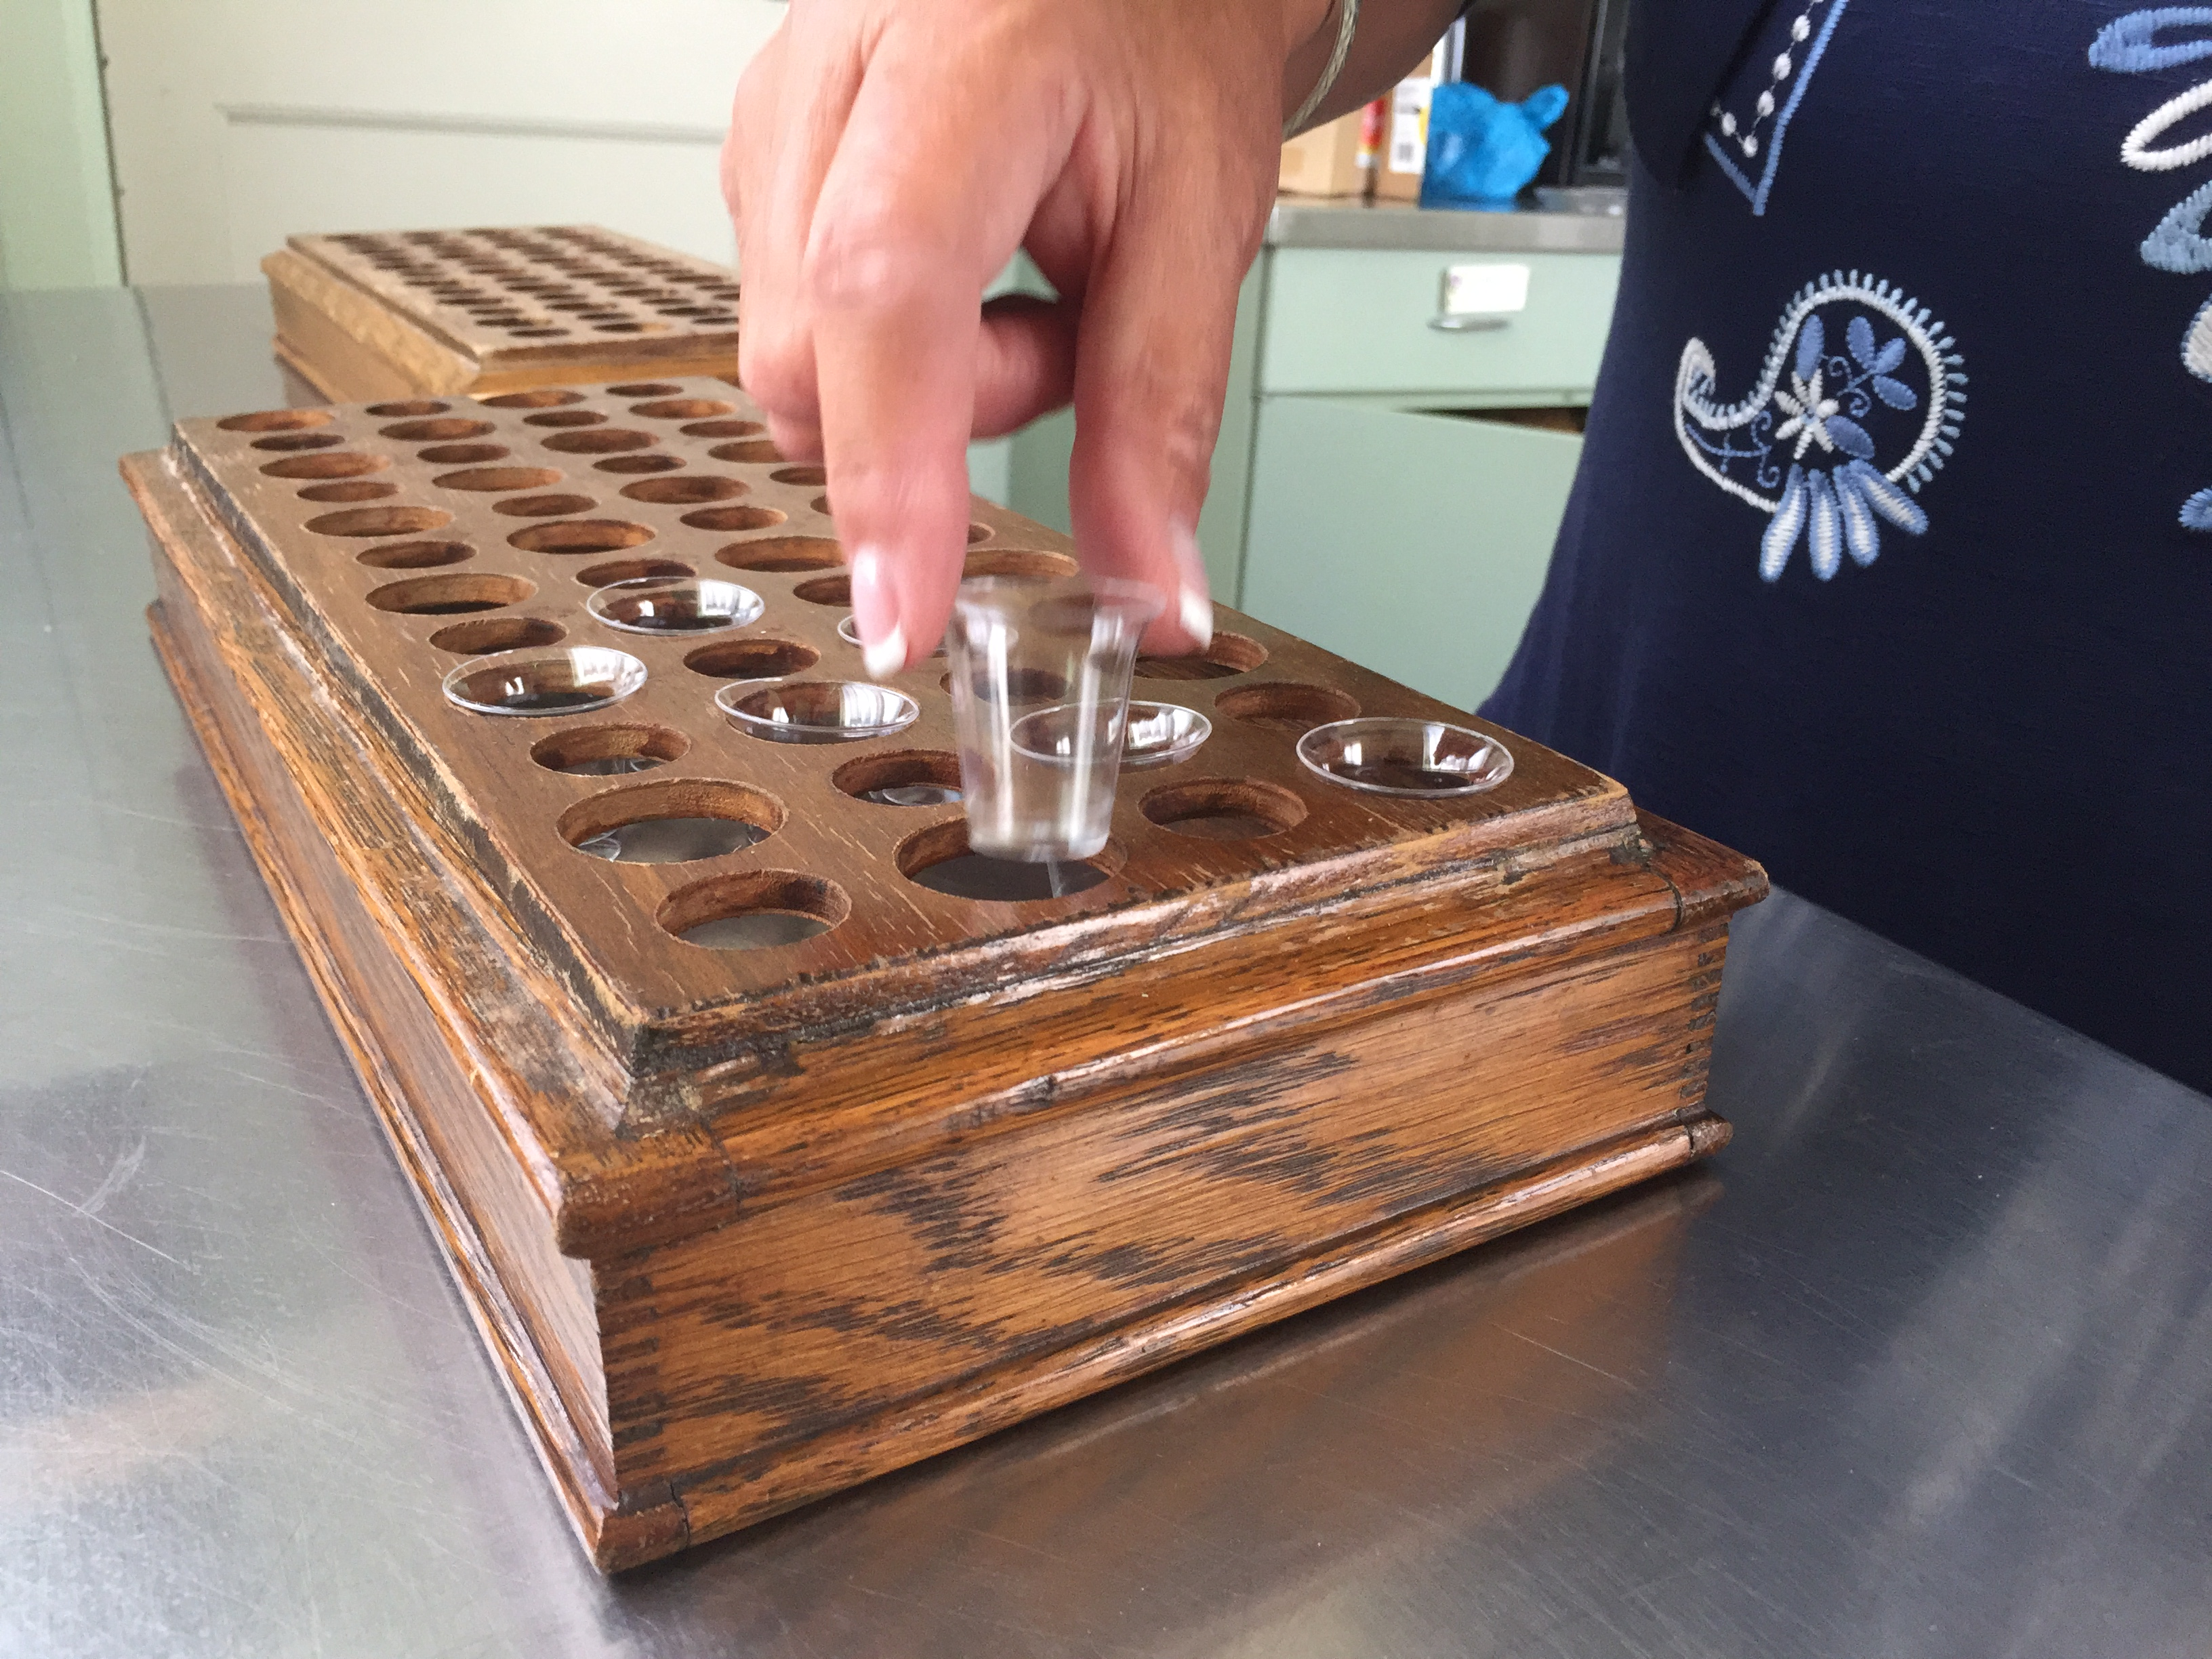

The Worship Advisory Committee has identified urgent needs for the following positions:
- Communion Steward - Volunteers are needed monthly to set up worship service locations for communion. Tasks include gathering supplies, assembling trays with plastic cups and bread, filling cups, and positioning trays on the communion rails.
- Communion Bread Maker - Volunteers are needed monthly to prepare communion bread at the volunteer's home according to the church's recipe, and then deliver the bread to the church.
- Usher - Volunteers are needed weekly during worship services to welcome people and distribute bulletins, assist churchgoers with seating, collect the offering, lead people to communion, and help out during the service as needed. Training will be provided.
Please call the church office if you are interested in helping: 412-531-7131.

Keep in Prayer

Convalescing in Care Facilities
Leila Berkey, Asbury Heights
Ed Clarke, Asbury Place
Pat Seitz, Concordia
Tim Watters, Baptist Home

Convalescing at Home
Mary Caldwell, David Lewis,
May Frederick, Earl Killian,
Susan Lichtenfels, Betty Trout,
John White

In the Military

Jason Boyer, SPC Natalie Brown

Capt. Zachary Allen Finch, USMC
James Iantelli, 1st Lt. Jaskiewicz
S. Sgt. Keith Kimmell, Adam Kmick
PFC Brendan Lamport
Sgt. Matthew McConahan

Sgt. Richard Okello, Thomas Orda
Lt. Col. Mark Patterson

Lt. Com. Scott Patterson

Lt. Col. Sean Patterson
David Poncel, Sgt. Steven Reitz
Capt. Scott B. Rushe, Pastor Rick Townes
Maj. Azizi Wesmiller

Maj. Matthew C. Wesmiller
Sgt. Keith Scott Winkowski

CALENDAR – SUNDAY, JULY 30 THRU SATURDAY, AUGUST 5
Vacation Bible School Week - Monday, July 31 thru Friday, August 4, 9:30 – 11:30 am

SUNDAY 7/30
8:30 am Worship Sanner Chapel
9:30 am Faith for Today Asbury Center
10:45 am Worship Asbury Center
Kids Praise Welcome Center
2 pm Korean Worship Sanner Chapel

TUESDAY 8/1
7 pm Boy Scout Troop #23 Wesley Hall
7 pm Boy Scout Parents Epworth Chapel

WEDNESDAY 8/2
6:30 am Northside Lunch Program Prep Kitchen
6 pm Homebuilders Picnic Asbury Center

THURSDAY 8/3
8:30 am Northside Lunch Program Prep Kitchen
12 pm TNT Asbury Heights

FRIDAY 8/4
9:30 am Women’s Bible Study Room 102

SATURDAY 8/5
10 am Food Distribution Food Pantry

