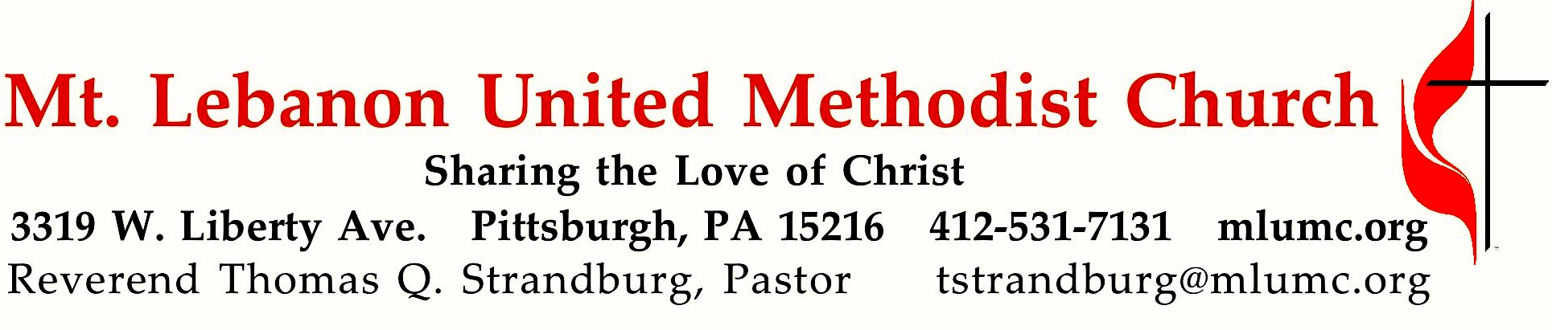
July 9, 2017 8:30 & 10:45
5th Sunday After Pentecost
We love mirrors. We must because they're everywhere. Now comes the True Mirror, a mirror that allows us to see ourselves as others see us. Place a book in front of this mirror and the title will be readable. That's what a true mirror is. The Bible reminds us that Jesus Christ is the True Mirror.

WE GATHER IN GOD’S NAME …

Gathering Music 8:30
Hymn 454 Open my eyes, that I may see Open my eyes

Greeting
Leader: O sing to the Lord a new song, for he has done marvelous things.
People: All the ends of the earth have seen the victory of our God.
Psalm 98:1a, 3b

Announcements

Call to Worship
Pastor: From our busy lives, God calls us together to worship and to pray.
People: We are here, Holy One!
Pastor: From different places, Christ calls us to gather, to love, and to live.
People: We are here, blessed Jesus!
Pastor: From the unexpected journeys, the Spirit calls us into unity to serve and to grow.
People: We are here, Holy Spirit!
Pastor: Come! Let us worship.
Karen Ellis

… TO GIVE PRAISE TO GOD …

Hymn 384 Love divine, all loves excelling (standing) Beecher
Opening Prayer (in unison, standing)
Loving God, from the very beginning you have journeyed with your people. Journey with us this day, as we learn what it means to follow you. Open our ears to your word. Open our hearts to your love and compassion. Open our hands to receive your grace and to share it with others. Enable us to faithfully claim the name, “Christian,” as we strive to follow the ways and teachings of Jesus, the Christ. Empower us with your Holy Spirit, as we worship you and serve one another. In your holy name, we pray. Amen.

… TO CELEBRATE THE FAMILY OF FAITH …

The Sign of Peace Please pass the peace to your neighbors as a sign of reconciliation and love.
Leader: The peace of Christ be with you.
People: And also with you.

Gathering Song James Ritchie
This, this is where children belong,
welcomed as part of the worshiping throng.
Water, God’s Word, bread and cup, prayer and song:
This is where children belong.
WORDS: James Ritchie MUSIC: James Ritchie ©1999 Abingdon Press

Message for Young Disciples Rev. Thomas Q. Strandburg
All children are invited. Please sing as children come forward. After the children’s message at the 10:45 service, children ages 3 - 3rd grade may attend Kids Praise in the Welcome Center. Children will be escorted to and from Kids Praise by teachers. They will return to Asbury Center near the end of the service.

… TO HEAR GOD’S WORD PROCLAIMED …

Hymn 182 Word of God, come down on earth (seated) Liebster Jesu

Scripture Reading 8:30 Marda Katshir
10:45 JJ Knabb
A Lesson from the New Testament
Romans 7:15-25a Humanity’s struggle against sin

Worship & Song 3137 Jésus le Christ
Lord Jesus Christ, your light shines within us.
Let not my doubts nor my darkness speak to me.
Lord Jesus Christ, your light shines within us.
Let my heart always welcome your love.

The Lord’s Prayer
Our Father, who art in heaven, hallowed be thy name. Thy kingdom come, thy will be done, on earth as it is in heaven. Give us this day our daily bread. And forgive us our trespasses, as we forgive those who trespass against us. And lead us not into temptation, but deliver us from evil. For thine is the kingdom, and the power, and the glory forever. Amen.

Celtic Alleluia Alleluia (sing 4 times) O’Carroll and Walker

Scripture Reading
A Lesson from the Gospels (standing)
Matthew 11:16-19, 25-30 Put on the yoke of Christ

Response
Leader: The Word of the Lord.
People: Thanks be to God.

… TO OFFER OUR GIFTS AND TO DEDICATE OUR LIVES …

Offertory Solo 8:30 Deep River Spiritual, arr. Held

Offertory Anthem 10:45 Laura Manzo
They shall soar like eagles; rise up and soar like eagles.
They who wait upon the Lord shall not be weary.
They shall never stumble, but gain new strength and power.
They who wait upon the Lord.
Those who are weary and burdened with sorrow
need not despair there is hope for tomorrow.
God will be there each time you call on Him.
They shall soar like eagles; rise up and soar like eagles.
They who wait upon the Lord shall not be weary.
They shall never stumble, but gain new strength and power.
They who wait upon the Lord. Isaiah 40:29-31

Doxology 94 (standing)
Praise God from whom all blessings flow;
Praise God, all creatures here below: Alleluia! Alleluia!
Praise God the source of all our gifts!
Praise Jesus Christ, whose power uplifts!
Praise the Spirit, Holy Spirit. Alleluia! Alleluia! Alleluia!

Prayer of Dedication
Sermon “The True Mirror” Rev. Thomas Q. Strandburg

… TO GO REJOICING IN GOD’S NAME!

Hymn 400 Come, thou Fount of every blessing (standing) Nettleton

Benediction

Today’s Services

The flower arrangement provided for worship today is given by Linda Nixon in loving memory of her father, Herbert B. Heinz.

Special music at 10:45 is provided by the Chancel Choir with flautist Melissa Lessure, whose presence with us is made possible through contributors to the Friends of Music Fund.

Greeters 8:30 George Lindow 10:45 Bob and Chris James

Worship options for children We encourage children to participate in the Children’s Sermon at both services, and in Kids Praise during the 10:45 service. Nursery services are offered in Room 204 of the Education Building. Ask ushers or greeters and follow signs for direction.

Podcasts of Sunday Sermons Would you like to share this morning’s sermon with a friend or did you miss a Sunday? Catch up on the messages from MLUMC with a podcast of Pastor Tom’s and others’ Sunday sermons. A month’s sermons are at http://mlumc.buzzsprout.com or navigate to the site from the link on our webpage, www.mlumc.org. Sermons older than a month will be posted to iTunes. Full recordings of the service are available upon request.

Honor or remember a loved one with a flower donation. To donate an arrangement for the worship service, contact Sharon Slater, 412-343-1137.

Today’s Scriptures
Romans 7:15-25a
¹⁵I do not understand my own actions. For I do not do what I want, but I do the very thing I hate. ¹⁶Now if I do what I do not want, I agree that the law is good. ¹⁷But in fact it is no longer I that do it, but sin that dwells within me. ¹⁸For I know that nothing good dwells within me, that is, in my flesh. I can will what is right, but I cannot do it. ¹⁹For I do not do the good I want, but the evil I do not want is what I do. ²⁰Now if I do what I do not want, it is no longer I that do it, but sin that dwells within me. ²¹So I find it to be a law that when I want to do what is good, evil lies close at hand. ²²For I delight in the law of God in my inmost self, ²³but I see in my members another law at war with the law of my mind, making me captive to the law of sin that dwells in my members. ²⁴Wretched man that I am! Who will rescue me from this body of death? ²⁵Thanks be to God through Jesus Christ our Lord! So then, with my mind I am a slave to the law of God, but with my flesh I am a slave to the law of sin.

Matthew 11:16-19, 25-30
¹⁶“But to what will I compare this generation? It is like children sitting in the marketplaces and calling to one another, ¹⁷‘We played the flute for you, and you did not dance; we wailed, and you did not mourn.’ ¹⁸For John came neither eating nor drinking, and they say, ‘He has a demon’; ¹⁹the Son of Man came eating and drinking, and they say, ‘Look, a glutton and a drunkard, a friend of tax collectors and sinners!’ Yet wisdom is vindicated by her deeds.”
²⁵At that time Jesus said, “I thank you, Father, Lord of heaven and earth, because you have hidden these things from the wise and the intelligent and have revealed them to infants; ²⁶yes, Father, for such was your gracious will. ²⁷All things have been handed over to me by my Father; and no one knows the Son except the Father, and no one knows the Father except the Son and anyone to whom the Son chooses to reveal him. ²⁸“Come to me, all you that are weary and are carrying heavy burdens, and I will give you rest. ²⁹Take my yoke upon you, and learn from me; for I am gentle and humble in heart, and you will find rest for your souls. ³⁰For my yoke is easy, and my burden is light.”

Keep in Prayer

Convalescing in Care Facilities
Leila Berkey, Asbury Heights
Ed Clarke, Asbury Place
Pat Seitz, Concordia
Tim Watters, Baptist Home

Convalescing at Home
Mary Caldwell, David Lewis,
May Frederick, Earl Killian,
Susan Lichtenfels, Betty Trout

In the Military

Jason Boyer, SPC Natalie Brown

Capt. Zachary Allen Finch, USMC
James Iantelli, 1st Lt. Jaskiewicz
S. Sgt. Keith Kimmell, Adam Kmick
PFC Brendan Lamport
Sgt. Matthew McConahan

Sgt. Richard Okello, Thomas Orda
Lt. Col. Mark Patterson

Lt. Com. Scott Patterson

Lt. Col. Sean Patterson
David Poncel, Sgt. Steven Reitz
Capt. Scott B. Rushe, Pastor Rick Townes
Maj. Azizi Wesmiller

Maj. Matthew C. Wesmiller
Sgt. Keith Scott Winkowski

I would like to thank the church for the beautiful cross necklace I received upon my retirement from Weekday Ministries. It will be a reminder every time I wear it of the wonderful group of people I had the pleasure of getting to know, from both the daycare and the church.

Thank you for the privilege of serving the families who utilize the church’s outreach to the community, through the daycare. God’s continued blessings on all your congregation’s efforts to serve those around you.

With heartfelt appreciation,
Nancy Phillips
Weekday Ministries (Infant room lead teacher)

Faith for Today 9:30-10:30 am Sundays Asbury Center
TODAY Carnegie Museum Family Friendly -The Iroquois in PA, Educators from Carnegie Museum of Natural History will help us learn about the Iroquois, a group of Native Americans who resided in Western Pennsylvania. Children and adults will explore Iroquois music, games, food, and more at a variety of hands-on learning stations

July 16 Dr. Todd DePastino War Stories from Pittsburgh’s WWII Veterans Todd DePastino knows how to tell a good story. As an award-winning historian, that’s his job. But for the past six years, he's been focused on listening. And the stories he's heard—some beautiful and heartbreaking, others gut-wrenching—are largely about war. Todd is co-founder and director of the Veterans Breakfast Club, a 501(c)(3) nonprofit organization dedicated to gathering veterans of all eras and generations together to share their stories of service. Using photographs of the veterans he’s met and interviewed, Todd will tell the extraordinary WWII stories he’s heard from veterans living in the region and will also discuss his quest to preserve and celebrate them.

July 23 Matt Haff Working with the Prison Population

July 30 Dr. Jack Aupperle Reflections on Tom Brokaw: A Life Well Lived

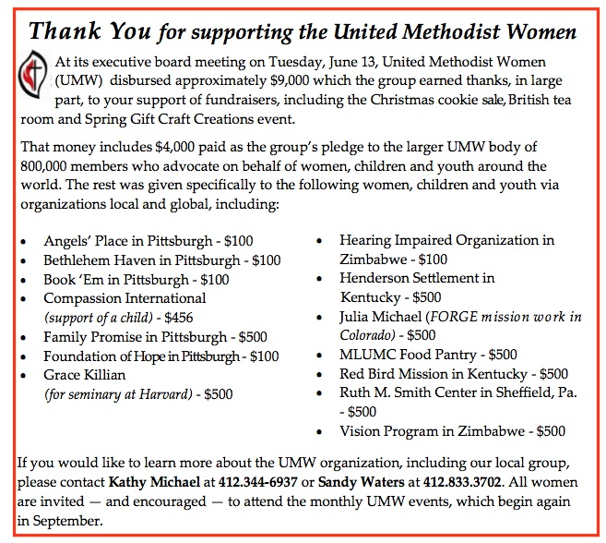

Time to Register for VBS
Vacation Bible School, Mon. July 31 - Fri. August 4,
9:30—11:30 a.m. $5 per child, ages 4 -5th grade.
Register on-line at www.mlumc.org, or pick up a registration form.
To volunteer or for more info, contact
Kim Rhoton: krhoton@mlumc.org

CALENDAR – SUNDAY, JULY 9 THRU SATURDAY, JULY 15

SUNDAY 7/9
8:30 am Worship Sanner Chapel
9:30 am Faith for Today Asbury Center
10:45 am Worship Asbury Center
Kids Praise Welcome Center
2 pm Korean Worship Sanner Chapel

TUESDAY 7/11
7 pm Boy Scout Troop #23 Wesley Hall
7 pm Boy Scout Board of Reviews Room 105

WEDNESDAY 7/12
6 pm Homebuilders Picnic Asbury Center
7:30 pm Finance Wesley Hall

FRIDAY 7/14
9:30 am Women’s Bible Study Room 102
1:30 pm Memoirs Group Wesley Hall

SATURDAY 7/15
10 am Food Distribution Food Pantry

