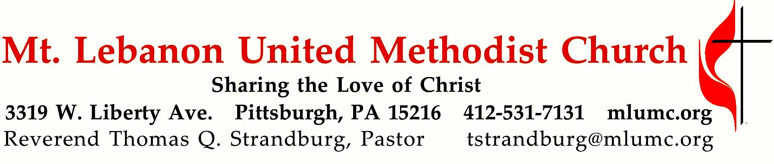
August 6, 2017 8:30 & 10:45
Then Sings My Soul
Summer Sermon Series
Peace. Humanity clamors for it, even as we sometimes work against it. The 19th Century composer, Joseph M. Scriven, surmounted the trials in his own life to find “the peace of God which surpasses all understanding.” (Philippians 4:6) That peace inspired him to write the beloved hymn, “What a Friend We Have in Jesus.”

WE GATHER IN GOD’S NAME …

Gathering Music 8:30
Hymn 618 Let us break bread together (seated) Let us break bread

Greeting
Leader: I was glad when they said unto me,
People: Let us go into the house of the Lord!
Psalm 122:1
Announcements

Call to Worship
Pastor: We have one Lord.
People: God lives in each of us. We have one faith. God works in each of us.
Pastor: We have one baptism.
People: God gives gifts to each of us.
Pastor: We are one body.
People: God makes us all one. Ephesians 4

… TO GIVE PRAISE TO GOD …

Hymn 185 When morning gilds the skies (standing) Laudes domini

Opening Prayer (in unison, standing)
Almighty God, speak your truth to us this day. Give us the treasure of your wisdom and love that we might become for the world the treasure you seek us to be. Clothe us with your compassion and courage that we might be the Body of Christ to a hurting world. In your holy name we pray. Amen.

… TO CELEBRATE THE FAMILY OF FAITH …

The Sign of Peace Please pass the peace to your neighbors as a sign of reconciliation and love.
Leader: The peace of Christ be with you.
People: And also with you.

Gathering Song James Ritchie
This, this is where children belong,
welcomed as part of the worshiping throng.
Water, God’s Word, bread and cup, prayer and song:
This is where children belong.
WORDS: James Ritchie MUSIC: James Ritchie ©1999 Abingdon Press

Message for Young Disciples Rev. Thomas Q. Strandburg
All children are invited. Please sing as children come forward. After the children’s message at the 10:45 service, children ages 3 - 3rd grade may attend Kids Praise in the Welcome Center. Children will be escorted to and from Kids Praise by teachers. They will return to Asbury Center near the end of the service.

… TO HEAR GOD’S WORD PROCLAIMED …

Scripture Reading 8:30 Scott Miller
10:45 Chris James
A Lesson from the New Testament
Philippians 4:1-7 Rejoice in the Lord always

Worship & Song 3137 Jésus le Christ
Lord Jesus Christ, your light shines within us.
Let not my doubts nor my darkness speak to me.
Lord Jesus Christ, your light shines within us.
Let my heart always welcome your love.

Pastoral Prayer

The Lord’s Prayer
Our Father, who art in heaven, hallowed be thy name. Thy kingdom come, thy will be done, on earth as it is in heaven. Give us this day our daily bread. And forgive us our trespasses, as we forgive those who trespass against us. And lead us not into temptation, but deliver us from evil. For thine is the kingdom, and the power, and the glory forever. Amen.

Celtic Alleluia Alleluia (sing 4 times, standing) O’Carroll and Walker

Scripture Reading
A Lesson from the Gospel
John 15:12-17 The Great Commandment

Response
Leader: The Word of the Lord.
People: Thanks be to God.

… TO OFFER OUR GIFTS AND TO DEDICATE OUR LIVES …

Offertory Solo En Prière (In Prayer) Gabriel Faure
Translation:
If the voice of a child can reach you, O my Father,
listen to the prayer of Jesus on His knees before You.
If You have chosen me to teach Your laws
on the earth I will know how to serve You, holy King of Kings, O Light!
Place on my lips, O Lord, the salutary truth, so that whoever doubts should with humility revere You.
Do not abandon me, give me the gentleness so necessary to relieve the suffering,
to alleviate pains and misery. Reveal Yourself to me, Lord, in whom I have faith and hope.
I want to suffer for You and to die on the cross at Calvary.

Doxology 94 (standing)
Praise God from whom all blessings flow;
Praise God, all creatures here below: Alleluia! Alleluia!
Praise God the source of all our gifts!
Praise Jesus Christ, whose power uplifts!
Praise the Spirit, Holy Spirit. Alleluia! Alleluia! Alleluia!

Prayer of Dedication

Sermon “What a Friend We Have in Jesus” Rev. Thomas Q. Strandburg

Hymn of Preparation Come to the table of grace Worship & Song, #3168

The Sacrament of Holy Communion

The Great Thanksgiving
Leader: The Lord be with you.
People: And also with you
Leader: Lift up your hearts.
People: We lift them up to the Lord.
Leader: Let us give thanks to the Lord our God..
People: It is right to give our thanks and praise.
Leader: (The pastor continues in prayer, and concludes with the following words. . . )
This cup and your thoughts of me will sustain you and restore your spirits.
People: Amen

Giving the Bread and Cup

Prayer following Communion
You have opened to us the Scriptures, O Christ, and you have made yourself known in the breaking of the bread. Abide with us, we pray, that, blessed by your royal presence, we may walk with you all the days of our lives, and at its end behold you in the glory of the eternal Trinity, one God for ever and ever. Amen.

… TO GO REJOICING IN GOD’S NAME!

Hymn 526 What a friend we have in Jesus (standing) Converse

Benediction

What a Friend: The Wesleyan Means of Grace

Works of Piety

Individual Practices – reading, meditating and studying the scriptures, prayer, fasting, regularly attending worship, healthy living, and sharing our faith with others

Communal Practices – regularly share in the sacraments, Christian conferencing (accountability to one another), and Bible study

Works of Mercy

Individual Practices - doing good works, visiting the sick, visiting those in prison, feeding the hungry, and giving generously to the needs of others

Communal Practices – seeking justice, ending oppression and discrimination, and addressing the needs of the poor

Today’s Services
The flowers for worship today are given by Cheryl Herrington in memory of her beloved family: father, Artemis Herrington; mother, Shirley Herrington and sisters Gail Beeson and Judy Androus.

This morning’s music is provided by Cori DeLuca, a member of this church and piano teacher in the area; and Robert Richards, a member of the Chancel Choir.

Greeters 8:30 Erma Henry 10:45 Marianne Boyd

Worship options for children We encourage children to participate in the Children’s Sermon at both services, and in Kids Praise during the 10:45 service. Nursery services are offered in Room 204 of the Education Building. Ask ushers or greeters and follow signs for direction.

Podcasts of Sunday Sermons Would you like to share this morning’s sermon with a friend or did you miss a Sunday? Catch up on the messages from MLUMC with a podcast of Pastor Tom’s and others’ Sunday sermons. A month’s sermons are at http://mlumc.buzzsprout.com or navigate to the site from the link on our webpage, www.mlumc.org. Sermons older than a month will be posted to iTunes. Full recordings of the service are available upon request.

Honor or remember a loved one with a flower donation. To donate an arrangement for the worship service, contact Sharon Slater, 412-343-1137.
Today’s Scriptures

Philippians 4:1-7
Therefore, my brothers and sisters, whom I love and long for, my joy and crown, stand firm in the Lord in this way, my beloved. ²I urge Euodia and I urge Syntyche to be of the same mind in the Lord. ³Yes, and I ask you also, my loyal companion, help these women, for they have struggled beside me in the work of the gospel, together with Clement and the rest of my co-workers, whose names are in the book of life. ⁴Rejoice in the Lord always; again I will say, Rejoice. ⁵Let your gentleness be known to everyone. The Lord is near. ⁶Do not worry about anything, but in everything by prayer and supplication with thanksgiving let your requests be made known to God. ⁷And the peace of God, which surpasses all understanding, will guard your hearts and your minds in Christ Jesus.

John 15:12-17
¹²“This is my commandment, that you love one another as I have loved you. ¹³No one has greater love than this, to lay down one’s life for one’s friends. ¹⁴You are my friends if you do what I command you. ¹⁵I do not call you servants any longer, because the servant does not know what the master is doing; but I have called you friends, because I have made known to you everything that I have heard from my Father. ¹⁶You did not choose me but I chose you. And I appointed you to go and bear fruit, fruit that will last, so that the Father will give you whatever you ask him in my name. ¹⁷I am giving you these commands so that you may love one another.

HELP WANTED: Volunteers for Worship Services

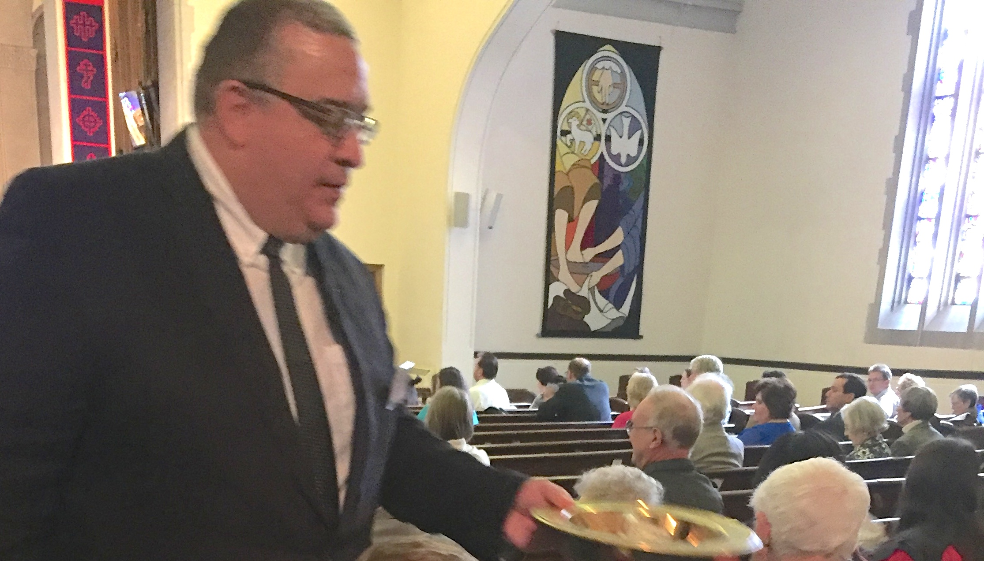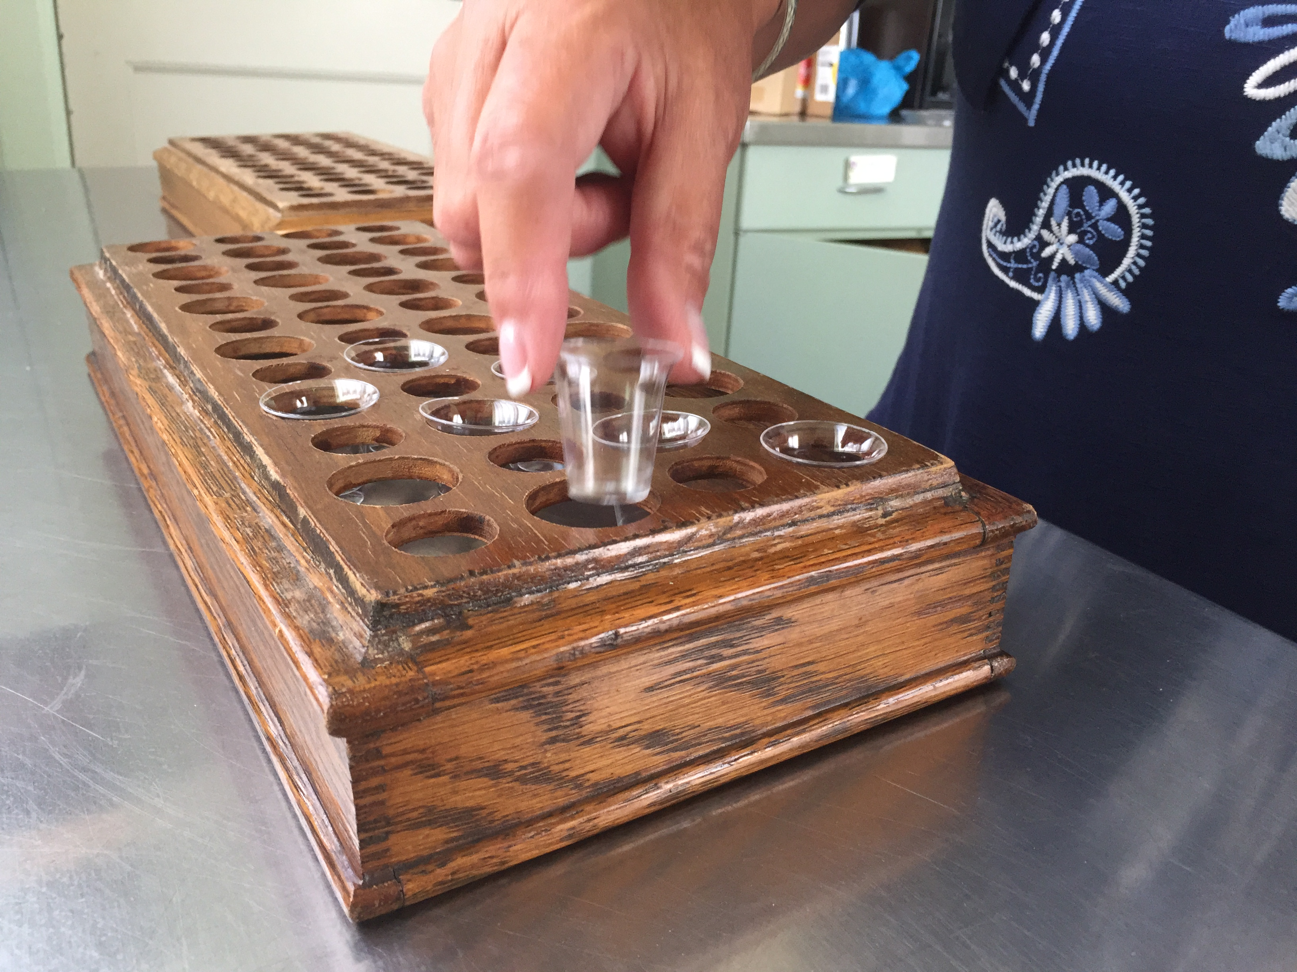

The Worship Advisory Committee has identified urgent needs for the following positions:
- Communion Steward - Volunteers are needed monthly to set up worship service locations for communion. Tasks include gathering supplies, assembling trays with plastic cups and bread, filling cups, and positioning trays on the communion rails.
- Usher - Volunteers are needed weekly during worship services to welcome people and distribute bulletins, assist churchgoers with seating, collect the offering, lead people to communion, and help out during the service as needed. Training will be provided.
Please call the church office if you are interested in helping: 412-531-7131.

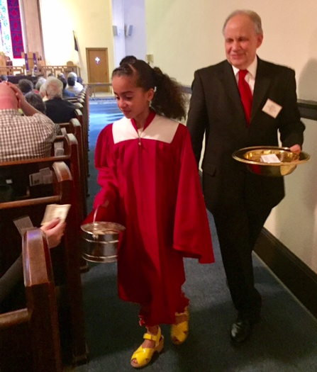
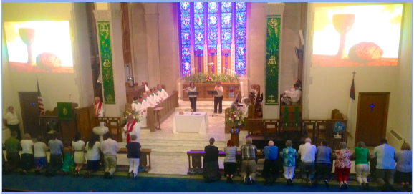

Keep in Prayer
Hospitalized
John Dean, St. Clair

Convalescing in Care Facilities
Leila Berkey, Asbury Heights
Ed Clarke, Asbury Place
Pat Seitz, Concordia
Tim Watters, Baptist Home

Convalescing at Home
Mary Caldwell, David Lewis,
May Frederick, Earl Killian,
Susan Lichtenfels, Betty Trout,
John White

In the Military

Jason Boyer, SPC Natalie Brown

Capt. Zachary Allen Finch, USMC
James Iantelli, 1st Lt. Jaskiewicz
S. Sgt. Keith Kimmell, Adam Kmick
PFC Brendan Lamport
Sgt. Matthew McConahan

Sgt. Richard Okello, Thomas Orda
Lt. Col. Mark Patterson

Lt. Com. Scott Patterson

Lt. Col. Sean Patterson
David Poncel, Sgt. Steven Reitz
Capt. Scott B. Rushe, Pastor Rick Townes
Maj. Azizi Wesmiller

Maj. Matthew C. Wesmiller
Sgt. Keith Scott Winkowski

CALENDAR – SUNDAY, AUGUST 6 THRU SATURDAY, AUGUST 12

SUNDAY 8/6
8:30 am Worship Sanner Chapel
9:30 am Faith for Today Asbury Center
10:45 am Worship Asbury Center
Kids Praise Welcome Center
2 pm Korean Worship Sanner Chapel

TUESDAY 8/8
7 pm Boy Scout Troop #23 Wesley Hall
7 pm Boy Scout Board of Reviews Room 105

WEDNESDAY 8/9
6 pm Homebuilders Picnic Asbury Center
7:30 pm Finance Committee Wesley Hall

FRIDAY 8/11
9:30 am Women’s Bible Study Room 102
1:30 pm Memoirs Group Wesley Hall

