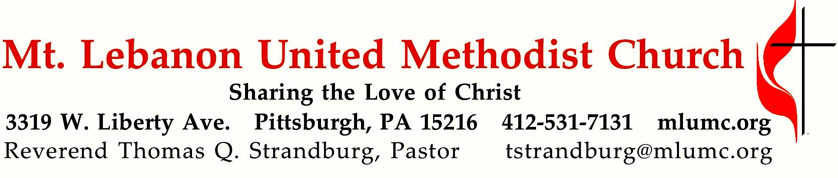
October 15, 2017 8:30 & 10:45

WE GATHER IN GOD’S NAME …

Gathering Music
Worship & Song 3093 Fill my cup, Lord Fill my cup
Worship & Song 3029 In the desert (stanzas 1-3) Lauda anima

Welcome and Announcements 8:30 Bob Mallery 10:45 Noel Slater

Call to Worship Stacy Rosleck
Leader: We are appointed by Jesus Christ.
People: We go with God.
Leader: We offer peace in the Spirit of the Lord to everyone we meet.
People: We open our hearts.
Leader: We proclaim the good news.
People: The kingdom of God is near.
… TO GIVE PRAISE TO GOD …

Worship & Song 3150 Father, we have heard you calling Hyfrydol

Opening Prayer Linda Minnotte

Silent Prayer

Worship & Song 3022 Pahoa
Peace of our praying, song of our singing, truth of our telling, love of all loves,
health of our healing, gift of our giving, life of our living, light of all lights.

… TO CELEBRATE THE FAMILY OF FAITH …

The Sign of Peace Please pass the peace to your neighbors as a sign of reconciliation and love.
Leader: The peace of Christ be with you.
People: And also with you.

Gathering Song James Ritchie
This, this is where children belong,
welcomed as part of the worshiping throng.
Water, God’s Word, bread and cup, prayer and song:
This is where children belong.
WORDS AND MUSIC: James Ritchie ©1999 Abingdon Press

Message for Young Disciples Jen Barnabei
All children are invited. Please sing as children come forward. After the children’s message at the 10:45 service, children ages 3 - 3rd grade may attend Kids Praise in the Welcome Center. Children will be escorted to and from Kids Praise by teachers. They will return to the Sanctuary near the end of the service.

… TO HEAR GOD’S WORD PROCLAIMED …

Handbell Anthem 10:45 Minuet in G J. S. Bach, arr. Jason Krug

Celtic Alleluia Alleluia (sing 4 times, standing) O’Carroll and Walker

Scripture Reading Cleon and Vera Jane Cornes, narrator and respondent
A Lesson from the Gospels (standing)
Luke 10:1-11 Jesus Sends Out the Seventy-Two

Response
Leader: The Word of the Lord.
People: Thanks be to God.
Anthem 10:45 Lord, here am I Stephen Paulus
To walk in your wonder, send me, run in your river, wash in your water,
feast in your freedom
Refrain: Holy is the Lord of hosts and the whole earth is full of his glory.
To go in your glory, send me, eat in your Easter, cry in your Christmas,
sing in your silence. Refrain
To hope in your heaven, send me, mind in your mercy, serve in your Spirit,
joy in your Jesus. Refrain Send me, Lord.

Prayers of the People Sally Munro
Leader: For our unity and the unity of your whole church in your mission to make disciples of Jesus Christ for the transformation of the world,
People: Hear us, O God.
Leader: With leaders at every level of our common life – villages, towns, states, nations, corporations, and international associations – that there may be peace and justice for all people,
People: Hear us, O God.
Leader: For the earth, that we may be, and inspire others to be, good stewards of all the gifts of your creation,
People: Hear us, O God.
Leader: With all who need your healing and deliverance from physical or mental illness, isolation, deprivation, violence, and any form of oppesssion,
People: Hear us, O God.

The Lord’s Prayer
Our Father, who art in heaven, hallowed be thy name. Thy kingdom come, thy will be done, on earth as it is in heaven. Give us this day our daily bread. And forgive us our trespasses, as we forgive those who trespass against us. And lead us not into temptation, but deliver us from evil. For thine is the kingdom, and the power, and the glory forever. Amen.

… TO OFFER OUR GIFTS AND TO DEDICATE OUR LIVES …

Offertory 8:30

Offertory Anthem 10:45 Taylor Davis
Hope of the world, thou Christ of great compassion,
Speak to our fearful hearts by conflict rent.
Save us, thy people from consuming passion,
who by our own false hopes and aims are spent.
Hope of the world, God’s gift from highest heaven,
bringing to hungry souls the bread of life,
still lest thy spirit unto us be given, to heal earth’s wounds and end all bitter strife.
Hope of the world, afoot on dusty highways,
showing to wandering souls the path of light,
walk beside us lest the tempting byways lure us away from thee to endless night.
Hope of the world, O Christ, o’er death victorious,
Who by this sign didst conquer grief and pain,
we would be faithful to thy gospel glorious,
thou art our Lord Thou dost forever reign. Hope of the world.
text by Georgia Harkness (1891-1974)

Doxology Hymn 97 (standing) Tune: #688 Ar hyd y nos
For the fruits of this creation, thanks be to God;
for good gifts to every nation, thanks be to God;
for the plowing, sowing, reaping, silent growth while we are sleeping,
future needs in earth’s safe-keeping, thanks be to God.

Offertory Prayer 8:30 Bob Mallery 10:45 Andrea Sherwin

Sermon “Therefore Go!” Bob Mallery

… TO GO REJOICING IN GOD’S NAME!

Hymn 547 O church of God, united (standing) Ellacombe el

Benediction

Today’s Services
The chancel flowers are given by Gerry Oelschlager in honor of Corinne O. Potter

The flowers on the altar are given in celebration of Rob and Jane Spicher’s 3rd anniversary.

Special music at 10:45 is provided by the Grace Notes (Linda Minnotte, Mary Paine and Andy Seay), the women of the Chancel Choir and the Chancel Choir with pianist Cori DeLuca.

Greeters 8:30 Rich and Kathy Tremblay 10:45 Jane Casey

Acolytes Anna Rhoton and Xavier Sanchez
+
Worship options for children We encourage children to participate in the Children’s Sermon at both services, and in Kids Praise during the 10:45 service. Nursery services are offered in Room 204 of the Education Building. Ask ushers or greeters and follow signs for direction.

Podcasts of Sunday Sermons Would you like to share this morning’s sermon with a friend or did you miss a Sunday? Catch up on the messages from MLUMC with a podcast of Pastor Tom’s and others’ Sunday sermons. A month’s sermons are at http://mlumc.buzzsprout.com or navigate to the site from the link on our webpage, www.mlumc.org. Sermons older than a month will be posted to iTunes. Full recordings of the service are available upon request.

Honor or remember a loved one with a flower donation. To donate an arrangement for the worship service, contact Sharon Slater, 412-343-1137.

Today’s Scriptures
Luke 10:1-11
After this the Lord appointed seventy-two others and sent them two by two ahead of him to every town and place where he was about to go. He told them, “The harvest is plentiful, but the workers are few. Ask the Lord of the harvest, therefore, to send out workers into his harvest field. Go! I am sending you out like lambs among wolves. Do not take a purse or bag or sandals; and do not greet anyone on the road. “When you enter a house, first say:

‘Peace to this house.’

If someone who promotes peace is there, your peace will rest on them; if not, it will return to you. Stay there, eating and drinking whatever they give you, for the worker deserves his wages. Do not move around from house to house. “When you enter a town and are welcomed, eat what is offered to you. Heal the sick who are there and tell them:

‘The kingdom of God has come near to you.’

But when you enter a town and are not welcomed, go into its streets and say,

‘Even the dust of your town we wipe from our feet as a warning to you. Yet be sure of this:
The kingdom of God has come near.’

Keep in Prayer
Convalescing in Care Facilities
Leila Berkey, Asbury Heights
Ed Clarke, Asbury Place
Erma Henry, Providence Place Health Care
Pat Seitz, Concordia
Tim Watters, Baptist Home

Convalescing at Home
Jean Boyer, Mary Caldwell, David Lewis, Earl Killian, Susan Lichtenfels, Betty Trout

In the Military

Jason Boyer, SPC Natalie Brown

Maj. Zachary Allen Finch, USMC
James Iantelli, 1st Lt. Jaskiewicz
S. Sgt. Keith Kimmell, Adam Kmick
PFC Brendan Lamport
Sgt. Matthew McConahan, Thomas Orda
Lt. Col. Mark Patterson

Lt. Com. Scott Patterson

Lt. Col. Sean Patterson
David Poncel, Sgt. Steven Reitz
Capt. Scott B. Rushe, Pastor Rick Townes
Maj. Azizi Wesmiller

Maj. Matthew C. Wesmiller
Sgt. Keith Scott Winkowski

Sgt. Michael Zimmerman

Sympathy
Condolences are extended to the Miller and Douds families on the death of LaVerne Miller, mother of our former pastor Jeffrey Miller and Grandma to Janna Douds and her family. LaVerne died on September 27. Condolences may be sent to:
Jeffrey Miller
333 S Highland Av #704
Pittsburgh, PA 15206

Urgent Volunteer Needs for Hurricane Affected Areas

From the Disaster Response Coordinator of the W PA UMC Pittsburgh District, Fred Watts; and the Coordinator for the United Methodist Volunteers in Mission, Northeastern Jurisdiction, Rev. Tom Lank:

ERT and VIM Teams Needed for Hurricane Response

Florida
The Florida Annual Conference needs teams right away. All volunteers will be accepted, regardless of ERT training. Individuals and teams are encouraged to register and should expect to be deployed in the southern part of the state.

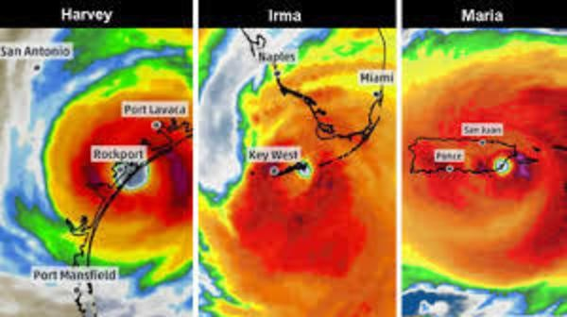
Texas
The Texas Annual Conference (Houston and north Gulf Coast) is very much in need of volunteer help. In the last few weeks, teams have mucked out and gutted more than 6000 homes, but they are still finding communities where the damage has not been assessed. Volunteers should be over age 18, Safe Sanctuaries certified, and at least one member of the team should be ERT trained.

Puerto Rico and US Virgin Islands (US Territories)
This is still a government-controlled situation. They are in emergency relief phase and it is NOT appropriate for volunteers to go yet. We will update you as this situation changes. UMCOR is releasing grants to Puerto Rico quickly and talking daily with the Bishop and other church leaders on the islands.

Pause on collection of new relief supplies
Amy Fuselier, Director of the Relief Supply Network for UMCOR, shared that she was overwhelmed by the response from local churches to the call for relief supplies this Fall. Thanks to your generosity, Texas and Florida have been fully supplied with cleaining buckets and hygiene kits. There are 28,000 cleaning kits in the warehouse right now awaiting delivery to Puerto Rico when that becomes possible. For the time being, do not begin any new collections of relief supplies. Once more kits have been delivered, there will be space in the warehouse to hold more.

Over $8 million raised since Harvey!
Cathy Earl, Director of Disaster Response and US Partner Relations for UMCOR, reports that more than $8 million has been raised through the Advance for US Disaster Response since the beginning of this hurricane season. These funds will be distributed to the response efforts for Harvey, Irma, and Maria as well as the wildfires in the West. Keep up the good work! We know this recovery will be long and expensive, so your donations really make a difference! Use Advance #901670 to donate today.

CALENDAR – SUNDAY, OCTOBER 15 THRU SATURDAY, OCTOBER 121

SUNDAY 10/15
8:30 am Worship Sanner Chapel
9:30 am Sunday School for All Ages/Coffee Café Various/Brookline Parlor
10:45 am Worship Sanctuary
Kids Praise Welcome Center
2 pm Korean Worship Sanner Chapel
4:30 pm Youth Choir Choir Room
5 pm Youth Group Asbury Center
6:30 pm BSA Eagle Board Review Various

MONDAY 10/16
7 pm Chapel Bells Rehearsal Bell Room
7:30 pm Community Events and Outreach Wesley Hall

TUESDAY 10/17
6 pm Terrific Tuesday Asbury Center
7 pm Boy Scout Troop #23 Wesley Hall
7 pm Mission Committee Room 105

WEDNESDAY 10/18
7 pm Koinonia UMW Welcome Center
7 pm Cub Scout Pack Asbury Center
7 pm Trustees Wesley Hall

THURSDAY 10/19
9:30 am UMW Faith Circle Wesley Hall
12 pm UMW Rebecca Circle, carpool from church Linda Hoover’s Home
6:30 pm Promise Bells Rehearsal Bell Room 7:30 pm Chancel Choir Rehearsal Choir Room

FRIDAY 10/20
9:30 am Women’s Bible Study Room 102

SATURDAY 10/21
10 am Food Distribution Pantry
4 pm Family Fall Festival Asbury Center

