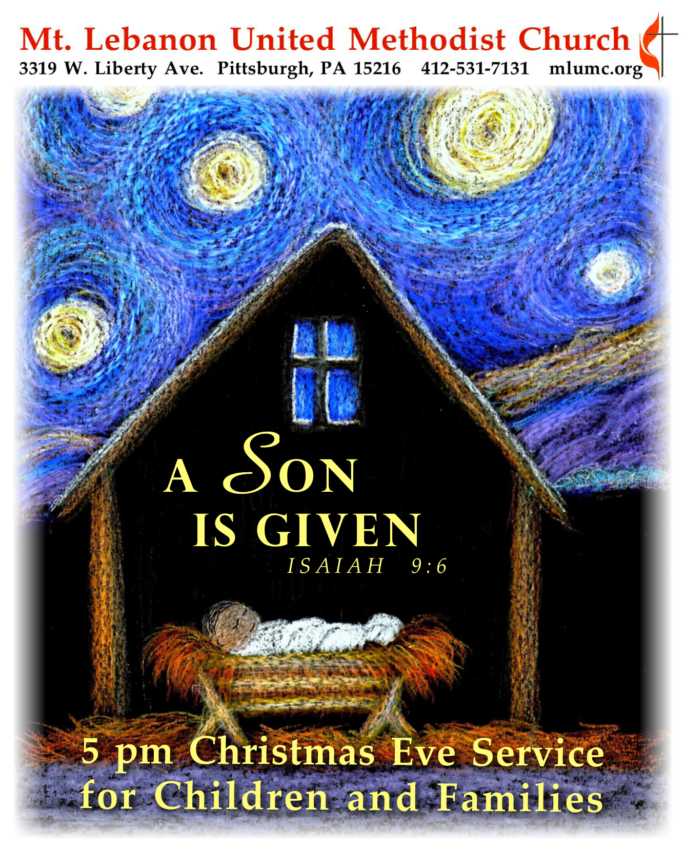
December 24, 2017 Christmas Eve Service for Children & Families 5 pm

Gathering and Greeting Rev. Thomas Q. Strandburg
Leader: In the beginning was the Word, and the Word was with God, and the Word was God. He was in the beginning with God. All things came into being through him, and without him not one thing came into being. What has come into being in him was life, and the life was the light of all people. The light shines in the darkness, and the darkness did not overcome it.
People: Thanks be to God!

Welcome Rev. Thomas Q. Strandburg

Call to Worship Hannah Baker
Leader: Animals came to prepare your bed.!
People: Come, Lord Jesus, come!
Leader: Shepherds stood guard, marveled and said:
People: Come, Lord Jesus, come!
Leader: Angels sang to calm your cries!
People: Come, Lord Jesus, come!
Leader: And all the world gave one great sigh:
People: Ah, Lord Jesus, you have come!

Processional Carol 234 O come, all ye faithful (stanzas 1, 3, 4, 6, standing)

Anthem Into My Heart Harry D. Clark
Children’s Choir

Lighting of the Advent and Christ Candles Alan, Jennifer, Grant and Vivienne Volek

Christmas Lessons and Carols

First Lesson Isaiah 9:2-7 Emily Shoff
Children’s Choir Star-Light/ Bright arr. John Erickson

Second Lesson Psalm 96 Fiona Curran
Carol 224 Good Christian Men Rejoice (1, 2)

Third Lesson Titus 2:11-14 Kate Rhoton
Carol 230 O Little Town of Bethlehem (1, 3)

Fourth Lesson Luke 2:13-20 Addison Alexander
Children’s Choir Fum, Fum, Fum arr. John D. Miller

Drummer Boy Loren Long

Carol Into My Heart Congregation and Children’s Choir
(Please join in and sing with the children.)

Into my heart, into my heart, come into my heart, Lord Jesus;
Come in today, come in to stay; come into my heart, Lord Jesus.

Out of my heart, out of my heart, shine out of my heart, Lord Jesus;
Shine out today, shine out always; shine out of my heart, Lord Jesus.

(Children return to their families)

Prayer Rev. Thomas Q. Strandburg

Christmas Offering Carol of the Manger arr. Dale Wood

Lighting of the Candles
Remember to keep lighted candles upright; only tilt the unlit candle to avoid dripping wax on yourself, the pew and the carpet. As the sanctuary lights dim, the pastor will light a candle from the Christ candle and share it with the ushers. They will light the candles of those seated in the pews.

Carol 239 Silent night, holy night (stanzas 1,3, standing)

Carol 246 Joy to the world (stanzas 1,4)

Benediction Rev. Thomas Q. Strandburg

Candles may now be extinguished.

Join us Sunday, December 31, for a unity service at 10:45 in the Sanctuary. The worship will be
a Christmas Carol Communion Service, led by Rev. Kimberly Greway. There will be no Sunday school, nursery or Kids Praise during the service, but a wiggle room will be available.

Tonight’s Service
Special music is provided by the Children’s Choir led by Courtney Heath and Kim Rhoton.

Nursery services – A wiggle room is available for parents and children in Brookline Parlor, adjacent to the sanctuary.

Holiday hours – The church office is closed and will reopen on Wednesday, December 27 at
8:30 am.

Help Deliver Poinsettias
Spread the Christmas cheer. Take a name card or two from the table in the Narthex and deliver a poinsettia to a shut in. Plants may be picked up any time after the 11 pm Christmas Eve service

Poinsettias and Food Pantry Memorial
POINSETTIA DONOR IN MEMORY OF
Betty Lou Albright Rev. Dr. H. Pat Albright
Kathleen Amant Rev. Dr. H. Pat Albright and my parents & brother
Carol Argiro Harold & Micki Heard
Arthur A. Babuscio Marilyn & Arthur Babuscio
Jim & Cindy Biery Frances Waters Soroka, Claire Biery, and Christine McCullough
Jean G. Boyer Dale E. Boyer
Russ Connelley Russell K. Connelley & J. Harrison Miller
Laura S. Deklewa My parents, Willard A. Smith & Genevieve R. Smith
Ruth Ann & John Esaias Our parents
Anna Fairgrieve Robert Fairgrieve
Tommilea & Dave Giegel Our parents and those we have lost
Donald & Donna Greer Our mothers, Elaine Saxon & Gertrude Greer
Edee Hutchinson My parents, Eleanor & Robert, and my brother, Richard
Edee Hutchinson My aunts, Kathryn Miller & Henrietta Hutchinson, and uncle, Frank Miller
Edee Hutchinson Special friends - Virginia & Vern Starr, Dottie Siebert, Margaret Ott, Jack & Vi Richardson, & Margie Jellison
Bob & Chris James Sam & Lu Vance
Mr. & Mrs. Martin Kaminski Mr. & Mrs. Hayden Prosser
Bill & Kathy Karns Frann Karns
Nancy & Phil Koch The Agnew Family
Dawn Lonsinger Loved ones
Laurie & Betsy Lowe Bill & June Lowe
Doris and Ford McBeth Our Parents and Grandparents--Fae & Archie McCormick and Bernice & Paul McBeth
Sara A. Mercer Magdalene P. Mercer, James R. Mercer, Magdalena V. Page & Ellen P. Mercer
Carla Meridith Catherine DeAngelis, Best Mom Ever
Bill & Judy Moeller James C. Dunbar III & William V. Moeller
Linda Nixon Mr. & Mrs. Herbert B. Heinz and Clarence B. Nixon, Jr.
Marsha & Brian Roche Our parents, Joe & Rita Roche, and Dorothy Lutes; Rev. Dr. H. Pat Albright
Jon & Jan Rutter Our parents, Dr. Kenneth & Ruth Rutter and Don & Shirley Paterson
Evan & Emily Shoff Gwen Lammert
Steve Stockton Saralyn Stockton, J.R. Stockton, Evalyn Redhair, Bob & Sunny Nicklas
Tom & Kathy Strandburg Our parents and grandparents
Jennifer Thompson & Doug Dusbiber Our parents Glen & Sarah Dusbiber, Granparents Ed & Arvell Kiel
Cindy Volek My brother, John Dalzell
Lily Yuan My parents
The Paine Family Dwight Ladd & Edna Mae Starr
The Capoto, Floss, Masar, & Kathy Caputo, Judy Floss, Frank Floss, Bitt Floss and
Krewin Families Thom Knowlson

POINSETTIA DONOR IN HONOR OF
Meghan & Andrew Buckley Kathleen Amant
Anna Fairgrieve My Family
Ruth Fleming Our three daughters, Susan, Marcy, & Wendy
Mary Garber Mike Staab & The UMW
Tommilea & Dave Giegel Church Volunteers, Friends, & Family
Bunny & John Knabb Our grandchildren
Corinne & HowardPotter Gerry Oelschlager
Noel, Sharon, Juliana & Lydia Slater Eileen Slater
Steve Stockton Doris Stockton
Jennifer Thompson Mt. Lebanon UMC Choirs
Jennifer Thompson & Doug Dusbiber Our children Mollie, Joe, Ellen, Madeline & Lauren
Silas & Asher Ward Martha & Darl Roberts; Debbie & Gene Girman
John & Marilyn White Grandchildren - Brandon, Brooke, Drew, Abbey, Lizzy & Rachel
Keith Will In loving honor of my three daughters - Patricia Lynne Will Krause, Barbara Lynne Will Myer, and Deborah Lynne Will Rambeau

FOOD PANTRY DONOR IN MEMORY OF
Carolyn G Dagg Ronald D. Dagg
Betty Lou Albright Rev. Dr. H. Pat Albright
Connie Allen Loved ones
Kathleen Amant Rev. Dr. H. Pat Albright and my parents & brother
Arthur A. Babuscio Marilyn Babuscio
Louanne Baily Ruth & Bob Baily
Russ & Gloria Barber Our parents and sister, Lois
Jim & Cindy Biery William Soroka & John Wesley Biery
Mary Birks June Galioto
John, Donna & Shannon College Johnathan H. College, Melvin & Bernice Alster, Walter & Nellie Nickmeyer
Lois Colley Robert Colley
Paulette Colonna Our parents - Paul & Mary Wosotowsky
Hazel Cope Parents, Leslie & Doris Cramer
Hazel Cope Leslie Cramer & Doris Scott; Joe & Gertie Cope
Anna Fairgrieve Kooser & Fairgrieve Families
Carol Fairgrieve Robert Fairgrieve
Bob & Beverly Festor Our parents - Ed & Rita Schwarz and Sam & Betty Jane Violet Festor
May Frederick Bertie Frederick, his wife Mae and Family
Tommilea & Dave Giegel Our parents
Joyce Gorman Walter & Ruth Genge - my parents
Donald & Donna Greer Our mothers, Elaine Saxon & Gertrude Greer
Erma Henry Family members who have passed
Anne Hoffman Paul W. Hoffman
Vera & Dave Hughes Loved ones
Chuck Hutchinson Loved ones
Edee Hutchinson My grandparents - George & Ora Miller and Frank & Hazel Hutchinson
Bob & Chris James Elaine Babcock
Mr. & Mrs. Martin Kaminski Mr. & Mrs. Hayden Prosser
Bill & Kathy Karns Dr. & Mrs. Robert L. Kelley
Bunny & John Knabb Our parents
Nancy & Phil Koch Ivan & Mildred Koch
Dawn Lonsinger Loved ones
Joyce Magill Joseph H. Magill
Karen & Bill Manning Helen Manning, beloved mother of Bill
Martha Matthews Loved ones
Kay McAninch Loved ones
Stuart & Bonnie McMinn Homer & Nelle McMinn
Sara A. Mercer Magdalene P. Mercer, James R. Mercer, Magdalena V. Page & Ellen P. Mercer
Ruth A. Miller Loved ones
Luann Minnick My parents, Joseph & Dina Mosesso
Bill & Judy Moeller James C. Dunbar III & William V. Moeller
Clark & Mary Remington Charles & Joan Harden
Gail Seymour My parents, Harry & Mary Jane Seymour
Fred & Marianne Siersdorfer Jr. Our parents
Rob Spicher Howard & Marie Spicher
Arlene Stewart With Loving Memories, Arthur Stewart
Kathy & Rich Tremblay & Family Dorothy & Dan Nesbit and Lois & Harold Tremblay
Jim & Beverly Weber Our parents
Keith Will In loving memory of Mr. & Mrs. Ralph Doll Will by their children: Keith Douglass Will, Cheryl Lynne Will Graunke, Cythia Eve Will Agryle
Lily Yuan My parents
The Amos Family Harold Amos
The Oettinger Family Perk & Rainy Sawhill

FOOD PANTRY DONOR IN HONOR OF
Betty Lou Albright Bishop & Mrs. George B. Bashore
Betty Lou Albright Rev. & Mrs. Thomas Q. Strandburg
Betty Lou Albright Rev. Dr. & Mrs. David H. Watson
Jean G. Boyer Food Pantry Volunteers
Martha Clarke Ed and our three sons
John & Donna College Shannon College
Paulette Colonna Liz DiPietro and her tireless work for our food pantry
Ruth Ann & John Esaias The Young Adult Sunday School Class
Frances Graham Food Pantry Volunteers
Monica Kao Food Lift Volunteers
Robert & Julie Kmick Our Grandsons
George Lindow Church volunteers
Bill & Bernice Merchant Our children
Bette Lou & Ed Reichard Our first great-grandson, Theo
Karen & Don Shaffer Family & Friends
Rob Spicher Jane Spicher
Jane Spicher Rob Spicher
Steve Stockton Saralyn Stockton, J.R. Stockton, Evalyn Redhair, Bob & Sunny Nicklas
Peg Stouffer In honor and gratitude to staff and all volunteers at MLUMC
Jennifer Thompson & Doug Dusbiber Our children, Mollie, Joe, Ellen, Madeline & Lauren
Kate, Kara and Tori Touscany Mike and Sally Touscany
David & Barbara Watson Gwen Lammert
John & Marilyn White Family & Friends
Anonymous Staff & every volunteer
UMW Women Francie Robb

