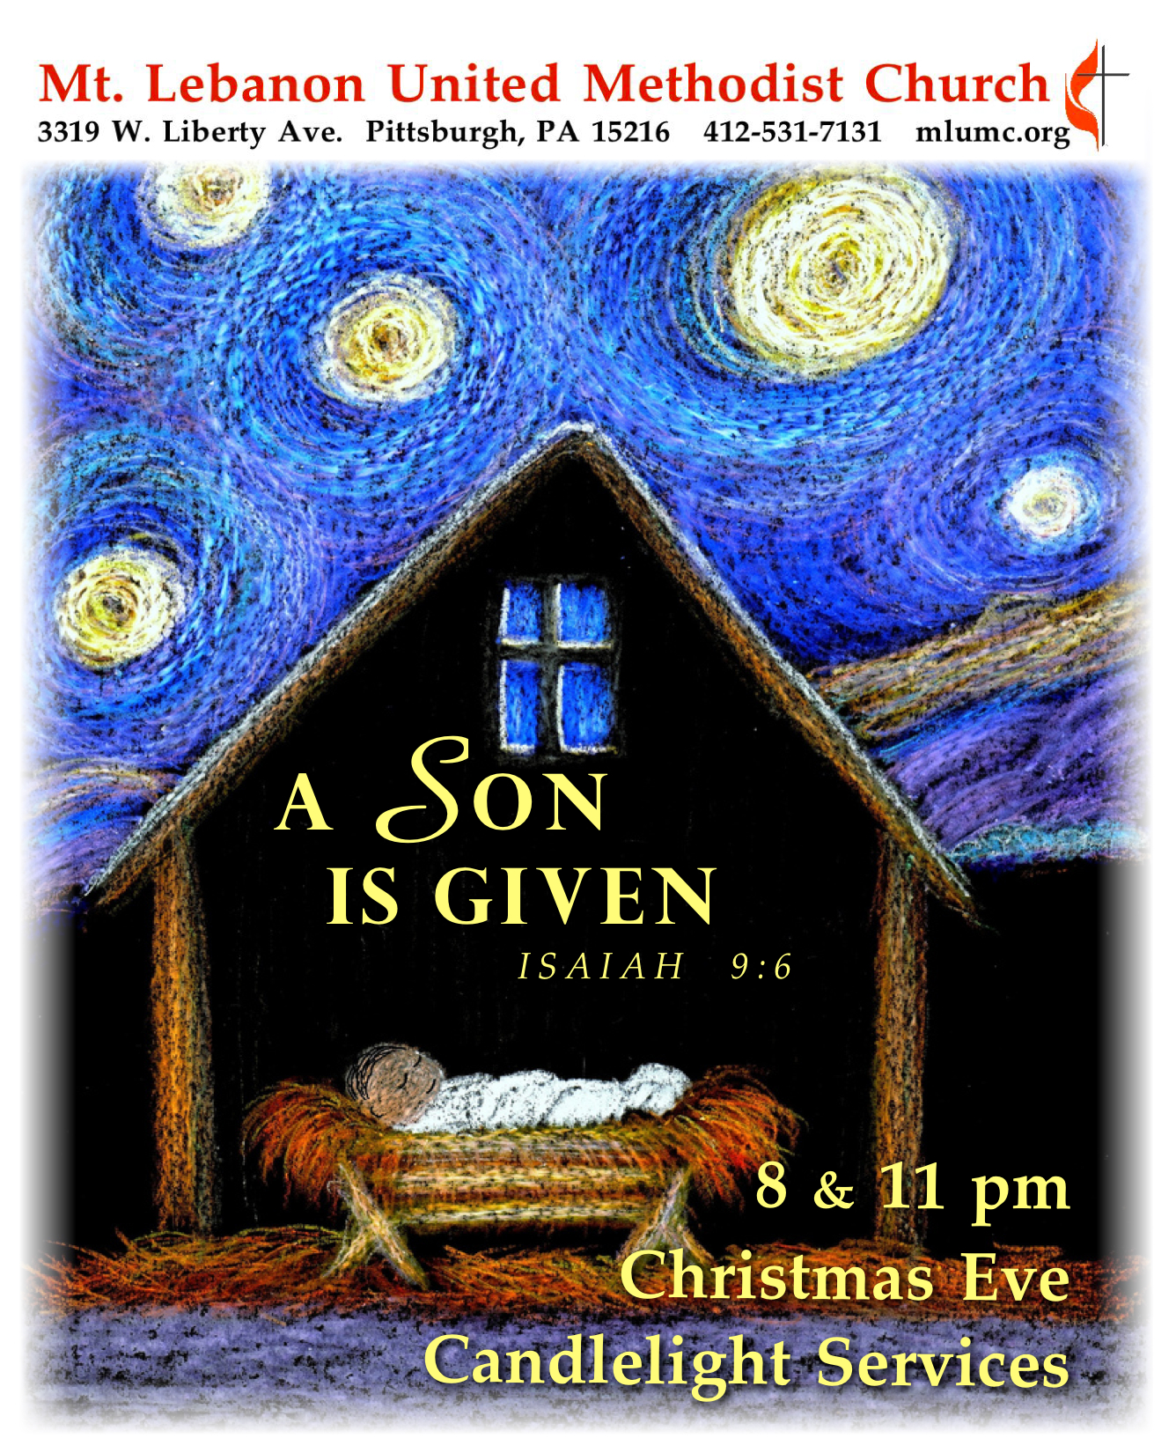
December 24, 2017 8 and 11 pm
A Service of Christmas Lessons and Carols

Prelude
Where shepherds lately knelt Craig Courtney
What child is this arranged by Dale Warland
Still, still, still Traditional Austrian Carol
Aria Marcel Grandjany

Processional Hymn 234 O come, all ye faithful (stanzas 1-3, 6, standing) Adeste Fideles

Lighting of the Advent and Christ Candles 8:00 Chris and Stacey Roslek
11:00 Linda and Rick Minnotte

Hymnal 196 Come, thou long-expected Jesus (stanza 2, seated) Hyfrydol
Born thy people to deliver, born a child and yet a King,
born to reign in us forever, now thy gracious kingdom bring.
By thine own eternal spirit rule in all our hearts alone;
by thine all sufficient merit, raise us to thy glorious throne.

The Bidding Prayer
Leader: Beloved in Christ,
this Christmas Eve it is our duty and delight
to prepare ourselves to hear again the message of the angels,
and to go in heart and mind to Bethlehem,
and see this thing which is come to pass,
and the Babe lying in a manger.
Therefore let us hear again from Holy Scripture
the tale of the loving purposes of God from the first days of our sin
until the glorious redemption brought us by this holy Child;
and let us make this house of prayer glad with our carols of praise.
But first, because this of all things would rejoice Jesus' heart,
let us pray to him for the needs of the whole world, and all his people;
for peace upon the earth he came to save;
for love and unity within the one Church he did build;
for goodwill among all peoples.
And particularly at this time let us remember
the poor, the cold, the hungry, the oppressed;
the sick and them that mourn; the lonely and the unloved;
the aged and the little children;
Lastly let us remember all those who rejoice with us,
but upon another shore and in a greater light,
that multitude which no one can number,
whose hope was in the Word made flesh,
and with whom, in this Lord Jesus, we for evermore are one.
These prayers and praises let us humbly offer up to the throne of heaven,
in the words that Christ himself has taught us.

The Lord’s Prayer
Our Father, who art in heaven, hallowed be thy name. Thy kingdom come, thy will be done, on earth as it is in heaven. Give us this day our daily bread. And forgive us our trespasses, as we forgive those who trespass against us. And lead us not into temptation, but deliver us from evil. For thine is the kingdom, and the power, and the glory forever. Amen.

Blessing
Leader: The almighty God bless us with divine grace,
Christ give us the joys of everlasting life,
and unto the fellowship of the citizens above
may the King of Angels bring us all.
People: Amen

Sung Response 184 Of the Father's love begotten (stanza 1) Divinum Mysterium

First Lesson Genesis 3:8-15, 17-19
God announces in the Garden of Eden Adam and Eve's punishment for their rebellion
and that the seed of woman shall bruise the serpent's head.

Lector: The Word of the Lord.
People: Thanks be to God.

Carol 196 Come, thou long expected Jesus (stanzas 1-2) Hyfrydol

Second Lesson Genesis 22:15-18
God promises to Abraham that by his descendants all the nations of the earth
shall obtain blessing.

Lector: The Word of the Lord.
People: Thanks be to God.
Carol 211 O come, O come, Emmanuel (stanzas 1, 4) Veni Emmanuel

Anthem Weihnachten (Christmas Evening) Humperdinck, arr. Proulx

Third Lesson Isaiah 9:2, 6-7
The prophet announces the birth of a king to a people in darkness.

Lector: The Word of the Lord.
People: Thanks be to God.

Carol 216 Lo, how a Rose e'er blooming (stanzas 1, 2) Es ist ein Ros

Anthem 8:00 Night of Silence Daniel Kantor

Fourth Lesson Micah 5:2-5a
The king is coming and will usher in a reign of justice for the poor
and peace for all of God's creation.

Lector: The Word of the Lord.
People: Thanks be to God.

Carol 230 O little town of Bethlehem (stanzas 1, 4) St. Louis

Fifth Lesson Luke 1:26-35, 38
The angel Gabriel announces to the virgin Mary that she will give birth to God's promised Son whose kingdom shall never end.

Lector: The Word of the Lord.
People: Thanks be to God.

Christmas Offering

Anthem Angels’ Carol John Rutter

Doxology 221 In the bleak midwinter (stanza 4, standing) Cranham
What can I give him, poor as I am?
If I were a shepherd, I would bring a lamb;
if I were a Wise Man, I would do my part;
yet what I can I give him: give my heart.

Sixth Lesson Luke 2:1-7
Against a backdrop of emperors and taxes, Jesus is born.

Lector: The Word of the Lord.
People: Thanks be to God.

Carol 245 The first Noel (stanzas 1-2) The First Noel

Seventh Lesson Luke 2:8-16
The shepherds go to see the Savior of the world, lying in a manger.

Lector: The Word of the Lord.
People: Thanks be to God.

Carol 229 Infant holy, infant lowly W Zlobie Lezy

Meditation Rev. Thomas Q. Strandburg

Christmas Prayer (in unison)
Eternal God, by the birth of Jesus Christ you gave yourself to the world.
Grant that, being born in our hearts, he may save us from all our sins,
and restore within us the image and likeness of our Creator,
to whom be everlasting praise and glory, world without end. Amen.

Lighting of the Candles
Remember to keep lighted candles upright; only tilt the unlit candle to avoid dripping wax on yourself, the pew and the carpet. As the sanctuary lights dim the pastors will light a candle from the Christ candle and share it with the ushers. They will light the candles of those seated in the pews.

Anthem A Savior from on high Stephen Paulus

Carol 239 Silent night, holy night (stanzas 1, 3) Stille Nacht

Carol 246 Joy to the world (stanzas 1, 4) Antioch

Nunc Dimittis Rev. Thomas Q. Strandburg
Leader: Master, now you are dismissing your servants in peace.
People: For our eyes have seen your salvation, which you have prepared
in the presence of all people.
Leader: A light for revelation to the Gentiles and for glory to your people Israel.
People: Let us share this Light with the world.
Candles may now be extinguished.

Congregational Benedictions Please exchange greetings and blessings with each other.

Join us on Sunday, December 31, for a Unity Service at 10:45 am in the Sanctuary. The service will feature a Christmas Carol Communion, led by Rev. Kimberly Greway. A wiggle room will be offered in Brookline Parlor, but there will be NO Sunday School hour, no nursery and no Kids Praise.

Tonight’s Services

Special music is provided by the Youth Choir, accompanied by Kathleen Whittaker, during the 8:00 service only, and the Chancel Choir, with soloists Timothi Williams, Kirby Dilworth and Kathleen Whittaker; conductor Richard Minnotte; harpist Julia Scott and oboist Renate Sakins. The presence of the instrumentalists is made possible by contributors to the Friends of Music Fund.

Holiday hours – The church office is closed and will reopen on Wednesday, December 27 at
8:30 am.

Nursery services - A wiggle room is available for parents and children in Brookline Parlor, adjacent to the sanctuary during the 8 pm service.

Each year the W PA Conference and Eastern German Conference create daily Advent and Christmas devotionals for use in our homes and churches. We have chosen devotionals from each week. This is the devotional for Christmas Eve.

Rev. John Mize, Westmont UMC
John 21:4 Just after daybreak, Jesus stood on the beach; but the disciples did not know that it was Jesus.

As we fly through our preparations for Christmas and look forward to the coming of the Christ child, He often comes to us. He is in the line ahead of us at the grocery store, looking for the last few cents to buy his meager dinner. He in struggling to get His food to the car as He slowly moves across the lot with a walker. He is watching us through the eyes of the foreigner who does not understand our ways and is astonished at the extravagance. He is standing there watching us; waiting for us to recognize him. Sometimes we drop a few pennies in the red bucket and feel great about ourselves as we walk to our car, making sure everyone knows about our generosity. We make sure we attend all the church services so everyone will know how much we love Jesus. But He is watching waiting for us to show Him. Do we?

Dr. Michael Wetzel, Lößnitz
In John 21 the evangelist portrays disciples who have fallen back into routine. Disheartened, they are starring at their empty fishnets. John not only shows us empty nets but also empty souls – disciples without the fire of faith, without visions. And when Jesus approaches them in the morning they don`t even recognize him. Is this the picture of true disciples? And, thinking ahead, is this the state of the churches in the so-called Western societies? The great Lutheran reformation and the methodist awakening have cooled off. Routine seems to be the daily business of the church. And Christmas? Even Christmas celebrations might become a routine and some of us therefore might consider modern Christianity a story of crisis and decline.
But the story is going on. Jesus approaches the weak and discouraged disciples, perhaps silently and gently, but full of the power that becomes strong in the weak. He approaches his disciples to address them and to open their eyes for him. Christmas reveals the message: Even the midst of today`s discouragement Jesus wants to address us, he wants to open our eyes for his everlasting presence. He is seeking for our confession that we need him.

Help Deliver Poinsettias
Spread the Christmas cheer. Take a name card or two from the table in the Narthex and deliver a poinsettia to a shut in. Plants may be picked up any time after the 11 pm Christmas Eve service.

Poinsettias and Food Pantry Memorial
POINSETTIA DONOR IN MEMORY OF
Betty Lou Albright Rev. Dr. H. Pat Albright
Kathleen Amant Rev. Dr. H. Pat Albright and my parents & brother
Carol Argiro Harold & Micki Heard
Arthur A. Babuscio Marilyn & Arthur Babuscio
Jim & Cindy Biery Frances Waters Soroka, Claire Biery, and Christine McCullough
Jean G. Boyer Dale E. Boyer
Russ Connelley Russell K. Connelley & J. Harrison Miller
Laura S. Deklewa My parents, Willard A. Smith & Genevieve R. Smith
Ruth Ann & John Esaias Our parents
Anna Fairgrieve Robert Fairgrieve
Tommilea & Dave Giegel Our parents and those we have lost
Donald & Donna Greer Our mothers, Elaine Saxon & Gertrude Greer
Edee Hutchinson My parents, Eleanor & Robert, and my brother, Richard
Edee Hutchinson My aunts, Kathryn Miller & Henrietta Hutchinson, and uncle, Frank Miller
Edee Hutchinson Special friends - Virginia & Vern Starr, Dottie Siebert, Margaret Ott, Jack & Vi Richardson, & Margie Jellison
Bob & Chris James Sam & Lu Vance
Mr. & Mrs. Martin Kaminski Mr. & Mrs. Hayden Prosser
Bill & Kathy Karns Frann Karns
Nancy & Phil Koch The Agnew Family
Dawn Lonsinger Loved ones
Laurie & Betsy Lowe Bill & June Lowe
Doris and Ford McBeth Our Parents and Grandparents--Fae & Archie McCormick and Bernice & Paul McBeth
Sara A. Mercer Magdalene P. Mercer, James R. Mercer, Magdalena V. Page & Ellen P. Mercer
Carla Meridith Catherine DeAngelis, Best Mom Ever
Bill & Judy Moeller James C. Dunbar III & William V. Moeller
Linda Nixon Mr. & Mrs. Herbert B. Heinz and Clarence B. Nixon, Jr.
Marsha & Brian Roche Our parents, Joe & Rita Roche, and Dorothy Lutes; Rev. Dr. H. Pat Albright
Jon & Jan Rutter Our parents, Dr. Kenneth & Ruth Rutter and Don & Shirley Paterson
Evan & Emily Shoff Gwen Lammert
Steve Stockton Saralyn Stockton, J.R. Stockton, Evalyn Redhair, Bob & Sunny Nicklas
Tom & Kathy Strandburg Our parents and grandparents
Jennifer Thompson & Doug Dusbiber Our parents Glen & Sarah Dusbiber, Granparents Ed & Arvell Kiel
Cindy Volek My brother, John Dalzell
Lily Yuan My parents
The Paine Family Dwight Ladd & Edna Mae Starr
The Capoto, Floss, Masar, & Kathy Caputo, Judy Floss, Frank Floss, Bitt Floss and
Krewin Families Thom Knowlson

POINSETTIA DONOR IN HONOR OF
Meghan & Andrew Buckley Kathleen Amant
Anna Fairgrieve My Family
Ruth Fleming Our three daughters, Susan, Marcy, & Wendy
Mary Garber Mike Staab & The UMW
Tommilea & Dave Giegel Church Volunteers, Friends, & Family
Bunny & John Knabb Our grandchildren
Corinne & HowardPotter Gerry Oelschlager
Noel, Sharon, Juliana & Lydia Slater Eileen Slater
Steve Stockton Doris Stockton
Jennifer Thompson Mt. Lebanon UMC Choirs
Jennifer Thompson & Doug Dusbiber Our children Mollie, Joe, Ellen, Madeline & Lauren
Silas & Asher Ward Martha & Darl Roberts; Debbie & Gene Girman
John & Marilyn White Grandchildren - Brandon, Brooke, Drew, Abbey, Lizzy & Rachel
Keith Will In loving honor of my three daughters - Patricia Lynne Will Krause, Barbara Lynne Will Myer, and Deborah Lynne Will Rambeau

FOOD PANTRY DONOR IN MEMORY OF
Carolyn G Dagg Ronald D. Dagg
Betty Lou Albright Rev. Dr. H. Pat Albright
Connie Allen Loved ones
Kathleen Amant Rev. Dr. H. Pat Albright and my parents & brother
Arthur A. Babuscio Marilyn Babuscio
Louanne Baily Ruth & Bob Baily
Russ & Gloria Barber Our parents and sister, Lois
Jim & Cindy Biery William Soroka & John Wesley Biery
Mary Birks June Galioto
John, Donna & Shannon College Johnathan H. College, Melvin & Bernice Alster, Walter & Nellie Nickmeyer
Lois Colley Robert Colley
Paulette Colonna Our parents - Paul & Mary Wosotowsky
Hazel Cope Parents, Leslie & Doris Cramer
Hazel Cope Leslie Cramer & Doris Scott; Joe & Gertie Cope
Anna Fairgrieve Kooser & Fairgrieve Families
Carol Fairgrieve Robert Fairgrieve
Bob & Beverly Festor Our parents - Ed & Rita Schwarz and Sam & Betty Jane Violet Festor
May Frederick Bertie Frederick, his wife Mae and Family
Tommilea & Dave Giegel Our parents
Joyce Gorman Walter & Ruth Genge - my parents
Donald & Donna Greer Our mothers, Elaine Saxon & Gertrude Greer
Erma Henry Family members who have passed
Anne Hoffman Paul W. Hoffman
Vera & Dave Hughes Loved ones
Chuck Hutchinson Loved ones
Edee Hutchinson My grandparents - George & Ora Miller and Frank & Hazel Hutchinson
Bob & Chris James Elaine Babcock
Mr. & Mrs. Martin Kaminski Mr. & Mrs. Hayden Prosser
Bill & Kathy Karns Dr. & Mrs. Robert L. Kelley
Bunny & John Knabb Our parents
Nancy & Phil Koch Ivan & Mildred Koch
Dawn Lonsinger Loved ones
Joyce Magill Joseph H. Magill
Karen & Bill Manning Helen Manning, beloved mother of Bill
Martha Matthews Loved ones

Kay McAninch Loved ones
Stuart & Bonnie McMinn Homer & Nelle McMinn
Sara A. Mercer Magdalene P. Mercer, James R. Mercer, Magdalena V. Page & Ellen P. Mercer
Ruth A. Miller Loved ones
Luann Minnick My parents, Joseph & Dina Mosesso
Bill & Judy Moeller James C. Dunbar III & William V. Moeller
Clark & Mary Remington Charles & Joan Harden
Gail Seymour My parents, Harry & Mary Jane Seymour
Fred & Marianne Siersdorfer Jr. Our parents
Rob Spicher Howard & Marie Spicher
Arlene Stewart With Loving Memories, Arthur Stewart
Kathy & Rich Tremblay & Family Dorothy & Dan Nesbit and Lois & Harold Tremblay
Jim & Beverly Weber Our parents
Keith Will In loving memory of Mr. & Mrs. Ralph Doll Will by their children: Keith Douglass Will, Cheryl Lynne Will Graunke, Cythia Eve Will Agryle
Lily Yuan My parents
The Amos Family Harold Amos
The Oettinger Family Perk & Rainy Sawhill

FOOD PANTRY DONOR IN HONOR OF
Betty Lou Albright Bishop & Mrs. George B. Bashore
Betty Lou Albright Rev. & Mrs. Thomas Q. Strandburg
Betty Lou Albright Rev. Dr. & Mrs. David H. Watson
Jean G. Boyer Food Pantry Volunteers
Martha Clarke Ed and our three sons
John & Donna College Shannon College
Paulette Colonna Liz DiPietro and her tireless work for our food pantry
Ruth Ann & John Esaias The Young Adult Sunday School Class
Frances Graham Food Pantry Volunteers
Monica Kao Food Lift Volunteers
Robert & Julie Kmick Our Grandsons
George Lindow Church volunteers
Bill & Bernice Merchant Our children
Bette Lou & Ed Reichard Our first great-grandson, Theo
Karen & Don Shaffer Family & Friends

Rob Spicher Jane Spicher
Jane Spicher Rob Spicher
Steve Stockton Saralyn Stockton, J.R. Stockton, Evalyn Redhair, Bob & Sunny Nicklas
Peg Stouffer In honor and gratitude to staff and all volunteers at MLUMC
Jennifer Thompson & Doug Dusbiber Our children, Mollie, Joe, Ellen, Madeline & Lauren
Kate, Kara and Tori Touscany Mike and Sally Touscany
David & Barbara Watson Gwen Lammert
John & Marilyn White Family & Friends
Anonymous Staff & every volunteer
UMW Women Francie Robb

