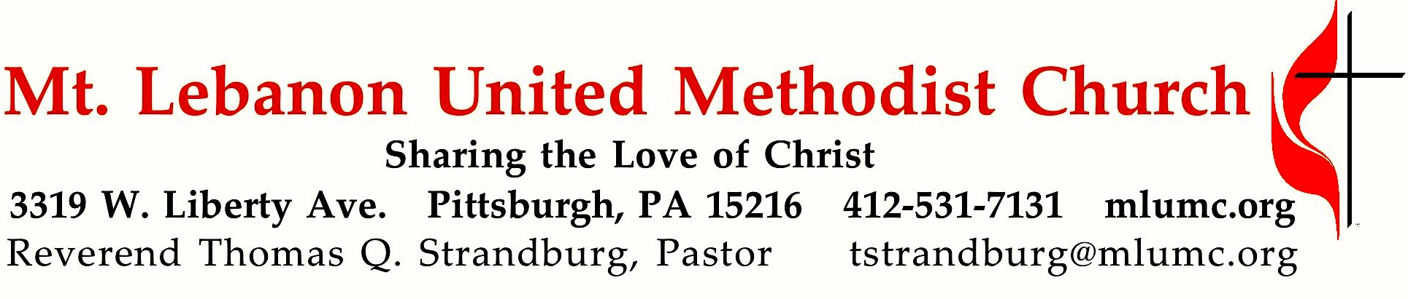

December 31, 2017 10:45
First Sunday after Christmas
The Gospel accounts of the early life of Jesus end abruptly, leaving a large gap in our knowledge. The Christmas story is not over. It has only just begun. What if every heart became a “manger” and every day was Christmas?

WE GATHER IN GOD’S NAME …
Gathering Music

Hymnal 238 Angels we have heard on high Gloria
Hymnal 221 In the bleak midwinter Cranham

Call to Worship
Leader: Christ is born, give him glory!
People: Christ has come down from heaven, receive him! Christ is now on earth; exalt him!
Leader: O you earth, sing to the Lord!
People: O you nations, praise him in joy, for he has been glorified!
Traditional Byzantine Christmas Prayer

… TO GIVE PRAISE TO GOD …

Hymnal 220 Angels from the realms of glory (standing) Regent Square

Lighting of the Christ Candle

Opening Prayer (in unison)
O God our Father, you have brought us again to the glad season
when we celebrate the birth of your Son, Jesus Christ our Lord.
Grant that his Spirit may be born anew in our hearts this day
and that we may joyfully welcome him to reign over us.
Open our ears that we may hear again the angelic chorus of old.
Open our lips that we, too, may sing with uplifted hearts.
Glory to God in the highest, and on earth, peace, goodwill toward all;
through Jesus Christ our Lord. Amen. Book of Worship, 1944

Silent Prayer

… TO CELEBRATE THE FAMILY OF FAITH …

The Sign of Peace Please pass the peace to your neighbors as a sign of reconciliation and love.
Leader: The peace of Christ be with you.
People: And also with you.

Gathering Song James Ritchie
This, this is where children belong,
welcomed as part of the worshiping throng.
Water, God’s Word, bread and cup, prayer and song:
This is where children belong.
WORDS & MUSIC: James Ritchie ©1999 Abingdon Press

Message for Young Disciples Rev. Thomas Q. Strandburg
All children are invited. Please sing as children come forward. There is no Kids Praise today following the Children’s Message.

… TO HEAR GOD’S WORD PROCLAIMED …

Scripture Reading Bob Mallery
A Lesson from the Hebrew Scriptures
Isaiah 61:10-62:3 Jerusalem redeemed

Prayer for the New Year Rev. Lutz Brückner; translated by Deanna Baird
2018 New Year’s Prayer for the Congregations of the Eastern Germany Annual Conference and the Western Pennsylvania Conference (See the church website, mlumc.org, for text.)

The Lord’s Prayer

Celtic Alleluia Alleluia (sing 4 times, standing) O’Carroll and Walker
Scripture Reading
A Lesson from the Gospels
Luke 2:22-40 The early life of Jesus

Response
Leader: The Word of the Lord.
People: Thanks be to God.

… TO OFFER OUR GIFTS AND TO DEDICATE OUR LIVES …

Offertory Anthem In the bleak midwinter Harold Darke
In the bleak midwinter frosty wind made moan,
earth stood hard as iron, water like a stone;
snow had fallen, snow on snow, snow on snow, in the bleak midwinter long ago.
Our God, heaven cannot hold Him, nor earth sustain.
Heaven and earth shall flee away, when He comes to reign.
In the bleak midwinter, a stable place sufficed the Lord God Almighty, Jesus Christ.
Enough for Him, whom cherubin, worship night and day, a breast full of mild,
and a manger full of hay. Enough for Him, whom angels, fall down before,
the ox and ass and camel, which adore.
What can I give Him, poor as I am? If I were a shepherd I would bring a lamb;
if I were a wise man I would do my part. Yet what I can I give Him, give my heart.

Doxology Hymnal 221 (standing)
What can I give him, poor as I am?
If I were a shepherd, I would bring a lamb;
if I were a Wise Man, I would do my part;
yet what I can I give him: give my heart.

Prayer of Dedication

Sermon “Jesus of the Gaps” Rev. Thomas Q. Strandburg

Sacrament of Holy Communion Rev. Kimberly Greway
During communion, join the choir singing the first 2 stanzas of hymns beginning with #223.
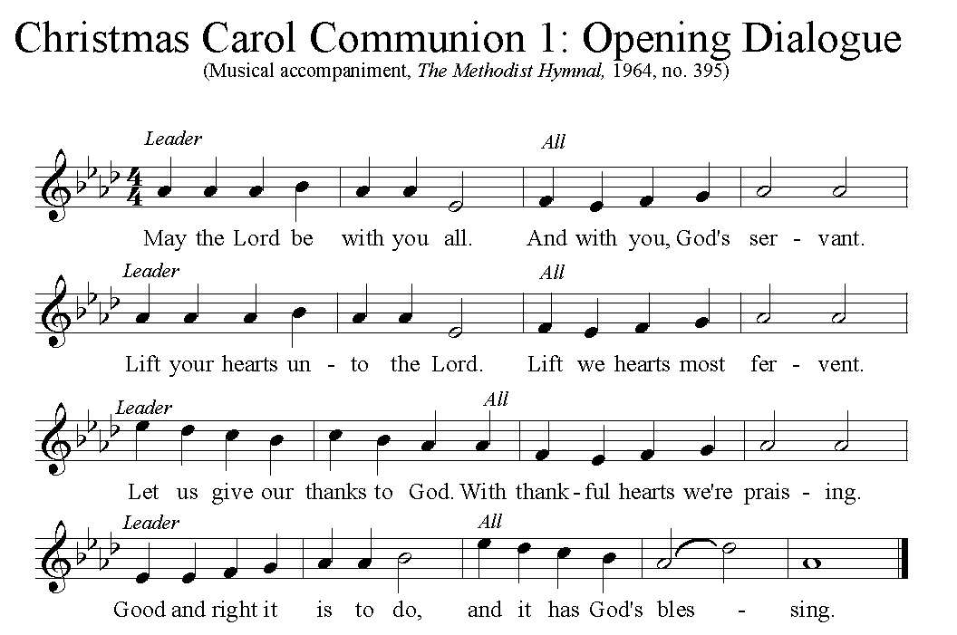
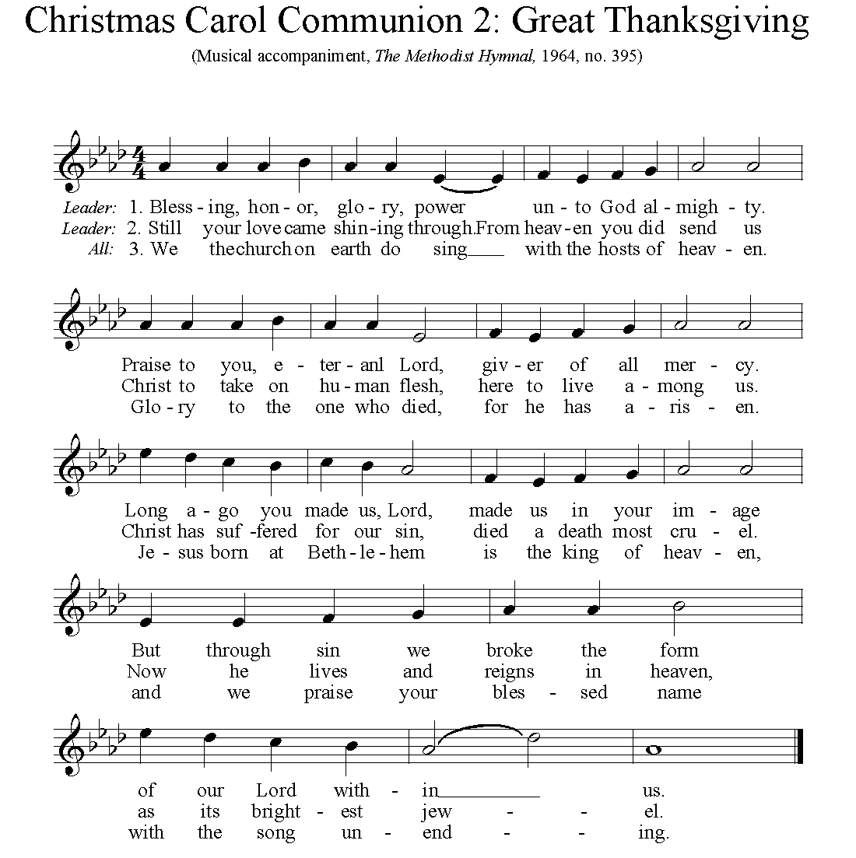

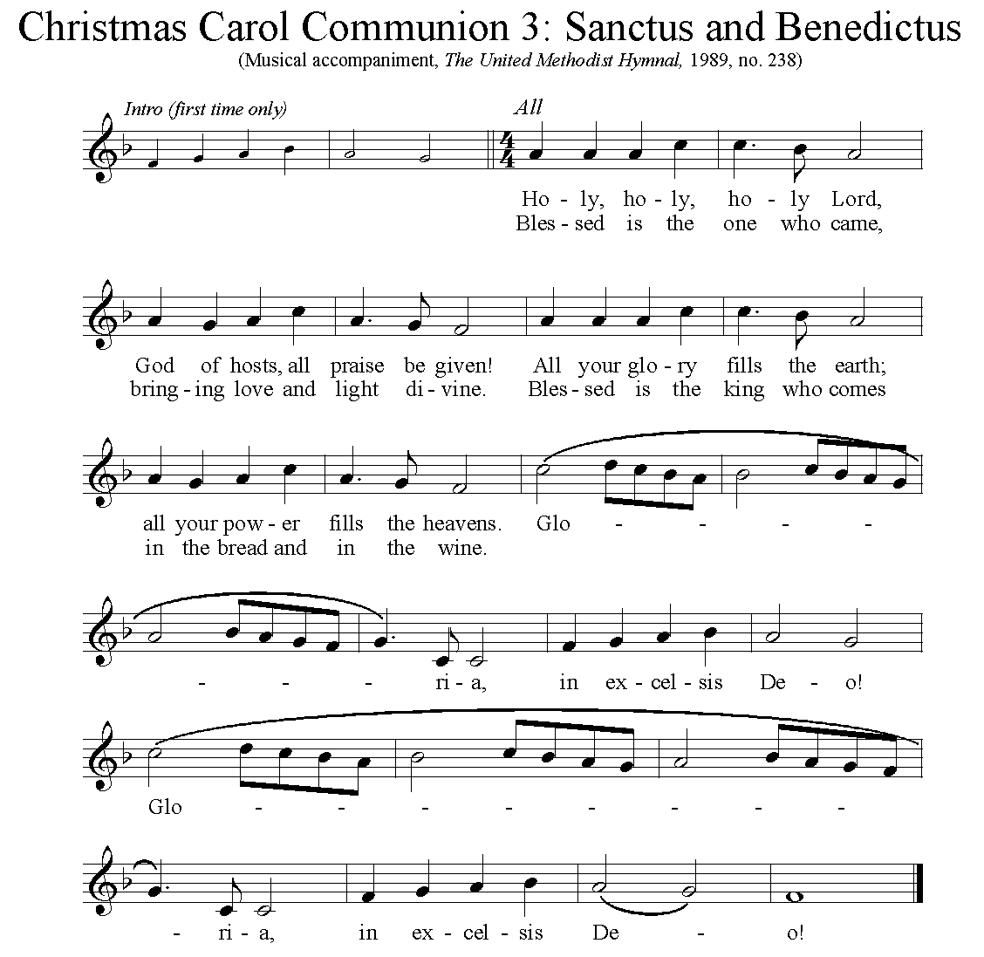

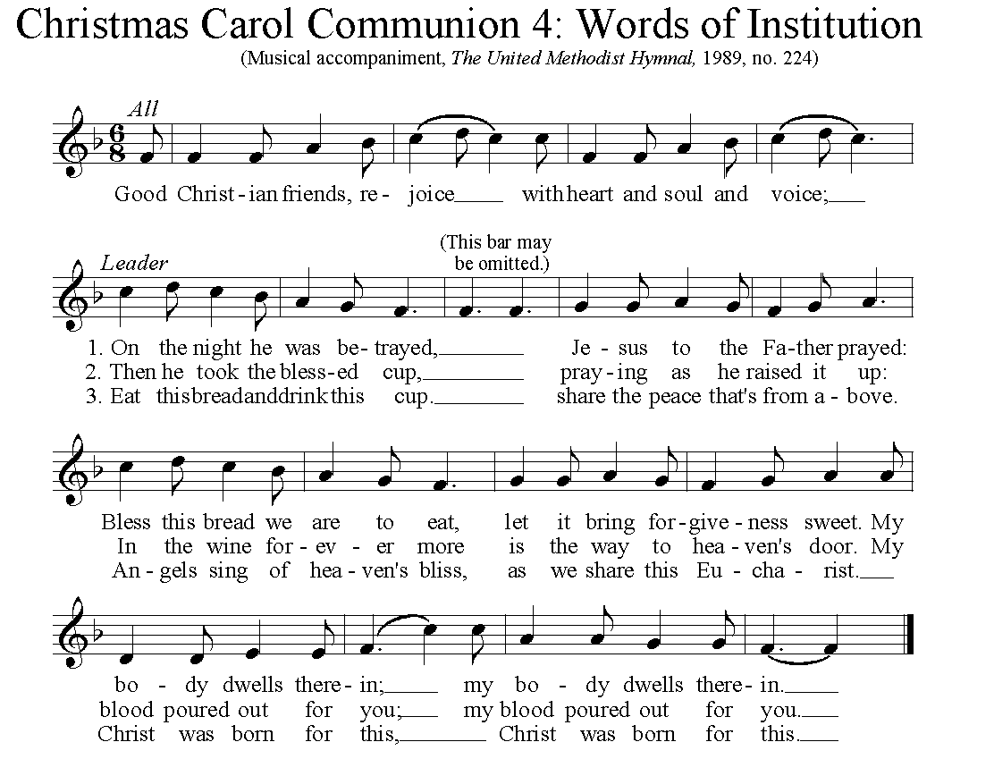

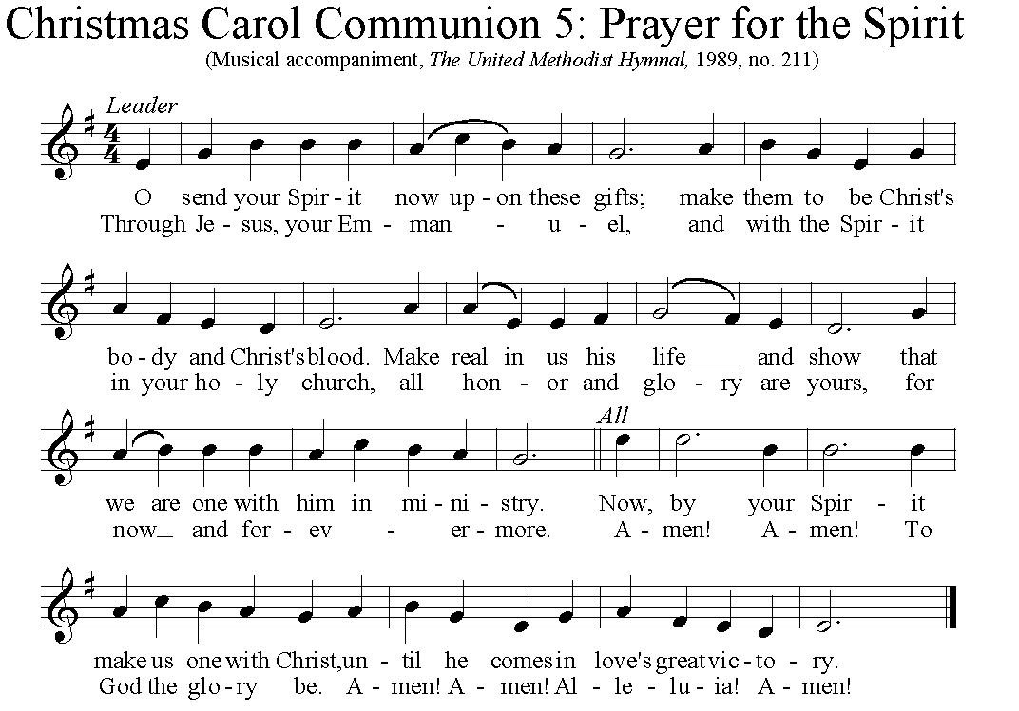

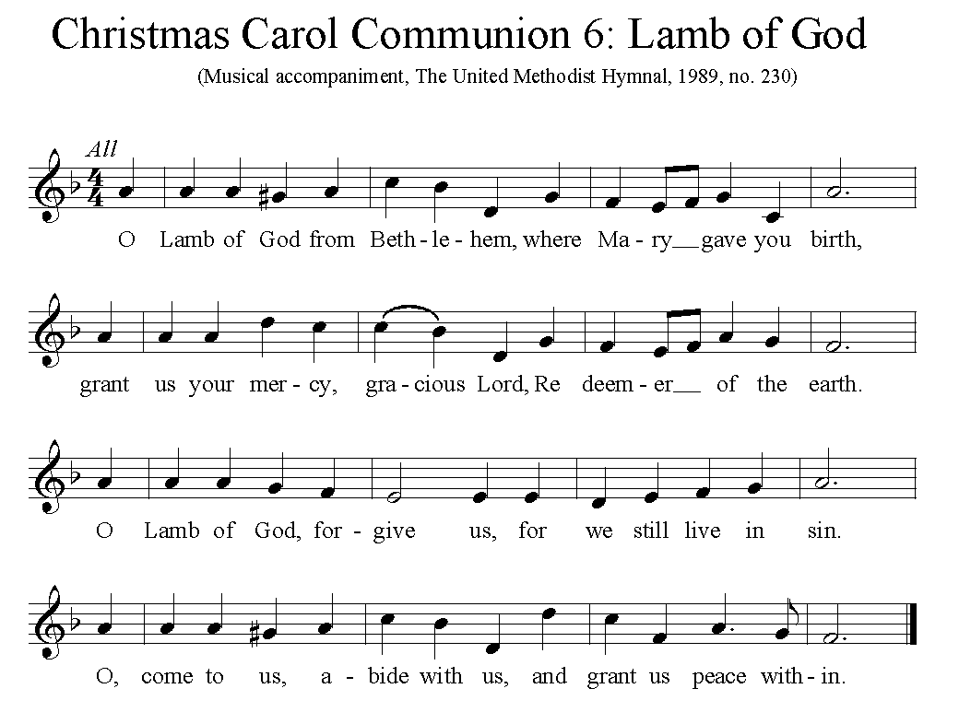

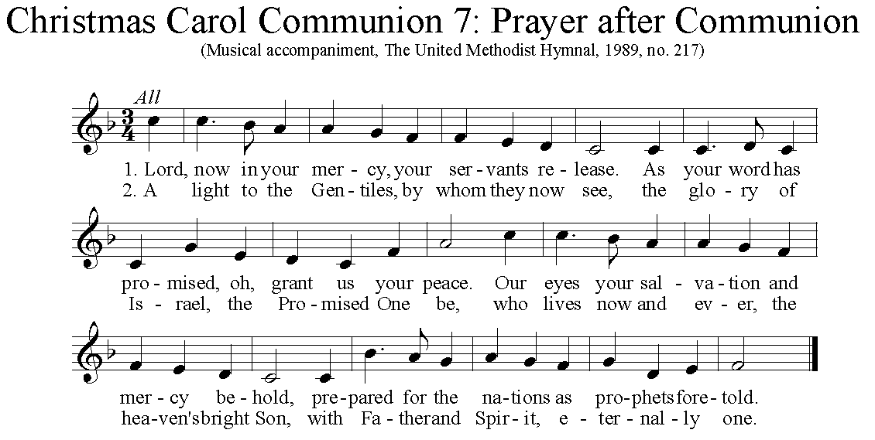

… TO GO REJOICING IN GOD’S NAME!

Hymnal 224 Good Christian friends, rejoice (standing) In dulci jubilo

Benediction

Today’s Services
Rev. Kimberly Greway, formerly our Associate Pastor from 2006-2010, is the Director of Chaplaincy Services at the Allegheny County Jail and Chief Operating Officer of the Foundation of HOPE which serves inmates and ex-offenders in Allegheny County.

The altar flowers are given in celebration of Noel Slater’s birthday by Sharon, Juliana and Lydia.

Special music is provided by the Chancel Choir.

Holiday hours The church office is closed and will reopen on Wed., January 3 at 8:30 am.

Worship options for children A wiggle room is provided today in Brookline Parlor, adjacent to the Sanctuary. Sunday School from 8:30-9:30, and Kids Praise, during the 10:45 service, will resume next Sunday.

Podcasts of Sunday Sermons Catch up on the messages from MLUMC with a podcast of Pastor Tom’s and others’ Sunday sermons. Sermons can be found at http:// mlumc.buzzsprout.com or navigate to the site from the link on our webpage, www.mlumc.org. Sermons also will be posted to iTunes. Full recordings of the service are available upon request.
Today’s Scriptures
Isaiah 61:10-62:3
¹⁰I will greatly rejoice in the Lord, my whole being shall exult in my God; for he has clothed me with the garments of salvation, he has covered me with the robe of righteousness, as a bridegroom decks himself with a garland, and as a bride adorns herself with her jewels. ¹¹For as the earth brings forth its shoots, and as a garden causes what is sown in it to spring up, so the Lord God will cause righteousness and praise to spring up before all the nations.

For Zion’s sake I will not keep silent, and for Jerusalem’s sake I will not rest, until her vindication shines out like the dawn, and her salvation like a burning torch. ²The nations shall see your vindication, and all the kings your glory; and you shall be called by a new name that the mouth of the Lord will give. ³You shall be a crown of beauty in the hand of the Lord, and a royal diadem in the hand of your God.

Luke 2:22-40
²²When the time came for their purification according to the law of Moses, they brought him up to Jerusalem to present him to the Lord²³(as it is written in the law of the Lord, “Every firstborn male shall be designated as holy to the Lord”), ²⁴and they offered a sacrifice according to what is stated in the law of the Lord, “a pair of turtledoves or two young pigeons.”

²⁵Now there was a man in Jerusalem whose name was Simeon; this man was righteous and devout, looking forward to the consolation of Israel, and the Holy Spirit rested on him. ²⁶It had been revealed to him by the Holy Spirit that he would not see death before he had seen the Lord’s Messiah. ²⁷Guided by the Spirit, Simeon came into the temple; and when the parents brought in the child Jesus, to do for him what was customary under the law, ²⁸Simeon took him in his arms and praised God, saying,²⁹“Master, now you are dismissing your servant in peace, according to your word; ³⁰for my eyes have seen your salvation, ³¹which you have prepared in the presence of all peoples, ³²a light for revelation to the Gentiles and for glory to your people Israel.” ³³And the child’s father and mother were amazed at what was being said about him. ³⁴Then Simeon blessed them and said to his mother Mary, “This child is destined for the falling and the rising of many in Israel, and to be a sign that will be opposed ³⁵so that the inner thoughts of many will be revealed—and a sword will pierce your own soul too.” ³⁶There was also a prophet, Anna the daughter of Phanuel, of the tribe of Asher. She was of a great age, having lived with her husband seven years after her marriage, ³⁷then as a widow to the age of eighty-four. She never left the temple but worshiped there with fasting and prayer night and day. ³⁸At that moment she came, and began to praise God and to speak about the child to all who were looking for the redemption of Jerusalem. ³⁹When they had finished everything required by the law of the Lord, they returned to Galilee, to their own town of Nazareth. ⁴⁰The child grew and became strong, filled with wisdom; and the favor of God was upon him.

Keep in Prayer
Hospitalized
John Katshir, Mercy
Earl Killian, St. Clair

Convalescing in Care Facilities
Leila Berkey, Asbury Heights
Ed Clarke, Asbury Place
Pat Seitz, Concordia

Convalescing at Home
Jean Boyer, Mary Caldwell, Carolyn Dagg,
Charles Hohing, David Lewis,
Susan Lichtenfels, George Lindow,
Robert Murray, Betty Trout

In the Military

Jason Boyer, SPC Natalie Brown

Maj. Zachary Allen Finch, USMC
James Iantelli, 1st Lt. Jaskiewicz
S. Sgt. Keith Kimmell, Adam Kmick
PFC Brendan Lamport
Sgt. Matthew McConahan, Thomas Orda
David Poncel, Sgt. Steven Reitz
Capt. Scott B. Rushe, Pastor Rick Townes
Maj. Azizi Wesmiller

Maj. Matthew C. Wesmiller
Sgt. Keith Scott Winkowski

Sgt. Michael Zimmerman

ANNOUNCEMENTS

Small Study Groups Are Forming in January Our church is undertaking an exciting new ministry by creating a variety of small groups.
New Testament Study - Clark Remington will begin leading a New Testament study on January 8 in his home. This group will meet monthly through May in the evening for a light dinner, viewing a DVD and discussion. (Filled at this time.)
Book Study - Rob and Jane Spicher will lead a monthly group that will begin Friday, January 26 at 6:30 in their home with dinner. This group will discuss Max Lucado's latest book, "Anxious for Nothing...Finding Calm in a Chaotic World." Contact Rob Spicher: 412-720-4589
Men's Group - On Saturday morning, January 13, a men's group under the leadership of Matt Baker will begin holding monthly meetings at the church.
We hope many of you will decide to join one of these interesting new ministries. You may sign up at the desk in the vestibule where a group leader can assist you.

Welcome New Secretary The Staff-Parish Relations Committee is pleased to announce the hiring of Sara Miller as our new church secretary, effective January 3rd, 2018. Sara comes to us with experience in a similar position at the First United Methodist Church of Kalamazoo, Michigan. She resides with her husband in Mt. Lebanon. More biographical information will be published in the near future.
Flower Donations Honor or remember a loved one or friend with a Sunday flower arrangement donation. Contact Lizzie Diller, 412-860-3614.

Each year the W PA Conference and Eastern German Conference create daily Advent and Christmas devotionals for use in our homes and churches. We have chosen devotionals from each week.
Pastor Werner Philipp D. Min., Dresden
Revelation 3: 14-22 To the angel of the church in Laodicea write: These are the words of the Amen, the faithful and true witness, the ruler of God’s creation. I know your deeds, that you are neither cold nor hot. I wish you were either one or the other! So, because you are lukewarm—neither hot nor cold—I am about to spit you out of my mouth. You say, ‘I am rich; I have acquired wealth and do not need a thing.’ But you do not realize that you are wretched, pitiful, poor, blind and naked. I counsel you to buy from me gold refined in the fire, so you can become rich; and white clothes to wear, so you can cover your shameful nakedness; and salve to put on your eyes, so you can see. Those whom I love I rebuke and discipline. So be earnest and repent. Here I am! I stand at the door and knock. If anyone hears my voice and opens the door, I will come in and eat with that person, and they with me. To the one who is victorious, I will give the right to sit with me on my throne, just as I was victorious and sat down with my Father on his throne. Whoever has ears, let them hear what the Spirit says to the churches.” (NIV)

The Advent season has always been a time of repentance and fasting. It is a time for contemplation and renewal of our thoughts and actions. This is true for each of us as individuals, for our congregations and the church as a whole. From time to time it is important to examine our way of thinking, to leave old ways of doing things behind and take on a fresh, new approach to following Jesus Christ. The seven letters in the book of Revelation provide us with pastoral counseling and promise us comfort while at the same time issuing a wake-up call.

He who knows each of us and our thoughts and actions is speaking in this letter! In His presence, we do not need to pretend to be anyone other than ourselves. He looks lovingly upon us (and sees through us) as we “dutifully” go about attending to our church business. Having to answer to this ”faithful and true witness“ is helpful and brings healing. He has the last say regarding what is pleasing in God‘s eyes and what is not.

The church in Laodicea has to bear harsh words. The congregation there is called upon to awake from their lethargy and self-deceit and to start following Christ again with renewed vigor. The wealth they have amassed is keeping them from following Him. Their complacency and comfort with the status quo betray a spiritual blindness and poverty. Repentance means honestly admitting that we need help. All it takes to start walking with Christ again is a bit of hope and sincere desire.

Here I am! I stand at the door and knock. If anyone hears my voice and opens the door, I will come in and eat with that person, and they with me.
This passage reminds me of the Sunday services at the Zwickau-Planitz church I attended as a teenager. These words adorned the walls of the sanctuary there and seemed to „shine“ down upon me as I read them. At such moments, the traditional spiritual Somebody is knocking at your door frequently went through my head and often gave me a renewed sense of joy in following Christ.

The Advent season is a time for anticipating the Lord‘s coming. He pays us frequent “visits” through His word and through Holy Communion in order to change His church and the world. Let us throw the doors wide open for Him!

Rev. Tom Strandburg, Mt. Lebanon UMC, Pittsburgh
This is the time of the year when we often daydream wistfully about “the good old days” from our past. Nostalgia fills the air throughout this holiday season. We are sometimes tempted to think that things were so much better in the past than they are today. This tendency can be especially strong within the church. In the past, we think, the church had more people and more resources to accomplish its work. What an idealistic picture we paint in our own minds, as we view our past “with rose-colored glasses!”

The words of John of Patmos in Revelation 3 remind us that some of the history of the church was very difficult indeed. We see no idealized picture of the church in the Seven Letters to the Seven Churches, but a mixture of faith and unfaith, responsibility and irresponsibility, which always characterizes the church in our world. John urges every Christian to remain faithful in the midst of these times of trial. His words to the church at Laodicea provide a special challenge to the churches in the more economically developed countries of our world today. Many of our citizens are tempted by the thought – “I am rich; I have acquired wealth and do not need a thing.” (3:17) Overcoming such arrogant thinking is the challenge of doing Christian ministry in the midst of affluent society.

We are challenged today by the image of Christ, who stands at the door and knocks. In the famous painting of that scene by the artist Warner Sallman, the door has no handle on the outside. It must be opened from within. To the one who “overcomes” by opening that door, and following Jesus in faithful living, the offer is made of God’s presence through all eternity! In Revelation, the desired quality of the Christian life is expressed by a Greek word, which Elizabeth Schüssler Fiorenza has translated as “consistent resistance” to oppressive power. The word is derived from a verb which means “stand one’s ground, not to give in.” Let us never be “lukewarm” in our discipleship as we follow God’s call!

CALENDAR – SUNDAY, DECEMBER 31 THRU SATURDAY, JANUARY 6

SUNDAY 12/31
10:45 am Worship Sanctuary
2 pm Korean Worship Sanner Chapel
MONDAY 1/1 OFFICE CLOSED FOR NEW YEAR’S DAY HOLIDAY
TUESDAY 1/2 OFFICE CLOSED FOR NEW YEAR’S DAY HOLIDAY
7 pm Boy Scout Troop #23 Wesley Hall
7 pm Boy Scout Parents Epworth Chapel
WEDNESDAY 1/3
6:30 am Northside Lunch Program Prep Kitchen
6 pm Homebuilder’s Potluck Wesley Hall
THURSDAY 1/4
8:30 am Northside Lunch Program Prep Kitchen
9:30 pm Hands & Hearts Epworth
12 pm TNT Asbury Heights
6:30 pm Promise Bells Rehearsal Bell Room
7:30 pm Chancel Choir Rehearsal Choir Room
FRIDAY 1/5
9:30 am Women’s Bible Study Room 102
SATURDAY 1/6
10 am Food Distribution Food Pantry

CHURCH TALENT SHOW
Sunday, Feb. 11 @ 4:00
Proceeds go to missions and youth work camp.
Your ticket includes: Gallery Walk, Dinner, and Talent Show
$10 Adult $5 Child $25 Family
Do you have a talent to share?
Contact Clark Remington corkrem@verizon.net

