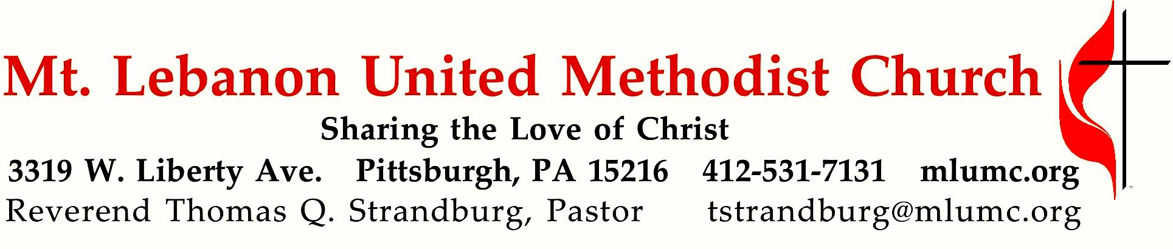

January 21, 2018 8:30 & 10:45
3rd Sunday after Epiphany

Escape Rooms are the latest group gaming and team-building craze. Have you ever visited one? Game designers develop crazy scenarios that force a team of people to work together in gathering clues so that they can find the exit before time runs out. In this week's text, Jonah tries to escape a nightmare scenario of his own but discovers there's no escape from the call of God.

WE GATHER IN GOD’S NAME …

Gathering Music
Hymn 404 Every time I feel the Spirit Afro-American Spiritual
Hymnal p.19 Musical Setting B James A. Kriewald

Greeting
Leader: Sing to the Lord a new song! Sing to the Lord, all the earth!
People: Declare God’s glory among the nations; declare his wondrous works among all people. Psalm 96:1, 3

Announcements

Introit 10:45 Psalm 100: 1-2 Karle Erickson
Make a joyful noise to the Lord, and come into his presence with singing!

Call to Worship
Leader: What a beautiful thing to be called to worship!
People: What a gift to come together in praise!
Leader: We are different people with different lives and stories.
People: But, in Christ, we all are one.

… TO GIVE PRAISE TO GOD …

Hymnal 674 See the morning sun ascending (standing) Unser Herrscher

Opening Prayer (in unison)
God of creation, your heavens and earth shout out the amazing news of your power and glory. God of justice, your laws of mercy and goodness reveal your vision of harmony for all people. God of love, your Son Jesus Christ proclaims the amazing news of your liberation for all who are hungry, poor, or oppressed. May we join with all of creation to become your message of love to the world. Amen.

Silent Prayer

Worship & Song 3131 Hymn Chant
Hear my prayer, O God, and listen to my plea;
faithful, righteous One, give ear and answer me.
Judge me not, I pray; no merit dare I claim;
knowing my own faults, I trust in your just Name.

… TO CELEBRATE THE FAMILY OF FAITH …

Sacrament of Baptism 10:45 Baptismal Covenant II, UM Hymnal #39 Emersyn Reese Rossman, daughter of Mike and Kiley Rossman

Pastor: Will you nurture one another in the Christian faith and life
and include Emersyn Reese now before you in your care?
People: With God’s help we will proclaim the good news
and live according to the example of Christ.
We will surround Emersyn Reese with a community
of love and forgiveness,
that she may grow in her service to others.
We will pray for her that she may be a true disciple
who walks in a way that leads to life.

The Sign of Peace Please pass the peace to your neighbors as a sign of reconciliation and love.
Leader: The peace of Christ be with you.
People: And also with you.

Gathering Song James Ritchie
This, this is where children belong,
welcomed as part of the worshiping throng.
Water, God’s Word, bread and cup, prayer and song:
This is where children belong. WORDS and MUSIC: James Ritchie ©1999 Abingdon Press

Message for Young Disciples Rev. Thomas Q. Strandburg
All children are invited. Please sing as children come forward.
After the children’s message at the 10:45 service, children ages 3 - 3rd grade may attend Kids Praise in the Welcome Center. Children will be escorted to and from Kids Praise by teachers. They will return to the Sanctuary near the end of the service, and parents may meet them.

… TO HEAR GOD’S WORD PROCLAIMED …

Anthem 10:45 The king of love and grace arranged by Christopher Aspaas
The King of love my Shepherd is, whose goodness faileth never;
I nothing lack if I am His and He is mine forever.
Where streams of living water flow, my ransomed soul He leadeth,
and where the verdant pastures grow, with food celestial feedeth.
Amazing grace, how sweet the sound that saved a wretch like me,
I once was lost, but now am found, was blind but now I see.
And so through all the length of days, thy goodness faileth never;
Good Shepherd may I sing thy praise within thy house forever.

Scripture Reading 8:30 Kathy Tremblay 10:45 Bob James
A Lesson from the Hebrew Scriptures
Jonah 3:1-10 God sends Jonah to preach to Nineveh

Handbell Anthem 10:45 Pastoral Bach, arranged by Barbara Kinyon

Pastoral Prayer

The Lord’s Prayer
Our Father, who art in heaven, hallowed be thy name. Thy kingdom come, thy will be done, on earth as it is in heaven. Give us this day our daily bread. And forgive us our trespasses, as we forgive those who trespass against us. And lead us not into temptation, but deliver us from evil. For thine is the kingdom, and the power, and the glory forever. Amen.

Celtic Alleluia Alleluia (sing 4 times, standing) O’Carroll and Walker

Scripture Reading
A Lesson from the Gospel
Mark 1:14-20 Jesus introduces his message, and calls his first disciples

Response
Leader: The Word of the Lord.
People: Thanks be to God.

… TO OFFER OUR GIFTS AND TO DEDICATE OUR LIVES …

Offertory Anthem 10:45 Total Praise Richard Smallwood, arranged by Joel Raney
Lord, I will lift my eyes to the hills, knowing my help is coming from you.
Your peace you give in time of the storm.
Refrain: You are the source of my strength; you are the strength of my life.
I lift my hands in total praise to you.
Holy, holy, holy! Lord God almighty! Early in the morning my song shall rise to thee.
Holy, holy, holy! Merciful and mighty, God in three persons, blessed Trinity! Refrain

Doxology 587 Tune: Tallis’ Canon, Hymnal 682
Bless thou the gifts our hands have brought;
bless thou the work our hearts have planned.
Ours is the faith, the will, the thought;
the rest, O God, is in thy hand.

Prayer of Dedication

Sermon “Jonah’s Escape Room Strategy” Rev. Thomas Q. Strandburg

… TO GO REJOICING IN GOD’S NAME!

Hymnal 436 The voice of God is calling (standing) Meirionydd

Benediction

Today’s Services

The flowers in the Chancel are given by the Lonsinger family in loving memory of Dick Lonsinger, who died January 21, 2015.

The flowers on the altar are given by Keith D. Will, Cheryl Lynn Graunke and Cynthia E. Argyle in loving memory of their parents, Ralph Doll Will and Ethel Gloria Smith Will.
Special music at 10:45 is provided by the Chapel Bells, directed by Nancy R. Lutz; and the Chancel Choir, with pianists Mary Paine, who teaches piano in the area and plays with the Chapel Bells, and Kathleen Whittaker. The anthem, “The king of love and grace,” is sung by the men of the Chancel Choir in celebration of the birthday of Bishop George Bashore.

Acolytes Lydia Slater and Anna Rhoton

Greeters 8:30 Joe Catalano 10:45 Priscilla Utzig

Worship options for children We encourage children to participate in the Children’s Sermon at both services, and in Kids Praise during the 10:45 service. Nursery services are offered in Room 204 of the Education Building. Ask ushers or greeters and follow signs for direction.

Podcasts of Sunday Sermons Catch up on messages from MLUMC with a podcast of Pastor Tom’s and others’ Sunday sermons. Sermons can be found at http:// mlumc.buzzsprout.com or navigate to the site from the link on our webpage, www.mlumc.org. Sermons also will be posted to iTunes. Full recordings of the service are available upon request.

Flower Donations Honor or remember a loved one or friend with a Sunday flower arrangement donation. Contact Lizzie Diller, 412-860-3614.

Today’s Scriptures

Jonah 3:1-10
The word of the Lord came to Jonah a second time, saying, ²“Get up, go to Nineveh, that great city, and proclaim to it the message that I tell you.” ³So Jonah set out and went to Nineveh, according to the word of the Lord. Now Nineveh was an exceedingly large city, a three days’ walk across. ⁴Jonah began to go into the city, going a day’s walk. And he cried out, “Forty days more, and Nineveh shall be overthrown!”

⁵And the people of Nineveh believed God; they proclaimed a fast, and everyone, great and small, put on sackcloth. ⁶When the news reached the king of Nineveh, he rose from his throne, removed his robe, covered himself with sackcloth, and sat in ashes. ⁷Then he had a proclamation made in Nineveh: “By the decree of the king and his nobles: No human being or animal, no herd or flock, shall taste anything. They shall not feed, nor shall they drink water. ⁸Human beings and animals shall be covered with sackcloth, and they shall cry mightily to God. All shall turn from their evil ways and from the violence that is in their hands. ⁹Who knows? God may relent and change his mind; he may turn from his fierce anger, so that we do not perish.” ¹⁰When God saw what they did, how they turned from their evil ways, God changed his mind about the calamity that he had said he would bring upon them; and he did not do it.

Mark 1:14-20
¹⁴Now after John was arrested, Jesus came to Galilee, proclaiming the good news of God, ¹⁵and saying, “The time is fulfilled, and the kingdom of God has come near; repent, and believe in the good news.” ¹⁶As Jesus passed along the Sea of Galilee, he saw Simon and his brother Andrew casting a net into the sea—for they were fishermen. ¹⁷And Jesus said to them, “Follow me and I will make you fish for people.” ¹⁸And immediately they left their nets and followed him. ¹⁹As he went a little farther, he saw James son of Zebedee and his brother John, who were in their boat mending the nets. ²⁰Immediately he called them; and they left their father Zebedee in the boat with the hired men, and followed him.

Small Study Groups
Book Study - Please join Rob and Jane Spicher, beginning Friday, January 26th at 6:30 pm, for a 5 session study. The focus of discussion will be “Anxious for Nothing” by Max Lucado, an insight from Phillippians 4:4-8. Dinner will be served. The study will meet at 1803 Cambridge Drive, Presto (Collier Township) PA, 15142, and the group will continue to meet monthly in the homes of group members. There is room for 10 to join. Please call Rob (412-720-4589) or e-mail Rob (robert.spicher@pnc.com) if you would like to join.

You may sign up for the Spicher's Study Group at the Welcome desk in the narthex. In addition, Cindy Biery will be leading a book study in the spring. More details will follow.

Become a Greeter: Extend a Welcome Hand
The Sunday morning greeter is often the first person a visitor or member contacts on entering the church. A greeter’s smile, handshake and cheerful words may set the tone for not only a church goer’s worship experience, but also an entire day. MLUMC is in need of Sunday morning greeters. Consider serving at one of the two worship services. You’ll become a vital part of the church’s ministry of hospitality and make new friends. If you can offer this service once or twice a year, fill out the form below and drop it in the collection basket or deliver it to the office.

Greeter Volunteer Name _______________________________________________
Worship service choice _______8:30 ______10:45
Phone # _________________________ email ________________________________

Keep in Prayer

Hospitalized
Charles Hohing, St. Clair
John Katshir, Mercy
Wilda Kietz, St. Clair
Gerald Raubaugh, St. Clair
Virginia (Jinny) Sheppard, St. Clair

Convalescing in Care Facilities
Leila Berkey, Asbury Heights
Ed Clarke, Asbury Place
Lois Colley, Concordia
Pat Seitz, Concordia
Carol Van Sickle, Manor Care, Bethel Park

Convalescing at Home
Jean Boyer, Mary Caldwell,
Carolyn Dagg, Earl Killian,
David Lewis, Susan Lichtenfels,
George Lindow, Robert Murray,
Betty Trout

In the Military

Jason Boyer, SPC Natalie Brown
Maj. Zachary Allen Finch, USMC
James Iantelli, 1st Lt. Jaskiewicz
S. Sgt. Keith Kimmell, Adam Kmick

PFC Brendan Lamport
Sgt. Matthew McConahan, Thomas Orda
David Poncel, Sgt. Steven Reitz
Capt. Scott B. Rushe, Pastor Rick Townes
Maj. Azizi Wesmiller

Maj. Matthew C. Wesmiller
Sgt. Keith Scott Winkowski

Sgt. Michael Zimmerman

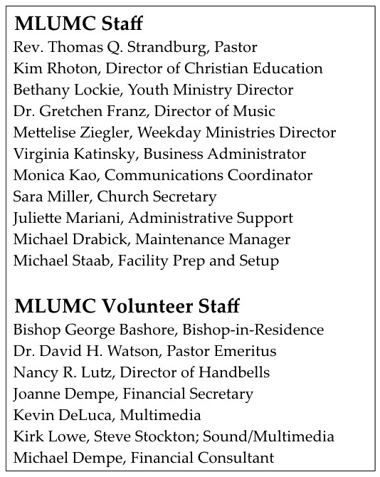

CALENDAR – SUNDAY, JANUARY 21 THRU SATURDAY, JANUARY 27

SUNDAY 1/21
8:30 am Worship Sanner Chapel
9:30 am Sunday School/ Coffee Café Various/ Brookline Parlor
10:45 am Worship Sanctuary
Kids Praise Welcome Center
11:45 am Youth Choir Rehearsal Choir Room
5 pm Youth Group Asbury Center
6:30 pm Eagle Board of Review Various

MONDAY 1/22
7 pm Chapel Bells Rehearsal Bell Room
7:30 pm Community Events & Outreach Committee Wesley Hall

TUESDAY 1/23
6 pm Terrific Tuesday Asbury Center
7 pm Boy Scout Troop #23 Wesley Hall
7 pm Boy Scout Board of Reviews Room 105

WEDNESDAY 1/24
7 pm Wolf Den Cub Scout Room 105
7 pm Tiger Den Epworth
7 pm Bear Den Room 104

THURSDAY 1/25
6:30 pm Promise Bells Rehearsal Bell Room
7:30 pm Chancel Choir Rehearsal Choir Room

FRIDAY 1/26
9:30 am Women’s Bible Study Room 102

SATURDAY 1/27
11:30 am “A Taste of Winter” Community Lunch Asbury Center

