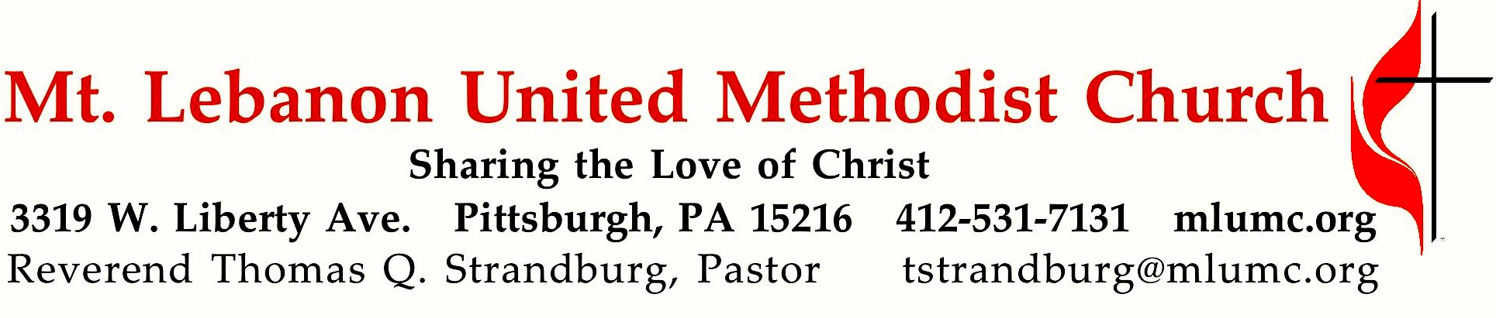
January 28, 2018 8:30 & 10:45
4th Sunday after Epiphany
Who can you trust? That’s a constant question in life. Israel was faced with a similar dilemma -- how can you tell the difference between a real prophet and just another religious pitchman? It's a question for everyone who wants to hear an authentic word from the Lord.

WE GATHER IN GOD’S NAME …

Gathering Music
Hymnal 404 Every time I feel the Spirit Afro-American Spiritual
Hymnal 264 Silence, frenzied, unclean Spirit (stanzas 1-2) Authority

Greeting
Leader: Sing to the Lord a new song! Sing to the Lord, all the earth!
People: Declare God’s glory among the nations; declare his wondrous works among all people. Psalm 96:1, 3
Announcements

Introit 10:45 Psalm 100: 1-2 Karle Erickson
Make a joyful noise to the Lord, and come into his presence with singing!

Call to Worship
Leader: Where can we go and seek refuge?
People: We’ve taken refuge in you, Lord.
Leader: Who can rescue us from the grip of the wrongdoer?
People: We plead our case to you, Lord.
Leader: Is there any place we can run to escape the spiritual dangers
that surround us?
People: The Lord is our rock and refuge.
Leader: Let us lift up our praise as we celebrate the deliverance found
only in the Lord.

… TO GIVE PRAISE TO GOD …

Hymnal 173 Christ, whose glory fills the skies (standing) Ratisbon

Opening Prayer (in unison)
God of hope and love, let your light shine upon us this day. Let your patience and kindness flow through us, inspiring us to new depths of love and hope. Transform our love, that we might overcome envy and resentment, and rejoice in justice and righteousness. Envelop us in your love, that believing, hoping, and enduring may become our way of life on the path of love. In loving hope, we pray. Amen.

Silent Prayer

Worship & Song 3131 Hymn Chant
Hear my prayer, O God, and listen to my plea;
faithful, righteous One, give ear and answer me.
Judge me not, I pray; no merit dare I claim;
knowing my own faults, I trust in your just Name.

… TO CELEBRATE THE FAMILY OF FAITH …

The Sign of Peace Please pass the peace to your neighbors as a sign of reconciliation and love.
Leader: The peace of Christ be with you.
People: And also with you.

Gathering Song James Ritchie
This, this is where children belong,
welcomed as part of the worshiping throng.
Water, God’s Word, bread and cup, prayer and song:
This is where children belong.
WORDS AND MUSIC: James Ritchie ©1999 Abingdon Press

Message for Young Disciples Rev. Thomas Q. Strandburg
(All children are invited. Please sing as children come forward.)

After the children’s message at the 10:45 service, children ages 3 - 3rd grade may attend Kids Praise in the Welcome Center. Children will be escorted to and from Kids Praise by teachers. They will return to the Sanctuary near the end of the service, and parents may meet them.

… TO HEAR GOD’S WORD PROCLAIMED …

Hymnal 264 Silence, frenzied, unclean Spirit (seated) Authority
Scripture Reading 8:30 Scott Miller
10:45 Vera Jane Cornes
A Lesson from the Hebrew Scriptures
Deuteronomy 18:15-20 The definition of a true prophet

Pastoral Prayer

The Lord’s Prayer
Our Father, who art in heaven, hallowed be thy name. Thy kingdom come, thy will be done, on earth as it is in heaven. Give us this day our daily bread. And forgive us our trespasses, as we forgive those who trespass against us. And lead us not into temptation, but deliver us from evil. For thine is the kingdom, and the power, and the glory forever. Amen.

Celtic Alleluia Alleluia (sing 4 times, standing) O’Carroll and Walker

Scripture Reading
A Lesson from the Gospels
Mark 1:21-28 Jesus casts out a demon

Response
Leader: The Word of the Lord.
People: Thanks be to God.

… TO OFFER OUR GIFTS AND TO DEDICATE OUR LIVES …

Offertory Anthem 10:45 Sanctuary Thompson and Scruggs, arranged by Lloyd Larson
Refrain: Lord, prepare me to be a sanctuary, pure and holy, tried and true;
with thanksgiving, I’ll be a living sanctuary for you.

I am a temple, God’s holy temple, for his spirit lives in me;
created as a sacred dwelling of the most High God! Refrain

Doxology 587 Tune: Tallis’ Canon, Hymnal 682
Bless thou the gifts our hands have brought;
bless thou the work our hearts have planned.
Ours is the faith, the will, the thought;
the rest, O God, is in thy hand.

Prayer of Dedication

Sermon “Prophet or Pitchman?” Rev. Thomas Q. Strandburg

… TO GO REJOICING IN GOD’S NAME!

Hymnal 671 Lord, dismiss us with thy blessing (standing) Sicilian Mariners

Benediction

Today’s Services

The flowers in the chancel are given by Tom and Sharon Diller in celebration of their beloved daughter Lizzie Diller Florian’s birthday today.

The flowers on the altar are given by Jane Spicher in celebration of Rob Spicher’s birthday on February 3.

Special music at 10:45 is provided by the Chancel Choir, with pianist Cori DeLuca, who teaches piano in the area.

Greeters 8:30 George Lindow 10:45 Bob and Chris James

Worship options for children We encourage children to participate in the Children’s Sermon at both services, and in Kids Praise during the 10:45 service. Nursery services are offered in Room 204 of the Education Building. Ask ushers or greeters and follow signs for direction.

Podcasts of Sunday Sermons Catch up on messages from MLUMC with a podcast of Pastor Tom’s and others’ Sunday sermons. Sermons can be found at http:// mlumc.buzzsprout.com or navigate to the site from the link on our webpage, www.mlumc.org. Sermons also will be posted to iTunes. Full recordings of the service are available upon request.

Flower Donations Honor or remember a loved one or friend with a Sunday flower arrangement donation. Contact Lizzie Diller, 412-860-3614.

Today’s Scriptures
Deuteronomy 18:15-20
¹⁵The Lord your God will raise up for you a prophet like me from among your own people; you shall heed such a prophet. ¹⁶This is what you requested of the Lord your God at Horeb on the day of the assembly when you said: “If I hear the voice of the Lord my God any more, or ever again see this great fire, I will die.” ¹⁷Then the Lord replied to me: “They are right in what they have said. ¹⁸I will raise up for them a prophet like you from among their own people; I will put my words in the mouth of the prophet, who shall speak to them everything that I command.¹⁹Anyone who does not heed the words that the prophet shall speak in my name, I myself will hold accountable. ²⁰But any prophet who speaks in the name of other gods, or who presumes to speak in my name a word that I have not commanded the prophet to speak—that prophet shall die.”

Mark 1:21-28
²¹They went to Capernaum; and when the sabbath came, he entered the synagogue and taught. ²²They were astounded at his teaching, for he taught them as one having authority, and not as the scribes. ²³Just then there was in their synagogue a man with an unclean spirit, ²⁴and he cried out, “What have you to do with us, Jesus of Nazareth? Have you come to destroy us? I know who you are, the Holy One of God.” ²⁵But Jesus rebuked him, saying, “Be silent, and come out of him!” ²⁶And the unclean spirit, convulsing him and crying with a loud voice, came out of him.²⁷They were all amazed, and they kept on asking one another, “What is this? A new teaching—with authority! He commands even the unclean spirits, and they obey him.” ²⁸At once his fame began to spread throughout the surrounding region of Galilee.

Keep in Prayer
Hospitalized
Carol Van Sickle, St. Clair

Convalescing in Care Facilities
Leila Berkey, Asbury Heights
Ed Clarke, Asbury Place
Lois Colley, Concordia
Charles Hohing, Manor Care, McMurray
John Katshir, Asbury Heights
Pat Seitz, Concordia

Convalescing at Home
Jean Boyer, Mary Caldwell,
Carolyn Dagg, Earl Killian,
Wilda Dietz, David Lewis,
Susan Lichtenfels,
Robert Murray, Betty Trout
Virginia (Jinny) Sheppard

In the Military

Jason Boyer, SPC Natalie Brown
Maj. Zachary Allen Finch, USMC
James Iantelli, 1st Lt. Jaskiewicz
S. Sgt. Keith Kimmell, Adam Kmick

PFC Brendan Lamport
Sgt. Matthew McConahan, Thomas Orda
David Poncel, Sgt. Steven Reitz
Capt. Scott B. Rushe, Pastor Rick Townes
Maj. Azizi Wesmiller

Maj. Matthew C. Wesmiller
Sgt. Keith Scott Winkowski

Sgt. Michael Zimmerman

In Sympathy
Condolences are offered to the family of church member William Lewis who passed away on Tuesday, January 23, 2018. Prayers of sympathy may be sent to the family:
Lewis Family
730 Bower Hill Rd. #310
Pittsburgh, PA 15243

The congregation also offers its sympathy to the family of 87-year-old Gerald Raubaugh who passed away Wednesday, January 24, 2018. Condolences may be sent to the family:
Raubaugh Family
50 Vanadium Rd.
Bridgeville, PA 15017

Looking to send a card?
Here are some helpful addresses:

Asbury Heights
700 Bower Hill Road
Pittsburgh, PA 15243

Concordia Health Center
1300 Bower Hill Road
Pittsburgh, PA 15243

St. Clair Hospital
1000 Bower Hill Road
Pittsburgh, PA 15243

Church Membership Information Class Considering membership in Mt. Lebanon United Methodist Church? Want to learn more about our church? The church is scheduling an informative class for prospective new members on Saturday, February 24, from 10 am to noon, in the Welcome Center. If you would like to participate, call the office at 412-531-7131 or email churchsecretary@mlumc.org

A special session of the Charge Conference will be held on Monday, February 5th , at 7 p.m. in Wesley Hall, for the purpose of considering the endorsement of Scott Miller as a certified candidate for ministry in our congregation. Everyone is invited to attend.

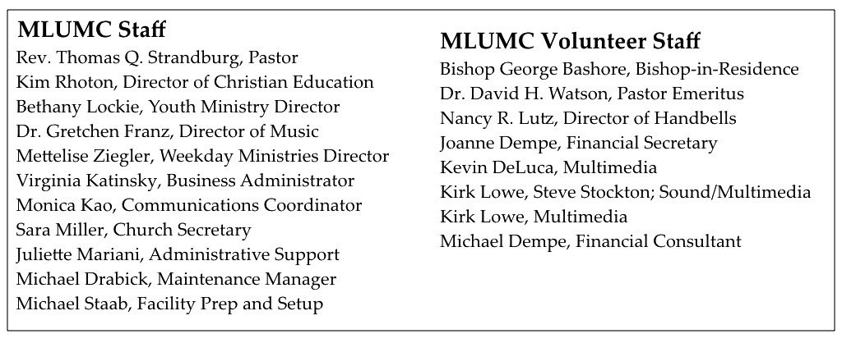

Become a Greeter: Extend a Welcome Hand
The Sunday morning greeter is often the first person a visitor or member contacts on entering the church. A greeter’s smile, handshake and cheerful words may set the tone for not only a church goer’s worship experience, but also an entire day. MLUMC is in need of Sunday morning greeters. Consider serving at one of the two worship services. You’ll become a vital part of the church’s ministry of hospitality and make new friends. If you can offer this service once or twice a year, fill out the form below and drop it in the collection basket or deliver it to the office.

Greeter Volunteer Name _______________________________________________
Worship service choice _______8:30 ______10:45
Phone # _________________________ email ________________________________
CALENDAR – SUNDAY, JANUARY 28 THRU SATURDAY, FEBRUARY 3

SUNDAY 1/28
8:30 am Worship Sanner Chapel
9:30 am Sunday School/ Coffee Café Various/ Brookline Parlor
10:45 am Worship Sanctuary
Kids Praise Welcome Center
11:45 am Youth Choir Rehearsal Choir Room
5 pm Youth Group Asbury Center
7 pm Boy Scout Patrol Leaders Room 105

MONDAY 1/29
7 pm Chapel Bells Rehearsal Bell Room

TUESDAY 1/30
6 pm Terrific Tuesday Asbury Center
7 pm Boy Scout Troop #23 Wesley Hall

WEDNESDAY 1/31
6:30 am Northside Lunch Program Prep Kitchen

THURSDAY 2/1
8:30 am Northside Lunch Program Prep Kitchen
9:00 am Hands & Hearts Epworth
12 pm TNT Asbury Heights
6:30 pm Promise Bells Rehearsal Bell Room
7:30 pm Chancel Choir Rehearsal Choir Room

FRIDAY 2/2
9:30 am Women’s Bible Study Room 102

SATURDAY 2/3
10 am Food Distribution Pantry

