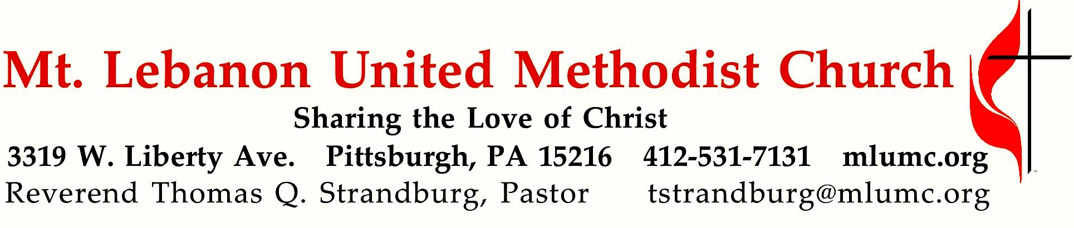

February 11, 2018 8:30 & 10:45
Transfiguration Sunday Boy Scout Sunday
How often do we spend our lives to working our way up the "ladder of success?" The problem with finally getting what we want is that then we've got it! The longed-for prize becomes just another new responsibility, another step on the ladder. "Success" is still somewhere else. Jesus offers not the "Ladder of Success" but the "Chute of Service."

WE GATHER IN GOD’S NAME …

Gathering Music
*Hymnal 95 Praise God, from whom all blessings flow Old 100th, arr. Bradley Sowash

Hymn/Anthem Jesus on the mountain peak Michael Burkhardt
4. Jesus is the chosen One, living hope of ev’ry nation,
hear and heed him, ev’ry one;
sing, with earth and all creation,
alleluia, alleluia, alleluia!

Greeting
Leader: O magnify the Lord with me,
People: and let us exalt God’s name together! Psalm 34:3

Boy Scout Sunday Celebration 10:45
Color Guard Procession
Luke Grabowski, Eric Montarti, Austin Rodgers, Damian Williams
Pledge of Allegiance and Scout Oath Alex Rodgers

Announcements

Introit 10:45 Psalm 100: 1-2 Karle Erickson
Make a joyful noise to the Lord, and come into his presence with singing!

Call to Worship
Leader: We, who live in the shelter of the Most High . . .
People: Let us come and trust in our God. God’s word us near us, on our lips and in our hearts.
Leader: We, who trust in God’s promises . . . let us come and rejoice in the power of the Spirit.
People: The Holy One is our refuge and our strength. We have come to worship the One who calls us!
Deborah Sokolove

… TO GIVE PRAISE TO GOD …

Hymnal 258 O wondrous sight! O vision fair (standing) Wareham

Opening Prayer (in unison)
God of signs and wonders, God of power and love, God of breath and life, you make no distinctions between us – distinctions of ethnic origin or race, gender or identity, riches or poverty. All who believe in you will be saved. In you, we learn to trust the changing seasons – giving thanks as winter turns to spring, as long, dark nights give way to brighter days. In you, we find the courage to turn away from all that is false, rejoicing instead in the constancy of your love. You, who are our rock and our redeemer, save us from falling into temptation, as we turn our hearts to you. Amen.
Deborah Sokolove

Silent Prayer

Hymnal 402 Lord, I want to be a Christian (stanza 2, seated) Afro-American Spiritual
Lord, I want to be more loving in my heart, in my heart;
Lord, I want to be more loving in my heart.
In my heart, in my heart; Lord, I want to be more loving in my heart.

… TO CELEBRATE THE FAMILY OF FAITH …

The Sign of Peace Please pass the peace to your neighbors as a sign of reconciliation and love.
Leader: The peace of Christ be with you.
People: And also with you.

Gathering Song James Ritchie
This, this is where children belong,
welcomed as part of the worshiping throng.
Water, God’s Word, bread and cup, prayer and song:
This is where children belong. WORDS & MUSIC: James Ritchie ©1999 Abingdon Press
Message for Young Disciples Rev. Thomas Q. Strandburg
All children are invited. Please sing as children come forward. After the children’s message at the 10:45 service, children ages 3 - 3rd grade may attend Kids Praise in the Welcome Center. Children will be escorted to and from Kids Praise by teachers. They will return to the Sanctuary near the end of the service

… TO HEAR GOD’S WORD PROCLAIMED …

Hymn/Anthem 10:45 (Congregation singing stanza 4) Michael Burkhardt
1. Jesus, on the mountain peak, stands alone in glory blazing.
Let us, if we dare to speak, join the saints and angels praising:
alleluia, alleluia, alleluia!
2. Trembling at his feet we saw Moses and Elijah speaking.
All the Prophets and the Law shout through them their joyful greeting:
alleluia, alleluia, alleluia!
3. Swift the cloud of glory came, God, proclaiming in its thunder,
Jesus as the Son by name! Nations, cry aloud in wonder:
alleluia, alleluia, alleluia!
4. Jesus is the chosen One, living hope of ev’ry nation,
hear and heed him, ev’ry one; sing, with earth and all creation,
alleluia, alleluia, alleluia!

Scripture Reading 8:30 Marcy Picardi
10:45 Jacob Lowe

A Lesson from the New Testament
2 Corinthians 4:3-6 The light of the Gospel

Pastoral Prayer

The Lord’s Prayer
Our Father, who art in heaven, hallowed be thy name. Thy kingdom come, thy will be done, on earth as it is in heaven. Give us this day our daily bread. And forgive us our trespasses, as we forgive those who trespass against us. And lead us not into temptation, but deliver us from evil. For thine is the kingdom, and the power, and the glory forever. Amen.

Celtic Alleluia Alleluia (sing 4 times, standing) O’Carroll and Walker

Scripture Reading 10:45 Oliver Casadei
A Lesson from the Gospel
Mark 9:2-9 The Transfiguration

Response
Leader: The Word of the Lord.
People: Thanks be to God.

… TO OFFER OUR GIFTS AND TO DEDICATE OUR LIVES …

Offertory Anthem 10:45 Song of the Transfiguration adapted by David Haas
- Transform us as you, transfigured, stood apart on Tabor’s height.
Lead us up our sacred mountains, search us with revealing light.
Lift us from where we have fallen, full of questions, filled with fright.
- Transform us as you, transfigured, once spoke with those holy ones.
We, surrounded by the witness of those saints whose work is done,
Live in this world as your Body, chosen daughters, chosen sons.
- Transform us as you, transfigured, would not stay within a shrine.
Keep us from our great temptation time and truth we quickly bind.
Lead us down those daily pathways where our love is not confined.

Doxology 587 Tune: Tallis’ Canon, Hymnal 682
Bless thou the gifts our hands have brought;
bless thou the work our hearts have planned.
Ours is the faith, the will, the thought;
the rest, O God, is in thy hand.

Prayer of Dedication

Sermon “Chutes or Ladders?” Rev. Thomas Q. Strandburg

… TO GO REJOICING IN GOD’S NAME!

Hymnal 582 Whom shall I send? (standing) Deus tuorum militum

Benediction

Following the 10:45 service, say hello to members of Boy Scout Troop #23 and Cub Scout Pack #870 at a reception in Asbury Center.

Today’s Services

The flowers on the altar are given by Cleon and Vera Jane Cornes in honor of their grandchildren: Lindsay, Adam, and Michael.

The flowers in the Chancel are given by Ken, Holly, Christian and Andy Schultz in loving memory of John F. Nigon, Holly’s father.

Special music at 10:45 is provided by the Chancel Choir, with soloist Kirby Dilworth and pianist Mary Paine, who teaches piano in the area and plays with our Chapel Bell Choir and the Grace Notes, a quartet of handbell ringers.

February is Black History month which we are celebrating by singing Afro-American Spirituals.

*The new Doxology, a very slightly altered version of the original found in our hymnal, dated 1551, will be sung March 4th when the Chancel Choir sings “Jazz Missa Brevis” by Will Todd during Communion with saxophone, two trumpets, bass, drums and piano.

Acolytes Luke Grabowski and Emily Shoff

Greeter 10:45 Alex Rodgers, member of BSA Troop 23

Worship options for children We encourage children to participate in the Children’s Sermon at both services, and in Kids Praise during the 10:45 service. Nursery services are offered in Room 204 of the Education Building. Ask ushers or greeters and follow signs for direction.

Honor or remember a loved one with a flower donation. The flowers that grace the Sanctuary each week are generously donated by our church family members. This is a great way to honor or memorialize a special person, event, or milestone in your personal life or in the life of the church. If you are interested in donating flowers on a particular Sunday, contact Lizzie Diller , 412-860-3614. Donati and Sons Florist provides the beautiful arrangements. The cost is $30 for the altar, narthex, or columbarium, and $60 for the chancel. The church is currently seeking flower donations for April.

Podcasts of Sunday Sermons Catch up on messages from MLUMC with a podcast of Pastor Tom’s and others’ Sunday sermons. Sermons can be found at http:// mlumc.buzzsprout.com or navigate to the site from the link on our webpage, www.mlumc.org. Sermons also will be posted to iTunes. Full recordings of the service are available upon request.

Today’s Scriptures

2 Corinthians 4:3-6

³And even if our gospel is veiled, it is veiled to those who are perishing. ⁴In their case the god of this world has blinded the minds of the unbelievers, to keep them from seeing the light of the gospel of the glory of Christ, who is the image of God. ⁵For we do not proclaim ourselves; we proclaim Jesus Christ as Lord and ourselves as your slaves for Jesus’ sake. ⁶For it is the God who said, “Let light shine out of darkness,” who has shone in our hearts to give the light of the knowledge of the glory of God in the face of Jesus Christ.

Mark 9:2-9
²Six days later, Jesus took with him Peter and James and John, and led them up a high mountain apart, by themselves. And he was transfigured before them, ³and his clothes became dazzling white, such as no one on earth could bleach them. ⁴And there appeared to them Elijah with Moses, who were talking with Jesus. ⁵Then Peter said to Jesus, “Rabbi, it is good for us to be here; let us make three dwellings, one for you, one for Moses, and one for Elijah.” ⁶He did not know what to say, for they were terrified. ⁷Then a cloud overshadowed them, and from the cloud there came a voice, “This is my Son, the Beloved; listen to him!” ⁸Suddenly when they looked around, they saw no one with them any more, but only Jesus.
⁹As they were coming down the mountain, he ordered them to tell no one about what they had seen, until after the Son of Man had risen from the dead.

Keep in Prayer

Convalescing in Care Facilities
Leila Berkey, Asbury Heights
Ed Clarke, Asbury Place
Lois Colley, Concordia
John Katshir, Asbury Heights
Pat Seitz, Concordia
Carol Van Sickle, Concordia

Convalescing at Home
Jean Boyer, Mary Caldwell,
Carolyn Dagg, Earl Killian,
Wilda Dietz, David Lewis,
Charles Hohing, Susan Lichtenfels,
Betty Trout, Virginia (Jinny) Sheppard

In the Military

Jason Boyer, SPC Natalie Brown
Maj. Zachary Allen Finch, USMC
James Iantelli, 1st Lt. Jaskiewicz
S. Sgt. Keith Kimmell, Adam Kmick

PFC Brendan Lamport
Sgt. Matthew McConahan, Thomas Orda
David Poncel, Sgt. Steven Reitz
Capt. Scott B. Rushe, Pastor Rick Townes
Maj. Azizi Wesmiller

Maj. Matthew C. Wesmiller
Sgt. Keith Scott Winkowski

Sgt. Michael Zimmerman

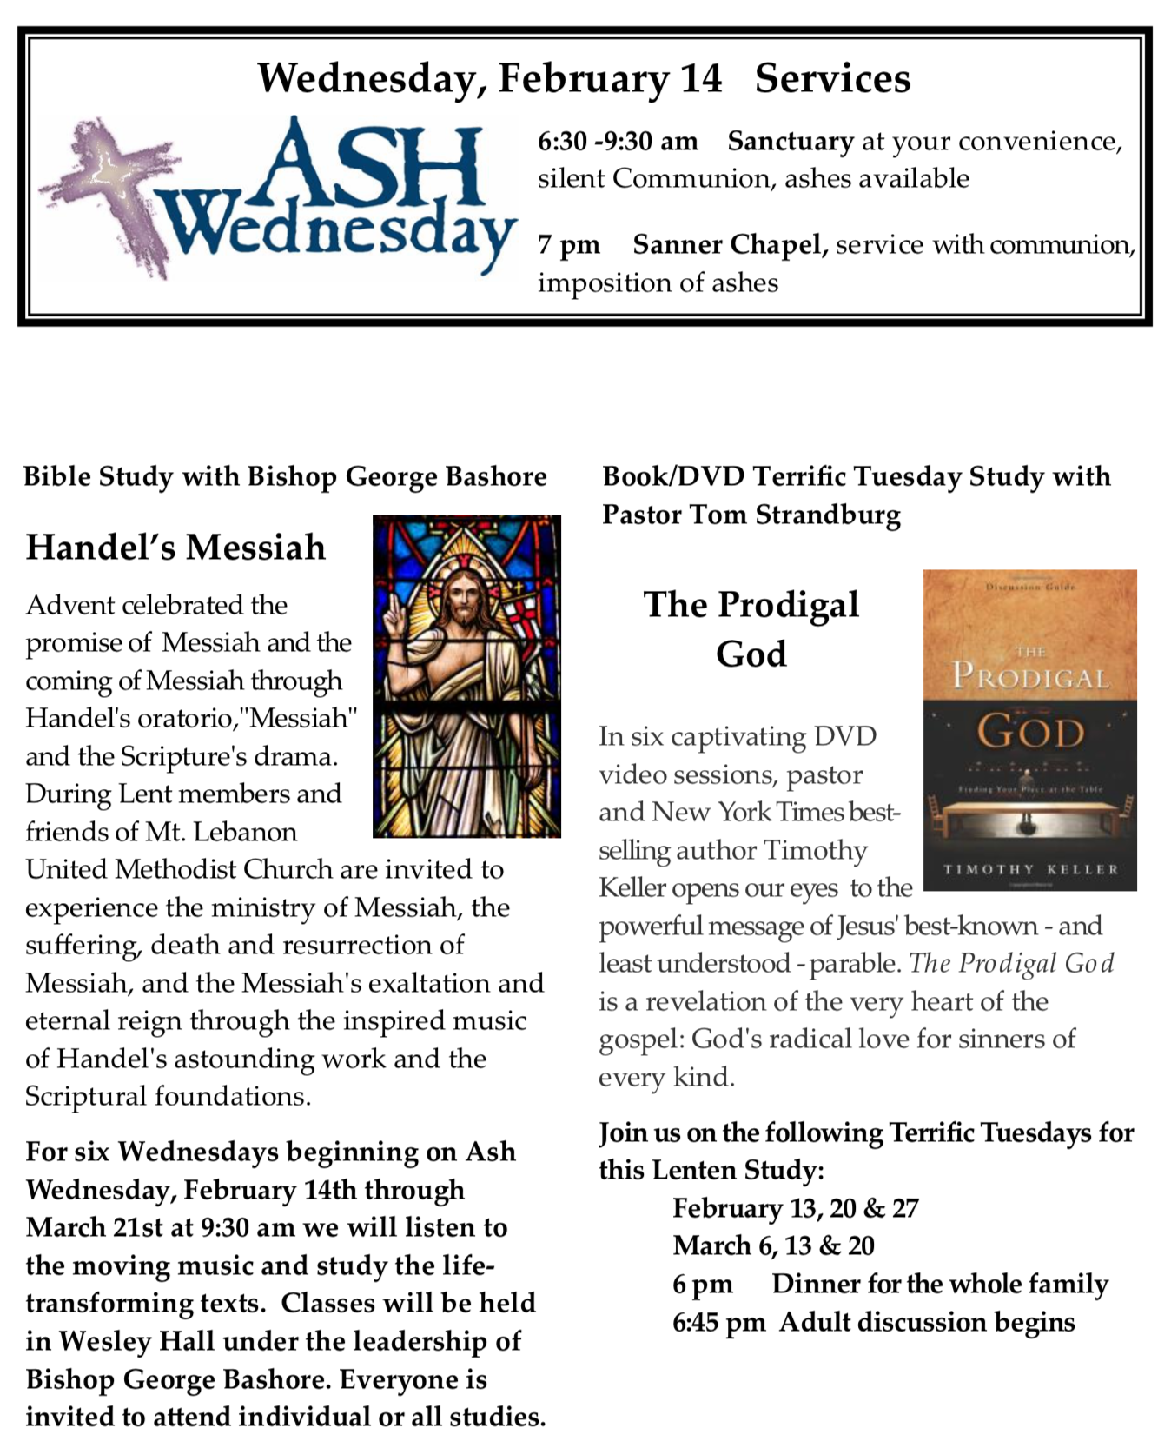
CALENDAR – SUNDAY, FEBRUARY 11 THRU SATURDAY, FEBRUARY 17

SUNDAY 2/11
8:30 am Worship Sanner Chapel
9:30 am Sunday School for All Ages/Coffee Café Various/Brookline Parlor
10:45 am Worship Sanctuary
Kids Praise Welcome Center
11:45 am Boy Scout Reception Asbury Center
11:45 am Youth Choir Rehearsal Choir Room
4 pm Talent Show Asbury Center

MONDAY 2/12
7 pm Chapel Bells Rehearsal Bell Room

TUESDAY 2/13
6 pm Terrific Tuesday Asbury Center
7 pm Boy Scout Troop #23 Wesley Hall
7 pm Boy Scout Board of Reviews Room 105
7 pm Cub Scout Planning Epworth Chapel

WEDNESDAY 2/14 ASH WEDNESDAY
6:30 am Silent Communion Sanctuary
9:30 am Bishop Bashore’s Lenten Study, “Messiah” Wesley Hall
7 pm Bear, Tiger and Wolf Cub Scouts Various
7 pm Ash Wednesday Communion Service Sanner Chapel

THURSDAY 2/15
6:30 pm Promise Bells Rehearsal Bell Room
7:30 pm Chancel Choir Rehearsal Choir Room

FRIDAY 2/16
9:30 am Women’s Bible Study Room 102

SATURDAY 2/17
10 am Food Distribution and Free Market Food Pantry

