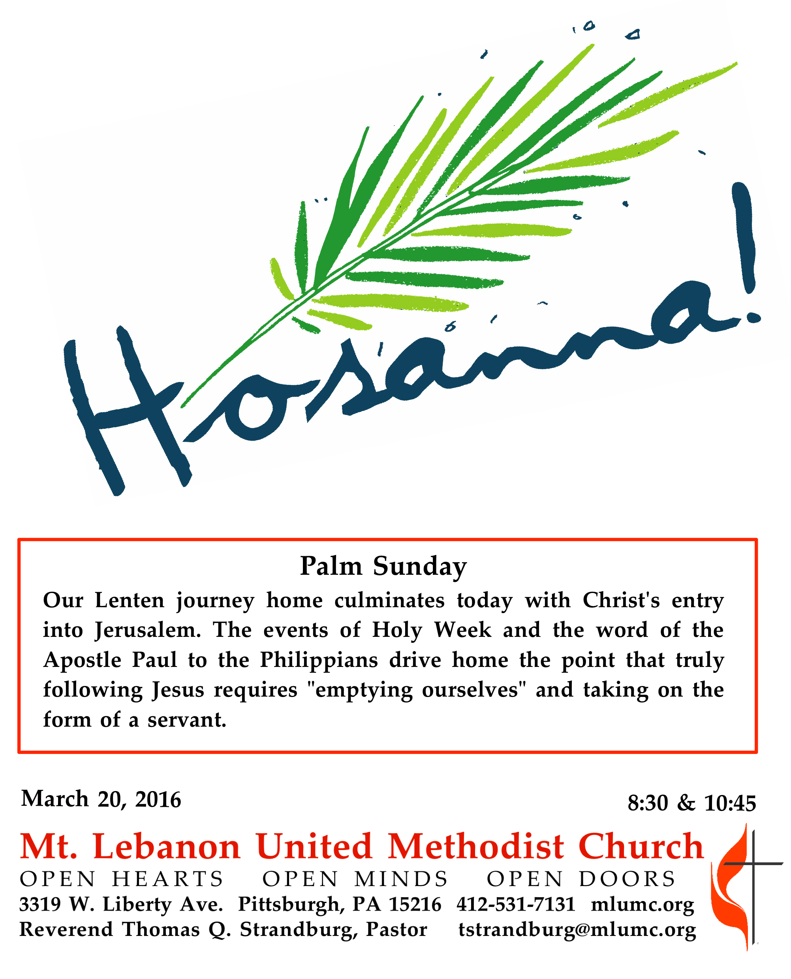
Palm Sunday

The crowds acclaimed Jesus as king upon his entry into Jerusalem, but his kingship defied their expectations. True success belongs to those who have truly accepted the self-giving love of Christ as the model for Christian behavior. It belongs to those who do nothing from selfish ambition or conceit, but in humility regard others as better than themselves.
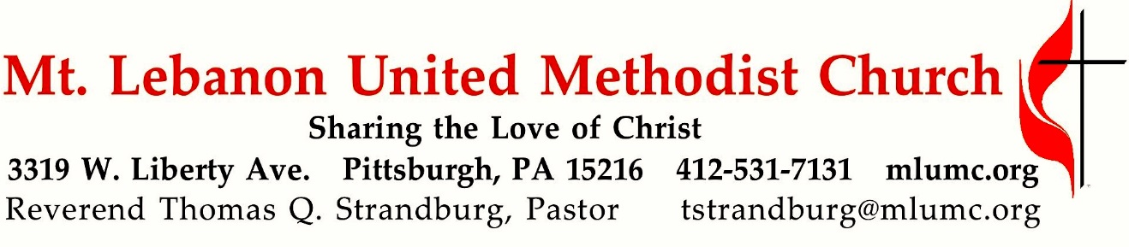
March 25, 2018 8:30 & 10:45

WE GATHER IN GOD’S NAME …
Gathering Music
Hymnal 277 Tell me the stories of Jesus (seated) Stories of Jesus
Gospel Acclamation Alleluia (sing 6 times after the choir sings) James Chepponis
Gospel Acclamation (the choir sings first) David Hurd
Praise and honor to you, O Lord Jesus Christ

Introit 10:45 Craig Courtney
Hosanna to the King of kings; hosanna to the Lord of lords;
Hosanna to the great I AM who reigns forevermore.

Call to Worship
Pastor: Give thanks to God,
People: whose steadfast love endures forever.
Pastor: Give praise to the one who comes in God’s name.
People: We wave our palms in praise and celebration.
Pastor: This is the day that our God has made.
People: Let us rejoice and be glad. Hosanna!
inspired by Mark 11 & Psalm 118

… TO GIVE PRAISE TO GOD …

Processional Anthem Hymnal 280 St. Theodulph
All glory, laud, and honor (omit stanza 2, standing)

Words of Welcome and Announcements

Opening Prayer (in unison)
God of steadfast love, we celebrate the coming of your Messiah with glad songs and hosannas. We wave our palms and cheer. May we wholeheartedly celebrate the life, the forboding, and the love and grace that this day symbolizes, even while clouds gather on the horizon. As we hear a familiar story told once more, open our hearts to receive these words anew, that they may shape our lives and faith. Amen.

Silent Prayer

Hymnal 408 The Gift of Love (stanza 3) Gift of Love
Come, Spirit, come, our hearts control, our spirits long to be made whole.
Let inward love guide every deed; by this we worship, and are freed.
Anthem 10:45 Ride on now, O King! Helen Kemp
Christ Jesus entered Jerusalem; not proudly but humbly rode He.
Upon a brown donkey, a lowly beast, Christ rode in humility.
Refrain: Hosanna we sing to Christ our King! Hosanna we sing to our Lord!
Ride on now, O King, without scepter or crown, ride into the hearts of mankind!
Rule Thou our lives with love and peace, ride on now, O King divine!
Refrain

… TO CELEBRATE THE FAMILY OF FAITH …

The Sign of Peace Please pass the peace to your neighbors as a sign of reconciliation and love.
Leader: The peace of Christ be with you.
People: And also with you.

Gathering Song James Ritchie
This, this is where children belong,
welcomed as part of the worshiping throng.
Water, God’s Word, bread and cup, prayer and song:
This is where children belong.
WORDS: James Ritchie MUSIC: James Ritchie ©1999 Abingdon Press

Message for Young Disciples Rev. Thomas Q. Strandburg
All children are invited. Please sing as children come forward. After the children’s message at the 10:45 service, children ages 3 - 3rd grade may attend Kids Praise in the Welcome Center. Children will be escorted to and from Kids Praise by teachers. They will return to the Sanctuary near the end of the service.

Anthem 10:45 Ride on, Jesus, ride! Afro-American Spiritual, arr. Barbara J. Martin
Refrain: Ride on, Jesus, ride. Ride on, Jesus, conquering King. Ride on, Jesus, ride.
King Jesus rides on a milk white horse. The river Jordan he did cross.
Refrain
My Jesus lifted his throne above. See his mercy and his love.
Refrain.

… TO HEAR GOD’S WORD PROCLAIMED …

Scripture Reading 8:30 Joeta D’este
10:45 Sally Munro
A Lesson from the New Testament
Philippians 2:5-11 The Mind of Christ

Pastoral Prayer
The Lord’s Prayer
Our Father, who art in heaven, hallowed be thy name. Thy kingdom come, thy will be done,
on earth as it is in heaven. Give us this day our daily bread. And forgive us our trespasses, as we forgive those who trespass against us. And lead us not into temptation, but deliver us from evil. For thine is the kingdom, and the power, and the glory forever. Amen.

Gospel Acclamation (the choir sings first) David Hurd
Praise and honor to you, O Lord Jesus Christ

Scripture Reading
A Lesson from the Gospels
Mark 11:1-11 Jesus enters Jerusalem

Response
Leader: The Word of the Lord.
People: Thanks be to God.

…TO OFFER OUR GIFTS AND TO DEDICATE OUR LIVES…

Offertory Anthem 8:30 The Palms Gabriel Fauré

Offertory Anthem 10:45 Hosanna to the King of Israel Richard A. Williamson
Hosanna to the Son of David, the King of Israel!
Blessed is He who comes in the name of the Lord.

Doxology 587 Tune: Tallis’ Canon, Hymnal 682
Bless thou the gifts our hands have brought;
bless thou the work our hearts have planned.
Ours is the faith, the will, the thought;
the rest, O God, is in thy hand.

Prayer of Dedication

Sermon “The Mind of Christ” Rev. Thomas Q. Strandburg

The Apostles’ Creed
I believe in God, the Father Almighty,
creator of heaven and earth.

I believe in Jesus Christ, his only Son, our Lord,
who was conceived by the Holy Spirit,
born of the Virgin Mary,
suffered under Pontius Pilate,
was crucified, died, and was buried;
he descended to the dead.
On the third day he rose again;
he ascended into heaven,
is seated at the right hand of the Father,
and will come again to judge the living and the dead.

I believe in the Holy Spirit,
the holy catholic church,
the communion of saints,
the forgiveness of sins,
the resurrection of the body,
and the life everlasting. Amen.
The Apostles’ Creed (ecumenical version)

… TO GO REJOICING IN GOD’S NAME!

Hymnal 278 Hosanna, loud hosanna (standing) Ellacombe

Benediction

Today’s Services
The flowers in the chancel are given in loving memory of Bill and June Lowe by Betsy Rayner and Laurie Lowe.

The flowers on the altar are given in loving memory of William B. Lockhart by his daughter, Laurel.

Special music at 8:30 is provided by John Esaias , a very active leader of this church and a member of the Chancel Choir.

Special music at 10:45 is provided by the Children’s Choir, directed by Courtney Heath and Kim Rhoton; the Youth Choir; and the Chancel Choir with Cori DeLuca, an area piano teacher.

Greeters 8:30 Kathryn Karns 10:45 Bill and Lavisa Ward

Acolytes Max Siegert and Tre Nagle Cross Bearer Mic Siegert

Worship options for children We encourage children to participate in the Children’s Sermon at both services, and in Kids Praise during the 10:45 service. Nursery services are offered in Room 204 of the Education Building. Ask ushers or greeters and follow signs for direction.

Today’s Scriptures
Philippians 2:5-11
⁵Let the same mind be in you that was in Christ Jesus, ⁶who, though he was in the form of God, did not regard equality with God as something to be exploited, ⁷but emptied himself, taking the form of a slave, being born in human likeness. And being found in human form, ⁸he humbled himself and became obedient to the point of death— even death on a cross.⁹Therefore God also highly exalted him and gave him the name that is above every name, ¹⁰so that at the name of Jesus every knee should bend, in heaven and on earth and under the earth, ¹¹and every tongue should confess that Jesus Christ is Lord, to the glory of God the Father.

Mark 11:1-11
When they were approaching Jerusalem, at Bethphage and Bethany, near the Mount of Olives, he sent two of his disciples ²and said to them, “Go into the village ahead of you, and immediately as you enter it, you will find tied there a colt that has never been ridden; untie it and bring it. ³If anyone says to you, ‘Why are you doing this?’ just say this, ‘The Lord needs it and will send it back here immediately.’” ⁴They went away and found a colt tied near a door, outside in the street. As they were untying it, ⁵some of the bystanders said to them, “What are you doing, untying the colt?” ⁶They told them what Jesus had said; and they allowed them to take it. ⁷Then they brought the colt to Jesus and threw their cloaks on it; and he sat on it. ⁸Many people spread their cloaks on the road, and others spread leafy branches that they had cut in the fields.⁹Then those who went ahead and those who followed were shouting,

“Hosanna!
Blessed is the one who comes in the name of the Lord!
¹⁰Blessed is the coming kingdom of our ancestor David!
Hosanna in the highest heaven!”

¹¹Then he entered Jerusalem and went into the temple; and when he had looked around at everything, as it was already late, he went out to Bethany with the twelve.
Honor or remember a loved one with a flower donation. The flowers that grace the sanctuary each week are generously donated by our church family members. This is a great way to honor or memorialize a special person, event, or milestone in your personal life or in the life of the church. If you are interested in donating flowers on a particular Sunday, contact Lizzie Diller , 412-860-3614. The cost is $30 for the altar, narthex, or columbarium, and $60 for the chancel.

Podcasts of Sunday Sermons Catch up on messages from MLUMC with a podcast of Pastor Tom’s and others’ Sunday sermons. Sermons can be found at http:// mlumc.buzzsprout.com or navigate to the site from the link on our webpage, www.mlumc.org. Sermons also will be posted to iTunes. Full recordings of the service are available upon request.

Keep in Prayer

Convalescing in Care Facilities
Leila Berkey, Asbury Heights
Ed Clarke, Asbury Place
John Katshir, Asbury Heights
Dorothy King, Asbury Heights
Pat Seitz, Concordia
Fred Siersdorfer, Friendship Village
Doris Trimble, Providence Point
Carol Van Sickle, Marian Manor

Convalescing at Home
Jean Boyer, Mary Caldwell,
Carolyn Dagg, David Lewis,
Susan Lichtenfels, Jinny Sheppard,
Betty Trout

In the Military

Jason Boyer, SPC Natalie Brown
Maj. Zachary Allen Finch, USMC
James Iantelli, 1st Lt. Jaskiewicz
S. Sgt. Keith Kimmell, Adam Kmick

PFC Brendan Lamport

Sgt. Matthew McConahan, Thomas Orda
David Poncel, Sgt. Steven Reitz
Capt. Scott B. Rushe, Pastor Rick Townes
Maj. Azizi Wesmiller

Maj. Matthew C. Wesmiller
Sgt. Keith Scott Winkowski

Sgt. Michael Zimm

Sympathy

It is with a deep sense of personal loss that we announce the death of our dear friend and colleague in ministry, Rev. Earl Killian. Earl was a faithful servant of Christ, first as partner in ministry with his beloved wife Debbie, then as father to his dear daughter Grace, and finally as pastor and spiritual adviser to United Methodists throughout

W. Pennsylvania. In recent years, he provided invaluable assistance as a volunteer pastoral presence here at MLUMC, leading Sunday School classes and Bible studies, and serving as co-coordinator of our Confirmation program for youth. He will be sorely missed.

The funeral service was in our sanctuary this past Monday. Condolences may be sent to Debbie and Grace Killian at:

The Killian Family

961 Castle Shannon Blvd.

Pittsburgh, PA 15234

CALENDAR – SUNDAY, MARCH 25 THRU SATURDAY, MARCH 31

SUNDAY 3/25
8:30 am Worship Sanner Chapel
9:30 am Sunday School for All Ages/Coffee Café Various/Brookline Parlor
10:45 am Worship Sanctuary
Kids Praise Welcome Center
12 pm Network’s French Toast Brunch Asbury Center
5 pm Youth Group Youth Room

MONDAY 3/26
7 pm Chapel Bells Rehearsal Bell Room

TUESDAY 3/27
6:30 pm Choir Rehearsal Choir Room
7 pm Boy Scout Troop #23 Wesley Hall
7 pm Boy Scout Board of Reviews Room 105

WEDNESDAY 3/28
7 pm Bear, Tiger and Wolf Den Meeting Various

THURSDAY 3/29 MAUNDAY THURSDAY
7:30 pm Tenebrae Service Sanctuary

FRIDAY 3/30 GOOD FRIDAY, OFFICE CLOSES AT NOON
9:30 am Women’s Bible Study Room 102
12 pm Community Worship Sanctuary
4 pm Fish Fry Asbury Center

