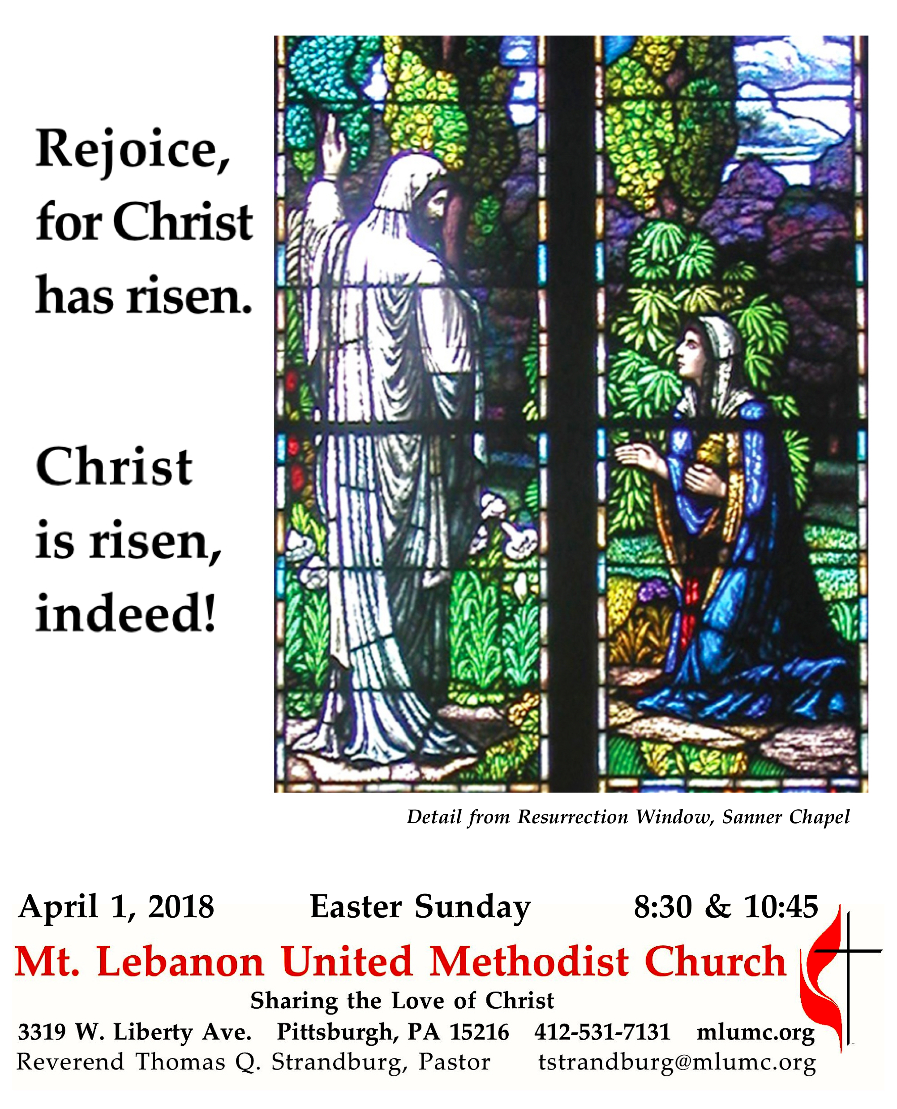
The Resurrection of the Lord

This year, the Season of Lent began with Ash Wednesday on Valentine’s Day. It ended in the early hours of this Easter morning – a day which is also known to many as “April Fool’s Day.” We can almost hear the voice of the angel say, at the entrance to the empty tomb – You’ve come here to find the body of one who was dead. April fool! He is alive!

WE GATHER IN GOD’S NAME …

Prelude 8:30 Come, thou fount of every blessing arranged by Dale Wood
10:45 Brass Quintet

Greeting
Pastor: Christ is risen!
People: Christ is risen indeed! Alleluia!
Traditional Easter Acclamation

Announcements

Introit (standing) Brian Balmages
This is the day the Lord has made. Let us rejoice and be glad in it.
Let us rejoice! Sing alleluia!

Call to Worship (remain standing)
Pastor: For this perishable body must put on imperishability, and this mortal body must put on immortality.
People: When this perishable body puts on imperishability, and this mortal body puts on immortality, then the saying that is written will be fulfilled: “Death has been swallowed up in victory.”
Pastor: Where, O death, is your victory?
People: Where, O death, is your sting?
1 Corinthians 15:53-55

… TO GIVE PRAISE TO GOD …

Hymnal 302 Christ the Lord is risen today (stanzas 1-4) Easter Hymn

Opening Prayer (in unison)
O God of time and space, maker of dancing quarks and ancient quasars, of energy and element, blessed are you, Creator God. Your saving love endures forever; your holy light pierces the cold darkness of death and chaos; you make a covenant of life with your creatures, which no evil can overcome. May the glorious radiance of resurrection dispel the shadows in our lives and conform us more closely to your risen Christ, to whom, with you and the Holy Spirit, be all honor, praise, and glory. Amen.
Worship & Song

Silent Prayer

Hymnal 408 The Gift of Love (stanza 3) Gift of Love
Come, Spirit, come, our hearts control, our spirits long to be made whole.
Let inward love guide every deed; by this we worship, and are freed.

… TO CELEBRATE THE FAMILY OF FAITH …

The Sign of Peace Please pass the peace to your neighbors as a sign of reconciliation and love.
Leader: The peace of Christ be with you.
People: And also with you.

Gathering Song
This, this is where children belong,
welcomed as part of the worshiping throng.
Water, God’s Word, bread and cup, prayer and song:
This is where children belong WORDS AND MUSIC: James Ritchie ©1999 Abingdon Press
Message for Young Disciples Rev. Thomas Q. Strandburg
All children are invited. Please sing as children come forward.

Hymnal 308 Thine be the glory (standing) Judas Maccabeus

… TO HEAR GOD’S WORD PROCLAIMED …

Scripture Reading
A Lesson from the New Testament
1 Corinthians 15:1-11 The Resurrection of Christ

Pastoral Prayer

The Lord’s Prayer
Our Father, who art in heaven, hallowed be thy name. Thy kingdom come, thy will be done, on earth as it is in heaven. Give us this day our daily bread. And forgive us our trespasses, as we forgive those who trespass against us. And lead us not into temptation, but deliver us from evil. For thine is the kingdom, and the power, and the glory forever. Amen.

Gospel Acclamation Alleluia (sing 6 times after the choir sings, standing) James Chepponis

Scripture Reading
A Lesson from the Gospels
John 20:1-18 The account of the resurrection

Response
Leader: The Word of the Lord.
People: Thanks be to God.

Response Messiah: "Hallelujah" Chorus G. F. Handel

… TO OFFER OUR GIFTS AND TO DEDICATE OUR LIVES …

Offertory Anthem Christ the Lord is risen today! Nancy Hill Cobb
Alleluia! Christ is risen! Christ the Lord is risen today, all creation join to say: alleluia!
Raise your joys and triumphs high; sing, O heavens, and earth reply: alleluia!
Love’s redeeming work is done, fought the fight, the battle won,
death in vain forbids him rise, Christ has opened paradise, alleluia!
Where, O death, is now your sting? Jesus died our souls to save.
Where your victory, O grave? Lives again our glorious King, alleluia!
Hail, the Lord of earth and heaven! Praise to You by both be given: alleluia!
Every knee to You shall bow, Risen Christ, triumphant now, alleluia!
Death, in vain, forbids Him rise. Christ is risen, alleluia!

Hymnal 94 Doxology (standing) Lasst uns erfreuen
Praise God from whom all blessings flow;
Praise God, all creatures here below: Alleluia! Alleluia!
Praise God the source of all our gifts!
Praise Jesus Christ, whose power uplifts!
Praise the Spirit, Holy Spirit. Alleluia! Alleluia! Alleluia!

Prayer of Dedication

Sermon “The Day the Revolution Began” Rev. Thomas Q. Strandburg
The Apostles’ Creed
Pastor: Let us join together in professing the Christian faith as contained in the Scriptures of the Old and New Testaments.
Do you believe in God the Father?
People: I believe in God, the Father Almighty, creator of heaven and earth.
Pastor: Do you believe in Jesus Christ?
People: I believe in Jesus Christ, his only Son, our Lord, who was conceived by the Holy Spirit, born of the Virgin Mary, suffered under Pontius Pilate, was crucified, died, and was buried;
he descended to the dead. On the third day he rose again; he ascended into heaven, is seated at the right hand of the Father, and will come again to judge the living and the dead.
Pastor: Do you believe in the Holy Spirit?
People: I believe in the Holy Spirit, the holy catholic church, the communion of saints, the forgiveness of sins, the resurrection of the body, and the life everlasting.

… TO GO REJOICING IN GOD’S NAME!

Hymn Alleluia! Sing to Jesus (standing) Hyfrydol, arr. by R. A. Hobby

- Alleluia! Sing to Jesus!
His the scepter, his the throne,
Alleluia! His the triumph,
His the victory alone.
Hark! The songs of peaceful Zion
Thunder like a mighty flood:
“Jesus out of ever’ry nation
Has redeemed us by his blood.”

- Alleluia! Not as orphans
Are we left in sorrow now;
Alleluia! He is near us;
Faith believes, nor questions how.
Though the cloud from sight received Him,
When the forty days were o’er,
Shall our hearts forget His promise—
“I am with you evermore?”

(choir only)
- Alleluia! Bread of angels,
Here on earth our food, our stay!
Alleluia! Here the sinful
Flee to you from day to day.
Intercessor, friend of sinners,
Earth’s redeemer, plea for me,
Where the songs of all the sinless
Sweep across the crystal sea.

- Alleluia! King eternal,
You the Lord of lords we own;
Alleluia! Born of Mary,
Earth your footstool, heav’n your throne.
You within the veil have entered,
Robed in flesh, our great high priest;
Here on earth both priest and victim
In the eucharistic feast.

Benediction

Postlude 10:45 Grand Choeur Dialogue Eugène Gigout

Today’s Services
Special music for the 8:30 service is provided by the Chancel Choir.

Special music for the 10:45 service is provided by the Chancel Choir with guest instrumentalists: Josh Boudreau and Stephen McGough, trumpet; Bryan Adkins, horn; Gonzalo Fernandez, trombone; Robert Tupper, bass trombone; and Will Buerger, timpani; with Richard Minnotte, conductor. The addition of the instrumentalists is made possible through contributions to the Friends of Music Fund. New contributors are most welcome - make a check to the church and note "Friends of Music Fund."

Greeters 8:30 Rob and Jane Spicher 10:45 Gloria Barber

Acolytes 8:30 Anna Rhoton 10:45 Anastasia Sunder and Abigail Nagle

Cross Bearer 8:30 Rob Spicher 10:45 Max Siegert

Today’s Scriptures
1 Corinthians 15:1-11
Now I would remind you, brothers and sisters, of the good news that I proclaimed to you, which you in turn received, in which also you stand, ²through which also you are being saved, if you hold firmly to the message that I proclaimed to you—unless you have come to believe in vain. ³For I handed on to you as of first importance what I in turn had received: that Christ died for our sins in accordance with the scriptures,⁴and that he was buried, and that he was raised on the third day in accordance with the scriptures, ⁵and that he appeared to Cephas, then to the twelve. ⁶Then he appeared to more than five hundred brothers and sisters at one time, most of whom are still alive, though some have died.⁷Then he appeared to James, then to all the apostles. ⁸Last of all, as to one untimely born, he appeared also to me. ⁹For I am the least of the apostles, unfit to be called an apostle, because I persecuted the church of God. ¹⁰But by the grace of God I am what I am, and his grace toward me has not been in vain. On the contrary, I worked harder than any of them—though it was not I, but the grace of God that is with me. ¹¹Whether then it was I or they, so we proclaim and so you have come to believe.

John 20:1-18
Early on the first day of the week, while it was still dark, Mary Magdalene came to the tomb and saw that the stone had been removed from the tomb. ²So she ran and went to Simon Peter and the other disciple, the one whom Jesus loved, and said to them, “They have taken the Lord out of the tomb, and we do not know where they have laid him.” ³Then Peter and the other disciple set out and went toward the tomb. ⁴The two were running together, but the other disciple outran Peter and reached the tomb first. ⁵He bent down to look in and saw the linen wrappings lying there, but he did not go in. ⁶Then Simon Peter came, following him, and went into the tomb. He saw the linen wrappings lying there, ⁷and the cloth that had been on Jesus’ head, not lying with the linen wrappings but rolled up in a place by itself. ⁸Then the other disciple, who reached the tomb first, also went in, and he saw and believed; ⁹for as yet they did not understand the scripture, that he must rise from the dead. ¹⁰Then the disciples returned to their homes.

¹¹But Mary stood weeping outside the tomb. As she wept, she bent over to look into the tomb;
¹²and she saw two angels in white, sitting where the body of Jesus had been lying, one at the head and the other at the feet. ¹³They said to her, “Woman, why are you weeping?” She said to them, “They have taken away my Lord, and I do not know where they have laid him.” ¹⁴When she had said this, she turned around and saw Jesus standing there, but she did not know that it was Jesus.
¹⁵Jesus said to her, “Woman, why are you weeping? Whom are you looking for?” Supposing him to be the gardener, she said to him, “Sir, if you have carried him away, tell me where you have laid him, and I will take him away.” ¹⁶Jesus said to her, “Mary!” She turned and said to him in Hebrew, “Rabbouni!” (which means Teacher). ¹⁷Jesus said to her, “Do not hold on to me, because I have not yet ascended to the Father. But go to my brothers and say to them, ‘I am ascending to my Father and your Father, to my God and your God.’” ¹⁸Mary Magdalene went and announced to the disciples, “I have seen the Lord”; and she told them that he had said these things to her.

Keep in Prayer
Hospitalized
Maxine Furedy, St. Clair

Convalescing in Care Facilities
Leila Berkey, Asbury Heights
Ed Clarke, Asbury Place
Ted Hardy, Providence Point
John Katshir, Asbury Heights
Dorothy King, Asbury Heights
Pat Seitz, Concordia
Fred Siersdorfer, Friendship Village
Doris Trimble, Providence Point
Carol Van Sickle, Marian Manor
Dan Van Sickle, Marian Manor

Convalescing at Home
Jean Boyer, Mary Caldwell, Carolyn Dagg, David Lewis, Susan Lichtenfels,
Jinny Sheppard, Betty Trout
In the Military

Jason Boyer, SPC Natalie Brown
Maj. Zachary Allen Finch, USMC
James Iantelli, 1st Lt. Jaskiewicz
S. Sgt. Keith Kimmell, Adam Kmick

PFC Brendan Lamport

Sgt. Matthew McConahan, Thomas Orda
David Poncel, Sgt. Steven Reitz
Capt. Scott B. Rushe, Pastor Rick Townes
Maj. Azizi Wesmiller

Maj. Matthew C. Wesmiller
Sgt. Keith Scott Winkowski

Sgt. Michael Zimm

Honor or remember a loved one with a flower donation. The flowers that grace the sanctuary each week are generously donated by our church family members. This is a great way to honor or memorialize a special person, event, or milestone in your personal life or in the life of the church. If you are interested in donating flowers on a particular Sunday, contact Lizzie Diller , 412-860-3614. The cost is $30 for the altar, narthex, or columbarium, and $60 for the chancel.

Podcasts of Sunday Sermons Catch up on messages from MLUMC with a podcast of Pastor Tom’s and others’ Sunday sermons. Sermons can be found at http:// mlumc.buzzsprout.com or navigate to the site from the link on our webpage, www.mlumc.org. Sermons also will be posted to iTunes. Full recordings of the service are available upon request.

CALENDAR – SUNDAY, APRIL 1 THROUGH SATUDAY, APRIL 7

SUNDAY 4/1 EASTER SUNDAY
8:30 am Worship Sanctuary
10:45 am Worship Sanctuary

MONDAY 4/2 EASTER MONDAY – OFFICE CLOSED
7 pm Chapel Bells Rehearsal Bell Room

TUESDAY 4/3
7 pm Boy Scout Troop #23 Wesley Hall

WEDNESDAY 4/4
7:30 am Northside Lunch Program Prep Kitchen
6 pm Homebuilders’ Potluck Wesley Hall

THURSDAY 4/5
8:30 am Northside Lunch Program Prep Kitchen
9 am Hands and Hearts Epworth Chapel
12 pm TNT Asbury Heights
6:30 pm Promise Bells Rehearsal Bell Room
7:30 pm Chancel Choir Rehearsal Choir Room

FRIDAY 4/6
9:30 am Women’s Bible Study Room 102

SATURDAY 4/7 Food Distribution and Food Lift Free Market Food Pantry

