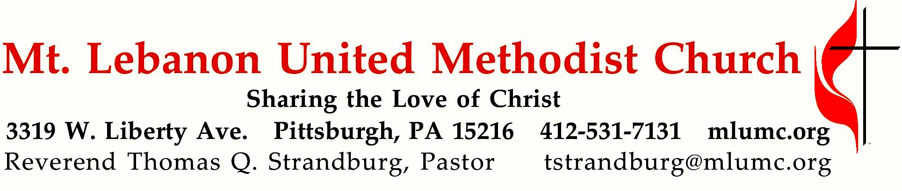

April 8, 2018 8:30 & 10:45
Second Sunday of Easter
Our gospel reading for today affords a look at the role doubt plays in the life of faith. Apathy, not doubt, is the opposite of faith. Doubt is an opportunity to dive deeper into our faith and to find our faith strengthened through the struggle.

WE GATHER IN GOD’S NAME …

Gathering Music
Hymnal 620 One bread, one body (John B. Foley)
Worship & Song 3119 Take, O take me as I am (John Bell)
Take, O take me as I am; summon out what I shall be;
Set your seal upon my heart and live in me.
Text © 1995, The Iona Community, GIA Publications, Inc., agent.
Used under OneLicense A-728761

Greeting
Leader: Christ is risen!
People: Christ is risen indeed! Alleluia!

Announcements

Introit 10:45 Karl Erickson
Alleluia! Our Savior Jesus Christ has abolished death 2 Timothy 1:10
and brought life and immortality through the Gospel. Alleluia!

Call to Worship
Pastor: Jesus said, "I am the resurrection and the life.
People: “Those who believe in me, even though they die, will live,
and everyone who lives and believes in me will never die."

… TO GIVE PRAISE TO GOD …

Hymnal 307 (standing) Christ is risen W Zlobie Lezy

Prayer of Confession (people’s responses sung to #581 in the blue hymnal) Beach Spring
Pastor: Gracious and loving God, hear our confession:
People: We are hasty to judge others, blind to proof of human need.
Pastor: Open our eyes, O God, and remove from us the desire to judge.
People: And our lack of understanding demonstrates our inner greed.
Pastor: Our selfishness endangers others and puts greater burdens on the poor.
People: We have wasted earth's resources; want and suffering we've ignored.
Pastor: Open our hearts, open our eyes.
People: Come and cleanse us, then restore us; make new hearts within us, Lord!

Assurance of Pardon (people’s response sung to the last phrase of #581)
Pastor: Our God's grace, as deep as oceans, now surpasses all our needs.
People: Christ our priest who shared our human pain:
Christ our true priest intercedes.

Silent Prayer

Worship & Song 3119 Take, O take me as I am
Take, O take me as I am; summon out what I shall be; John Bell
Set your seal upon my heart and live in me.
Text © 1995, The Iona Community, GIA Publications, Inc., agent.
Used under OneLicense A-728761

… TO CELEBRATE THE FAMILY OF FAITH …

The Sign of Peace Please pass the peace to your neighbors as a sign of reconciliation and love.
Leader: The peace of Christ be with you.
People: And also with you.

Gathering Song Where children belong
This, this is where children belong, James Ritchie
welcomed as part of the worshiping throng.
Water, God’s Word, bread and cup, prayer and song:
This is where children belong.
Text ©1999 Abingdon Press. Used under OneLicense A-728761

Message for Young Disciples Rev. Kimberly Greway
All children are invited. Please sing as children come forward. After the children’s message at the 10:45 service, children ages 3 - 3rd grade may attend Kids Praise in the Welcome Center. Children will be escorted to and from Kids Praise by teachers. They will return to the Sanctuary near the end of the service

… TO HEAR GOD’S WORD PROCLAIMED …

Scripture Reading 8:30 Liz DiPietro 10:45 Bob Mallery
A Lesson from the Hebrew Scriptures Psalm 133

Pastoral Prayer

The Lord’s Prayer
Our Father, who art in heaven, hallowed be thy name.
Thy kingdom come, thy will be done, on earth as it is in heaven.
Give us this day our daily bread.
And forgive us our trespasses,
as we forgive those who trespass against us.
And lead us not into temptation, but deliver us from evil.
For thine is the kingdom, and the power, and the glory forever. Amen.

Scripture Reading 8:30 Liz DiPietro 10:45 Bob Mallery
A Lesson from the New Testament Acts 4:32-35
Leader: The Word of the Lord.
People: Thanks be to God.

… TO OFFER OUR GIFTS AND TO DEDICATE OUR LIVES …

Offertory Duet 8:30 He Lives Ackley
I serve a risen Savior, he’s in the world today;
I know that he is living, whatever foes may say.
I see his hand of mercy, I hear his voice of cheer,
And just the time I need him, he’s always near.

He lives, he lives, Christ Jesus lives today!
He walks with me and talks with me along life’s narrow way.
He lives, he lives, salvation to impart!
You ask me how I know he lives? He lives within my heart.

Rejoice, rejoice, O Christian, lift up your voice and sing
eternal hallelujas to Jesus Christ the King!
The hope of all who seek him, the help of all who find;
None other is so loving, so good and kind.

He lives, he lives, Christ Jesus lives today!
He walks with me and talks with me along life’s narrow way.
He lives, he lives, salvation to impart!
You ask me how I know he lives? He lives within my heart.

Offertory Anthem 10:45 With All I Am Taylor Davis
Though I may master all things known, though I may forfeit all I own John Thornburg
And do not live, I search in vain to find the God who knows my name.

Love does not hide or run away, it does not threaten or delay.
Alive in hope, it braves our schemes, it bears our pain, believes our dreams.

With all I am, in all I do, I pledge my faith, I honor you.
I give you, Lord, my solemn vow; my life, my love, I offer now.
Text © 2004, Choristers Guild, used under OneLicense A-728761

Hymnal 94 (standing) Doxology Lasst uns erfreuen
Praise God from whom all blessings flow;
Praise God, all creatures here below: Alleluia! Alleluia!
Praise God the source of all our gifts!
Praise Jesus Christ, whose power uplifts!
Praise the Spirit, Holy Spirit. Alleluia! Alleluia! Alleluia!

Prayer of Dedication

Gospel Acclamation Alleluia James Chepponis
(sing “Alleluia” six times after the choir and again after the solo verse)

Scripture Reading Rev. Kimberly Greway
A Lesson from the Gospel John 20:19-31

Gospel Acclamation Alleluia (sing six times with the choir) James Chepponis

Sermon “My Lord and my God!” Rev. Kimberly Greway

The Sacrament of Holy Communion

The Great Thanksgiving Easter Hymn Communion Service
text by Rev. Kimberly Greway
Opening Dialogue Diademata

Pastor: And so,
with your people on earth,
and all the company of heaven,
we praise your name and join in their unending hymn:
Sanctus Christ Arose
Vere Sanctus Truro
Holy are you, and blessed is Christ: the one whom we call Jesus.
His suffering and death and strife and resurrection brought eternal life.

Through him, the Christ, you gave us birth: delivered us from slavery
and made with us a new covenant which founded for all time your holy church.
By your great mercy we are born a new creation in the Lord,
by water and the Holy Spirit, a life which seems like everlasting morn.

Anamnesis and Institution Ackley
It was a normal Thursday when they were gathered there.
His followers were with him, thus showing that they cared.
He took the bread and blessed it, then quietly he said,
“Take eat, this is my body: I die in your stead.

I die, I die, I die for you today;
I ask you now to walk with me along this narrow way.
I die, I die, salvation to impart!
I die for you and many now. I’ll live within your heart.”
And when the meal was over, he took the rough-hewn cup.
He grasped it in his hands as he said, lifting it up:
“Take, drink, this is my blood which is given you this day;
poured out for you and many so you can now say:

‘He dies, he dies, he dies for us this day.
A covenant that’s new he brings: forgives our sinful way.
He died, he died, salvation to impart! He died for us and many more.
He’ll live within our hearts.’”
Memorial Acclamation W Zloby Lezy
Epicleseis and Doxology Near the Cross
Pour your Spirit on these gifts that you have us given;
also grace us gathered here with your Spirit from heaven.
Make them be; make us be Christ’s own blood and body.
That we, Christ-redeemed, may him for the world embody.

By your Spirit make us one: one with one another;
one in mission to the world serving all together.
Make us see; make us be one in Christ’s own victory
till we can all feast with him always throughout history.

Through your blessed Son, the Christ, known as Jesus on earth;
with the Holy Spirit in your holy church.
Honor, power, glory, might yours forever will be;
now and ever without end, God, our Lord Almighty.

… TO GO REJOICING IN GOD’S NAME!
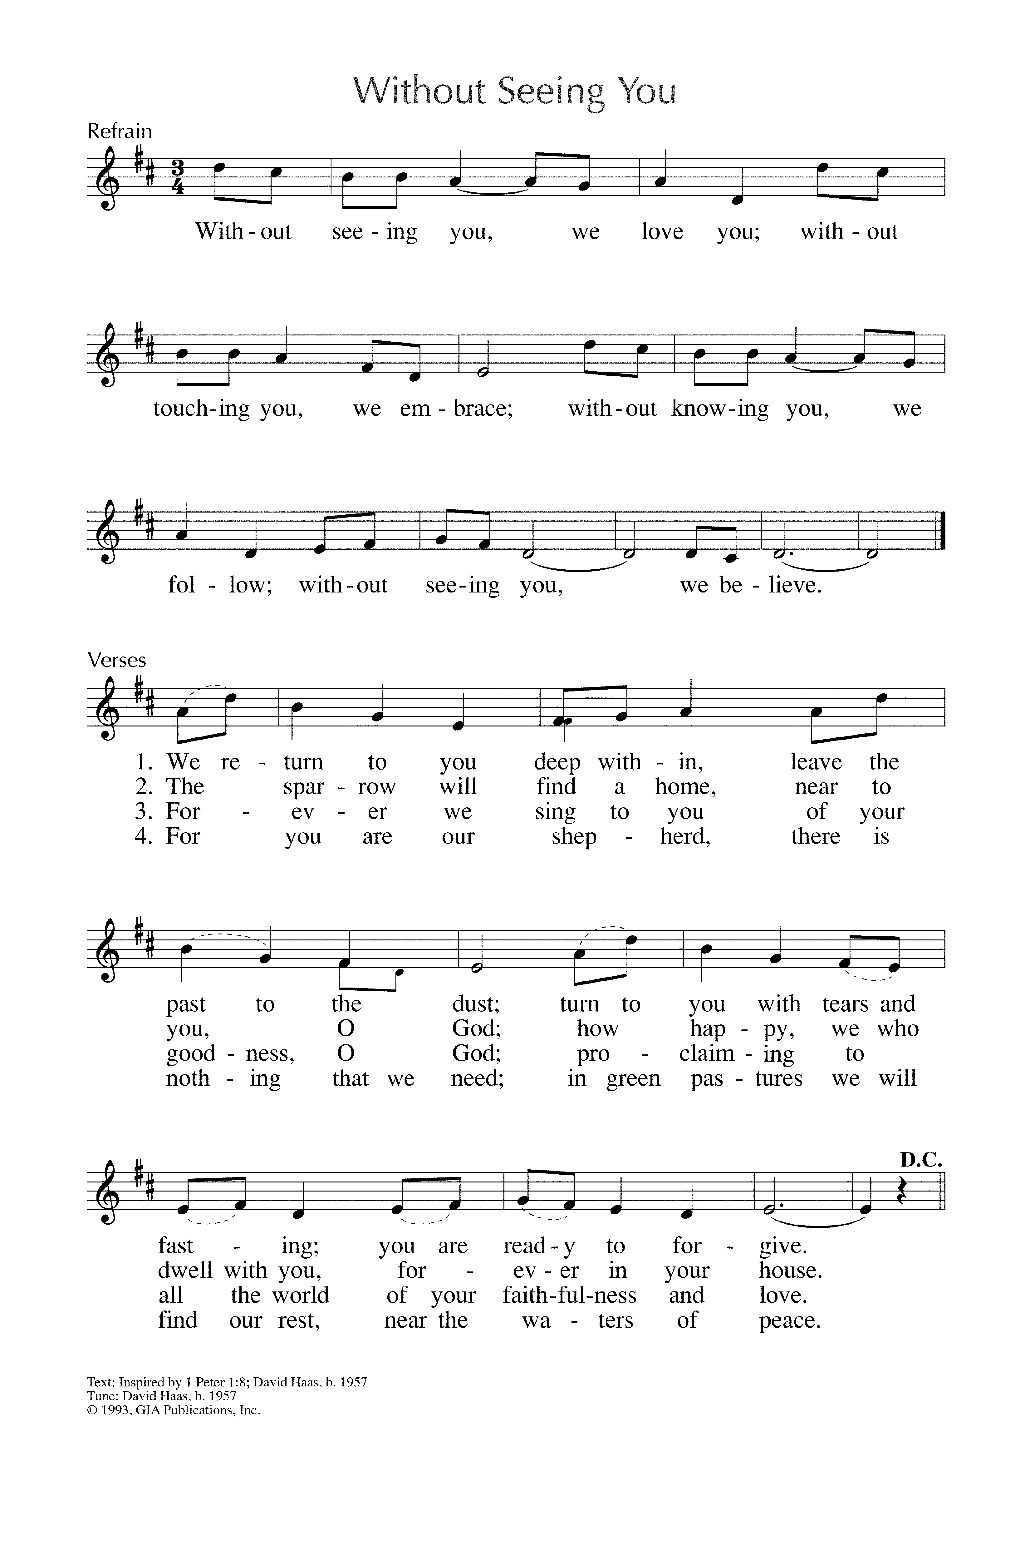Closing Hymn Without seeing you We Believe
David Haas
Text and tune © 1993, GIA Publications, Inc. Used under OneLicense A-728761

Benediction

Today’s Services
Participating in the Service Today: Rev. Kimberly Greway, formerly our Associate Pastor from 2006-2010, is the Director of Chaplaincy Services at the Allegheny County Jail and Chief Operating Officer of the Foundation of HOPE which serves inmates and ex-offenders in Allegheny County. She wrote the words to this Easter Hymn Communion service based on the much-loved Christmas Carol Communion service.

The flowers in the chancel are given by Chuck and Brenda Vogel in loving memory of their parents, Walter and Margaretta Vogel and Maynard and Mabel Turner.

The flowers on the altar are given by Roger and Gladys Arnold and family in loving memory of her parents, Mr. and Mrs. Cameron A. Wian.

Special music at 8:30 is provided by John Esaias and the Rev. Kimberly Greway.

Special music at 10:45 is provided by the Chancel Choir with accompanist Mary Paine, who teaches piano in the area.

Acolytes Cary Young and Jacob Lowe

Greeters 8:30 Judi Phelps 10:45 Carolyn and George Bashore

Worship options for children We encourage children to participate in the Children’s Sermon at both services, and in Kids Praise during the 10:45 service. Nursery services are offered in Room 204 of the Education Building. Ask ushers or greeters and follow signs for direction.

Honor or remember a loved one with a flower donation. The flowers that grace the sanctuary each week are generously donated by our church family members. This is a great way to honor or memorialize a special person, event, or milestone in your personal life or in the life of the church. If you are interested in donating flowers on a particular Sunday, contact Lizzie Diller , 412-860-3614. The cost is $30 for the altar, narthex, or columbarium, and $60 for the chancel.

Podcasts of Sunday Sermons Catch up on messages from MLUMC with a podcast of Pastor Tom’s and others’ Sunday sermons. Sermons can be found at http:// mlumc.buzzsprout.com or navigate to the site from the link on our webpage, www.mlumc.org. Sermons also will be posted to iTunes. Full recordings of the service are available upon request.

Today’s Scriptures

Psalm 133
¹How very good and pleasant it is when kindred live together in unity!
²It is like the precious oil on the head, running down upon the beard, on the beard of Aaron, running down over the collar of his robes.
³It is like the dew of Hermon, which falls on the mountains of Zion. For there the Lord ordained his blessing, life forevermore.

Acts 4:32-35
³²Now the whole group of those who believed were of one heart and soul, and no one claimed private ownership of any possessions, but everything they owned was held in common. ³³With great power the apostles gave their testimony to the resurrection of the Lord Jesus, and great grace was upon them all. ³⁴There was not a needy person among them, for as many as owned lands or houses sold them and brought the proceeds of what was sold. ³⁵They laid it at the apostles’ feet, and it was distributed to each as any had need.

John 20:19-31
¹⁹When it was evening on that day, the first day of the week, and the doors of the house where the disciples had met were locked for fear of the Jews, Jesus came and stood among them and said, “Peace be with you.” ²⁰After he said this, he showed them his hands and his side. Then the disciples rejoiced when they saw the Lord. ²¹Jesus said to them again, “Peace be with you. As the Father has sent me, so I send you.”²²When he had said this, he breathed on them and said to them, “Receive the Holy Spirit. ²³If you forgive the sins of any, they are forgiven them; if you retain the sins of any, they are retained.” ²⁴But Thomas (who was called the Twin), one of the twelve, was not with them when Jesus came.²⁵So the other disciples told him, “We have seen the Lord.” But he said to them, “Unless I see the mark of the nails in his hands, and put my finger in the mark of the nails and my hand in his side, I will not believe.”

²⁶A week later his disciples were again in the house, and Thomas was with them. Although the doors were shut, Jesus came and stood among them and said, “Peace be with you.” ²⁷Then he said to Thomas, “Put your finger here and see my hands. Reach out your hand and put it in my side. Do not doubt but believe.” ²⁸Thomas answered him, “My Lord and my God!” ²⁹Jesus said to him, “Have you believed because you have seen me? Blessed are those who have not seen and yet have come to believe.”³⁰Now Jesus did many other signs in the presence of his disciples, which are not written in this book. ³¹But these are written so that you may come to believe that Jesus is the Messiah, the Son of God, and that through believing you may have life in his name.

Keep in Prayer

Hospitalized
Maxine Furedy, St. Clair
Stephen Hahn, St. Clair

Convalescing in Care Facilities
Leila Berkey, Asbury Heights
Ed Clarke, Asbury Place
John Katshir, Asbury Heights
Pat Seitz, Concordia
Fred Siersdorfer, Friendship Village
Carol Van Sickle, Marian Manor

Convalescing at Home
Jean Boyer, Mary Caldwell,
Carolyn Dagg, David Lewis,
Susan Lichtenfels, Jinny Sheppard,
Betty Trout

In the Military

Jason Boyer, SPC Natalie Brown
Maj. Zachary Allen Finch, USMC
James Iantelli, 1st Lt. Jaskiewicz
S. Sgt. Keith Kimmell, Adam Kmick

PFC Brendan Lamport
Sgt. Matthew McConahan, Thomas Orda
David Poncel, Sgt. Steven Reitz
Capt. Scott B. Rushe, Pastor Rick Townes
Maj. Azizi Wesmiller

Maj. Matthew C. Wesmiller
Sgt. Keith Scott Winkowski

Sgt. Michael Zimmerman

Harry Daniel "Dan" VanSickle, age 81, of Upper St. Clair, formerly of Versailles, KY, Washington, PA and Bethel Park, PA, passed away peacefully on April 2, 2018. Dan was born October 27, 1936, in Friendsville, MD to Harry and Margaret VanSickle. He was the husband of Carol (Higinbotham) VanSickle, father of Lee Anne of Bethel Park and Lori (Dan) Barr of Upper St. Clair, grandfather of Daniel Barr of Upper St. Clair and Christopher (Chelsea) Barr of Bridgeville, great-grandfather of Kailee Barr, Declan Corba and Liam Barr, twin brother of Cloyde VanSickle of Hopwood, PA, brother of Irvin VanSickle of Northlake, IL and the late Marshall VanSickle and Barbara Benedek. Visitation Thursday 2-4 & 6-8 p.m. at the David J. Henney Funeral Home, 6364 Library Road (RT 88), Library, where a funeral service was held Friday at 10:00 a.m. In lieu of flowers, donations may be made to the Alzheimer's Association at alz.org or PA Dept. of Military Affairs at donate.dmva.pa.gov.

Laura Lee “Lee” Cramer, aged 85-years old, passed away peacefully on Good Friday, March 30, 2018, in her home in DeBordieu Colony, Georgetown, South Carolina, surrounded by her family and adoring husband of 62 years. Born on July 28, 1932 in Columbus, Ohio, Lee was the daughter of Jennie Lynn and E.S. Wheeler. Lee leaves behind her beloved husband Wilson B. Cramer, married on September 22, 1956, four adult children (Peter W. Cramer, Stephen T. Cramer, Lynnea Cramer-Mallalieu, and Julie L. Cramer), six grandchildren, and one great-granddaughter.
CALENDAR – SUNDAY, APRIL 8 THRU SATURDAY, APRIL 14

SUNDAY 4/8
8:30 am Worship Sanner Chapel
9:30 am Sunday School for All Ages/Coffee Café Various/Brookline Parlor
10:45 am Worship Sanctuary
Kids Praise Welcome Center
5 pm Youth Group Asbury Center

MONDAY 4/9
7 pm Chapel Bells Rehearsal Bell Room
7 pm Church Council Wesley Hall

TUESDAY 4/10
7 pm Boy Scout Troop #23 Wesley Hall
7 pm Boy Scout Board of Reviews Room 105
7 pm Cub Scout Planning Epworth Chapel

WEDNESDAY 4/11
7 pm Bear, Tiger and Wolf Cub Scouts Various

THURSDAY 4/12
9:30 am UMW Board Meeting Room 105
11 am UMW Meeting Asbury Center
6:30 pm Promise Bells Rehearsal Bell Room
7:30 pm Chancel Choir Rehearsal Choir Room

FRIDAY 4/13
1:30 pm Memoirs Group Wesley Hall
7 pm Cub Scouts Arrow of Light Epworth Chapel

SATURDAY 4/14
8 am It’s A Guy Thing Men’s Group Wesley Hall

