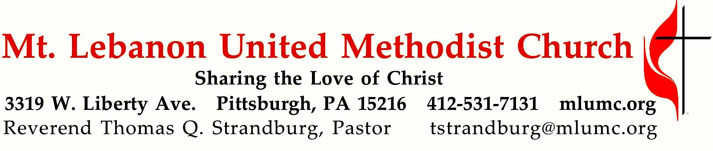
May 27, 2017 8:30 & 10:45
Trinity Sunday

Today we celebrate the notion of God as Trinity – three in one, and one in three. This three in one, one in three God invests in human beings so that they, too, might be one in spirit and mission while being unique individual creations in the image of God at the same time
WE GATHER IN GOD’S NAME …

Gathering Music
8:30 Hymnal 408 The Gift of Love (seated) Gift of Love
10:45 Kum ba yah (piano/organ duet) arranged by Joel Raney
Someone’s… 1. Dreamin’, 2. Laughin’, 3. Singing’, 4. Dancin’, 5. Mournin’, 6. Shoutin’

Greeting
Leader: No one has ever seen God;
People: if we love one another, God lives in us, and God’s love is perfected in us. 1 John 4:12
Announcements

Introit 10:45 John Ness Beck
How awesome is this place!
There is none other than the house of God, and this is the gate of heaven.

Call to Worship
Pastor: I give you thanks, O Lord, with my whole heart.
People: I bow down toward your temple and give thanks to your name.
Pastor: On the day I called, you answered me, you increased the strength of
my soul.
People: Though I walk in the midst of trouble, you preserve me against the wrath of my enemies.
Pastor: The Lord will fulfill the divine purpose for me.
People: Your steadfast love, O Lord, endures forever. Psalm 138:1-3, 7-8
… TO GIVE PRAISE TO GOD …

Hymnal 64 Holy, holy, holy! (standing) Nicaea

Opening Prayer (in unison)
Everlasting God: You have revealed yourself as Father, Son, and Holy Spirit, and ever live and reign in the perfect unity of love. Grant that we may always hold firmly and joyfully to this faith, and, living in praise of your divine majesty, may finally be one in you; who are three persons in one God, for ever and ever. Amen.
Church of South India, 20th Century

Silent Prayer

Worship & Song 3118 Take this moment, sign, and space (stanza 2) Take this moment
Take the time to call my name, take the time to mend
who I am and what I’ve been; all I’ve failed to tend.

… TO CELEBRATE THE FAMILY OF FAITH …

The Sign of Peace Please pass the peace to your neighbors as a sign of reconciliation and love.
Leader: The peace of Christ be with you.
People: And also with you.

Gathering Song James Ritchie
This, this is where children belong,
welcomed as part of the worshiping throng.
Water, God’s Word, bread and cup, prayer and song:
This is where children belong. WORDS AND MUSIC: James Ritchie ©1999 Abingdon Press

Message for Young Disciples Rev. Thomas Q. Strandburg
All children are invited. Please sing as children come forward. After the children’s message at the 10:45 service, children ages 3 - 3rd grade may attend Kids Praise in the Welcome Center. Children will be escorted to and from Kids Praise by teachers. They will return to the Sanctuary near the end of the service.

… TO HEAR GOD’S WORD PROCLAIMED …

Hymn 494 Kum ba yah (stanzas 1, 2, 5, seated) Desmond

Scripture Reading 8:30 Kathy Tremblay
10:45 Sara Knabb
A Lesson from the Hebrew Scriptures
Isaiah 6:1-8 The call of Isaiah
Pastoral Prayer

The Lord’s Prayer
Our Father, who art in heaven, hallowed be thy name. Thy kingdom come, thy will be done, on earth as it is in heaven. Give us this day our daily bread. And forgive us our trespasses, as we forgive those who trespass against us. And lead us not into temptation, but deliver us from evil. For thine is the kingdom, and the power, and the glory forever. Amen.

Gospel Acclamation Alleluia James Chepponis
(sing “Alleluia” 6 times following the pastor/choir, standing)

Scripture Reading
A Lesson from the New Testament
Romans 8:12-17 Heirs of God

Response
Leader: The Word of the Lord.
People: Thanks be to God.

… TO OFFER OUR GIFTS AND TO DEDICATE OUR LIVES …

Offertory Anthem 10:45 Jazz Alleluia Craig Curry
Alleluia!

Hymnal 94 Doxology (standing) Lasst uns erfreuen
Praise God from whom all blessings flow;
Praise God, all creatures here below: Alleluia! Alleluia!
Praise God the source of all our gifts!
Praise Jesus Christ, whose power uplifts!
Praise the Spirit, Holy Spirit. Alleluia! Alleluia! Alleluia!

Prayer of Dedication

Sermon “The Palindromic God” Rev. Thomas Q. Strandburg

… TO GO REJOICING IN GOD’S NAME!

Hymnal 438 Forth in thy name, O Lord (standing) Duke Street

Benediction

Today’s Services

The flowers in the chancel are given by Courtney and Eric Schmidt in loving memory of Toni and Chuck Kratz and Monica Kratz.

The flowers on the altar are given by Linh Quach and David Langenbacher in loving memory of Linh's mother, Ba Tran, and David's father, Howard Langenbacher.

The flowers at the columbarium are given by Martha Matthews in loving memory of her husband, Bill Matthews, whose birthday is June 2nd, and in celebration of Grace Hoellein's 100th birthday which will be on June 1st.

Special music for the 10:45 service is provided by pianist Kathleen Whittaker during the Gathering Music, and the Chancel Choir with pianist Mary Paine. Mrs. Paine, a member of the church, teaches piano in the area, is an active member of our handbell ministry, and conducts the Threshold Choir which ministers to hospice patients.

Greeters 8:30 Jeff Thayer 10:45 Frances Graham

Worship options for children We encourage children to participate in the Children’s Sermon at both services, and in Kids Praise during the 10:45 service. Nursery services are offered in Room 204 of the Education Building. Ask ushers or greeters and follow signs for direction.

Honor or remember a loved one with a flower donation. The flowers that grace the sanctuary each week are generously donated by our church family members. This is a great way to honor or memorialize a special person, event, or milestone in your personal life or in the life of the church. If you are interested in donating flowers on a particular Sunday, contact Lizzie Diller , 412-860-3614. The cost is $30 for the altar, narthex, or columbarium, and $60 for the chancel.

Podcasts of Sunday Sermons Catch up on messages from MLUMC with a podcast of Pastor Tom’s and others’ Sunday sermons. Sermons can be found at http:// mlumc.buzzsprout.com or navigate to the site from the link on our webpage, www.mlumc.org. Sermons also will be posted to iTunes. Full recordings of the service are available upon request.

Today’s Scriptures
Isaiah 6:1-8
In the year that King Uzziah died, I saw the Lord sitting on a throne, high and lofty; and the hem of his robe filled the temple. ²Seraphs were in attendance above him; each had six wings: with two they covered their faces, and with two they covered their feet, and with two they flew. ³And one called to another and said: “Holy, holy, holy is the Lord of hosts; the whole earth is full of his glory.” ⁴The pivots on the thresholds shook at the voices of those who called, and the house filled with smoke.

⁵And I said: “Woe is me! I am lost, for I am a man of unclean lips, and I live among a people of unclean lips; yet my eyes have seen the King, the Lord of hosts!” ⁶Then one of the seraphs flew to me, holding a live coal that had been taken from the altar with a pair of tongs. ⁷The seraph touched my mouth with it and said: “Now that this has touched your lips, your guilt has departed and your sin is blotted out.” ⁸Then I heard the voice of the Lord saying, “Whom shall I send, and who will go for us?” And I said, “Here am I; send me!”

Romans 8:12-17
¹²So then, brothers and sisters, we are debtors, not to the flesh, to live according to the flesh— ¹³for if you live according to the flesh, you will die; but if by the Spirit you put to death the deeds of the body, you will live. ¹⁴For all who are led by the Spirit of God are children of God. ¹⁵For you did not receive a spirit of slavery to fall back into fear, but you have received a spirit of adoption. When we cry, “Abba! Father!” ¹⁶it is that very Spirit bearing witness with our spirit that we are children of God,

¹⁷and if children, then heirs, heirs of God and joint heirs with Christ—if, in fact, we suffer with him so that we may also be glorified with him.

Keep In Prayer

Convalescing in Care Facilities
Bonnie Amos, Providence Point
Leila Berkey, Asbury Heights
Ed Clarke, Asbury Place
John Katshir, Asbury Heights
Marda Katshir, Asbury Heights
Pat Seitz, Concordia
Fred Siersdorfer, Friendship Village
Carol Van Sickle, Marian Manor

Convalescing at Home
Jean Boyer, Mary Caldwell,
John Dean, Joseph Festor,
David Lewis, Susan Lichtenfels,
Jinny Sheppard, Betty Trout,
Keith Will

In the Military

Jason Boyer, SPC Natalie Brown
Maj. Zachary Allen Finch, USMC
James Iantelli, 1st Lt. Jaskiewicz
S. Sgt. Keith Kimmell, Adam Kmick

Sgt. Brendan Lamport
Sgt. Matthew McConahan, Thomas Orda
David Poncel, Sgt. Steven Reitz
Capt. Scott B. Rushe, Pastor Rick Townes
Maj. Azizi Wesmiller

Maj. Matthew C. Wesmiller
Sgt. Keith Scott Winkowski

Sgt. Michael Zimmerman

100th Birthday Wishes
To the congregation:
Please join us in celebrating the 100th birthday of Grace Hoellein on June 1, 2018. Her address is:
730 Bower Hill Rd.
Asbury Heights, Apt. 325
Pittsburgh, PA 15243
She is in good health and good spirits and loves receiving cards.
We thank you for your kindness,
Ron and Joyce Hoellein

Office Volunteers Needed Sara Miller is putting together a ministry team to help welcome visitors and prepare mailings in the church office. The biggest needs are for front-desk coverage during monthly staff meetings and extra hands on the Christmas and Easter letter, but there are opportunities for friendly faces and busy hands at other times, too. If you think you might be interested -- or to find out more -- give Sara a call in the church office, (412) 531-7131.

Work with the Children of Weekday Ministries Weekday Ministries needs a staff person to work with one-year-olds from 3 pm to 6 pm every day. Please contact Mettelise at 412-531-5790 or email mziegler@mlumc.org today for more information!

Considering church membership? Want to learn more about our church? You are invited to an informative gathering for prospective new members. on Saturday, June 2 in Brookline Parlor at 10 am. For those who are interested, new members will then be officially received into our church fellowship at a later date. Please register for participation by contacting the church office
412-531-7131 or churchsecretary@mlumc.org.

Be a prayer partner for the youth mission trip . . . On July 8-14, our youth mission trip team will be working in Marion, VA, providing home renovations for people in need. We need your prayers! To be a prayer partner email blockie@mlumc.org or sign up after church.

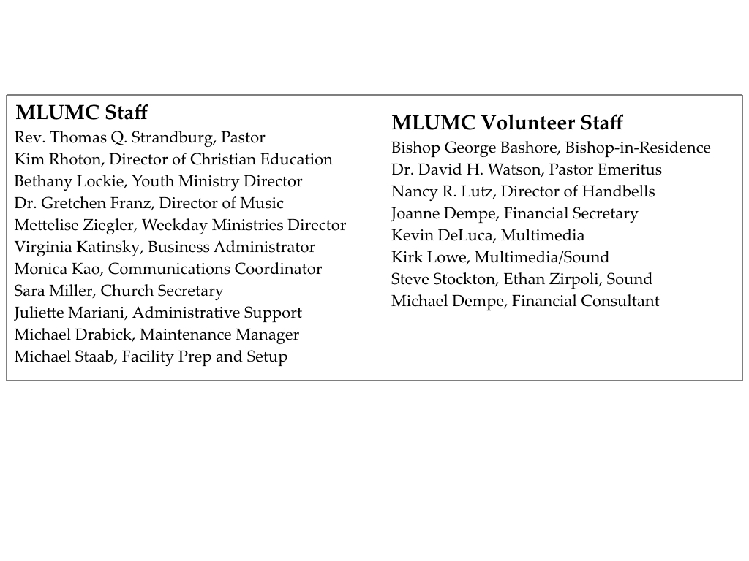

CALENDAR – SUNDAY, MAY 27 THRU SATURDAY, JUNE 2

SUNDAY 5/27
8:30 am Worship Sanner Chapel
9:30 am Sunday School/ Coffee Café Various/ Brookline Parlor
10:45 am Worship Sanctuary
Kids Praise Welcome Center
7 pm Boy Scout Patrol Leaders Room 105

MONDAY 5/28 OFFICE CLOSED FOR MEMORIAL DAY

TUESDAY 5/29
1:15 pm Conversations Book Club Brookline Parlor
6:30 pm Rummage Sale Set-Up Various
7 pm Divorce Recovery Group Welcome Center

WEDNESDAY 5/30
9 am-9 pm Rummage Sale Set-Up Various

THURSDAY 5/31
9 am-9 pm Rummage Sale Set-Up Various

FRIDAY 6/1
9 am-9 pm Rummage Sale Set-Up Various

SATURDAY 6/2
9 am Rummage Sale Various
10 am New Members Orientation Brookline Parlor

