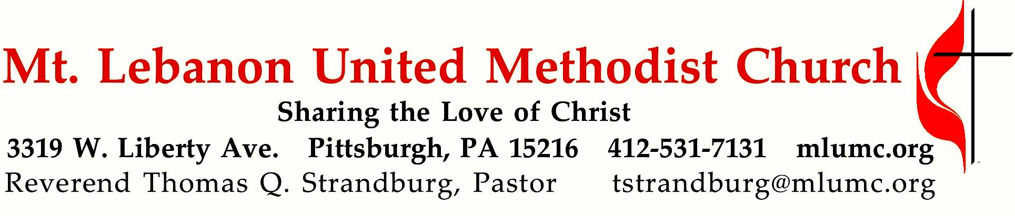
July 29, 2018 8:30 & 10:45
10th Sunday after Pentecost

Our hymnal is a book of theology and spirituality, as well as a book of lyrics and music. Throughout its pages, we have the opportunity to sing what we believe. On this day, to the tune of an 8th Century Irish folk melody, we sing unto God – “Be thou my Vision, O Lord of my heart.”

WE GATHER IN GOD’S NAME …

Gathering Music
Hymn 430 O Master, let me walk with thee (seated) Maryton

Greeting
Leader: Sing to the Lord a new song!
People: Sing to the Lord all the earth! Psalm 67:1-2

Announcements

Call to Worship
Pastor: When tears are our food,
People: God comes with a feast.
Pastor: When fear is our path,
People: God brings us courage.
Pastor: When sorrow is our friend,
People: God comforts and loves us.
Pastor: When all hope seems lost,
People: God is our rock and redeemer. 1 Kings 19, Psalm 42

… TO GIVE PRAISE TO GOD …

Hymnal 111 How can we name a Love (standing) Terra beata
Opening Prayer (in unison, standing)
Come to us in silence and in word, O God. Speak to our hearts that we may hear and respond. Soothe our souls that we may rest and renew. Strengthen our spirits that we may grow in faith and courage. In your name, we pray.

Silent Prayer

Worship & Song 3119 Take, O take me as I am Take, O take
Take, O take me as I am; summon out what I shall be;
set your seal upon my heart and live in me.

… TO CELEBRATE THE FAMILY OF FAITH …

The Sign of Peace Please pass the peace to your neighbors as a sign of reconciliation and love.
Leader: The peace of Christ be with you.
People: And also with you.

Gathering Song James Ritchie
This, this is where children belong,
welcomed as part of the worshiping throng.
Water, God’s Word, bread and cup, prayer and song:
This is where children belong. WORDS & MUSIC: James Ritchie ©1999 Abingdon Press

Message for Young Disciples Rev. Thomas Q. Strandburg
All children are invited. Please sing as children come forward. After the children’s message at the 10:45 service, children ages 3 - 3rd grade may attend Kids Praise in the Welcome Center. Children will be escorted to and from Kids Praise by teachers. They will return to Asbury Center near the end of the service.

… TO HEAR GOD’S WORD PROCLAIMED …

Worship & Song 3161 Gracious Creator (seated) Mona West

Scripture Reading 8:30 Marcy Picardi 10:45 Judy Moeller
A Lesson from the Hebrew Scriptures
Isaiah 6:1-8 The call of Isaiah

The Lord’s Prayer
Our Father, who art in heaven, hallowed be thy name. Thy kingdom come, thy will be done, on earth as it is in heaven. Give us this day our daily bread. And forgive us our trespasses, as we forgive those who trespass against us. Lead us not into temptation, but deliver us from evil. For thine is the kingdom, the power, and the glory forever. Amen.

Gospel Acclamation: Hymnal 486 Alleluia (standing) Chant Mode VI Alleluia. Alleluia. Alleluia.

Scripture Reading
A Lesson from the Gospels (standing)
Matthew 28:16-20 The Great Commission

Response
Leader: The Word of the Lord.
People: Thanks be to God.

… TO OFFER OUR GIFTS AND TO DEDICATE OUR LIVES …

Offertory Anthem 10:45 Traditional Irish, arranged by Dan Forrest
Be thou my vision, O Lord of my heart; naught be all else to me, save that thou art,
thou my best thought by day or by night, waking or sleeping, thy presence my light.
Be thou my wisdom, and thou my true word, I ever with thee and thou with me, Lord;
thou my great Father and I thy true son, thou in me dwelling, and I with thee one.
Riches I heed not, nor man’s empty praise, thou mine inheritance, now and always,
thou and thou only, first in my heart, high king of heaven, my treasure thou art.
High king of heaven, my victory won, may I reach heaven’s joys, O bright heaven’s Sun,
heart of my own heart, whatever befall, still be my vision, O Ruler of all.

Hymnal 94 Doxology (standing) Lasst uns erfreuen
Praise God from whom all blessings flow;
Praise God, all creatures here below: Alleluia! Alleluia!
Praise God the source of all our gifts!
Praise Jesus Christ, whose power uplifts!
Praise the Spirit, Holy Spirit. Alleluia! Alleluia! Alleluia!

Prayer of Dedication

Sermon “Be Thou My Vision” Rev. Thomas Q. Strandburg

… TO GO REJOICING IN GOD’S NAME!

Hymnal 451 Be thou my vision (standing) Slane

Benediction

Today’s Services
The flower arrangement provided for worship today is by Bill and Lavisa Ward in celebration of their anniversary yesterday and their family.

Guest pianist for the 8:30 service is Joy Crummie, former accompanist for the Mendelssohn Choir and present accompanist of Seraphic Singers.

Guest pianist for the 10:45 service is Mary Paine, an active member of our handbell ministry, a piano teacher in the area, and director of the Threshold Choir which was part of Faith for Today.

Special music for the 10:45 service is provided by the Chancel Choir conducted by Nancy R. Lutz.

Greeters 8:30 Rob and Beverly Festor 10:45 George and Carolyn Bashore

Worship options for children We encourage children to participate in the Children’s Sermon at both services, and in Kids Praise during the 10:45 service. Nursery services are offered in Room 204 of the Education Building. Ask ushers or greeters and follow signs for direction.

Honor or remember a loved one with a flower donation. The flowers that grace the sanctuary each week are generously donated by our church family members. This is a great way to honor or memorialize a special person, event, or milestone in your personal life or in the life of the church. If you are interested in donating flowers on a particular Sunday, contact Lizzie Diller , 412-860-3614. The cost is $30 for the altar, narthex, or columbarium, and $60 for the chancel.

Podcasts of Sunday Sermons. Catch up on messages from MLUMC with a podcast of Pastor Tom’s and others’ Sunday sermons. Sermons can be found at http://mlumc.buzzsprout.com or navigate to the site from the link on our webpage, www.mlumc.org. Sermons also will be posted to iTunes. Full recordings of the service are available upon request.

Today’s Scriptures
Isaiah 6:1-8
In the year that King Uzziah died, I saw the Lord sitting on a throne, high and lofty; and the hem of his robe filled the temple. ²Seraphs were in attendance above him; each had six wings: with two they covered their faces, and with two they covered their feet, and with two they flew. ³And one called to another and said: “Holy, holy, holy is the Lord of hosts; the whole earth is full of his glory.” ⁴The pivots on the thresholds shook at the voices of those who called, and the house filled with smoke.

⁵And I said: “Woe is me! I am lost, for I am a man of unclean lips, and I live among a people of unclean lips; yet my eyes have seen the King, the Lord of hosts!” ⁶Then one of the seraphs flew to me, holding a live coal that had been taken from the altar with a pair of tongs. ⁷The seraph touched my mouth with it and said: “Now that this has touched your lips, your guilt has departed and your sin is blotted out.” ⁸Then I heard the voice of the Lord saying, “Whom shall I send, and who will go for us?” And I said, “Here am I; send me!”

Matthew 28:16-20
¹⁶Now the eleven disciples went to Galilee, to the mountain to which Jesus had directed them. ¹⁷When they saw him, they worshiped him; but some doubted. ¹⁸And Jesus came and said to them, “All authority in heaven and on earth has been given to me. ¹⁹Go therefore and make disciples of all nations, baptizing them in the name of the Father and of the Son and of the Holy Spirit, ²⁰and teaching them to obey everything that I have commanded you. And remember, I am with you always, to the end of the age.”

Keep in Prayer

Convalescing in Care Facilities
Bonnie Amos, Providence Point
Leila Berkey, Asbury Heights
Ed Clarke, Asbury Place
John Katshir, Asbury Heights
Pat Seitz, Concordia
Carol Van Sickle, Marian Manor

Convalescing at Home
Jean Boyer, Mary Caldwell, Jane Casey,
John Dean, Joseph Festor, David Lewis, Susan Lichtenfels, Bill Merchant,
Diane Shaw, Jinny Sheppard,
Jane Spicher, Betty Trout

In the Military

Jason Boyer, SPC Natalie Brown
Maj. Zachary Allen Finch, USMC
James Iantelli, 1st Lt. Jaskiewicz
S. Sgt. Keith Kimmell, Adam Kmick

Sgt. Brendan Lamport
Sgt. Matthew McConahan, Thomas Orda
David Poncel, Sgt. Steven Reitz
Capt. Scott B. Rushe, Pastor Rick Townes
Maj. Azizi Wesmiller

Maj. Matthew C. Wesmiller
Sgt. Keith Scott Winkowski

Sgt. Michael Zimmerman

Prayers for Recovery
Keep Martina Bruckner in prayer, wife of Lutz Bruckner of our partner church in Zwickau, Germany. She is seriously ill with cancer and is undergoing treatment daily in a hospital. Prayers are needed for her treatments to be successful and for her recovery. She has been a part of the Zwickau church delegation that has visited our church.

Thank You
From Olivia Woods, who helps on Sunday mornings with our church’s Food Lift, our congregation and the Korean Church congregation:
I would like to thank the members of the church for their prayers, calls and cards that were sent while I was recovering from triple bypass heart surgery.
Thank you,
Olivia Woods

Faith for Today 9:30 – 10:30 am Sundays Asbury Center

Today - Pittsburgh Threshold Choir and Family Hospice Threshold Singers Cindy Harris, Founder & Director When invited, members of Threshold Choirs sing in groups of 2 or 3 at the bedsides of hospice patients and the very ill. The music offers comfort and compassion with simple messages of love, life and heart. We honor all spiritual paths but have no particular religious affiliation. Our singing is a gift; we are volunteers and do not charge for our service .

August 5 - Family Friendly Hands on Mission Projects Adults and children are invited to learn more about the missions of MLUMC and participate in creating care packages to benefit God’s children locally and around the world. Community children who participated in Vacation Bible School, July 30—Aug. 3, are invited to join us.

August 12 MLUMC Youth Mission Work in Virginia This year’s youth mission team worked with Project Crossroads in Marion, VA. Hear how their lives were touched in providing home renovations for low income families.

Pennsylvania Council of Churches
Advocacy Seminar in Pittsburgh

Faithful Advocacy for Criminal Justice Reform/Gun Violence Aug. 5 & Aug. 9, 2018
First United Methodist Church of Pittsburgh 5401 Centre Avenue Pgh, PA 15232

Learn why people of faith engage in advocacy. Support a bill that opens doors for our brothers and sisters who have served time. Registration: $20; to register, click on link under “Events” at www.pachurches.org.

Help Wanted
MLUMC currently has two job openings: full time secretary and part time youth leader. If you or someone you know is interested, you can request more information and/or email a resumé to sprc@mlumc.org .

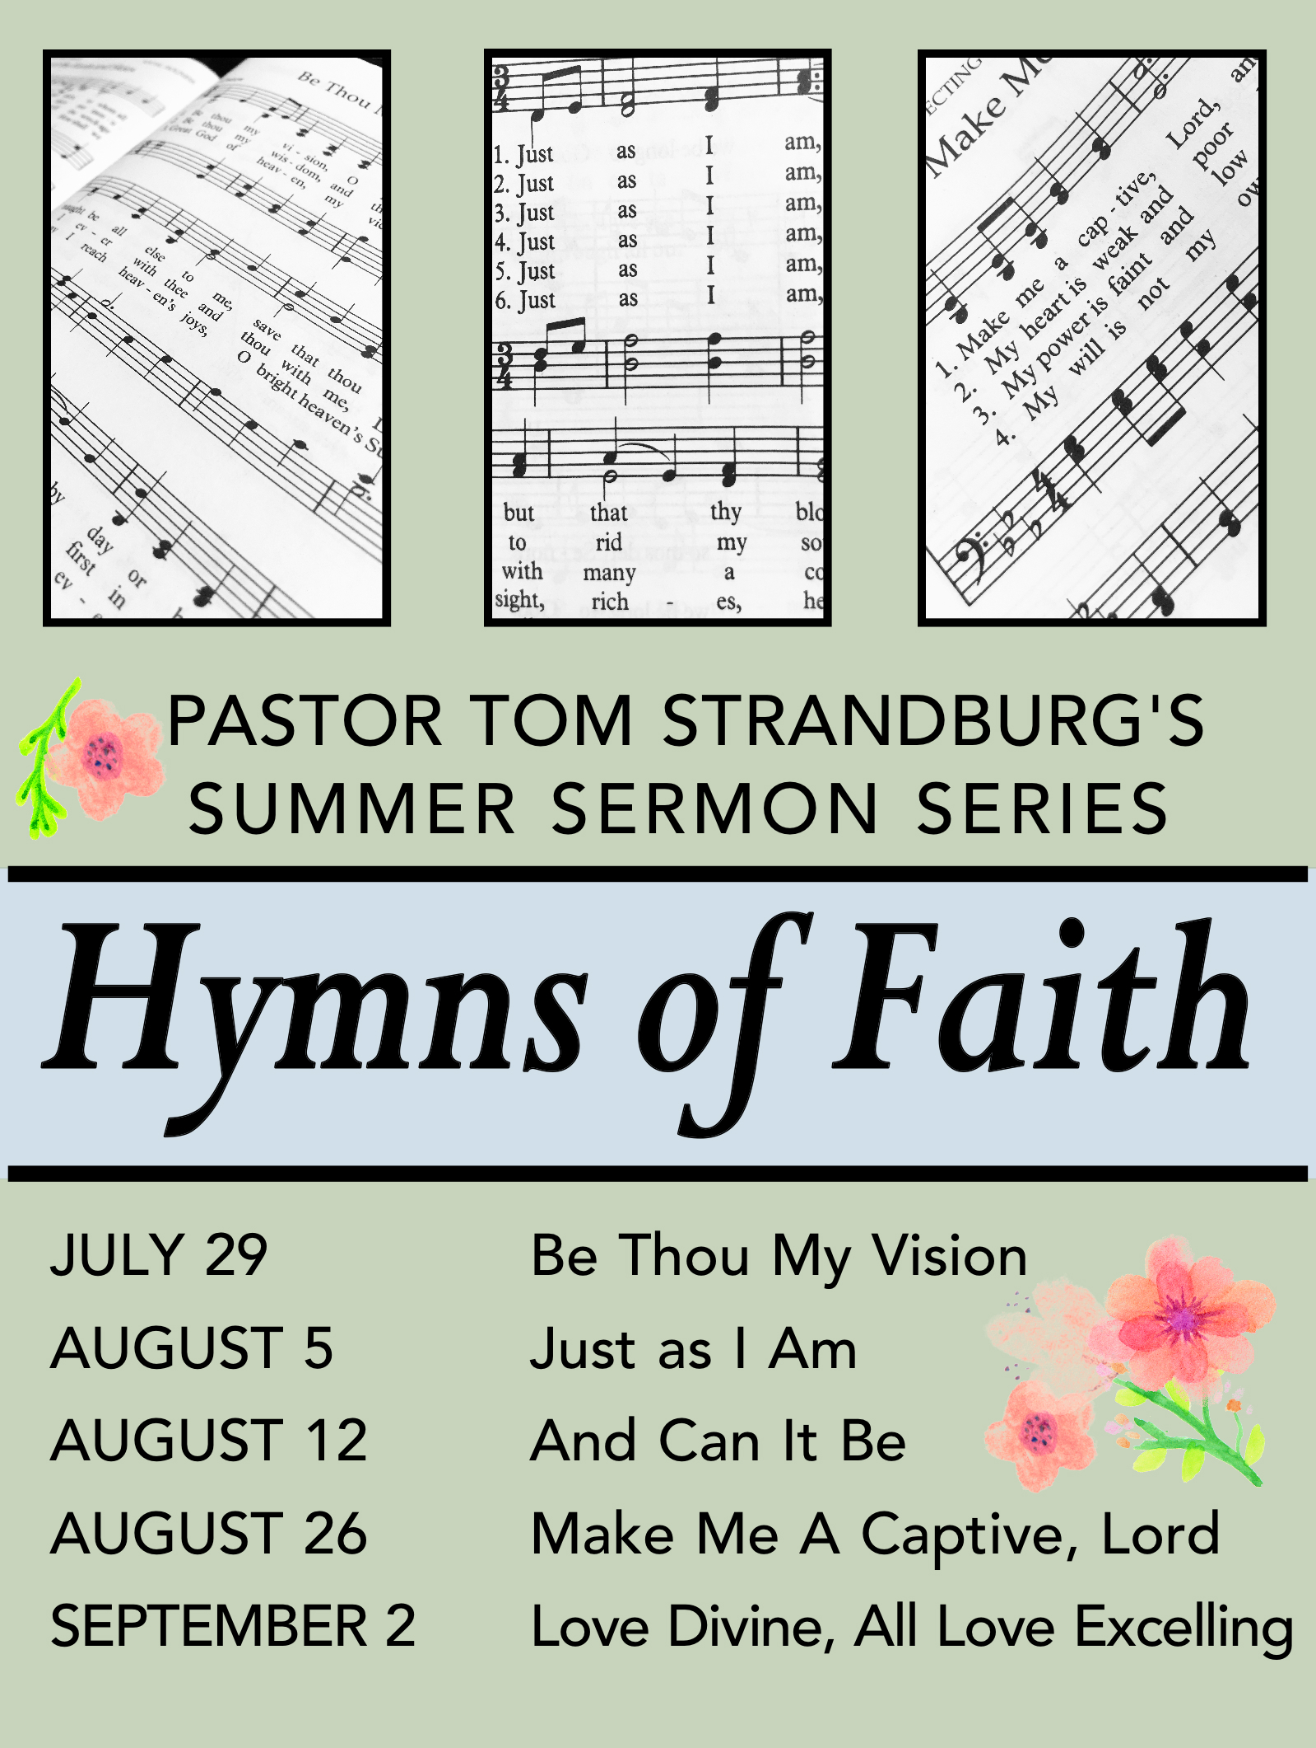

VBS Starts Tomorrow – Not Too Late to Register
“Peace Lab” Vacation Bible School is from 9:30 to 11:30 am for ages
4 through 5th grade. Register online at mlumc.org, or pick up a registration form. To volunteer or for more info, contact:
Kim Rhoton: krhoton@ mlumc.org.

CALENDAR – SUNDAY, JULY 29 THRU SATURDAY, AUGUST 4
Vacation Bible School Week - Monday, July 30 thru Friday, August 3, 9:30 – 11:30 am

SUNDAY 7/29
8:30 am Worship Sanner Chapel
9:30 am Faith for Today Asbury Center
10:45 am Worship Asbury Center
Kids Praise Welcome Center
5 pm Youth Group Youth Room

TUESDAY 7/31
7 pm Boy Scout Troop #23 Wesley Hall

WEDNESDAY 8/1
7:30 am Northside Lunch Program Prep Kitchen
6 pm Homebuilders Potluck Asbury Center

THURSDAY 8/2
8:30 am Northside Lunch Program Prep Kitchen
12 pm TNT Asbury Heights

FRIDAY 8/3
9:30 am Women’s Bible Study Room#102

SATURDAY 8/4
10 am Food Distribution and Food Lift Free Market Food Pantry

