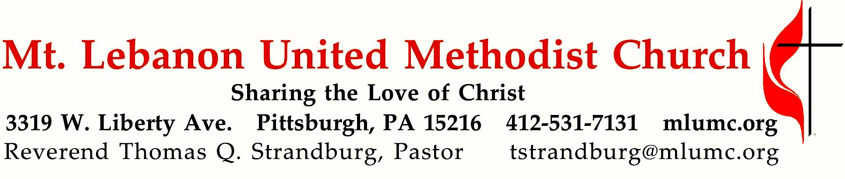
August 12, 2018 8:30 & 10:45
Hymns of Faith
Summer Sermon Series
Our hymnal is a book of theology and spirituality, as well as a book of lyrics and music. Throughout its pages, we have the opportunity to sing what we believe. Today, we hear the words of one the best-loved of Charles Wesley’s many hymns, written to celebrate his own conversion in 1738 -- "My chains fell off, my heart was free/I rose, went forth, and followed thee."

WE GATHER IN GOD’S NAME …

Gathering Music
Hymnal 420 Breathe on me, Breath of God (seated) Trentham
Worship & Song 3030 Eternal God transcending time (stanzas 1-2) Resignation

Greeting
Leader: Sing to the Lord a new song!
People: Sing to the Lord all the earth! Psalm 122:1

Announcements

Call to Worship
Pastor: You are the salt of the earth.
People: May we season the world with faithfulness, O God.
Pastor: You are the light of the world.
People: May your love shine through us, O Christ our Savior.
Pastor: You are a city built on a hill.
People: May your vigor make us bold witnesses, O Spirit of the living God.
Worship & Song

… TO GIVE PRAISE TO GOD …

Hymnal 674 See the morning sun ascending (standing) Unser Herrscher
Opening Prayer (in unison, standing)
Days pass and the years vanish, and we walk sightless among miracles. Lord, fill our eyes with seeing and our minds with knowing; let there be moments when your presence, like lightning, illumines the darkness in which we walk. Help us to see, wherever we gaze, that the bush burns unconsumed. And we, clay touched by God, will reach out for holiness, and exclaim in wonder: How filled with awe is this place, and we did not know it: “Blessed is the Eternal One, the holy God!” Amen. Worship & Song

Silent Prayer

Worship & Song 3119 Take, O take me as I am Take, O take
Take, O take me as I am; summon out what I shall be;
set your seal upon my heart and live in me.

… TO CELEBRATE THE FAMILY OF FAITH …

The Sign of Peace Please pass the peace to your neighbors as a sign of reconciliation and love.
Leader: The peace of Christ be with you.
People: And also with you.

Gathering Song James Ritchie
This, this is where children belong,
welcomed as part of the worshiping throng.
Water, God’s Word, bread and cup, prayer and song:
This is where children belong. WORDS & MUSIC: James Ritchie ©1999 Abingdon Press

Message for Young Disciples Rev. Thomas Q. Strandburg
All children are invited. Please sing as children come forward. After the children’s message at the 10:45 service, children ages 3 - 3rd grade may attend Kids Praise in the Welcome Center. Children will be escorted to and from Kids Praise by teachers. They will return to Asbury Center near the end of the service.

… TO HEAR GOD’S WORD PROCLAIMED …

Worship & Song 3030 Eternal God transcending time (seated) Resignation

Scripture Reading 8:30 Joeta D’Este
10:45 Hazel Cope
A Lesson from the Hebrew Scriptures
Isaiah 53:1-6 The Suffering Servant

Pastoral Prayer

The Lord’s Prayer
Our Father, who art in heaven, hallowed be thy name. Thy kingdom come, thy will be done, on earth as it is in heaven. Give us this day our daily bread. And forgive us our trespasses, as we forgive those who trespass against us. Lead us not into temptation, but deliver us from evil. For thine is the kingdom, the power, and the glory forever. Amen.

Scripture Reading
A Lesson from the New Testament
Romans 3:21-26 God’s righteousness through faithfulness of Christ

Response
Leader: The Word of the Lord.
People: Thanks be to God.

… TO OFFER OUR GIFTS AND TO DEDICATE OUR LIVES …

Offertory Solo 10:45 My Jesus I Love Thee arr. Dan Forrest

Hymnal 94 Doxology (standing) Lasst uns erfreuen
Praise God from whom all blessings flow;
Praise God, all creatures here below: Alleluia! Alleluia!
Praise God the source of all our gifts!
Praise Jesus Christ, whose power uplifts!
Praise the Spirit, Holy Spirit. Alleluia! Alleluia! Alleluia!

Prayer of Dedication

Sermon “And Can It Be?” Rev. Thomas Q. Strandburg

… TO GO REJOICING IN GOD’S NAME!

Hymnal 363 And can it be that I should gain (standing) Sagina

Benediction

Join us in Asbury Center following the 10:45 service for a Farewell Reception for Bethany Lockie, who has resigned from the position of Youth Leader.

Today’s Services
The flowers for worship today are given in honor of Bethany Lockie for her years of service as Youth Ministry Director at MLUMC. Her gentle, loving spirit and positive attitude will be missed very much.

Guest pianist is Joy Crummie, former accompanist of the Mendelssohn Choir and present accompanist of the Seraphic Singers.

Special music for the 10:45 service is provided by Bob Mallery, a member of the Chancel Choir and an active member of this church.

Greeters 8:30 Pete and Beth Santore 10:45 Chuck and Brenda Vogel

Worship options for children We encourage children to participate in the Children’s Sermon at both services, and in Kids Praise during the 10:45 service. Nursery services are offered in Room 204 of the Education Building. Ask ushers or greeters and follow signs for direction.

Today’s Scriptures
Isaiah 53:1-6
Who has believed what we have heard? And to whom has the arm of the Lord been revealed? ²For he grew up before him like a young plant, and like a root out of dry ground; he had no form or majesty that we should look at him, nothing in his appearance that we should desire him. ³He was despised and rejected by others; a man of suffering and acquainted with infirmity; and as one from whom others hide their faces he was despised, and we held him of no account.

⁴Surely he has borne our infirmities and carried our diseases; yet we accounted him stricken, struck down by God, and afflicted. ⁵But he was wounded for our transgressions, crushed for our iniquities; upon him was the punishment that made us whole, and by his bruises we are healed.⁶All we like sheep have gone astray; we have all turned to our own way, and the Lord has laid on him the iniquity of us all.

Romans 3:21-26
²¹But now, apart from law, the righteousness of God has been disclosed, and is attested by the law and the prophets, ²²the righteousness of God through faith in Jesus Christ for all who believe. For there is no distinction, ²³since all have sinned and fall short of the glory of God;²⁴they are now justified by his grace as a gift, through the redemption that is in Christ Jesus, ²⁵whom God put forward as a sacrifice of atonement by his blood, effective through faith. He did this to show his righteousness, because in his divine forbearance he had passed over the sins previously committed; ²⁶it was to prove at the present time that he himself is righteous and that he justifies the one who has faith in Jesus.

Keep in Prayer

Hospitalized
Ruth Seip, St. Clair

Convalescing in Care Facilities
Bonnie Amos, Providence Point
Leila Berkey, Asbury Heights
Ed Clarke, Asbury Place
John Katshir, Asbury Heights
Pat Seitz, Concordia
Carol Van Sickle, Marian Manor

Convalescing at Home
Jean Boyer, Mary Caldwell, Jane Casey
John Dean, Joseph Festor, David Lewis Susan Lichtenfels, George Lindow
Bill Merchant, Diane Shaw, Jinny Sheppard
Jane Spicher, Betty Trout

In the Military

Jason Boyer, SPC Natalie Brown
Maj. Zachary Allen Finch, USMC
James Iantelli, 1st Lt. Jaskiewicz
S. Sgt. Keith Kimmell, Adam Kmick

Sgt. Brendan Lamport
Sgt. Matthew McConahan, Thomas Orda
David Poncel, Sgt. Steven Reitz
Capt. Scott B. Rushe, Pastor Rick Townes
Maj. Azizi Wesmiller

Maj. Matthew C. Wesmiller
Sgt. Keith Scott Winkowski

Sgt. Michael Zimmerman

Faith for Today 9:30-10:30 am Sundays Asbury Center

Today MLUMC Youth, Mission Work in Virginia This year, the youth mission team worked with Project Crossroads in Marion, VA to provide home renovations for low income families. They will be sharing their mission team experiences.

August 19 - World War I: The War that Did Not End All Wars, Hazel & Alan Cope, Barbara & David Watson 2018 marks the centenary of the end of what used to be called “The Great War.” This multimedia presentation includes photos and audio from a soldier who took part and other personal histories. It will try to explain why the war began and America’s role in the final phase and peace treaty. You are invited to bring photographs for a display table.

August 26 Hour of Joy Contemporary Service

Help Wanted MLUMC currently has two job openings: full time secretary and part time youth leader. If you or someone you know is interested, you can request more information and/or email a resumé to sprc@mlumc.org

Honor or remember a loved one with a flower donation. The flowers that grace the sanctuary each week are generously donated by our church family members. This is a great way to honor or memorialize a special person, event, or milestone in your personal life or in the life of the church. If you are interested in donating flowers on a particular Sunday, contact Lizzie Diller , 412-860-3614. The cost is $30 for the altar, narthex, or columbarium, and $60 for the chancel.

Podcasts of Sunday Sermons Catch up on messages from MLUMC with a podcast of Pastor Tom’s and others’ Sunday sermons. Sermons can be found at http://mlumc.buzzsprout.com or navigate to the site from the link on our webpage, www.mlumc.org. Sermons also will be posted to iTunes. Full recordings of the service are available upon request.

Help the Food Pantry During Picnic Season
It’s that time of year when adult Sunday school classes, the choir, the finance and trustee committees have picnics. If your group has a picnic or meeting this month, consider charging admission. Ask members to bring a jar of peanut butter or jelly to help stock the food pantry. The jars can be placed on the shelves right inside the food pantry entry door or in a drop-off box near the entry. Help the pantry keep the shelves stocked during these very challenging times for our food pantry members.

Cub Scout Recruitment Event Cub Scout Pack 870 is holding a recruitment event for those interested in joining the Cub Scouts. Grade ranges for Cub Scouts is Kindergarten through 5th grade. Come join us for the opening event for the season here at MLUMC from 6:30pm until 8pm on Wednesday August 29th! Dinner (cookout food) will be served, so come hungry!

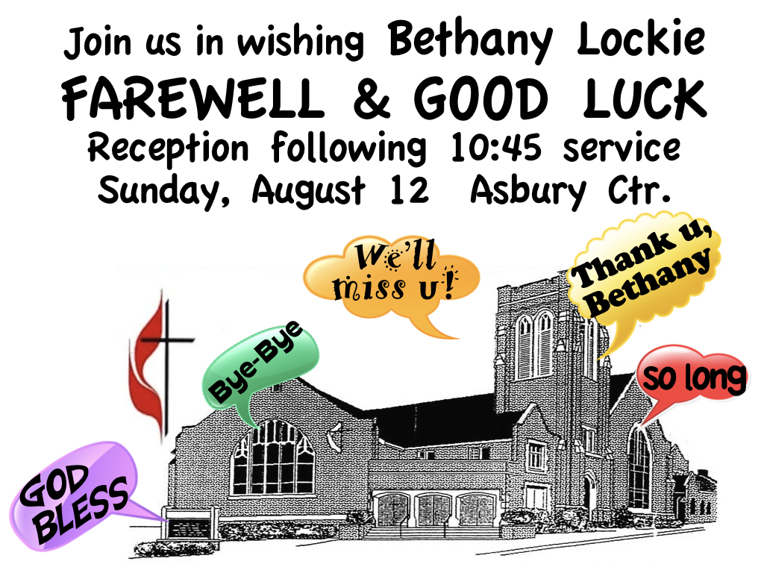

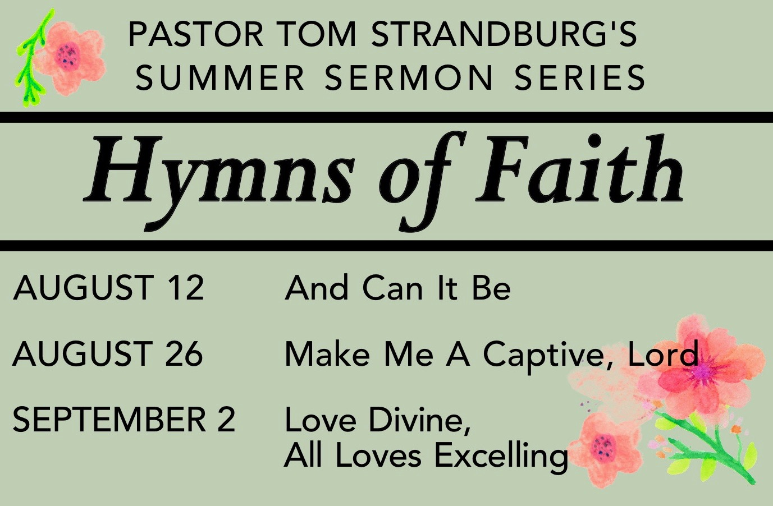

CALENDAR – SUNDAY, AUGUST 12 THRU SATURDAY, AUGUST 18

SUNDAY 8/12
8:30 am Worship Sanner Chapel
9:30 am Faith for Today Asbury Center
10:45 am Worship Asbury Center
Kids Praise Welcome Center

TUESDAY 8/14
6:30 pm Family Promise Board of Directors Library
7 pm Boy Scout Troop #23 Wesley Hall
7 pm BSA Board of Reviews Room 105
7 pm Cub Scout Planning Meeting Room 102
7:30 pm Worship Team Meeting Asbury Center

WEDNESDAY 8/15
6 pm Homebuilders Potluck Asbury Center
7 pm Trustees Wesley Hall

SATURDAY 8/18
10 am Food Distribution & Food Lift Free Market Food Pantry

