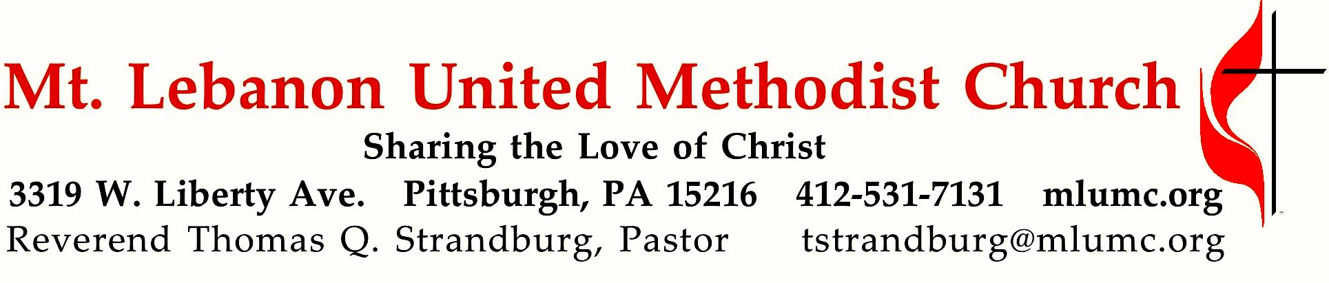
August 5, 2018 8:30 & 10:45
Hymns of Faith
Summer Sermon Series
Our hymnal is a book of theology and spirituality, as well as a book of lyrics and music. Throughout its pages, we have the opportunity to sing what we believe. Today, Charlotte Elliott’s words remind us that we are invited to come to Christ just as we are, remembering his promise that “anyone who comes to me I will never drive away.” (John 6:37)

WE GATHER IN GOD’S NAME …
Gathering Music
Hymn 427 Where cross the crowded (stanzas 1-3, seated) Germany

Greeting
Leader: Sing to the Lord a new song!
People: Sing to the Lord all the earth! Psalm 122:1

Announcements

Call to Worship
Pastor: We have one Lord.
People: God lives in each of us. We have one faith. God works in each of us.
Pastor: We have one baptism.
People: God gives gifts to each of us.
Pastor: We are one body.
People: God makes us all one. Ephesians 4

… TO GIVE PRAISE TO GOD …

Hymnal 629 You satisfy the hungry heart (standing) Gift of finest Wheat

Opening Prayer (in unison, standing)
Almighty God, speak your truth to us this day. Give us the treasure of your wisdom and love that we might become for the world the treasure you seek us to be. Clothe us with your compassion and courage that we might be the Body of Christ to a hurting world.
In your holy name we pray. Amen.

Silent Prayer

Worship & Song 3119 Take, O take me as I am Take, O take
Take, O take me as I am; summon out what I shall be;
set your seal upon my heart and live in me.

… TO CELEBRATE THE FAMILY OF FAITH …

The Sign of Peace Please pass the peace to your neighbors as a sign of reconciliation and love.
Leader: The peace of Christ be with you.
People: And also with you.

Gathering Song James Ritchie
This, this is where children belong,
welcomed as part of the worshiping throng.
Water, God’s Word, bread and cup, prayer and song:
This is where children belong. WORDS & MUSIC: James Ritchie ©1999 Abingdon Press

Message for Young Disciples Kim Rhoton
All children are invited. Please sing as children come forward. After the children’s message at the 10:45 service, children ages 3 - 3rd grade may attend Kids Praise in the Welcome Center. Children will be escorted to and from Kids Praise by teachers. They will return to Asbury Center near the end of the service.

… TO HEAR GOD’S WORD PROCLAIMED …

Scripture Reading 8:30 Marcy Picardi 10:45 Chuck Vogel
A Lesson from the Hebrew Scriptures
Jeremiah 31:31-34 A New Covenant

Pastoral Prayer

The Lord’s Prayer
Our Father, who art in heaven, hallowed be thy name. Thy kingdom come, thy will be done, on earth as it is in heaven. Give us this day our daily bread. And forgive us our trespasses, as we forgive those who trespass against us. Lead us not into temptation, but deliver us from evil. For thine is the kingdom, the power, and the glory forever. Amen.
Gospel Acclamation: Hymnal 486 Alleluia (standing) Chant Mode VI Alleluia. Alleluia. Alleluia.

Scripture Reading
A Lesson from the Gospel
John 6:26-40 The Bread of Life

Response
Leader: The Word of the Lord.
People: Thanks be to God.

… TO OFFER OUR GIFTS AND TO DEDICATE OUR LIVES …

Offertory Solo 10:45 Shall we gather at the river Lowry, arr. Luigi Zaninelli

Hymnal 94 Doxology (standing) Lasst uns erfreuen
Praise God from whom all blessings flow;
Praise God, all creatures here below: Alleluia! Alleluia!
Praise God the source of all our gifts!
Praise Jesus Christ, whose power uplifts!
Praise the Spirit, Holy Spirit. Alleluia! Alleluia! Alleluia!

Prayer of Dedication

Sermon “Just as I Am” Rev. Thomas Q. Strandburg

Hymnal 357, Hymn of Preparation Just as I Am (stanza 1 & 2, seated) Woodworth

The Sacrament of Holy Communion

The Great Thanksgiving
Leader: The Lord be with you.
People: And also with you
Leader: Lift up your hearts.
People: We lift them up to the Lord.
Leader: Let us give thanks to the Lord our God..
People: It is right to give our thanks and praise.
Leader: (The pastor continues in prayer

Giving the Bread and Cup

Prayer following Communion (in unison)
You have opened to us the Scriptures, O Christ, and you have made yourself known in the breaking of the bread. Abide with us, we pray, that, blessed by your royal presence, we may walk with you all the days of our lives, and at its end behold you in the glory of the eternal Trinity, one God for ever and ever. Amen.

… TO GO REJOICING IN GOD’S NAME!

Hymnal #357 Just as I Am (stanzas 3-6, standing) Woodworth

Benediction

Today’s Services
The flower arrangement provided for worship today is given by Mary Garber in celebration of the Latvian Annual Conference meeting this coming weekend in Leipa, Latvia. The Methodist church in Leipa is part of the Hope Center residence. Hope Center is a Methodist residence for homeless teenagers and their children, and a new mission connection of our church.

Special music for the 10:45 service is provided by our tenor soloist Kirby Dilworth.

Greeters 8:30 Jeff Thayer 10:45 Frances Graham

Worship options for children We encourage children to participate in the Children’s Sermon at both services, and in Kids Praise during the 10:45 service. Nursery services are offered in Room 204 of the Education Building. Ask ushers or greeters and follow signs for direction.

Today’s Scriptures

Jeremiah 31:31-34
³¹The days are surely coming, says the Lord, when I will make a new covenant with the house of Israel and the house of Judah. ³²It will not be like the covenant that I made with their ancestors when I took them by the hand to bring them out of the land of Egypt—a covenant that they broke, though I was their husband, says the Lord. ³³But this is the covenant that I will make with the house of Israel after those days, says the Lord: I will put my law within them, and I will write it on their hearts; and I will be their God, and they shall be my people. ³⁴No longer shall they teach one another, or say to each other, “Know the Lord,” for they shall all know me, from the least of them to the greatest, says the Lord; for I will forgive their iniquity, and remember their sin no more.

John 6:26-40
²⁶Jesus answered them, “Very truly, I tell you, you are looking for me, not because you saw signs, but because you ate your fill of the loaves. ²⁷Do not work for the food that perishes, but for the food that endures for eternal life, which the Son of Man will give you. For it is on him that God the Father has set his seal.”

²⁸Then they said to him, “What must we do to perform the works of God?” ²⁹Jesus answered them, “This is the work of God, that you believe in him whom he has sent.” ³⁰So they said to him, “What sign are you going to give us then, so that we may see it and believe you? What work are you performing? ³¹Our ancestors ate the manna in the wilderness; as it is written, ‘He gave them bread from heaven to eat.’” ³²Then Jesus said to them, “Very truly, I tell you, it was not Moses who gave you the bread from heaven, but it is my Father who gives you the true bread from heaven. ³³For the bread of God is that which comes down from heaven and gives life to the world.” ³⁴They said to him, “Sir, give us this bread always.” ³⁵Jesus said to them, “I am the bread of life. Whoever comes to me will never be hungry, and whoever believes in me will never be thirsty. ³⁶But I said to you that you have seen me and yet do not believe. ³⁷Everything that the Father gives me will come to me, and anyone who comes to me I will never drive away; ³⁸for I have come down from heaven, not to do my own will, but the will of him who sent me. ³⁹And this is the will of him who sent me, that I should lose nothing of all that he has given me, but raise it up on the last day. ⁴⁰This is indeed the will of my Father, that all who see the Son and believe in him may have eternal life; and I will raise them up on the last day.”

Keep in Prayer

Convalescing in Care Facilities
Bonnie Amos, Providence Point
Leila Berkey, Asbury Heights
Ed Clarke, Asbury Place
John Katshir, Asbury Heights
Pat Seitz, Concordia
Carol Van Sickle, Marian Manor

Convalescing at Home
Jean Boyer, Mary Caldwell, Jane Casey,
John Dean, Joseph Festor, David Lewis, Susan Lichtenfels, George Lindow
Bill Merchant, Diane Shaw, Jinny Sheppard,
Jane Spicher, Betty Trout

In the Military

Jason Boyer, SPC Natalie Brown
Maj. Zachary Allen Finch, USMC
James Iantelli, 1st Lt. Jaskiewicz
S. Sgt. Keith Kimmell, Adam Kmick

Sgt. Brendan Lamport
Sgt. Matthew McConahan, Thomas Orda
David Poncel, Sgt. Steven Reitz
Capt. Scott B. Rushe, Pastor Rick Townes
Maj. Azizi Wesmiller

Maj. Matthew C. Wesmiller
Sgt. Keith Scott Winkowski

Sgt. Michael Zimmerman

Prayers for Recovery
Keep Martina Bruckner in prayer, wife of Lutz Bruckner of our partner church in Zwickau, Germany. She is seriously ill with cancer and is undergoing treatment daily in a hospital. Prayers are needed for her treatments to be successful and for her recovery. She has been a part of the Zwickau church delegation that has visited our church.

Faith for Today 9:30 – 10:30 am Sundays Asbury Center

Today - Family Friendly Hands on Mission Projects Adults and children are invited to learn more about the missions of MLUMC and participate in creating care packages to benefit God’s children locally and around the world. Community children who participated in Vacation Bible School, July 30—Aug. 3, are joining us.

August 12 MLUMC Youth Mission Work in Virginia This year’s youth mission team worked with Project Crossroads in Marion, VA. Hear how their lives were touched in providing home renovations for low income families.

Blood Pressure Screenings Today Stop in Brookline Pralor aftr the 10:45 service for a blood pressure check from the MLUMC Health Ministry (WHOM). The ministry team nurses offer screenings the first Sunday of every month.

Help Wanted MLUMC currently has two job openings: full time secretary and part time youth leader. If you or someone you know is interested, you can request more information and/or email a resumé to sprc@mlumc.org

Podcasts of Sunday Sermons. Catch up on messages from MLUMC with a podcast of Pastor Tom’s and others’ Sunday sermons. Sermons can be found at http://mlumc.buzzsprout.com or navigate to the site from the link on our webpage, www.mlumc.org. Sermons also will be posted to iTunes. Full recordings of the service are available upon request.

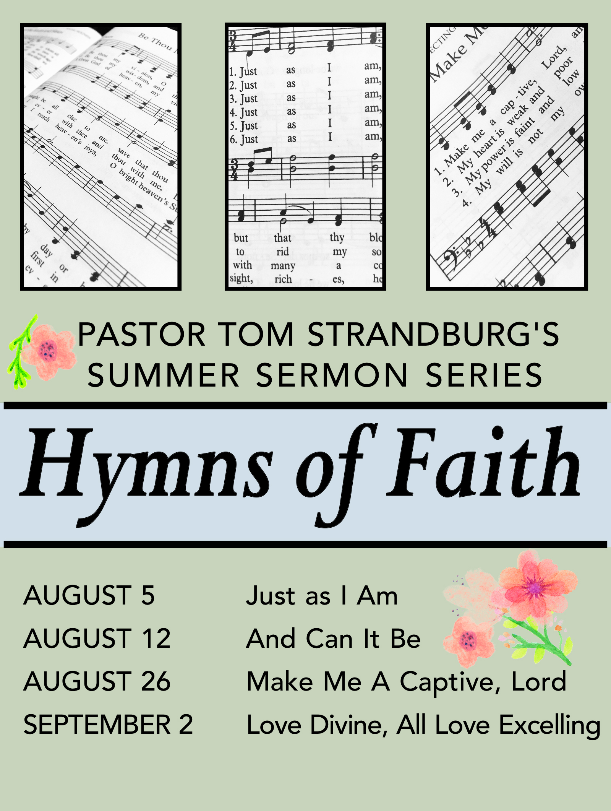

Honor or remember a loved one with a flower donation. The flowers that grace the sanctuary each week are generously donated by our church family members. This is a great way to honor or memorialize a special person, event, or milestone in your personal life or in the life of the church. If you are interested in donating flowers on a particular Sunday, contact Lizzie Diller , 412-860-3614. The cost is $30 for the altar, narthex, or columbarium, and $60 for the chancel.

CALENDAR – SUNDAY, AUGUST 5 THRU SATURDAY, AUGUST 11

SUNDAY 8/5
8:30 am Worship Sanner Chapel
9:30 am Faith for Today Asbury Center
10:45 am Worship Asbury Center
Kids Praise Welcome Center
12 pm Blood Pressure Screening Brookline Parlor

TUESDAY 8/7
7 pm Boy Scout Troop #23 Wesley Hall
7:30 pm Worship Team Asbury Center

WEDNESDAY 8/8
6 pm Homebuilders Potluck Asbury Center
7:30 pm Finance Committee Wesley Hall

THURSDAY 8/9
9 am Hands & Hearts Epworth Chapel
7 pm Education Committee Brookline Parlor

FRIDAY 8/10
9:30 am Women’s Bible Study Room 102
7 pm Arrow of Light Cub Scouts Room 102

SATURDAY 8/11
8 am It’s a Guy Thing Men’s Group Asbury Center

