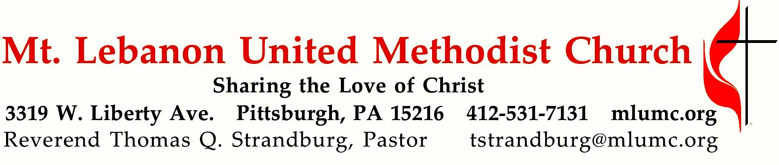
September 2, 2018 8:30 & 10:45
Hymns of Faith
Summer Sermon Series

The introductory sentence in the 1933 British Methodist hymnbook proclaimed that “Methodism was born in song.” Another has written that “the real embodiment of Methodist theology is the Methodist Hymnbook, and especially Charles Wesley’s hymns. In the great hymn, Love Divine, All Loves Excelling, we find a theology one can sing.

WE GATHER IN GOD’S NAME …

Gathering Music
Hymnal 395 Take time to be holy (stanzas 1-3, seated) Holiness
Greeting
Leader: But I thank the Lord for his righteousness;
People: I will sing praises to the name of the Lord Most High.
Psalm 7:17 (CEB)

Announcements

Call to Worship
Pastor: Those who place their trust in the Lord are like Mount Zion, never shaken, lasting forever.
People: Mountains surround the holy city of Jerusalem, and the Lord continually surrounds and protects God’s people.
Pastor: The Lord’s favor is ever with those whose hearts are in the right place.
People: May peace be always with God’s people!
Psalm 125

… TO GIVE PRAISE TO GOD …

Hymnal 158 Come, Christians, join to sing (standing) Spanish Hymn

PRAYER OF CONFESSION (in unison)
God of compassion: We talk about being faithful to your love, while our hearts go after other desires. Our love for you and for others often fails, while we devise complex rules and regulations for judging others. We want to be yours, but harmful thoughts carry us away from your purposes. In spite of our faults, enable us to be people of your own heart. Cleanse the meditations of our hearts, that our thoughts may reflect your goodness. Keep us from envy, greed, and deceit, and remake us in the image of your love. Amen.

WORDS OF ASSURANCE
Pastor: Jesus said, “Come to me all who labor and are heavy-laden, and I will give you rest.” (Matthew 11:28) In the Name of Jesus Christ you are forgiven.
People: In the Name of Jesus Christ you are forgiven! Glory to God! Amen.

Silent Prayer

Worship & Song 3119 Take, O take me as I am Take, O take
Take, O take me as I am; summon out what I shall be;
set your seal upon my heart and live in me.

… TO CELEBRATE THE FAMILY OF FAITH …

The Sign of Peace Please pass the peace to your neighbors as a sign of reconciliation and love.
Leader: The peace of Christ be with you.
People: And also with you.

Gathering Song James Ritchie
This, this is where children belong,
welcomed as part of the worshiping throng.
Water, God’s Word, bread and cup, prayer and song:
This is where children belong.
WORDS: and MUSIC: James Ritchie ©1999 Abingdon Press

Message for Young Disciples Rev. Thomas Q. Strandburg
All children are invited. Please sing as children come forward. After the children’s message at the 10:45 service, children ages 3 - 3rd grade may attend Kids Praise in the Welcome Center. Children will be escorted to and from Kids Praise by teachers. They will return to Asbury Center near the end of the service.

… TO HEAR GOD’S WORD PROCLAIMED …

Scripture Reading 8:30 Kathy Tremblay 10:45 Bob James
A Lesson from the Hebrew Scriptures
Philippians 3:1-2 Values and priorities

Pastoral Prayer

The Lord’s Prayer
Our Father, who art in heaven, hallowed be thy name. Thy kingdom come, thy will be done, on earth as it is in heaven. Give us this day our daily bread. And forgive us our trespasses, as we forgive those who trespass against us. And lead us not into temptation,
but deliver us from evil. For thine is the kingdom, the power, the glory forever. Amen.

Gospel Acclamation: Hymnal 486 Alleluia (standing) Chant Mode VI Alleluia. Alleluia. Alleluia.

Scripture Reading
A Lesson from the Gospels
Matthew 5:43-48 The law of love

Response
Leader: The Word of the Lord.
People: Thanks be to God.

… TO OFFER OUR GIFTS AND TO DEDICATE OUR LIVES …

Offertory Solo 10:45 O Love, that will not let me go arranged by John Ness Beck

Hymnal 94 Doxology (standing) Lasst uns erfreuen
Praise God from whom all blessings flow;
Praise God, all creatures here below: Alleluia! Alleluia!
Praise God the source of all our gifts!
Praise Jesus Christ, whose power uplifts!
Praise the Spirit, Holy Spirit. Alleluia! Alleluia! Alleluia!

Prayer of Dedication

Sermon “Love Divine, All Loves Excelling” Rev. Thomas Q. Strandburg

Hymnal #384 “Love divine, all loves excelling” (stanza 1)
Sacrament of Holy Communion

The Great Thanksgiving
The Lord be with you.
And also with you.
Lift up your hearts.
We lift them up to the Lord.
Let us give thanks to the Lord our God.
It is right to give our thanks and praise.
(The pastor continues in prayer)
Giving the Bread & Cup

Prayer following Communion (in unison)
Finish, then, Thy new creation;
Pure and spotless let us be;
Let us see Thy great salvation
Perfectly restored in Thee;
Changed from glory into glory,
Till in Heav’n we take our place,
Till we cast our crowns before Thee,
Lost in wonder, love, and praise. Amen.
Charles Wesley

… TO GO REJOICING IN GOD’S NAME!

Hymnal 384 “Love divine, all loves excelling” (stanza 2-4)

Benediction

Hymnal 408 The Gift of Love (standing) Gift of Love

Today’s Services
The flower arrangement provided for worship today is given by Phillip and Nancy Koch in loving memory of Nancy Agnew who passed away one year ago today.

The rosebud on the altar is given in celebration of the birth of Arazio Anthony Antoline, born August 9th. Arazio's proud family includes grandparents Rob and Jane Spicher, parents Anthony and Emily, and big sister Allaire.

Special music for the 10:45 service is provided by our soprano soloist Kathleen Whittaker. Dr. Whittaker is keyboardist and singer for the Taizé services at the East Liberty Presbyterian Church and is a professor in the Counseling Psychology Graduate program at Chatham University.

Greeters 8:30 Erma Henry 10:45 Cleon and Vera Jane Cornes

Worship options for children We encourage children to participate in the Children’s Sermon at both services, and in Kids Praise during the 10:45 service. Nursery services are offered in Room 204 of the Education Building. Ask ushers or greeters and follow signs for direction.

Podcasts of Sunday Sermons Catch up on messages from MLUMC with a podcast of Pastor Tom’s and others’ Sunday sermons. Sermons can be found at http://mlumc.buzzsprout.com or navigate to the site from the link on our webpage, www.mlumc.org. Sermons also will be posted to iTunes. Full recordings of the service are available upon request.

Honor or remember a loved one with a flower donation. The flowers that grace the sanctuary each week are generously donated by our church family members. This is a great way to honor or memorialize a special person, event, or milestone in your personal life or in the life of the church. If you are interested in donating flowers on a particular Sunday, contact Lizzie Diller , 412-860-3614. The cost is $30 for the altar, narthex, or columbarium, and $60 for the chancel.

Blood Pressure Screenings Today Stop in Brookline Parlor after the 10:45 service for a blood pressure check from the MLUMC Health Ministry (WHOM). The ministry team nurses offer screenings the first Sunday of every month.

Today’s Scriptures

Philippians 3:1-2
3Finally, my brothers and sisters, rejoice in the Lord. To write the same things to you is not troublesome to me, and for you it is a safeguard.²Beware of the dogs, beware of the evil workers, beware of those who mutilate the flesh!

Matthew 5:43-48
⁴³“You have heard that it was said, ‘You shall love your neighbor and hate your enemy.’ ⁴⁴But I say to you, Love your enemies and pray for those who persecute you, ⁴⁵so that you may be children of your Father in heaven; for he makes his sun rise on the evil and on the good, and sends rain on the righteous and on the unrighteous. ⁴⁶For if you love those who love you, what reward do you have? Do not even the tax collectors do the same? ⁴⁷And if you greet only your brothers and sisters, what more are you doing than others? Do not even the Gentiles do the same? ⁴⁸Be perfect, therefore, as your heavenly Father is perfect.

Keep in Prayer

Convalescing in Care Facilities
Bonnie Amos, Providence Point
Leila Berkey, Asbury Heights
Ed Clarke, Asbury Place
Grace Gullborg, Providence Point
John Katshir, Asbury Heights
Pat Seitz, Concordia
Carol Van Sickle, Marian Manor

Convalescing at Home
Jean Boyer, Mary Caldwell,
John Dean, Joseph Festor,
Leon Grant, Jr., David Lewis,
Susan Lichtenfels, George Lindow,
Bill Merchant, Diane Shaw,
Jinny Sheppard, Betty Trout

In the Military

Jason Boyer, SPC Natalie Brown,
Maj. Zachary Allen Finch, USMC,
James Iantelli, 1st Lt. Jaskiewicz,
S. Sgt. Keith Kimmell, Adam Kmick,

Sgt. Brendan Lamport,
Sgt. Matthew McConahan, Thomas Orda,
David Poncel, Sgt. Steven Reitz,
Capt. Scott B. Rushe, Pastor Rick Townes,
Maj. Azizi Wesmiller ,

Maj. Matthew C. Wesmiller ,
Sgt. Keith Scott Winkowski,

Sgt. Michael Zimmerman

Pastor Lutz and Martina Bruckner
Keep Martina Bruckner in prayer, wife of Lutz Bruckner of our partner church in Zwickau, Germany. She is seriously ill with cancer and is undergoing treatment daily in a hospital. She has been a part of the Zwickau church delegation that has visited our church. You can send get well wishes to Martina at the following address:
Hermannstrasse 17
Zwickau 08064
Germany

Sympathy

The congregation sends its condolences to the friends and family of Jean Esther Sutton who passed away at the age of 95 this month. Jean and her late husband Harry were members of our church until they moved to Myrtle Beach a number of years ago. Their late daughter, Kim Sutton-Tyrrell, and her husband Mark were also members. A memorial service will be held at MLUMC. Arrangements are incomplete.

Condolences may be sent to:

Mark Tyrrell

110 Horizon Drive

Venetia, PA 15367

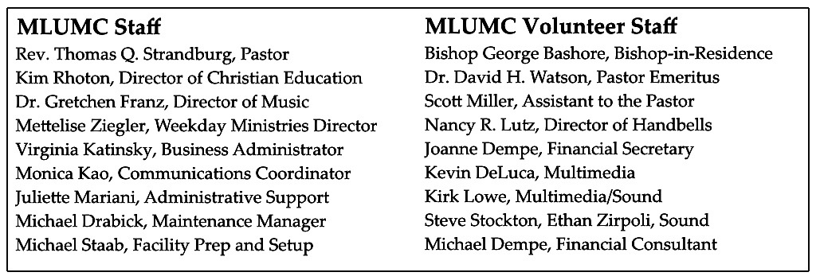

CALENDAR – SUNDAY, SEPTEMBER 2 THRU SATURDAY, SEPTEMBER 8

SUNDAY 9/2
8:30 am Worship Sanner Chapel
9:30 am Adult Sunday School – “Making Sense of the Bible” Wesley Hall
9:30-10:30 am Kids’ Sunday School Room 204
9:30-noon Nursery Room 204
10:45 am Worship Asbury Center
Kids Praise Welcome Center
12:00 pm Blood Pressure Screening Brookline Parlor

MONDAY 9/3
Office Closed – Labor Day

TUESDAY 9/4
7 pm Boy Scout Troop #23 Wesley Hall
7 pm Church Council Meeting Network

WEDNESDAY 9/5
7:30 am Northside Lunch Program Prep Asbury Kitchen
6:30 pm Cub Scout Recruitment Event Wesley Hall

THURSDAY 9/6
7:30 am Northside Lunch Program Prep Asbury Kitchen
9:00 am Hearts and Hands Epworth
6:30 pm Promise Bells Bell Room
7:30 pm Choir Rehearsal Choir Room

SATURDAY 9/8
8:00 am It’s a Guy Thing Wesley Hall

