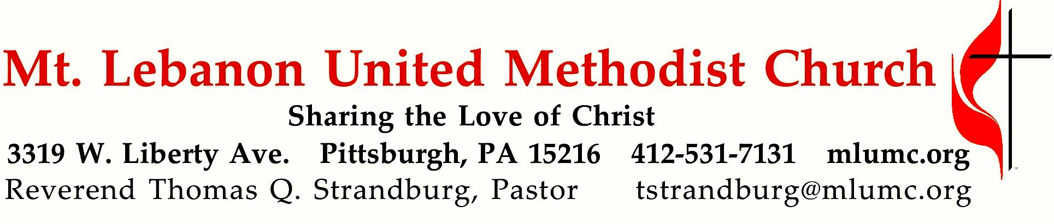
October 14, 2018 8:30 & 10:45
2018 Fall Worship Series
Be Opened!
Mark 7:35 tells the story of Christ’s healing of a man born deaf. As he placed his hands upon the man, Jesus exclaimed, “Be opened!” Throughout our fall worship series, we will hear the command of Jesus to open our lives to God’s transforming power through our prayers, our presence, our gifts, our service, and our witness, as a concrete expression of our thanksgiving to God.
WE GATHER IN GOD’S NAME …

Gathering Music
Hymnal 351 8:30 Pass me not, O gentle Savior (seated) Pass me not
Promise Bells 10:45 Jubilee Arnold B. Sherman

Greeting
Leader: Sing praises to the Lord, O you God’s faithful ones,
People: and give thanks to God’s holy name. Psalm 30:4

Announcements

Choral Introit 10:45 Psalm 95:1 Richard C. Baker
O come let us sing unto the Lord; let us make a joyful noise unto the rock of our salvation.

Call to Worship (standing)
Leader: As the rains pour from heaven, soaking the earth that it may produce good things…
People: So God pours God’s love upon us, that we, too, may produce goodnes and peace.
Leader: We have been blessed with many gifts and talents.
People: God desires that we use these gifts and talents for healing, peace, and hope.

Leader: Come let us worship and celebrate the mighty love and power of God.
People: Praise be to God who has blessed us in so many ways. AMEN

… TO GIVE PRAISE TO GOD …

Hymnal 127 Guide me, O thou great Jehovah (standing) Cwm Rhondda

Opening Prayer (in unison, standing)
Loving God, you have given us life and freedom. Everything we have and everything that we are is a gift from you. You call us to be stewards of these gifts. We give, because you first gave to us. May the level of our generosity mirror your own. Help us to always use your gifts wisely. Lead us as we share them generously with others. Enable our faithful stewardship to show the presence of Christ to all the world. We pray these things in His name.

Silent Prayer

Worship & Prayer 3131 Hear my prayer, O God (stanza 1, standing) Hymn Chant
Hear my prayer, O God, and listen to my plea;
faithful, righteous One, give ear and answer me.
Judge me not, I pray; no merit dare I claim;
knowing my own faults, I trust in your just Name.

… TO CELEBRATE THE FAMILY OF FAITH …

The Sign of Peace Please pass the peace to your neighbors as a sign of reconciliation and love.
Leader: The peace of Christ be with you.
People: And also with you.

Gathering Song James Ritchie
This, this is where children belong,
welcomed as part of the worshiping throng.
Water, God’s Word, bread and cup, prayer and song:
This is where children belong. WORDS & MUSIC: James Ritchie ©1999 Abingdon Press

Message for Young Disciples Rev. Thomas Q. Strandburg
All children are invited. Please sing as children come forward. After the children’s message at the 10:45 service, children ages 3 - 3rd grade may attend Kids Praise in the Welcome Center. Children will be escorted to and from Kids Praise by teachers. They will return to the Sanctuary near the end of the service.

… TO HEAR GOD’S WORD PROCLAIMED …

Hymnal 356 8:30 When we are living (seated) Somos del Señor
Chapel Bells 10:45 I will arise and go to Jesus arranged by Cathy Moklebust

Scripture Reading 8:30 Kathy Tremblay 10:45 Nate Jara
A Lesson from the New Testament
1 Timothy 6:17-19 The wealth of good works

Response
Leader: Hear what the Spirit is saying to God’s people.
People: Thanks be to God.

Pastoral Prayer

The Lord’s Prayer
Our Father, who art in heaven, hallowed be thy name. Thy kingdom come, thy will be done, on earth as it is in heaven. Give us this day our daily bread. And forgive us our trespasses, as we forgive those who trespass against us. Lead us not into temptation, but deliver us from evil. For thine is the kingdom, the power, and the glory forever. Amen.

Gospel Acclamation: Festival Alleluia (standing) James Chepponis Alleluia. (repeat 6 times)

Scripture Reading
A Lesson from the Gospel
Luke 12:13-21 Warning against greed

Response
Leader: The Word of the Lord.
People: Thanks be to God.

… TO OFFER OUR GIFTS AND TO DEDICATE OUR LIVES …

Offertory Anthem 10:45 Thomas W. Jefferson
Lord we praise you. Lord we bless you. Lord we magnify your holy name.
From the rising of the sun, to the setting of the same,
Lord, I will praise you and bless your name.
Lord you saved me. Lord, you raised me. Lord you lifted me from sin and shame.
And now I can tell the whole world now that I’m not the same.
And I’ll ever praise you and bless your name.

You made the heavens, and you made all the earth; sun, moon,
and stars you set into place.
Let all creation, with the whole human race, join in one chorus this anthem we raise.
We sing alleluia.

Hymnal 94 Doxology (standing) Lasst uns erfreuen
Praise God from whom all blessings flow;
Praise God, all creatures here below: Alleluia! Alleluia!
Praise God the source of all our gifts!
Praise Jesus Christ, whose power uplifts!
Praise the Spirit, Holy Spirit. Alleluia! Alleluia! Alleluia!

Prayer of Dedication

Sermon “Gifts from the Heart” Rev. Thomas Q. Strandburg

… TO GO REJOICING IN GOD’S NAME!

Open Our Hearts (standing, sung to the music of “Open My Eyes,” Hymnal 454) Open My Eyes

1. Open our hearts that we might pray,
Asking our Lord to show the way.
Give us the strength to follow your will
Bid us your calling while we’re still.

(Chorus)
Silently now we wait for thee
Ready our God your will to see
Open our hearts, illumine us
Spirit divine.

2. Open our minds to see your way,
Making our presence on this day.
And as we worship in this great church
Realizing this is where to search.

(Chorus)
Silently now we wait for thee
Ready our God your will to see
Open our minds, illumine us
Spirit divine.

3. Open our lives and freely give
So that your loved ones freely live.
And as our gifts spread through all the Earth
May the receivers gain new birth.

(Chorus)
Silently now we wait for thee
Ready our God your will to see
Open our lives, illumine us
Spirit divine.

Benediction

Hymnal 665 Go now in peace (standing, sing as a canon with pulpit side first) Go in peace
Go now in peace, go now in peace,
may the love of God surround you everywhere, everywhere you may go.

Our Third Vow – Gifts Today we are singing the third stanza of the new hymn, Open Our Hearts. This verse is emphasizing the vow we took to give to our church. Gifts can be our financial resources as well as our talents. As we sing the third stanza today, may we be reminded that we are expected to support our ministries with our financial gifts as well as our talents. The gifts that we bring do change lives! Fulfilling our vow of giving is in addition to our vows of praying for the church and being present in worship as well as other activities. These two vows are mentioned in the first two stanzas. Let us sing unto the Lord as we promise to fulfill our sacred vows of membership in The United Methodist Church.

Today’s Services
The flowers on the altar are given in celebration of Rob and Jane Spicher's 4th anniversary.

The flowers in the chancel are given by Gerry Oelschlager in honor of Corrine O. Potter.

Special music for the 10:45 service is provided by the Promise Bells and Chapel Bells, directed by Nancy R. Lutz; and the Chancel Choir with pianist Cori DeLuca who teaches piano in the area.

Greeters 8:30 Bob and Beverly Fester 10:45 Jane Casey and Gloria Barber

Acolytes Lydia Slater and Emily Shoff

Worship options for children We encourage children to participate in the Children’s Sermon at both services, and in Kids Praise during the 10:45 service. Nursery services are offered in Room 204 of the Education Building. Ask ushers or greeters and follow signs for direction.

Today’s Scriptures
1 Timothy 6:17-19
¹⁷As for those who in the present age are rich, command them not to be haughty, or to set their hopes on the uncertainty of riches, but rather on God who richly provides us with everything for our enjoyment. ¹⁸They are to do good, to be rich in good works, generous, and ready to share, ¹⁹thus storing up for themselves the treasure of a good foundation for the future, so that they may take hold of the life that really is life

Luke 12:13-21
¹³Someone in the crowd said to him, “Teacher, tell my brother to divide the family inheritance with me.” ¹⁴But he said to him, “Friend, who set me to be a judge or arbitrator over you?” ¹⁵And he said to them, “Take care! Be on your guard against all kinds of greed; for one’s life does not consist in the abundance of possessions.”¹⁶Then he told them a parable: “The land of a rich man produced abundantly. ¹⁷And he thought to himself, ‘What should I do, for I have no place to store my crops?’¹⁸Then he said, ‘I will do this: I will pull down my barns and build larger ones, and there I will store all my grain and my goods. ¹⁹And I will say to my soul, ‘Soul, you have ample goods laid up for many years; relax, eat, drink, be merry.’ ²⁰But God said to him, ‘You fool! This very night your life is being demanded of you. And the things you have prepared, whose will they be?’ ²¹So it is with those who store up treasures for themselves but are not rich toward God.”

Keep in Prayer

Hospitalized
Bishop George Bashore, Allegheny General
Olivia Woods, Mercy

Convalescing in Care Facilities
Bonnie Amos, Providence Point
Ed Clarke, Asbury Place
Grace Gullborg, Providence Point
John Katshir, Asbury Heights
Pat Seitz, Concordia
Carol Van Sickle, Marian Manor

Convalescing at Home
Jean Boyer, Mary Caldwell,
Mark Cleveland, John Dean, Joseph Festor,
Leon Grant, Jr., Susan Lichtenfels,
George Lindow, Sandy McPhee,
Bill Merchant, Diane Shaw,
Jinny Sheppard, Betty Trout

In the Military

Jason Boyer, SPC Natalie Brown,
Maj. Zachary Allen Finch, USMC,
James Iantelli, 1st Lt. Jaskiewicz,
S. Sgt. Keith Kimmell, Adam Kmick,

Sgt. Brendan Lamport,
Sgt. Matthew McConahan, Thomas Orda,
David Poncel, Sgt. Steven Reitz,
Capt. Scott B. Rushe, Pastor Rick Townes,
Maj. Azizi Wesmiller ,

Maj. Matthew C. Wesmiller ,
Sgt. Keith Scott Winkowski,

Sgt. Michael Zimmerman

From the WPA United Methodist Conference:

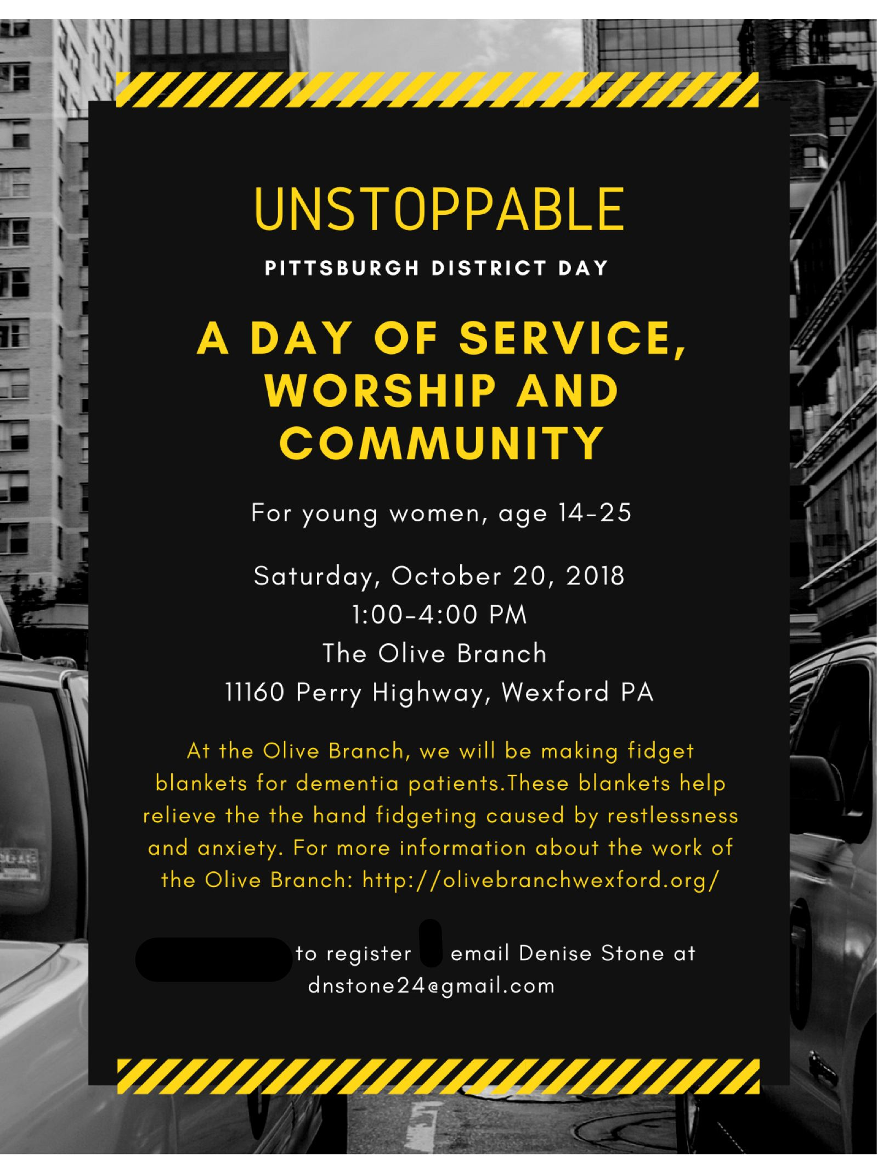

Honor or remember a loved one with a flower donation. The flowers that grace the sanctuary each week are generously donated by our church family members. This is a great way to honor or memorialize a special person, event, or milestone in your personal life or in the life of the church. To donate flowers on a particular Sunday, contact Lizzie Diller , 412-860-3614. The cost is $30 for the altar, narthex, or columbarium, and $60 for the chancel.

Podcasts of Sunday Sermons Catch up on messages from MLUMC with a podcast of Pastor Tom’s and others’ Sunday sermons. Sermons can be found at http://mlumc.buzzsprout.com or navigate to the site from the link on our webpage, www.mlumc.org. Sermons are also posted to iTunes. Full recordings of the service are available upon request.

CALENDAR – SUNDAY, OCTOBER 14 THRU SATURDAY, OCTOBER 20

SUNDAY 10/14
8:30 am Worship Sanner Chapel
9:30 am Sunday School for All Ages/Coffee Café Various/ Brookline Parlor
10:45 am Worship w/Kids Praise Sanctuary/ Welcome Center
11:50 am Youth Choir Choir Room
5 pm Youth Group Youth Room

MONDAY 10/15
7 pm Chapel Bells Rehearsal Bell Room
7 pm SPRC Library
7:30 pm Community Events and Outreach Wesley Hall

TUESDAY 10/16
6 pm Terrific Tuesday Asbury Center
7 pm Boy Scout Troop #23 Wesley Hall

WEDNESDAY 10/17
7 pm Trustees Welcome Center
7 pm Cub Scout Pack Wesley Hall
7 pm Koinonia Room 105

THURSDAY 10/18
6:30 pm Promise Bells Bells Room
7:30 pm Chancel Choir Rehearsal Choir Room

SATURDAY 10/20
10 am Food Distribution/Food Lift Free Market Food Pantry
4:30 pm Harshman/Blevins Wedding Sanctuary

