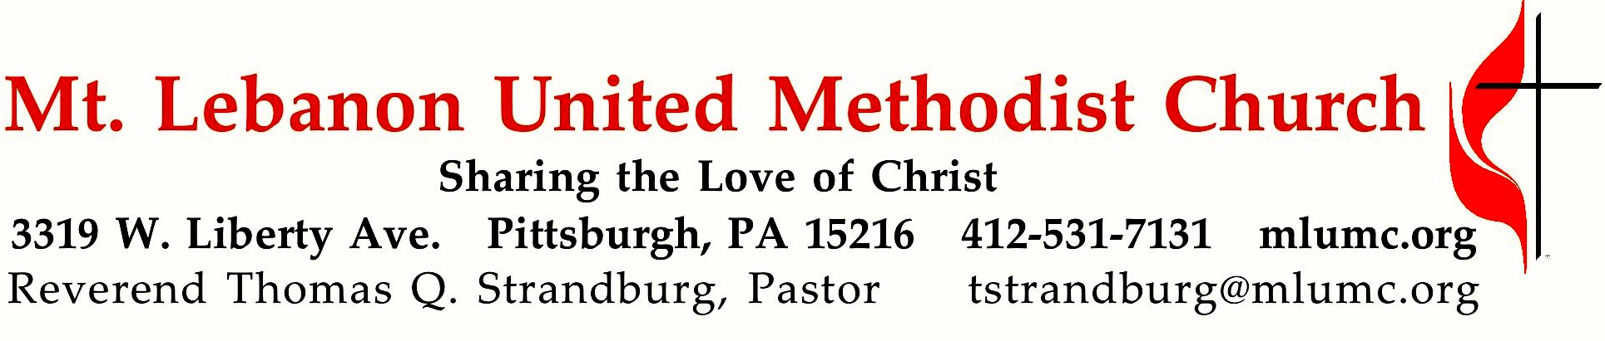

December 23, 2018 8:30 & 10:45
4th Sunday in Advent
“The Journey: Walking the Road to Bethlehem”

Today we follow Mary and Joseph as they travel from Nazareth to Bethlehem. Their most likely route would have passed many important sites from Israel’s history. Their journey would have been a “geographical recounting” of the history of God’s saving acts, the greatest of which is the child within Mary’s womb.

WE GATHER IN GOD’S NAME …
Gathering Music
Hymnal 218 It came upon the midnight clear (seated) Carol
Hymnal 217 Away in a manger Away in a manger

Greeting
Leader: Lift up your heads, O gates, and be lifted up, O ancient doors!
People: That the King of glory may come in. Psalm 24:7

Announcements

Choral Introit 10:45 Alleluia! His name shall be called Emmanuel. Alleluia! Karle Erickson

Call to Worship
Leader: We gather in preparation
People: for good news is about to be proclaimed.
Leader: We gather in expectation
People: for joy is about to break forth in our midst.
Leader: We gather in celebration
People: for we are those people who have said yes to the manger, yes to the one incarnate for others, yes to the wholeness of God.
Leader: In preparation and expectation, let us celebrate! Worship & Song

… TO GIVE PRAISE TO GOD …

Hymnal 248 On this day earth shall ring (standing) Personent Hodie

Opening Prayer (in unison)

God of Advent, of waiting and hoping, keep our hearts expectant, ready for your coming among us. God of Christmas, of celebration and rejoicing, make our hearts glad with the joy nothing can take from us. God of Epiphany, of hiding and making known, fill our hearts with wonder at the revelation of your glory that we have seen in Christ, our Lord. Worship & Song

Silent Prayer

Worship & Song 3119 (standing) Take, O take
Take, O take me as I am; summon out what I shall be;
set your seal upon my heart and live in me.

… TO CELEBRATE THE FAMILY OF FAITH …

Advent Candle Lighting (seated) 8:30 Rob and Jane Spicher
10:45 Laurie Lowe and Betsy Lowe Rayner

Hymnal 196 Come, thou long-expected Jesus (stanza 1, seated) Hyfrydol
Come, thou long-expected Jesus, born to set thy people free;
from our fears and sins release us, let us find our rest in thee.
Israel’s strength and consolation, hope of all the earth thou art;
dear desire of every nation, joy of every longing heart.

The Sign of Peace
Leader: The peace of Christ be with you.
People: And also with you.

Gathering Song
This, this is where children belong,
Welcomed as part of the worshiping throng.
Water, God’s Word, bread and cup, prayer and song:
This is where children belong.

Message for Young Disciples Rev. Thomas Q. Strandburg
(All children are invited. Please sing as children come forward.)
After the children’s message at the 10:45 service, children ages 3 through 3rd grade may attend Kids Praise in the Welcome Center. Children will be escorted to and from Kids Praise by teachers. They will return to the Sanctuary near the end of the service, and parents may meet them.

… TO HEAR GOD’S WORD PROCLAIMED …

Scripture Reading 8:30 Scott Miller 10:45 Sally Munro
A Lesson from the Hebrew Scriptures
Micah 5:2-5a The prophecy concerning Bethlehem

Response
Leader: Hear what the Spirit is saying to God’s people.
People: Thanks be to God.

Pastoral Prayer

The Lord’s Prayer
Our Father, who art in heaven, hallowed be thy name. Thy kingdom come, thy will be done, on earth as it is in heaven. Give us this day our daily bread. And forgive us our trespasses, as we forgive those who trespass against us. Lead us not into temptation, but deliver us from evil. For thine is the kingdom, the power, and the glory forever. Amen.

Gospel Acclamation: Festival Alleluia (standing) James Chepponis
Alleluia (repeat 6 times)

Scripture Reading
A Lesson from the Gospel
Luke 2:1-7 Jesus’ birth

Response
Leader: The Word of the Lord.
People: Thanks be to God.

… TO OFFER OUR GIFTS AND TO DEDICATE OUR LIVES …

Offertory Solo 8:30 O Holy Night! Adolphe Adam

Offertory Anthem 10:45 Winter’s Rose Praetorius, arr. Gregory M. Pysh
Lo, how a rose e’er blooming, from tender stem has sprung.
Of Jesse’s lineage coming, as seers of old have sung.
It came, a flow’ret bright, amid the cold of winter,
when half-spent was the night.

This flow’r whose fragrance tender with sweetness fills the air,
dispels in glorious splendor the darkness ev’rywhere.
True man, yet very God, from sin and death now save us
and share our ev’ry load.

Hymnal 219 What child is this (stanza 3) Greensleeves
So bring him incense, gold, and myrrh, come, peasant, king, to own him;
the King of kings salvation brings, let loving hearts enthrone him.
This, this is Christ the King, whom shepherds guard and angels sing;
haste, haste to bring him laud, the babe, the son of Mary.

Sermon “From Nazareth to Bethlehem” Rev. Thomas Q. Strandburg

Hymnal 250 Once in royal David’s city (standing) Irby

… TO GO REJOICING IN GOD’S NAME!
Benediction
Leader: A young woman is with child and shall bear a son. He shall be called Emmanuel.
People: We go forth with anticipation and longing. Share the good news — Emmanuel is coming. We hear, believe, accept and obey the Advent promise that God is with us.

Hymnal 211 O come, O come, Emmanuel (refrain) Veni Emmanuel
Rejoice! Rejoice! Emmanuel shall come to thee, O Israel.

Today’s Services
Special music for the 8:30 service is provided by John Esaias, a tenor in our Chancel Choir and a very active leader in this church.

Special music for the 10:45 service is provided by the Chancel Choir with Renate Sakins, oboe, and Richard Minnotte, percussionist and conductor.

Acolytes Abigail Nagle and Rachael Nagle

Greeters 8:30 Jeff Thayer 10:45 Betty Lou Reichard

Worship options for children We encourage children to participate in the Children’s Sermon at both services, and in Kids Praise during the 10:45 service. Nursery services are offered in Room 204 of the Education Building. Ask ushers or greeters and follow signs for direction.

Podcasts of Sunday Sermons Catch up on messages from MLUMC with a podcast of Pastor Tom’s and others’ Sunday sermons. Sermons can be found at http://mlumc.buzzsprout.com or navigate to the site from the link on our webpage, www.mlumc.org. Sermons also will be posted to iTunes. Full recordings of the service are available upon request.

Honor or remember a loved one with a flower donation. The flowers that grace the sanctuary each week are generously donated by our church family members. This is a great way to honor or memorialize a special person, event, or milestone in your personal life or in the life of the church. If you are interested in donating flowers on a particular Sunday, contact Lizzie Diller , 412-860-3614. The cost is $30 for the altar, narthex, or columbarium, and $60 for the chancel.

Today’s Scriptures

Micah 5:2-5a The Ruler from Bethlehem
²But you, O Bethlehem of Ephrathah, who are one of the little clans of Judah, from you shall come forth for me one who is to rule in Israel, whose origin is from of old, from ancient days. ³Therefore he shall give them up until the time when she who is in labor has brought forth; then the rest of his kindred shall return to the people of Israel. ⁴And he shall stand and feed his flock in the strength of the Lord, in the majesty of the name of the Lord his God. And they shall live secure, for now he shall be great to the ends of the earth; ⁵and he shall be the one of peace. If the Assyrians come into our land and tread upon our soil, we will raise against them seven shepherds and eight installed as rulers.

Luke 2:1-7 The Birth of Jesus 2In those days a decree went out from Emperor Augustus that all the world should be registered. ²This was the first registration and was taken while Quirinius was governor of Syria. ³All went to their own towns to be registered. ⁴Joseph also went from the town of Nazareth in Galilee to Judea, to the city of David called Bethlehem, because he was descended from the house and family of David. ⁵He went to be registered with Mary, to whom he was engaged and who was expecting a child.⁶While they were there, the time came for her to deliver her child. ⁷And she gave birth to her firstborn son and wrapped him in bands of cloth, and laid him in a manger, because there was no place for them in the inn.

Keep in Prayer

Hospitalized
Sara Mercer, Presbyterian

Convalescing in Care Facilities
Bonnie Amos, Providence Point
Ed Clarke, Asbury Place
John Katshir, Asbury Heights
Pat Seitz, Concordia
Carol Van Sickle, Marian Manor
Olivia Woods, Baptist Manor

Convalescing at Home
Bishop George Bashore, Jean Boyer,
Mary Caldwell, John Dean,
Joseph Festor, Leon Grant, Jr.,
Dave Lewis, Susan Lichtenfels,
Diane Shaw, Jinny Sheppard,

In the Military

Jason Boyer, SPC Natalie Brown,
Maj. Zachary Allen Finch, USMC,
James Iantelli, 1st Lt. Jaskiewicz,
S. Sgt. Keith Kimmell,
Sgt. Brendan Lamport,
Sgt. Matthew McConahan, Thomas Orda,
David Poncel, Sgt. Steven Reitz,
Capt. Scott B. Rushe, Pastor Rick Townes,
Maj. Azizi Wesmiller

Maj. Matthew C. Wesmiller ,
Sgt. Keith Scott Winkowski,

Sgt. Michael Zimmerman

Prayer Request and Update
Sara Mercer has asked that we update all of her dear friends at MLUMC concerning her current condition. Sara is once again hospitalized at UPMC Presbyterian Hospital, and is awaiting a lung transplant as soon as a donor is available. Her doctors
have asked that she not receive visitors, since the cold and flu season has now begun. Telephone calls would also not be advisable at this time. However, she would love to receive your prayers and your cards. You may send a greeting card to Sara at the following address:
UPMC Presbyterian Hospital
c/o Sara Mercer
200 Lothrop Street
Pittsburgh, PA 15213

Condolences
Sympathy is offered to the family of church member Betty Trout who passed away on Friday, December 6, 2018, at the age of 96. Prayers of comfort can be sent to her son:
Paul Steranka
725 Churchill Drive
Charleston, WV 25314
Betty’s life will be remembered at a memorial service in Sanner Chapel on Saturday, January 5th, at 3:00 p.m.

Each year the W PA Conference and Eastern German Conference create daily Advent and Christmas devotionals for use in our homes and churches. We have chosen devotionals from each week.

Rev. Richard C. Russell, Retired Pastor

For so God loved the world that he gave his one and only Son, that whoever believes in him shall not perish but have eternal life. For God did not send his Son into the world to condemn the world, but to save the world through him. Whoever believes in him is not condemned, but whoever does not believe stands condemned already because he has not believed in the name of God`s one and only Son. John 3: 16-18

The first verse of this reading is very familiar, oft quoted and often just held up as a reference. For God so loved the world, that he gave his one and only Son, that whoever believes in him should not perish, but have eternal life. We love to put this out there. We are even happy with the verse that states that this not an act of judgement, but of salvation. How wonderful this message as the time to celebrate the birth of that Son approaches. But what about that other verse, vs. 18? He who believes in him is not judged. He who doesn`t believe has been judged already, because he has not believed in the name of the only born Son of God. Many want us to end with verse 16, or even 17, but 18 reminds us of our part in this. We must believe! We must latch onto the gift salvation offered to us in the Christmas child/Man of the Cross. To reject or just ignore it to lose it. We have a choice to make, let us choose to accept that gift of Jesus this year. Prayer: Lord, help us to choose Jesus and follow him throughout the year, so that we know we are in the gift of salvation. Amen.

Mary Garber, Mt. Lebanon UMC

In that day this song will be sung in the land of Judah: We have a strong city; God makes salvation, its walls and ramparts. Open the gates that the righteous nation may enter, the nation that keeps faith. You will keep in perfect peace those whose minds are steadfast, because they trust in you. Trust in the Lord forever, for the Lord, the Lord himself, is the Rock eternal. Isaiah 26: 1-4

We have a strong city! The statement references Jerusalem, but this week it also references Pittsburgh, my home town. Strength means we all, stand together in supporting each other in prayer regardless of belief or background. This reference in Isaiah speaks loud and clear about the events in Pittsburgh. I know our news reached the world of the terribly violent situation that occurred in a synagogue in one of our culturally diverse sections of Pittsburgh. Eleven people were killed and 6 were wounded. As I write this the first funerals are occurring in a synagogue nearby. All week we have tried to console each other, Jewish and non- Jewish with words of caring and comfort. The tragedy has brought us together in ways I didn't think possible. Literally thousands of people have attended remembrance services, candle light vigils in a pouring rain storm, along with other church/synagogue gatherings. We try to understand why disasters like this happen, but we are determined not to let this divide us from the love of God. Our bishop Moore Koikoi suggested that for the next week, we spend17 minutes in meditation each day to help us to understand what it means to love each other. When you read this in December, memories will have faded a bit, but we all know, Jewish and Christians alike that God loves us, gives us strength to go on, and helps us be strong for each other. We have the strength of steel in our veins. The people of Pittsburgh still need the prayers of our German friends.

Thank you from the Sunday School! The Sunday school children and their teachers wish to thank you for your generous support of our Mission sale. We raised a record $240 that will be used to help support the orphan we sponsor in Zimbabwe. We couldn’t have done it without you!

New Code We will be changing the door codes on Wednesday, December 26th. Please call or visit the office for the new code.

Get to Know Your Acolytes - Rachael Nagle
Please welcome Rachael Nagle who is our newest member to the Acolyte Team. She is 10 years old, in the 4th Grade at Carmalt Elementary School in Brookline and the youngest daughter of John and Michele Nagle. Rachael’s big brother and big sister, Tre and Abigail are also participating Acolytes. Rachael’s family enjoys having pets which includes a black lab named Embers and a cat named Sandy. As a hobby, Rachael enjoys writing. Her favorite pastime however is gymnastics, where she learns and competes at the Brookline Dance Studio. Her best vacation was a trip to Canada that included time spent at a carnival with game playing. A yearly activity Racheal enjoys is Game Night hosted by her school. By far her favorite food is bacon especially enjoyed with dippy eggs. Her best TV show is Sponge Bob and most adored movie is the re-make of “IT”. When asked what she likes best about our church she said “Terrific Tuesday’s are Great”! Racheal’s aspirations are to someday be a professional gymnist or professional dancer. Say hello to Rachael when you see her.

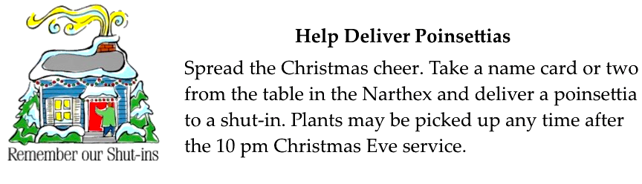

Christmas Memorials of Poinsettias, Food Pantry, and Family Fund

POINSETTIA DONOR IN MEMORY OF
Arthur Babuscio Marilyn and Arthur Babuscio
John & Shirley Baker Bill Ward
Jean Boyer Husband Dale E. Boyer & Thomas L. Watters
Ruth Ann & John Esaias Loved Ones
William H. Gullborg Grace E. Gullborg
Bob & Chris James Our Family
David & Cindy Jellison Jack & Margie Jellison
Phillip & Nancy Koch Agnew Family
Rosalie Peters Husband Vaughan Peters and children: Vaughan, Debra, & Paul
Betsy Rayner & Laurie Lowe Bill & June Lowe
Margaret M. Rodzwicz Frank R., Stella & Pete Rodzwicz, &
Ruth & Phillip Maddoz
Kathy, Rich, & Tremblay Family JoAnn Connor
Lily Yuan Parents

POINSETTIA DONOR IN HONOR OF
Connie Allen Loved Ones
Meghan, Andrew, & Matthew Buckley Kathleen Amant
Doris & Ford McBeth Mt. Lebanon UM Church Family past & present
Michael & Mary Paine Dwight Ladd & Edna Mae Starr &
Dwight Ladd Starr Jr.
Marsha & Brian Roche Nancy Lutz
Silas & Asher Ward Debbie & Gene Girman and Ann Metzger
Jim & Bev Weber Our Grandson Luke David Gerger
John & Marilyn White Our grandchildren: Brandon, Brooke, Drew, Abbey, Lizzy, & Rachael
Keith Will 2 sisters: Cheryl Lynne Will Graunke of Durham, NC and Cynthia Eva Will Argyle of Lancaster, OH

FOOD PANTRY DONOR IN MEMORY OF
Carolyn G. Dagg Ron Dagg, my husband and love of my life
Ruth Ann & John Esaias Paul Dodsworth (John's Uncle)
Carol K. Fairgrieve Linda K. Gruver, sister
May Frederick Bert Frederick
Joyce Gorman Walter & Ruth Genge (parents)
Kay Heberling Wade Heberling
Cheryl Herrington Father Art Herrington, Mother Shirley Herrington, and sisters Gail Beeson & Judy Androus
Dave & Vera Hughes Loved Ones
Chuck Hutchinson Loved Ones
Bob & Chris James Our Parents
Phillip & Nancy Koch Ivan & Mildred Koch
Bill & Karen Manning Helen Manning
Gail & Bob McCartney Helen & Lou Eppelsheimer
Bernice Merchant Betty Trout
Rosalie Peters Parents: William & Bessie Murray and George &
Helen Peters
Gale Seymour My parents Harry & Mary Seymour
Thomas & Kimberley Sloane Thomas P. & Thelma J. Sloane
Touscany Family James Walters, H. Pat Albright & John Touscany
Kathy, Rich, & Tremblay Family Dorothy & Dan Nesbit and Lois & Harold Tremblay
Keith Will Mr & Mrs Ralph Doll Will by their children: Keith Douglas Will, Cheryl Lynne Will, & Cynthia Eva Will
Lily Yuan Parents

FOOD PANTRY DONOR IN HONOR OF
Betty Lou Albright Bishop & Mrs. George B. Bashore, Rev. and Mrs. Thomas Q. Strandburg, Dr. and Mrs. David H. Watson, Mr. & Mrs. Scott Miller, and Mrs. Peg Smith
Mary Birks Children & Grandchildren
Jean Boyer My Family
Martha Clarke Ed Clarke
John & Donna College Shannon College
Paulette Colonna Liz DiPietro and her tireless efforts for our food pantry and in memory of our parents, Paul and Mary Wosotowsky
Bob & Beverly Festor Three children & five grandchildren
Kay Heberling Jeannine Heberling
Robert & Julie Kmick Our Grandsons
Martha Matthews Husband Bill, parents, and Grace Hoellein
Cindy Richard Kathleen Amant
Ken, Holly, Christian & Andy Schultz Lillian Schultz
Lillian Schultz Sandy & Joel Shaw and Ken & Holly and family
Karen & Don Shaffer Friends & Family
Richard & Andrea Sherwin Chuck & Brenda Vogel
Jane Spicher Rob Spicher
Kate, Kara, & Tori Touscany Sally Touscany
Thomas Wagner Byron & Mildred Wagner
John & Marilyn White Family & Friends

FAMILY FUND DONOR IN MEMORY OF
John & Shirley Baker Helen Manning
Chuck Hutchinson Loved Ones
Bob & Chris James Our Parents
Jon & Jan Rutter Our Parents

FAMILY FUND DONOR IN HONOR OF
Hazel Cope Betty Lou Albright
Frances Graham Church Volunteers
Bunny & John Knabb Our Grandchildren
Rob Spicher Jane Spicher
Keith Will 3 daughters: Patricia Lynn Will Krause, Barbara Lynn Will Myer, & Deborah Lynn Will Rambeau

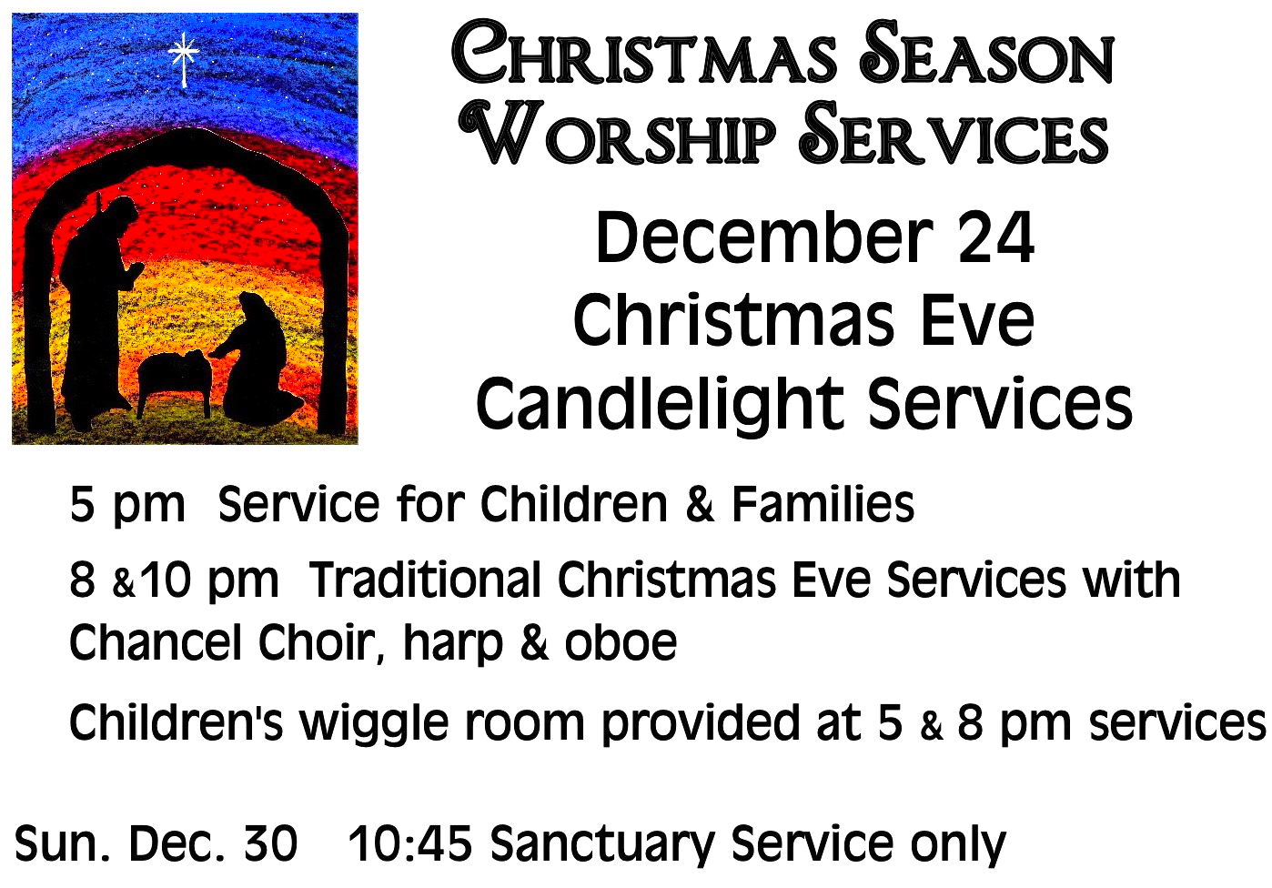

CALENDAR – SUNDAY, DECEMBER 23 THRU SATURDAY, DECEMBER 29

SUNDAY 12/23
8:30 am Worship Sanner Chapel
10:45 am Worship Sanctuary
Kids Praise Welcome Center
MONDAY 12/24
5:00 pm Christmas Eve Service for children & families Sanctuary
8:00 pm Traditional Christmas Eve Service Sanctuary
10:00 pm Traditional Christmas Eve Service Sanctuary

TUESDAY 12/25 OFFICE CLOSED FOR CHRISTMAS

WEDNESDAY 12/26 OFFICE CLOSED FOR CHRISTMAS
7:00 pm Bear, Tiger, Wolf Den Meeting Various

