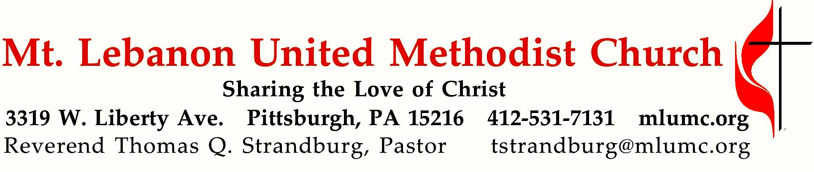

January 20, 2019 8:30 & 10:45
2nd Sunday after Epiphany
Unafraid: Living with Hope in Uncertain Times

A major type of fear in our world today is fear of “the other.” We tend to fear most our fellow human beings who are different from us – those of other religions, races, and socioeconomic groups. The words of 1 John 4 challenge us to combat fear with love, for “perfect love casts out fear.”

WE GATHER IN GOD’S NAME …
Gathering Music
Hymnal 369 Blessed assurance (seated) Assurance

Greeting
Leader: Sing to the Lord a new song! Sing to the Lord, all the earth!
People: Declare God’s glory among the nations; declare his wondrous works among all people.
Psalm 96:1, 3
Announcements

Choral Introit 10:45 John 1: 1 Karle Erickson
In the beginning was the Word, and the Word was with God, and the Word was God.
Call to Worship
Leader: Where can we go and seek refuge?
People: We’ve taken refuge in you, Lord.
Leader: Who can rescue us from the grip of the wrongdoer?
People: We plead our case to you, Lord.
Leader: Is there any place we can run to escape the spiritual dangers that surround us?
People: The Lord is our rock and refuge.
Leader: Let us lift up our praise as we celebrate the deliverance found only in the Lord. Joanne Carlson Brown

… TO GIVE PRAISE TO GOD …

Hymnal 89 Joyful, joyful, we adore thee (standing) Hymn to Joy

Opening Prayer (in unison)
God of hope and love, let your light shine upon us this day. Let your patience and kindness flow through us, inspiring us to new depths of love and hope. Transform our love, that we might overcome envy and resentment, and rejoice in justice and righteousness. Envelop us in your love, that believing, hoping, and enduring may become our way of life on the path of love. In loving hope, we pray. Amen.

Silent Prayer

Worship & Song 3159 (stanza 1, standing) Raymond
Let our earth be peaceful, let our hearts be hopeful,
let our hands be gentle for the love of God.

… TO CELEBRATE THE FAMILY OF FAITH …

Open Our Hearts January Emphasis Prayer
Open our hearts that we might pray,
Asking our Lord to show the way.
Give us the strength to follow your will
Bid us your calling while we’re still.

(Chorus)
Silently now we wait for thee
Ready our God your will to see
Open our hearts, illumine us
Spirit divine.

The Sign of Peace
Leader: The peace of Christ be with you.
People: And also with you.

Gathering Song
This, this is where children belong,
Welcomed as part of the worshiping throng.
Water, God’s Word, bread and cup, prayer and song:
This is where children belong. WORDS AND MUSIC: James Ritchie ©1999 Abingdon Press
Message for Young Disciples Rev. Thomas Q. Strandburg
(All children are invited. Please sing as children come forward.)
After the children’s message at the 10:45 service, children ages 3 - 3rd grade may attend Kids Praise in the Welcome Center. Children will be escorted to and from Kids Praise by teachers. They will return to the Sanctuary near the end of the service, and parents may meet them.

… TO HEAR GOD’S WORD PROCLAIMED …

Scripture Reading 8:30 Judi Phelps 10:45 Jessica Langston
A Lesson from the New Testament
1 John 4:18-21 God’s love and ours

Response
Leader: Hear what the Spirit is saying to God’s people.
People: Thanks be to God.

Pastoral Prayer

The Lord’s Prayer
Our Father, who art in heaven, hallowed be thy name. Thy kingdom come, thy will be done, on earth as it is in heaven. Give us this day our daily bread. And forgive us our trespasses, as we forgive those who trespass against us. And lead us not into temptation, but deliver us from evil. For thine is the kingdom, the power, and the glory forever. Amen.

Gospel Acclamation: Festival Alleluia (standing) James Chepponis
Alleluia (repeat 6 times)

Scripture Reading
A Lesson from the Gospels
John 2:1-11 Jesus at the wedding feast in Cana

Response
Leader: The Word of the Lord.
People: Thanks be to God.

… TO OFFER OUR GIFTS AND TO DEDICATE OUR LIVES …

Offertory Anthem 10:45 Michael Burkhardt
Beloved, God’s chosen, put on as a garment compassion, forgiveness,
and goodness of heart.
Above all, before all, let love be your raiment that binds into one ev’ry dissonant part.
Within, call forth Wisdom, to dwell in you richly;
let peace rule your hearts and that peace be of Christ.
Hymnal 219 What child is this (stanza 3, standing) Greensleeves
So bring him incense, gold, and myrrh, come, peasant, king, to own him;
the King of kings salvation brings, let loving hearts enthrone him.
This, this is Christ the King, whom shepherds guard and angels sing;
haste, haste to bring him laud, the babe, the son of Mary.

Prayer of Dedication

Sermon “Unafraid: The Fear of ‘the other’” Rev. Thomas Q. Strandburg

Call to Prayer – You are invited to approach the communion rail for prayer during the singing of our last hymn. Following the service, extended time for prayer will also be offered in the Sanctuary (8:30 service) or Sanner Chapel (10:45 service).

… TO GO REJOICING IN GOD’S NAME!

Hymnal 650 Give me the faith which can remove (stanzas 1-3, standing) Carey’s (Surrey)
Benediction

Hymnal 650 (stanza 4, standing) Carey’s (Surrey) Enlarge, inflame, and fill my heart with boundless charity divine,
so shall I all my strength exert, and love them with a zeal like thine,
and lead them to thy open side, the sheep for whom the Shepherd died.

Today’s Services

The flowers on the altar are given by Keith Donald Will, Cheryl Lynn Graunke and Cynthia E. Argyle in loving memory of their parents, Ralph Doll Will and Ethel Gloria Smith Will.

The flowers in the chancel are given by the Chancel Choir with loving thoughts toward Bernice Merchant and family upon the recent passing of Bill.

Special music for the 10:45 service is provided by the Chancel Choir, conducted by Richard Minnotte.
Acolytes Lydia Slater and Logan Walters

Greeters 8:30 Pete and Beth Santore 10:45 Chuck and Brenda Vogel

Worship options for children We encourage children to participate in the Children’s Sermon at both services, and in Kids Praise during the 10:45 service. Nursery services are offered in Room 204 of the Education Building. Ask ushers or greeters and follow signs for direction.

Today’s Scriptures

1 John 4:18-21

¹⁸There is no fear in love, but perfect love casts out fear; for fear has to do with punishment, and whoever fears has not reached perfection in love. ¹⁹We love because he first loved us. ²⁰Those who say, ‘I love God’, and hate their brothers or sisters, are liars; for those who do not love a brother or sister whom they have seen, cannot love God whom they have not seen. ²¹The commandment we have from him is this: those who love God must love their brothers and sisters also.

John 2:1-11

The Wedding at Cana
2On the third day there was a wedding in Cana of Galilee, and the mother of Jesus was there. ²Jesus and his disciples had also been invited to the wedding. ³When the wine gave out, the mother of Jesus said to him, ‘They have no wine.’ ⁴And Jesus said to her, ‘Woman, what concern is that to you and to me? My hour has not yet come.’ ⁵His mother said to the servants, ‘Do whatever he tells you.’ ⁶Now standing there were six stone water-jars for the Jewish rites of purification, each holding twenty or thirty gallons. ⁷Jesus said to them, ‘Fill the jars with water.’ And they filled them up to the brim. ⁸He said to them, ‘Now draw some out, and take it to the chief steward.’ So they took it. ⁹When the steward tasted the water that had become wine, and did not know where it came from (though the servants who had drawn the water knew), the steward called the bridegroom ¹⁰and said to him, ‘Everyone serves the good wine first, and then the inferior wine after the guests have become drunk. But you have kept the good wine until now.’ ¹¹Jesus did this, the first of his signs, in Cana of Galilee, and revealed his glory; and his disciples believed in him.
Podcasts of Sunday Sermons Catch up on messages from MLUMC with a podcast of Pastor Tom’s and others’ Sunday sermons. Sermons can be found at http://mlumc.buzzsprout.com or navigate to the site from the link on our webpage, www.mlumc.org. Sermons also will be posted to iTunes. Full recordings of the service are available upon request.

Honor or remember a loved one with a flower donation. The flowers that grace the sanctuary each week are generously donated by our church family members. This is a great way to honor or memorialize a special person, event, or milestone in your personal life or in the life of the church. If you are interested in donating flowers on a particular Sunday, contact Lizzie Diller , 412-860-3614. Beginning Feb. 1, the cost is $40 for the altar, narthex, or columbarium arrangements, and $80 for the chancel flowers.

Kerygma Adult Sunday School 9:30-10:30 am The Library
Jan. 20 What do Methodists believe?
Jan. 27 Retreat
Feb. 3 Dead Sea Scrolls Part 2
Feb. 10 Hazel Cope: Peace Makers During WWI
Feb. 17 Clark Remington: Practices of Christian Contemplation: Centering Prayer, Meditation, Lectio Divina
Feb. 24 Pastor Tom Strandburg: The Life and Ministry of the Apostle Paul
Mar. 3 Pastor Tom Strandburg: The Life and Ministry of the Apostle Paul
All Are Welcome

Keep in Prayer

Convalescing in Care Facilities
Bonnie Amos, Providence Point
Ed Clarke, Asbury Place
John Katshir, Asbury Heights
Pat Seitz, Concordia
Carol Van Sickle, Marian Manor
Olivia Woods, Baptist Manor

Convalescing at Home
Bishop George Bashore, Jean Boyer,
Mary Caldwell, John Dean,
Joseph Festor, Leon Grant, Jr.,
Dave Lewis, Susan Lichtenfels,
George Lindow, Sara Mercer,
Diane Shaw, Jinny Sheppard
Ruth Seip

In the Military

Jason Boyer, SPC Natalie Brown,
Maj. Zachary Allen Finch, USMC,
James Iantelli, 1st Lt. Jaskiewicz,
S. Sgt. Keith Kimmell,
Sgt. Brendan Lamport,
Sgt. Matthew McConahan, Thomas Orda,
David Poncel, Sgt. Steven Reitz,
Capt. Scott B. Rushe, Pastor Rick Townes,
Maj. Azizi Wesmiller

Maj. Matthew C. Wesmiller,
Sgt. Keith Scott Winkowski,

Sgt. Michael Zimmerman

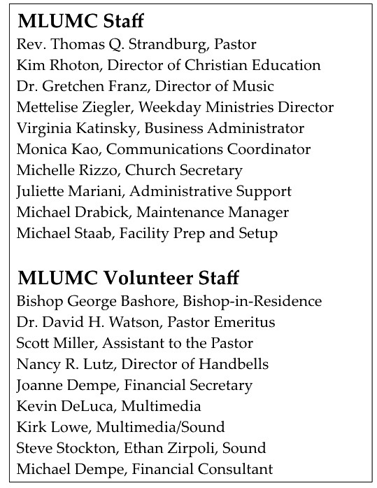

CALENDAR – SUNDAY, JANUARY 20 THRU SATURDAY, JANUARY 26

SUNDAY 1/20
8:30 am Worship Sanner Chapel
9:30 am Sunday School for All Ages/Coffee Café Various/Brookline Parlor 10:45 am Worship Sanctuary
5 pm Youth Group Youth Room
6:30 pm Eagle Scout Board of Review Epworth, Network, Wesley

MONDAY 1/21
OFFICE CLOSED-MARTIN LUTHER KING JR. DAY
7 pm Chapel Bells Rehearsal Bell Room
7:30 pm Community Events and Outreach Wesley Hall

TUESDAY 1/22
7 pm Boy Scout Meeting WesleyHall

WEDNESDAY 1/23
7 pm Bear Den Meeting Bridges
7 pm Tiger Den Meeting Epworth
7 pm Wolf Den Meeting Network

THURSDAY 1/24
6:30 pm Promise Bells Rehearsal Bell Room
7:30 pm Chancel Choir Rehearsal Choir Room

