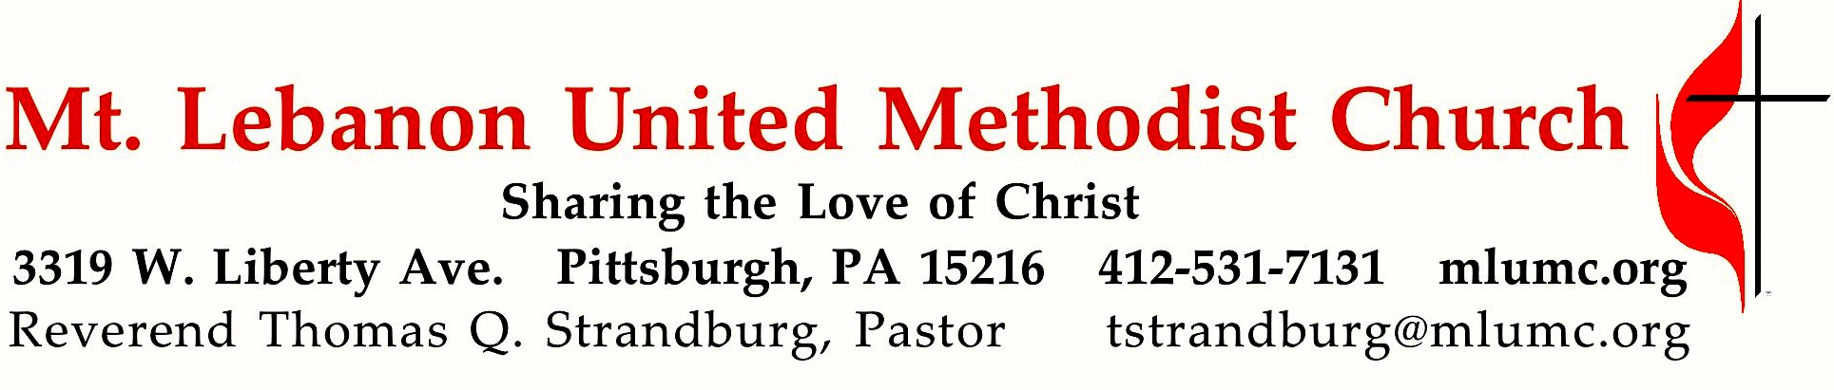

January 27, 2019 8:30 & 10:45
3rd Sunday after Epiphany
Unafraid: Living with Hope in Uncertain Times

We all feel lonely at times, and loneliness can often be a source of fear and anxiety. In Genesis 2:18 God said, “It is not good for Adam to be alone.” At the very beginning of scripture we find the human need for companionship. The church is called to be the kind of “authentic community” that people long for.

WE GATHER IN GOD’S NAME …
Gathering Music
Hymnal 358 Dear Lord and Father of mankind (stanzas 1-2, seated) Rest
Worship & Song 3139 We cannot measure how you heal (stanza 1) Candler

Greeting
Leader: Sing to the Lord a new song! Sing to the Lord, all the earth!
People: Declare God’s glory among the nations; declare his wondrous works among all people.
Psalm 96:1, 3
Announcements

Choral Introit 10:45 John 1: 1 Karle Erickson
In the beginning was the Word, and the Word was with God, and the Word was God.
Call to Worship
Leader: What a beautiful thing to be called to worship!
People: What a gift to come together in praise!
Leader: We are different people with different lives and different stories.
People: But, in Christ, we all are one.

… TO GIVE PRAISE TO GOD …

Hymnal 57 O for a thousand tongues to sing (stanzas 1, 3, 5, 6, standing) Azmon

Opening Prayer (in unison)
God of creation, your heavens and earth shout out the amazing news of your power and glory. God of justice, your laws of mercy and goodness reveal your vision of harmony for all people. God of love, your Son Jesus Christ proclaims the amazing news of your liberation for all who are hungry, poor, or oppressed. May we join with all of creation to become your message of love to the world. Amen.

Silent Prayer

Worship & Song 3159 (stanza 1, standing) Raymond
Let our earth be peaceful, let our hearts be hopeful,
let our hands be gentle for the love of God.

… TO CELEBRATE THE FAMILY OF FAITH …

January Emphasis: Prayer George Bashore (8:30)
Open our hearts that we might pray, Nathan Jara and George Bashore (10:45)
Asking our Lord to show the way.
Give us the strength to follow your will
Bid us your calling while we’re still.

Silently now we wait for thee
Ready our God your will to see
Open our hearts, illumine us
Spirit divine.

The Sign of Peace
Leader: The peace of Christ be with you.
People: And also with you.

Gathering Song
This, this is where children belong,
Welcomed as part of the worshiping throng.
Water, God’s Word, bread and cup, prayer and song:
This is where children belong. WORDS AND MUSIC: James Ritchie ©1999 Abingdon Press

Message for Young Disciples Rev. Thomas Q. Strandburg
(All children are invited. Please sing as children come forward.)
After the children’s message at the 10:45 service, children ages 3 - 3rd grade may attend Kids Praise in the Welcome Center. Children will be escorted to and from Kids Praise by teachers. They will return to the Sanctuary near the end of the service, and parents may meet them.

… TO HEAR GOD’S WORD PROCLAIMED …

Scripture Reading 8:30 Kathy Tremblay 10:45 Jane Casey
A Lesson from the Hebrew Scriptures
Psalm 139:1-10 God’s continual presence with us

Response
Leader: Hear what the Spirit is saying to God’s people.
People: Thanks be to God.

Pastoral Prayer

The Lord’s Prayer
Our Father, who art in heaven, hallowed be thy name. Thy kingdom come, thy will be done, on earth as it is in heaven. Give us this day our daily bread. And forgive us our trespasses, as we forgive those who trespass against us. And lead us not into temptation, but deliver us from evil. For thine is the kingdom, the power, and the glory forever. Amen.

Gospel Acclamation: Festival Alleluia (standing) James Chepponis
Alleluia (repeat 6 times)

Scripture Reading
A Lesson from the Gospels
Luke 4:14-21 Jesus in the synagogue in Nazareth

Response
Leader: The Word of the Lord.
People: Thanks be to God.

… TO OFFER OUR GIFTS AND TO DEDICATE OUR LIVES …

Offertory Anthem 10:45 Traditional Irish, arranged by Dan Forrest
Be thou my vision, O Lord of my heart; naught be all else to me, save that thou art,
thou my best thought by day or by night, waking or sleeping, thy presence my light.
Be thou my wisdom, and thou my true word, I ever with thee and thou with me, Lord;
thou my great Father and I thy true son, thou in me dwelling, and I with thee one.
Riches I heed not, nor man’s empty praise, thou mine inheritance, now and always,
thou and thou only, first in my heart, high king of heaven, my treasure thou art.
High king of heaven, my victory won, may I reach heaven’s joys, O bright heaven’s Sun,
heart of my own heart, whatever befall, still be my vision, O Ruler of all.

Hymnal 219 What child is this (stanza 3, standing) Greensleeves
So bring him incense, gold, and myrrh, come, peasant, king, to own him;
the King of kings salvation brings, let loving hearts enthrone him.
This, this is Christ the King, whom shepherds guard and angels sing;
haste, haste to bring him laud, the babe, the son of Mary.

Prayer of Dedication

Sermon “UNAFRAID: “Fear of Loneliness” Rev. Thomas Q. Strandburg

Call to Prayer – You are invited to approach the communion rail for prayer during the singing of our last hymn. Following the service, extended time for prayer will also be offered in the Sanctuary (8:30 service) or Sanner Chapel (10:45 service).

… TO GO REJOICING IN GOD’S NAME!

Worship & Song 3139 We cannot measure how you heal (standing) Candler
Benediction

Worship & Song 3139 We cannot measure how you heal (end of stanza 3, standing) Candler Lord, let your Spirit meet us here to mend the body, mind and soul,
to disentangle peace from pain and make your broken people whole.

Today’s Services

The flowers on the altar are given by John and Ruth Ann Esaias in loving memory of John's parents, the Rev. John and Ruth Esaias. Today would have been their 72nd wedding anniversary.
The flowers in the chancel are given by Ken, Holly, Christian and Andy Schultz in loving memory of John F. Nigon, Holly's father.

Special music for the 10:45 service is provided by the Chancel Choir with pianist Cori DeLuca, a member of the church who teaches in the area.
Acolytes Cameron and Luke Grabowski
Greeters 8:30 Paulette Colonna 10:45 David Seitz

Worship options for children We encourage children to participate in the Children’s Sermon at both services, and in Kids Praise during the 10:45 service. Nursery services are offered in Room 204 of the Education Building. Ask ushers or greeters and follow signs for direction.

Today’s Scriptures

Psalm 139:1-10

The Inescapable God
To the leader. Of David. A Psalm.
¹ O Lord, you have searched me and known me.
² You know when I sit down and when I rise up;
you discern my thoughts from far away.
³ You search out my path and my lying down,
and are acquainted with all my ways.
⁴ Even before a word is on my tongue,
O Lord, you know it completely.
⁵ You hem me in, behind and before,
and lay your hand upon me.
⁶ Such knowledge is too wonderful for me;
it is so high that I cannot attain it.
⁷ Where can I go from your spirit?
Or where can I flee from your presence?
⁸ If I ascend to heaven, you are there;
if I make my bed in Sheol, you are there.
⁹ If I take the wings of the morning
and settle at the farthest limits of the sea,
¹⁰ even there your hand shall lead me,
and your right hand shall hold me fast.

Luke 4:14-21

The Beginning of the Galilean Ministry
14 Then Jesus, filled with the power of the Spirit, returned to Galilee, and a report about him spread through all the surrounding country. ¹⁵He began to teach in their synagogues and was praised by everyone.

The Rejection of Jesus at Nazareth
16 When he came to Nazareth, where he had been brought up, he went to the synagogue on the sabbath day, as was his custom. He stood up to read, ¹⁷and the scroll of the prophet Isaiah was given to him. He unrolled the scroll and found the place where it was written:
¹⁸ ‘The Spirit of the Lord is upon me, because he has anointed me to bring good news to the poor.
He has sent me to proclaim release to the captives
and recovery of sight to the blind, to let the oppressed go free,
¹⁹ to proclaim the year of the Lord’s favour.’
²⁰And he rolled up the scroll, gave it back to the attendant, and sat down. The eyes of all in the synagogue were fixed on him. ²¹Then he began to say to them, ‘Today this scripture has been fulfilled in your hearing.’

Podcasts of Sunday Sermons Catch up on messages from MLUMC with a podcast of Pastor Tom’s and others’ Sunday sermons. Sermons can be found at http://mlumc.buzzsprout.com or navigate to the site from the link on our webpage, www.mlumc.org. Sermons also will be posted to iTunes. Full recordings of the service are available upon request.

Honor or remember a loved one with a flower donation. The flowers that grace the sanctuary each week are generously donated by our church family members. This is a great way to honor or memorialize a special person, event, or milestone in your personal life or in the life of the church. If you are interested in donating flowers on a particular Sunday, contact Lizzie Diller , 412-860-3614. Beginning Feb. 1, the cost is $40 for the altar, narthex, or columbarium arrangements, and $80 for the chancel flowers.

Keep in Prayer

Convalescing in Care Facilities
Bonnie Amos, Providence Point
Ed Clarke, Asbury Place
John Katshir, Asbury Heights
Pat Seitz, Concordia
Olivia Woods, Baptist Manor

Convalescing at Home
Bishop George Bashore, Jean Boyer,
Mary Caldwell, John Dean,
Joseph Festor, Leon Grant, Jr.,
Dave Lewis, Susan Lichtenfels,
George Lindow, Sara Mercer,
Diane Shaw, Jinny Sheppard
Ruth Seip, Carol Van Sickle

In the Military

Jason Boyer, SPC Natalie Brown,
Maj. Zachary Allen Finch, USMC,
James Iantelli, 1st Lt. Jaskiewicz,
S. Sgt. Keith Kimmell,
Sgt. Brendan Lamport,
Sgt. Matthew McConahan, Thomas Orda,
David Poncel, Sgt. Steven Reitz,
Capt. Scott B. Rushe, Pastor Rick Townes,
Maj. Azizi Wesmiller

Maj. Matthew C. Wesmiller,
Sgt. Keith Scott Winkowski,

Sgt. Michael Zimmerman

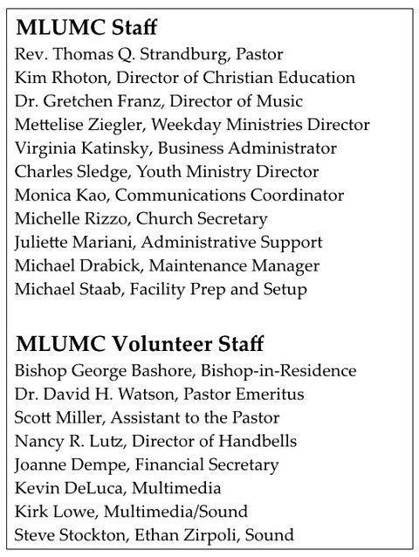

Dear Church Family,

Thank you so much for all the help, good wishes and prayers that you have sent to me. I have been overwhelmed by all of your cards and notes. I am doing well and look forward to being back among you soon.

With Warmest Appreciation,
Sara Mercer
CALENDAR – SUNDAY, JANUARY 27 THRU SATURDAY, FEBRUARY 2

SUNDAY 1/27
8:30 am Worship Sanner Chapel
9:30 am Prayer Walk Sanner Chapel
9:30 am Sunday School for All Ages/Coffee Café Various/Brookline Parlor 10:45 am Worship Sanctuary
11:45 am Prayer Walk Sanctuary
11:50 am Youth Choir Rehearsal Choir Room
5 pm Youth Group Asbury
7 pm Troop 23 Leadership Meeting Wesley

MONDAY 1/28
7 pm Chapel Bells Rehearsal Bell Room
7:15 pm Zwickau Committee Welcome Center

TUESDAY 1/29
6 pm Terrific Tuesday Asbury
7 pm Boy Scout Meeting WesleyHall

WEDNESDAY 1/30
1 pm Small Group Book Study Brookline Parlor

THURSDAY 1/31
2:45 pm Family Promise Goal Setting Meeting Welcome Center
6:30 pm Promise Bells Rehearsal Bell Room
7:30 pm Chancel Choir Rehearsal Choir Room

SATURDAY 2/2
10 am Food Distribution Food Pantry

