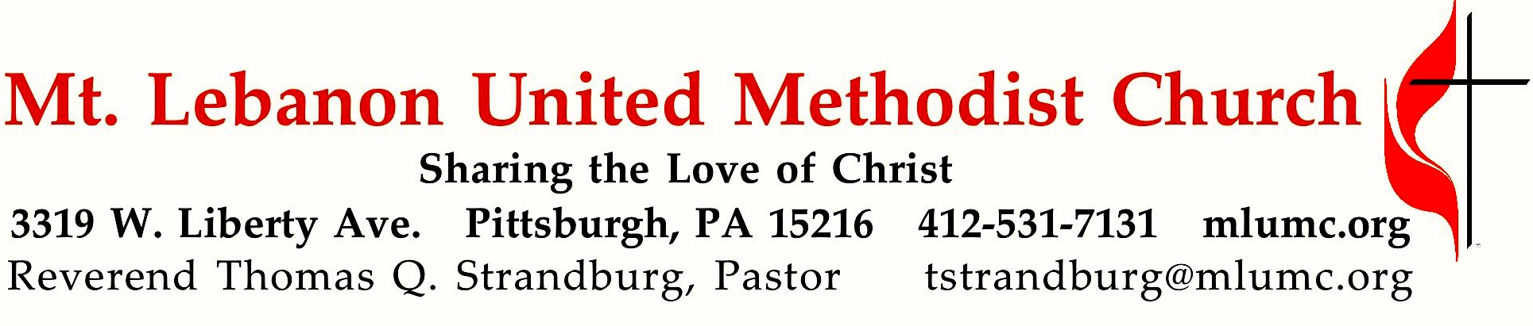

January 6, 2019 8:30 & 10:45
Epiphany Sunday
The Feast of Epiphany commemorates the manifestation of Christ to the Gentiles, as represented by the Magi in Matthew 2:1-12. It begins a season of the Christian calendar during which we celebrate the appearance of God in the lives of real people. Be alert for the appearance of God in your life today!

WE GATHER IN GOD’S NAME …
Gathering Music
Hymnal 254 We three kings (seated) Kings of Orient

Announcements

Choral Introit 10:45 Thomas Keesecker
Arise, shine; for your light has come,
and the glory of the Lord has risen upon you.

Call to Worship
Leader: Arise! Shine!
People: God's light has come to reveal The Way in this New Year.
Leader: Arise! Shine!
People: The glory of the Lord has risen upon us.
Leader: Arise! Shine!
People: God's light penetrates the darkness that covers the world.
Leader: Arise! Shine!
People: Nations shall come to God's light and kings to the brightness of God's dawn.
ALL: Arise! Shine! For the Glory of the Lord has risen upon us.

… TO GIVE PRAISE TO GOD …

Hymnal 245 The first Noel (standing) The first Noel

Lighting of the Christ Candle

Opening Prayer (in unison)
Light of God, illumine the path that leads us to healing, hope and salvation.
Glory of God, fill this sanctuary and expose the darkness that stalks our souls.
Light of God, shine with such brightness that we marvel in awe.
Glory of God, fill each temple of the Holy Spirit present today.
Light of God, Glory of God, we welcome you in this place.

Silent Prayer

Worship & Song 3159 (stanza 1, standing) Raymond
Let our earth be peaceful
Let our earth be peaceful, let our hearts be hopeful,
let our hands be gentle for the love of God.

… TO CELEBRATE THE FAMILY OF FAITH …

Open Our Hearts January Emphasis Prayer John Esaias
Open our hearts that we might pray,
Asking our Lord to show the way.
Give us the strength to follow your will
Bid us your calling while we’re still.

(Chorus)
Silently now we wait for thee
Ready our God your will to see
Open our hearts, illumine us
Spirit divine.

The Sign of Peace
Leader: The peace of Christ be with you.
People: And also with you.

Gathering Song
This, this is where children belong,
Welcomed as part of the worshiping throng.
Water, God’s Word, bread and cup, prayer and song:
This is where children belong.

Message for Young Disciples Rev. Kimberly Greway
(All children are invited. Please sing as children come forward.)
After the children’s message at the 10:45 service, children ages 3 - 3rd grade may attend Kids Praise in the Welcome Center. Children will be escorted to and from Kids Praise by teachers. They will return to the Sanctuary near the end of the service, and parents may meet them.

… TO HEAR GOD’S WORD PROCLAIMED …

Scripture Reading 8:30 Liz DiPietro 10:45 Dovey Alexander
A Lesson from the Old Testament
Isaiah 60:1-9 God’s Light enters a darkened world

Response
Leader: Hear what the Spirit is saying to God’s people.
People: Thanks be to God.

Pastoral Prayer

The Lord’s Prayer
Our Father, who art in heaven, hallowed be thy name. Thy kingdom come, thy will be done, on earth as it is in heaven. Give us this day our daily bread. And forgive us our trespasses, as we forgive those who trespass against us. Lead us not into temptation, but deliver us from evil. For thine is the kingdom, the power, and the glory forever. Amen.

Gospel Acclamation: Festival Alleluia (standing) James Chepponis
Alleluia (repeat 6 times)

Scripture Reading
A Lesson from the Gospel
Matthew 2:1-12 Arrival of the Magi

Response
Leader: The Word of the Lord.
People: Thanks be to God.

… TO OFFER OUR GIFTS AND TO DEDICATE OUR LIVES …

Offertory Duet 8:30 O Holy Night Adolphe Adam

Offertory Anthem 10:45 Howard Helvey
What star is this, with beams so bright, more lovely than the noonday light?
‘Tis sent to announce a newborn king, glad tidings of our God to bring.
‘Tis now fulfilled what God decreed, ‘From Jacob shall a star proceed;’
and lo! the Eastern sages stand to read in heaven the Lord’s command.
While outward signs the star displays, and inward light the Lord conveys
and urges them, with tender might, to seek the giver of the light.
O Jesus, fount of boundless grace, your star calls us to seek your face;
prepare our hearts to fully shine and share your light and love divine.

Hymnal 219 What child is this (stanza 3) Greensleeves
So bring him incense, gold, and myrrh, come, peasant, king, to own him;
the King of kings salvation brings, let loving hearts enthrone him.
This, this is Christ the King, whom shepherds guard and angels sing;
haste, haste to bring him laud, the babe, the son of Mary.

Prayer of Dedication

Sermon “Epiphany” Rev. Kimberly Greway

Sacrament of Holy Communion Rev. Kimberly Greway
During communion, join the choir singing the first 2 stanzas of hymns beginning with #223.
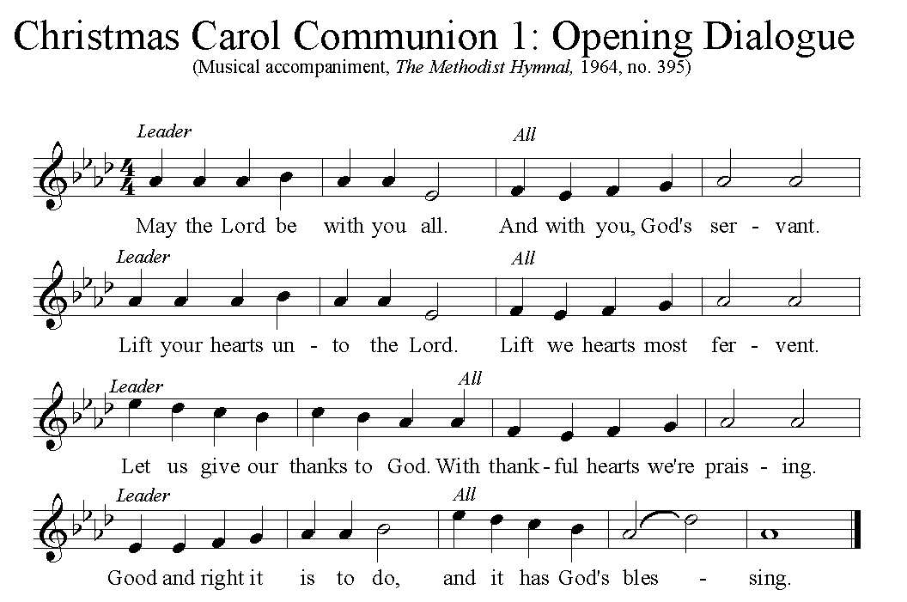

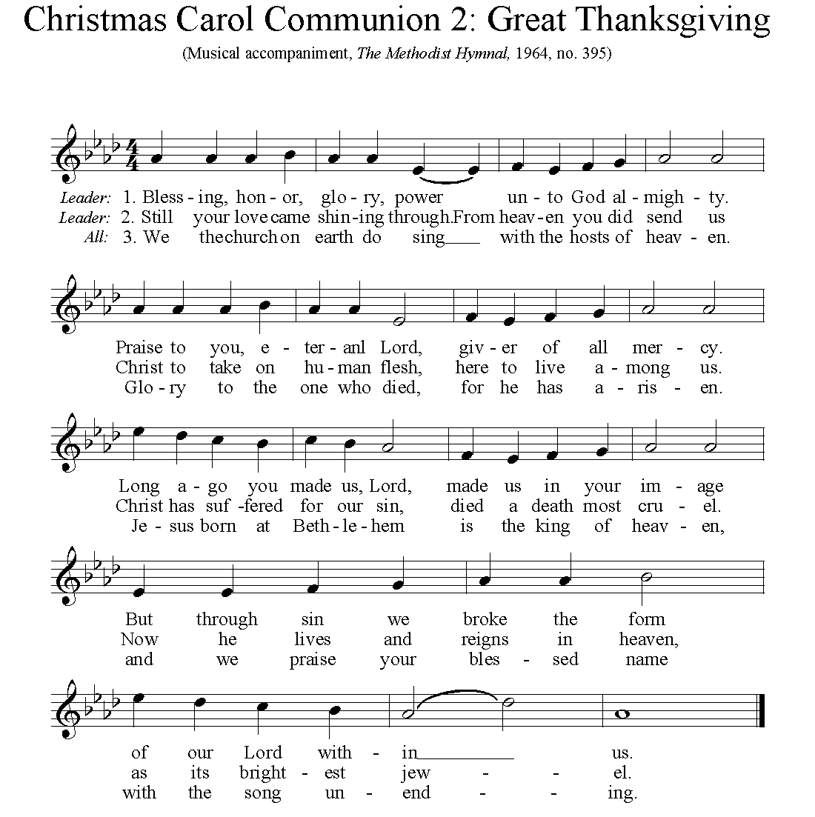

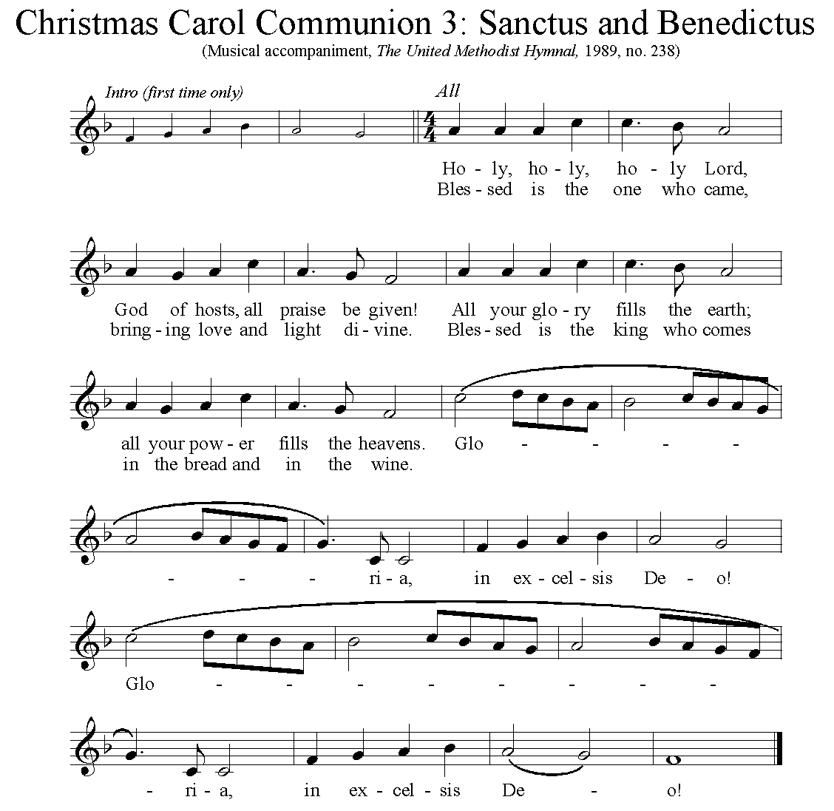

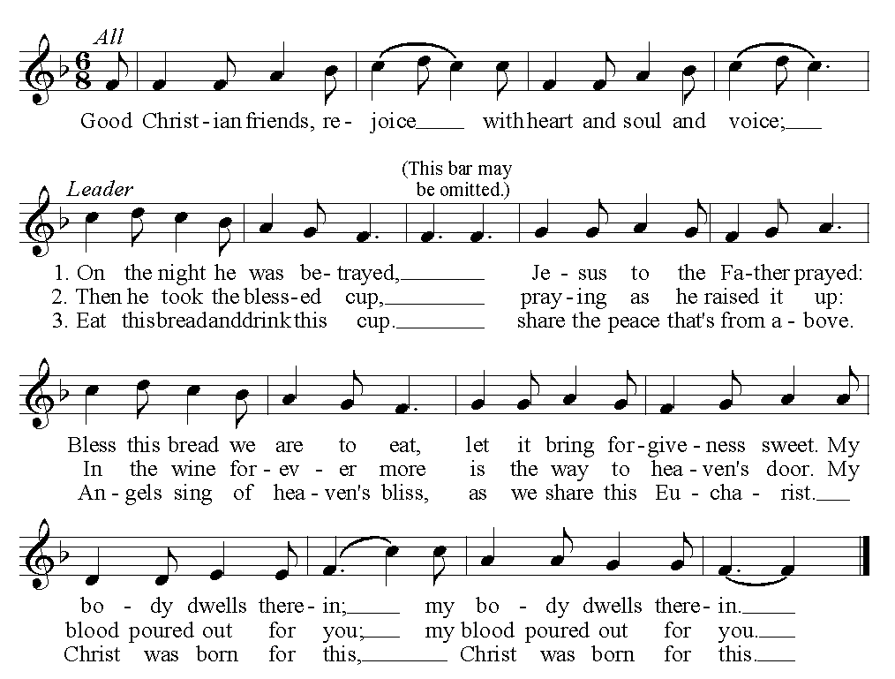

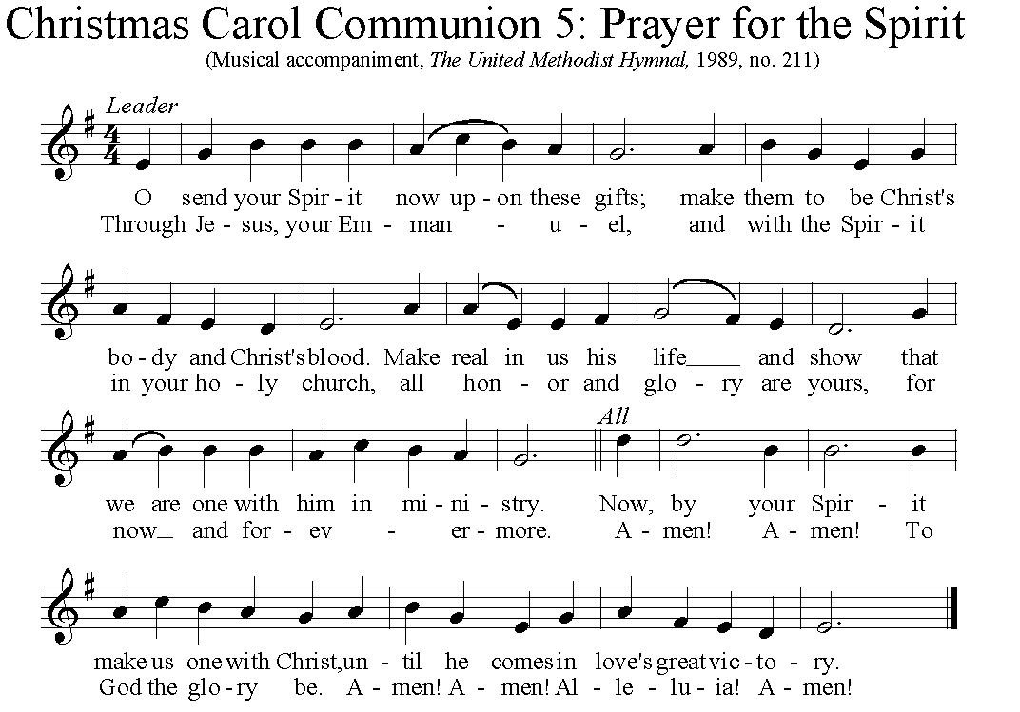

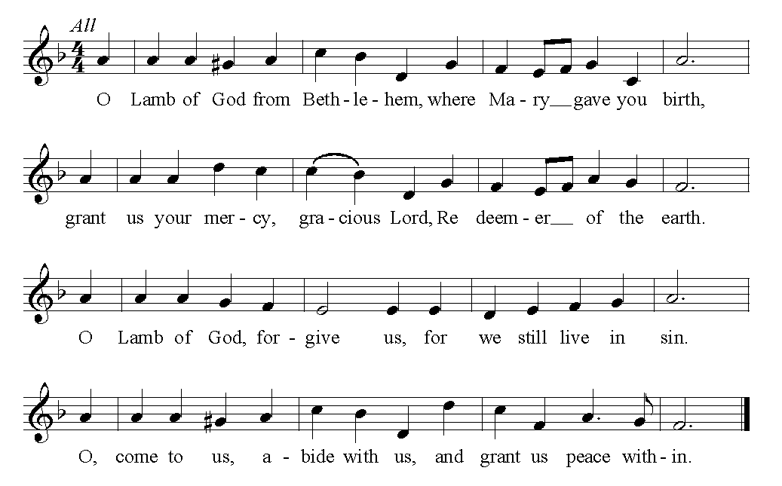

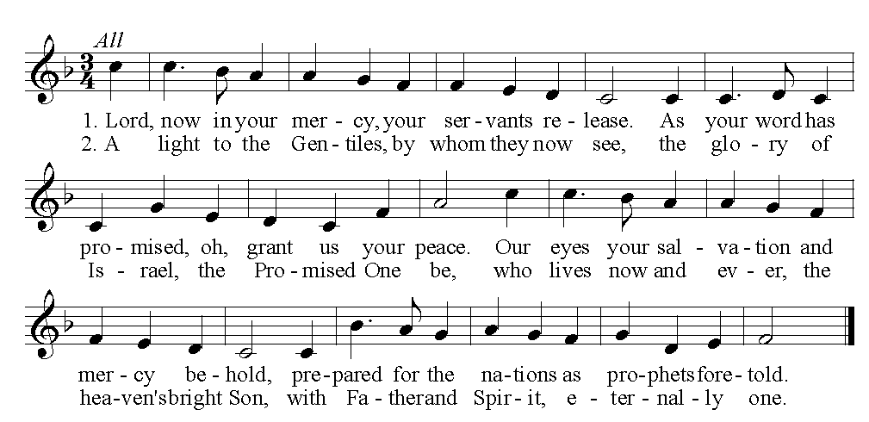
… TO GO REJOICING IN GOD’S NAME!

Hymnal 247 O Morning Star, how fair and bright (standing) Wie schön Leuchtet

Benediction

Hymnal 245 The first Noel (refrain) The first Noel
Noel, Noel, Noel, Noel, born is the King of Israel.

Today’s Services
Rev. Kimberly Greway, formerly our Associate Pastor from 2006-2010, is the Director of Chaplaincy Services at the Allegheny County Jail and Chief Operating Officer of the Foundation of HOPE which serves inmates and ex-offenders in Allegheny County.

The flowers on the altar are given in loving memory of Lucille Munro who was born 100 years ago on December 23, 1918.

The flowers in the chancel are given in honor and appreciation for all the wonderful work done by the staff here at MLUMC.

Special music for the 8:30 service is provided by Rev. Kimberly Greway and John Esaias, a member of the Chancel Choir.

Special music for the 10:45 service is provided by the Chancel Choir conducted by Ryan A. Keeling.

Acolytes Cary Young and Anastasia Sunder

Greeters 8:30 Fran Travis 10:45 Fern Frank

Worship options for children We encourage children to participate in the Children’s Sermon at both services, and in Kids Praise during the 10:45 service. Nursery services are offered in Room 204 of the Education Building. Ask ushers or greeters and follow signs for direction.

Podcasts of Sunday Sermons Catch up on messages from MLUMC with a podcast of Pastor Tom’s and others’ Sunday sermons. Sermons can be found at http://mlumc.buzzsprout.com or navigate to the site from the link on our webpage, www.mlumc.org. Sermons also will be posted to iTunes. Full recordings of the service are available upon request.

Honor or remember a loved one with a flower donation. The flowers that grace the sanctuary each week are generously donated by our church family members. This is a great way to honor or memorialize a special person, event, or milestone in your personal life or in the life of the church. If you are interested in donating flowers on a particular Sunday, contact Lizzie Diller , 412-860-3614. The cost is $30 for the altar, narthex, or columbarium, and $60 for the chancel.

Today’s Scriptures

Isaiah 60:1-9

Arise, shine; for your light has come, and the glory of the Lord has risen upon you. ²For darkness shall cover the earth, and thick darkness the peoples; but the Lord will arise upon you, and his glory will appear over you. ³Nations shall come to your light, and kings to the brightness of your dawn. ⁴Lift up your eyes and look around; they all gather together, they come to you; your sons shall come from far away, and your daughters shall be carried on their nurses’ arms. ⁵Then you shall see and be radiant; your heart shall thrill and rejoice, because the abundance of the sea shall be brought to you, the wealth of the nations shall come to you. ⁶A multitude of camels shall cover you, the young camels of Midian and Ephah; all those from Sheba shall come. They shall bring gold and frankincense, and shall proclaim the praise of the Lord. ⁷All the flocks of Kedar shall be gathered to you, the rams of Nebaioth shall minister to you; they shall be acceptable on my altar, and I will glorify my glorious house. ⁸Who are these that fly like a cloud, and like doves to their windows?
⁹For the coastlands shall wait for me, the ships of Tarshish first, to bring your children from far away, their silver and gold with them, for the name of the Lord your God, and for the Holy One of Israel, because he has glorified you.

Matthew 2: 1-12

2In the time of King Herod, after Jesus was born in Bethlehem of Judea, wise men from the East came to Jerusalem, ²asking, “Where is the child who has been born king of the Jews? For we observed his star at its rising, and have come to pay him homage.” ³When King Herod heard this, he was frightened, and all Jerusalem with him; ⁴and calling together all the chief priests and scribes of the people, he inquired of them where the Messiah was to be born. ⁵They told him, “In Bethlehem of Judea; for so it has been written by the prophet: ⁶‘And you, Bethlehem, in the land of Judah, are by no means least among the rulers of Judah; for from you shall come a ruler who is to shepherd my people Israel.’” ⁷Then Herod secretly called for the wise men and learned from them the exact time when the star had appeared. ⁸Then he sent them to Bethlehem, saying, “Go and search diligently for the child; and when you have found him, bring me word so that I may also go and pay him homage.”

⁹When they had heard the king, they set out; and there, ahead of them, went the star that they had seen at its rising, until it stopped over the place where the child was. ¹⁰When they saw that the star had stopped, they were overwhelmed with joy. ¹¹On entering the house, they saw the child with Mary his mother; and they knelt down and paid him homage. Then, opening their treasure chests, they offered him gifts of gold, frankincense, and myrrh. ¹²And having been warned in a dream not to return to Herod, they left for their own country by another road.

Prayer, Our January Membership Vow The Church Council has endorsed emphasizing our membership vows during 2019. In January, we will emphasize prayer during our worship services and through small group studies. During each service, there will be an opportunity to pray at the communion rail or with a prayer partner in Sanner Chapel after the service. In addition, Cindy Biery will be leading a small group study on Wednesday, January 30, February 13, and March 13 from 1:00-2:30 in Brookline Parlor. The book being used is Practicing the Presence of God Using Modern English by Brother Lawrence. Sign up to join the group at the desk in the vestibule. In addition, Pastor Tom will lead two Terrific Tuesday discussions using the same book.

Keep in Prayer

Convalescing in Care Facilities
Bonnie Amos, Providence Point
Ed Clarke, Asbury Place
John Katshir, Asbury Heights
Pat Seitz, Concordia
Carol Van Sickle, Marian Manor
Olivia Woods, Baptist Manor

Convalescing at Home
Bishop George Bashore, Jean Boyer,
Mary Caldwell, John Dean,
Joseph Festor, Leon Grant, Jr.,
Dave Lewis, Susan Lichtenfels,
George Lindow, Sara Mercer,
Diane Shaw, Jinny Sheppard

In the Military

Jason Boyer, SPC Natalie Brown,
Maj. Zachary Allen Finch, USMC,
James Iantelli, 1st Lt. Jaskiewicz,
S. Sgt. Keith Kimmell,
Sgt. Brendan Lamport,
Sgt. Matthew McConahan, Thomas Orda,
David Poncel, Sgt. Steven Reitz,
Capt. Scott B. Rushe, Pastor Rick Townes,
Maj. Azizi Wesmiller

Maj. Matthew C. Wesmiller,
Sgt. Keith Scott Winkowski,

Sgt. Michael Zimmerman

In sympathy
Condolences are offered to the family of church member Bill Merchant, who died, surrounded by his family, on Wednesday, December 26, 2018. Words of sympathy and prayers may be sent to his wife Bernice and their family:
2806 Queensboro Ave.
Pittsburgh, PA 15226

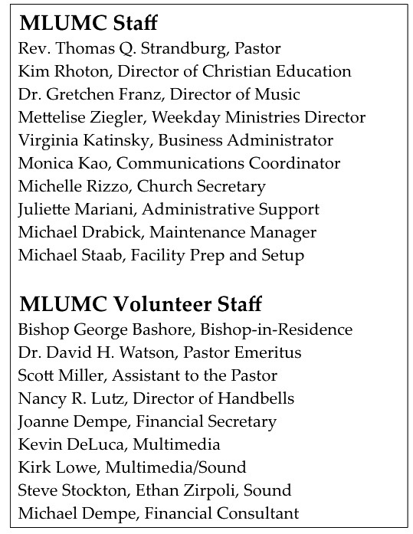

CALENDAR – SUNDAY JANUARY 6 THRU SATURDAY, JANUARY 12

SUNDAY 1/6
8:30 am Worship Sanner Chapel
9:30 am Sunday School for All Ages/Coffee Café Various/Brookline Parlor 10:45 am Worship Sanctuary
12:00 pm Blood Pressure Screening Brookline Parlor
5 pm Youth Group Youth Room

MONDAY 1/7
5:30 pm Faith for Today Meeting Wesley
7:00 pm Church Council Meeting Wesley
7:00 pm Chapel Bells Rehearsal Bell Room

TUESDAY 1/8
6:30 pm Family Promise Board of Directors Library
7:00 pm Board of Reviews Network
7:00 pm Boy Scout Meeting Wesley
7:00 pm Cub Scout Committee Planning Meeting Epworth

WEDNESDAY 1/9
6:00 pm Finance Committee Meeting Welcome Center
7 pm Bear, Tiger, Wolf Den Meeting Various

THURSDAY 1/10
6:30 pm Promise Bells Rehearsal Bell Room
7:00 pm Education Committee Meeting Brookline Parlor
7:30 pm Chancel Choir Rehearsal Choir Room

FRIDAY 1/11
12:00 pm It’s a Guy Thing Prep Wesley/Asbury Kitchen
7:00 pm Pk 870 Arrow of Light Meeting Epworth

SATURDAY 1/12
8 am It’s a Guy Thing Wesley/Asbury Kitchen
12 pm Three Rivers Ringers Asbury

