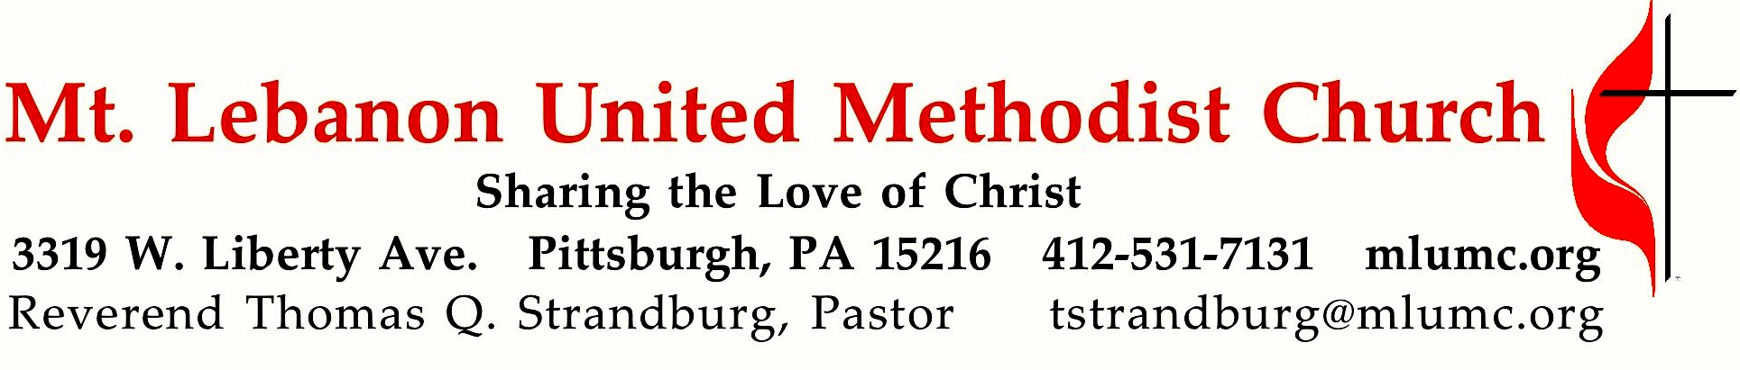
The Sixth Sunday of Easter
Memorial Day Weekend

Today’s New Testament reading, from the last two chapters of the biblical canon, proposes the culmination of this world in a city with no sun, no moon and no night. The Lamb of God will be its light! When we walk toward God, we have all the light we need.

May 26, 2019 8:30 & 10:45

WE GATHER IN GOD’S NAME …

Gathering Music Hymnal 437 This is my song (seated) Finlandia

Greeting
Leader: Praise the Lord from heaven!
Praise God on the heights!
People: Let us praise the name of the Lord,
who alone is exalted;
whose name is above earth and heaven.
Psalm 148:1, 13

Announcements

What a friend we have in rummage,
And a place for it to go
What a privilege to donate
All our stuff to raise some dough
Oh what help it offers many
Oh what gifts it will provide
All because we sponsor missions
In the name of God world wide.
Now we need some willing workers
Happy faces needed too
It will be a fun experience
Even if it’s like a zoo
You can make a big, big difference
You can help the mighty cause
All because God needs your service
So His Kingdom will not pause.

Introit 10:45 Karle Erickson
Alleluia! Our Savior Jesus Christ has abolished death
and brought life and immortality to the Gospel. Alleluia!
©2005 Birnamwood Publications, OneLicense A-700887, all rights reserved

Call to Worship
Leader: Praise to the Lamb who is seated on the Throne of Heaven!
People: Praise be to God who offers God’s love to us!
Leader: Let us sing continually of God’s wisdom, and power, and might.
People: Let our voices be raised in joyful celebration!
Leader: Worthy is the Lamb to receive honor, and glory, and majesty.
People: Let our hearts rejoice at God’s redeeming love for us.

… TO GIVE PRAISE TO GOD …

Hymnal 79 Holy God, we praise thy name (stanzas 1-4, standing) Grosser Gott

Opening Prayer
With joy we come this day to the house of the Lord. God provides for us abundantly even when we doubt and fear, even when we turn away. God is faithful. Open our hearts today, O Lord, to hear your word for us that we may become faithful disciples of our Lord all our days. Amen.

Silent Prayer

Worship & Song 3121 If you believe and I believe ( standing) If you believe

TO CELEBRATE THE FAMILY OF FAITH …

Sacrament of Baptism (10:45) page 39
Olivia Lee McCartney,
daughter of Matthew & Kimberly McCartney

Congregational Response:
Pastor: Will you nurture one another in the Christian faith and life
and include Olivia Lee now before you in your care?
People: With God's help we will proclaim the good news
and live according to the example of Christ.
We will surround Olivia Lee
with a community of love and forgiveness,
that she may grow in her service to others.
We will pray for her,
that she may be a true disciple,
who walks in the way that leads to life.

The Sign of Peace
Leader: The peace of Christ be with you.
People: And also with you.

Gathering Song
This, this is where children belong,
welcomed as part of the worshiping throng.
Water, God’s Word, bread and cup, prayer and song:
This is where children belong. words and music: James Ritchie ©1999 Abingdon Press

Message for Young Disciples
All children are invited. Please sing as children come forward. After the children’s message at the 10:45 service, children ages 3 - 3rd grade may attend Kids Praise in the Welcome Center. Children will be escorted to and from Kids Praise by teachers. They will return to the Sanctuary near the end of the service.

Worship & Song 3127 I have a dream (standing) Repton

… TO HEAR GOD’S WORD PROCLAIMED …

Open Our Hearts May Emphasis Witness 10:45 Kathy Michael

Open our mouths to witness love
Spreading the news of God above.
Give us the strength to glorify you,
In all our conversations, new.

Silently now we wait for thee
Ready our God your will to see
Open our mouths, illumine us
Spirit divine.

Scripture Reading 8:30 Betsy Harkins 10:45 Judy Moeller
A Lesson from the New Testament
Revelation 21:10, 22 – 22:5 The Lamb will be its light

Response
Leader: Hear what the Spirit is saying to God’s people.
People: Thanks be to God.

Pastoral Prayer

The Lord’s Prayer
Our Father, who art in heaven, hallowed be thy name. Thy kingdom come, thy will be done, on earth as it is in heaven. Give us this day our daily bread. And forgive us our trespasses, as we forgive those who trespass against us. And lead us not into temptation, but deliver us from evil. For thine is the kingdom, and the power, and the glory forever. Amen.

Good News Acclamation: (standing) James J. Chepponis
Alleluia. (sing 4 times)

Scripture Reading
A Lesson from the Gospel
John 14:13-29 The Comforter will come

Response
Leader: The Word of the Lord.
People: Thanks be to God.

… TO OFFER OUR GIFTS AND TO DEDICATE OUR LIVES …

Offertory Anthem 10:45 Jacob’s Ladder African-American Spiritual, arr. K. A. Newbury

We are climbing Jacob’s ladder, refrain: soldiers of the Cross.
Every round goes higher, higher, refrain. Sinners, do you love my Jesus: refrain.
If you love Him, why not serve Him: refrain.
Rise! Shine! Give God glory! refrain. We are climbing higher, higher, refrain.

Hymnal 94 (standing) Lasst uns erfreuen
Praise God, from whom all blessings flow;
Praise God, all creatures here below; Alleluia! Alleluia!
Praise God, the source of all our gifts!
Praise Jesus Christ, whose power uplifts!
Praise the Spirit, Holy Spirit! Alleluia! Alleluia! Alleluia!
adapt. © 1989 The U. Methodist Publishing House

Prayer of Dedication

Sermon “The Lamb is the Light” Rev. Thomas Q. Strandburg
… TO GO REJOICING IN GOD’S NAME!

Hymnal 433 All who love and serve your city (stanzas 1-4, standing) Charlestown

Benediction

Hymnal 433 All who love and serve your city (stanza 5, standing) Charlestown

Today’s Services
The flowers in the Chancel are given by Robert Simonton in loving memory of his parents, Lee and Ruth Simonton, and his grandparents.
The flowers on the altar are given by Lesley Troy in honor and memory of loved ones.

Special music for the 10:45 service is provided by the Chancel Choir, conducted by Julia Scott, a member of the Chancel Choir and a harpist by profession.

Worship options for children We encourage children to participate in the Children’s Sermon at both services, and in Kids Praise during the 10:45 service. Nursery services are offered in Room 204 of the Education Building. Ask ushers or greeters and follow signs for direction.

Honor or remember a loved one with a flower donation. The flowers that grace the sanctuary each week are generously donated by our church family members. This is a great way to honor or memorialize a special person, event, or milestone in your personal life or in the life of the church. If you are interested in donating flowers on a particular Sunday, contact Lizzie Diller , 412-860-3614. The cost is $33 for the altar, narthex, or columbarium arrangements, and $66 for the chancel flowers.

Podcasts of Sunday Sermons Catch up on messages from MLUMC with a podcast of Pastor Tom’s and others’ Sunday sermons. Sermons can be found at http://mlumc.buzzsprout.com or navigate to the site from the link on our webpage, www.mlumc.org. Sermons also will be posted to iTunes. Full recordings of the service are available upon request.

Today’s Scriptures

Revelation 21:10, 22 – 22:5
¹⁰And in the spirit he carried me away to a great, high mountain and showed me the holy city Jerusalem coming down out of heaven from God.²²I saw no temple in the city, for its temple is the Lord God the Almighty and the Lamb. ²³And the city has no need of sun or moon to shine on it, for the glory of God is its light, and its lamp is the Lamb. ²⁴The nations will walk by its light, and the kings of the earth will bring their glory into it. ²⁵Its gates will never be shut by day—and there will be no night there.²⁶People will bring into it the glory and the honor of the nations. ²⁷But nothing unclean will enter it, nor anyone who practices abomination or falsehood, but only those who are written in the Lamb’s book of life.
22Then the angel showed me the river of the water of life, bright as crystal, flowing from the throne of God and of the Lamb ²through the middle of the street of the city. On either side of the river is the tree of life with its twelve kinds of fruit, producing its fruit each month; and the leaves of the tree are for the healing of the nations. ³Nothing accursed will be found there any more. But the throne of God and of the Lamb will be in it, and his servants will worship him; ⁴they will see his face, and his name will be on their foreheads. ⁵And there will be no more night; they need no light of lamp or sun, for the Lord God will be their light, and they will reign forever and ever.

John 14:13-29
¹³I will do whatever you ask in my name, so that the Father may be glorified in the Son. ¹⁴If in my name you ask me for anything, I will do it.
¹⁵”If you love me, you will keep my commandments. ¹⁶And I will ask the Father, and he will give you another Advocate, to be with you forever.¹⁷This is the Spirit of truth, whom the world cannot receive, because it neither sees him nor knows him. You know him, because he abides with you, and he will be in you.
¹⁸”I will not leave you orphaned; I am coming to you. ¹⁹In a little while the world will no longer see me, but you will see me; because I live, you also will live. ²⁰On that day you will know that I am in my Father, and you in me, and I in you. ²¹They who have my commandments and keep them are those who love me; and those who love me will be loved by my Father, and I will love them and reveal myself to them.” ²²Judas (not Iscariot) said to him, “Lord, how is it that you will reveal yourself to us, and not to the world?” ²³Jesus answered him, “Those who love me will keep my word, and my Father will love them, and we will come to them and make our home with them. ²⁴Whoever does not love me does not keep my words; and the word that you hear is not mine, but is from the Father who sent me.
²⁵”I have said these things to you while I am still with you. ²⁶But the Advocate, the Holy Spirit, whom the Father will send in my name, will teach you everything, and remind you of all that I have said to you.²⁷Peace I leave with you; my peace I give to you. I do not give to you as the world gives. Do not let your hearts be troubled, and do not let them be afraid.
²⁸You heard me say to you, ‘I am going away, and I am coming to you.’ If you loved me, you would rejoice that I am going to the Father, because the Father is greater than I. ²⁹And now I have told you this before it occurs, so that when it does occur, you may believe.

Keep in Prayer

Convalescing in Care Facilities
Bonnie Amos, Providence Point
Ed Clarke, Asbury Heights
Isabella (Langston) Field,
St. Alphonsus Medical Center, Boise
John Katshir, Asbury Heights
Pat Seitz, Concordia
Olivia Woods, Baptist Manor

Convalescing at Home
Bishop George Bashore, Jean Boyer,
Mary Caldwell, John Dean,
Joseph Festor, Leon Grant, Jr., Dave Lewis
Susan Lichtenfels, George Lindow,
Sara Mercer, Carol Van Sickle,
Jinny Sheppard, Ruth Seip

In the Military

Jason Boyer, SPC Natalie Brown,
Maj. Zachary Allen Finch, USMC,
James Iantelli, 1st Lt. Jaskiewicz,
S. Sgt. Keith Kimmell,
Sgt. Brendan Lamport,
Sgt. Matthew McConahan, Thomas Orda,
David Poncel, Sgt. Steven Reitz,
Capt. Scott B. Rushe, Pastor Rick Townes,
Maj. Azizi Wesmiller,

Maj. Matthew C. Wesmiller,
Sgt. Keith Scott Winkowski,

Sgt Michael Zimmerman

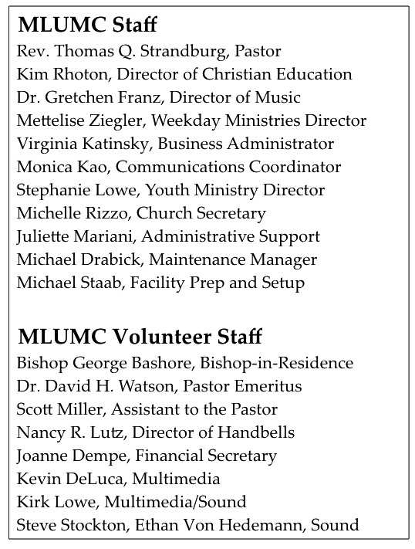

June UMW Meeting: Operation Safety Net On Tuesday, June 11 at 6 p.m., you’re invited to join UMW members for their annual salad supper. The speaker will be the director of Pittsburgh Mercy’s Operation Safety Net, the innovative, award-winning medical and social service outreach program for persons who are experiencing homelessness in Allegheny County.

Please bring a salad to share; we’ll provide drinks and dessert. Women of all ages are welcome — and encouraged — to attend this informative event!

CALENDAR – SUNDAY, MAY 26 THRU SATURDAY, JUNE 1

SUNDAY 5/26
8:30 am Worship Sanner Chapel
10:45 am Worship Sanctuary
10:45 am Kids Praise Welcome Center
5 pm Youth Group Asbury
7 pm Troop 23 Leadership Meeting Wesley

MONDAY 5/27 OFFICE CLOSED – MEMORIAL DAY

TUESDAY 5/28
7 pm Rummage Sale Set-Up with Scouts Various

WEDNESDAY 5/29 Rummage Sale Set-Up Various

THURSDAY 5/30 Rummage Sale Set-Up Various

FRIDAY 5/31 Rummage Sale Set-Up Various

SATURDAY 6/1
9 am RUMMAGE SALE Various

